Project Progress Report

Project Title: File Management System
Reporting Period: 25th December,2023 to 29nd December,2023.

Key Objectives:

Project Setup: Establish the project structure, dependencies, and initial configurations.

Backend Development: Implement basic backend functionality, including user authentication, database connection, and API endpoints.

Security Measures: Integrate security features such as password hashing using bcrypt and JWT token generation for authorization.

Utility Components: Create utility classes and components for handling asynchronous operations, API responses, and errors.

Middleware Integration: Add necessary middleware, such as CORS, for proper API endpoint access.

Accomplishments:
[Bhavya Anand]

Profile Page:

1. Developed a profile page to fetch and display details of the currently logged-in user.

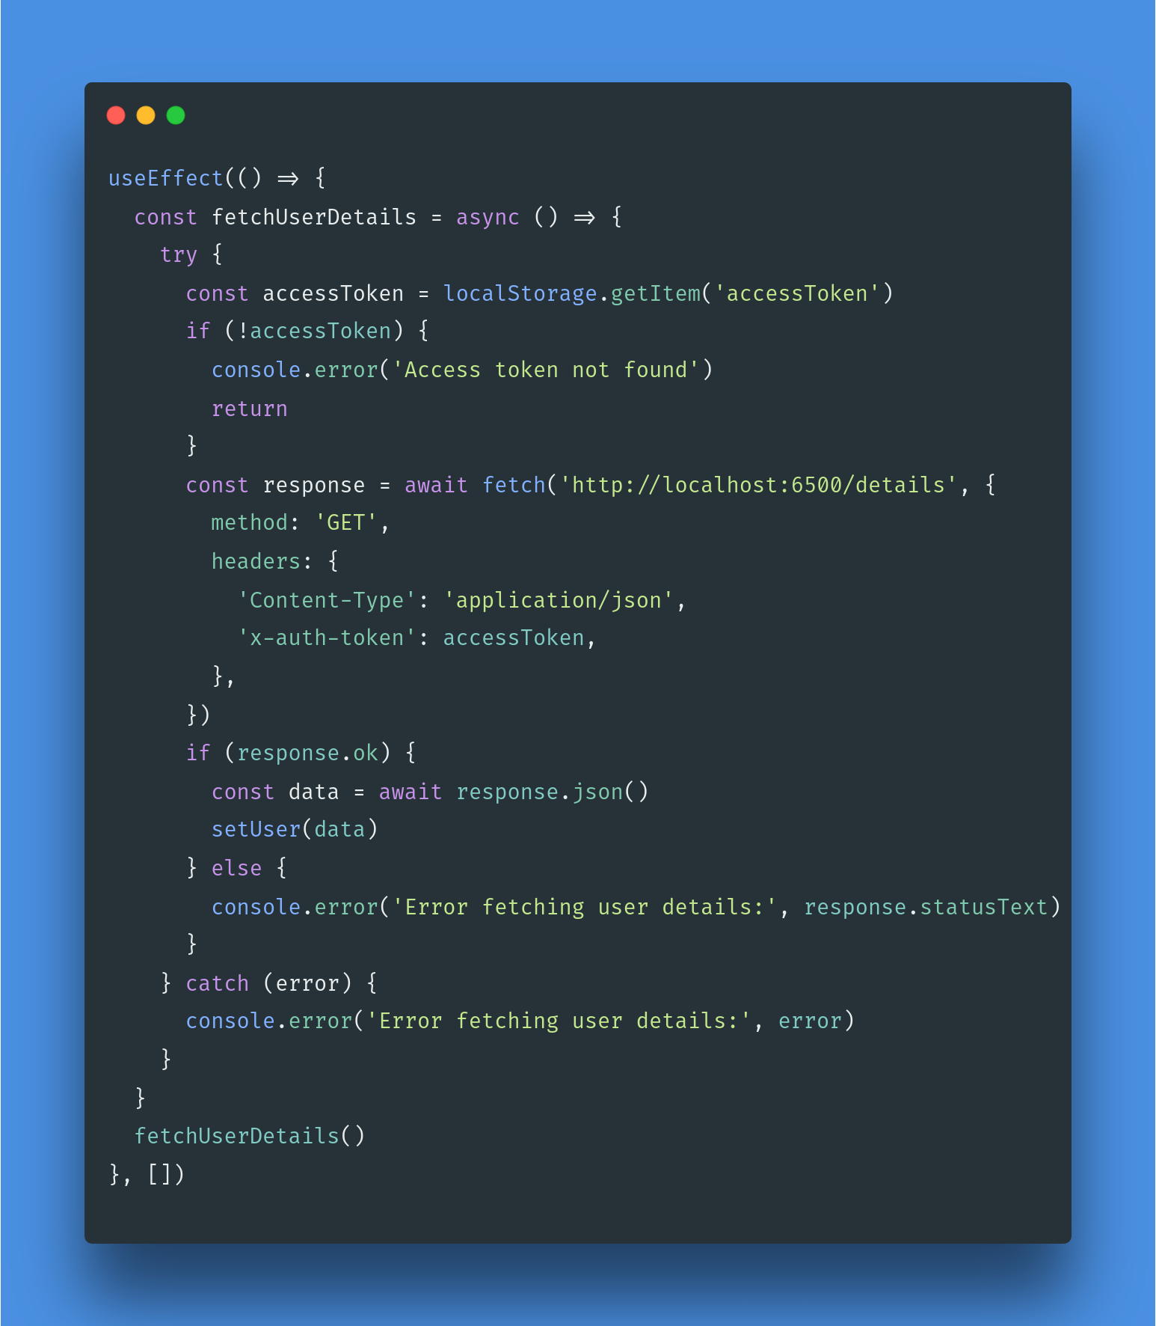

Dashboard and Folder Management:

1. Created a dashboard with the ability to add folders, implementing an API endpoint to save folder details to the database.
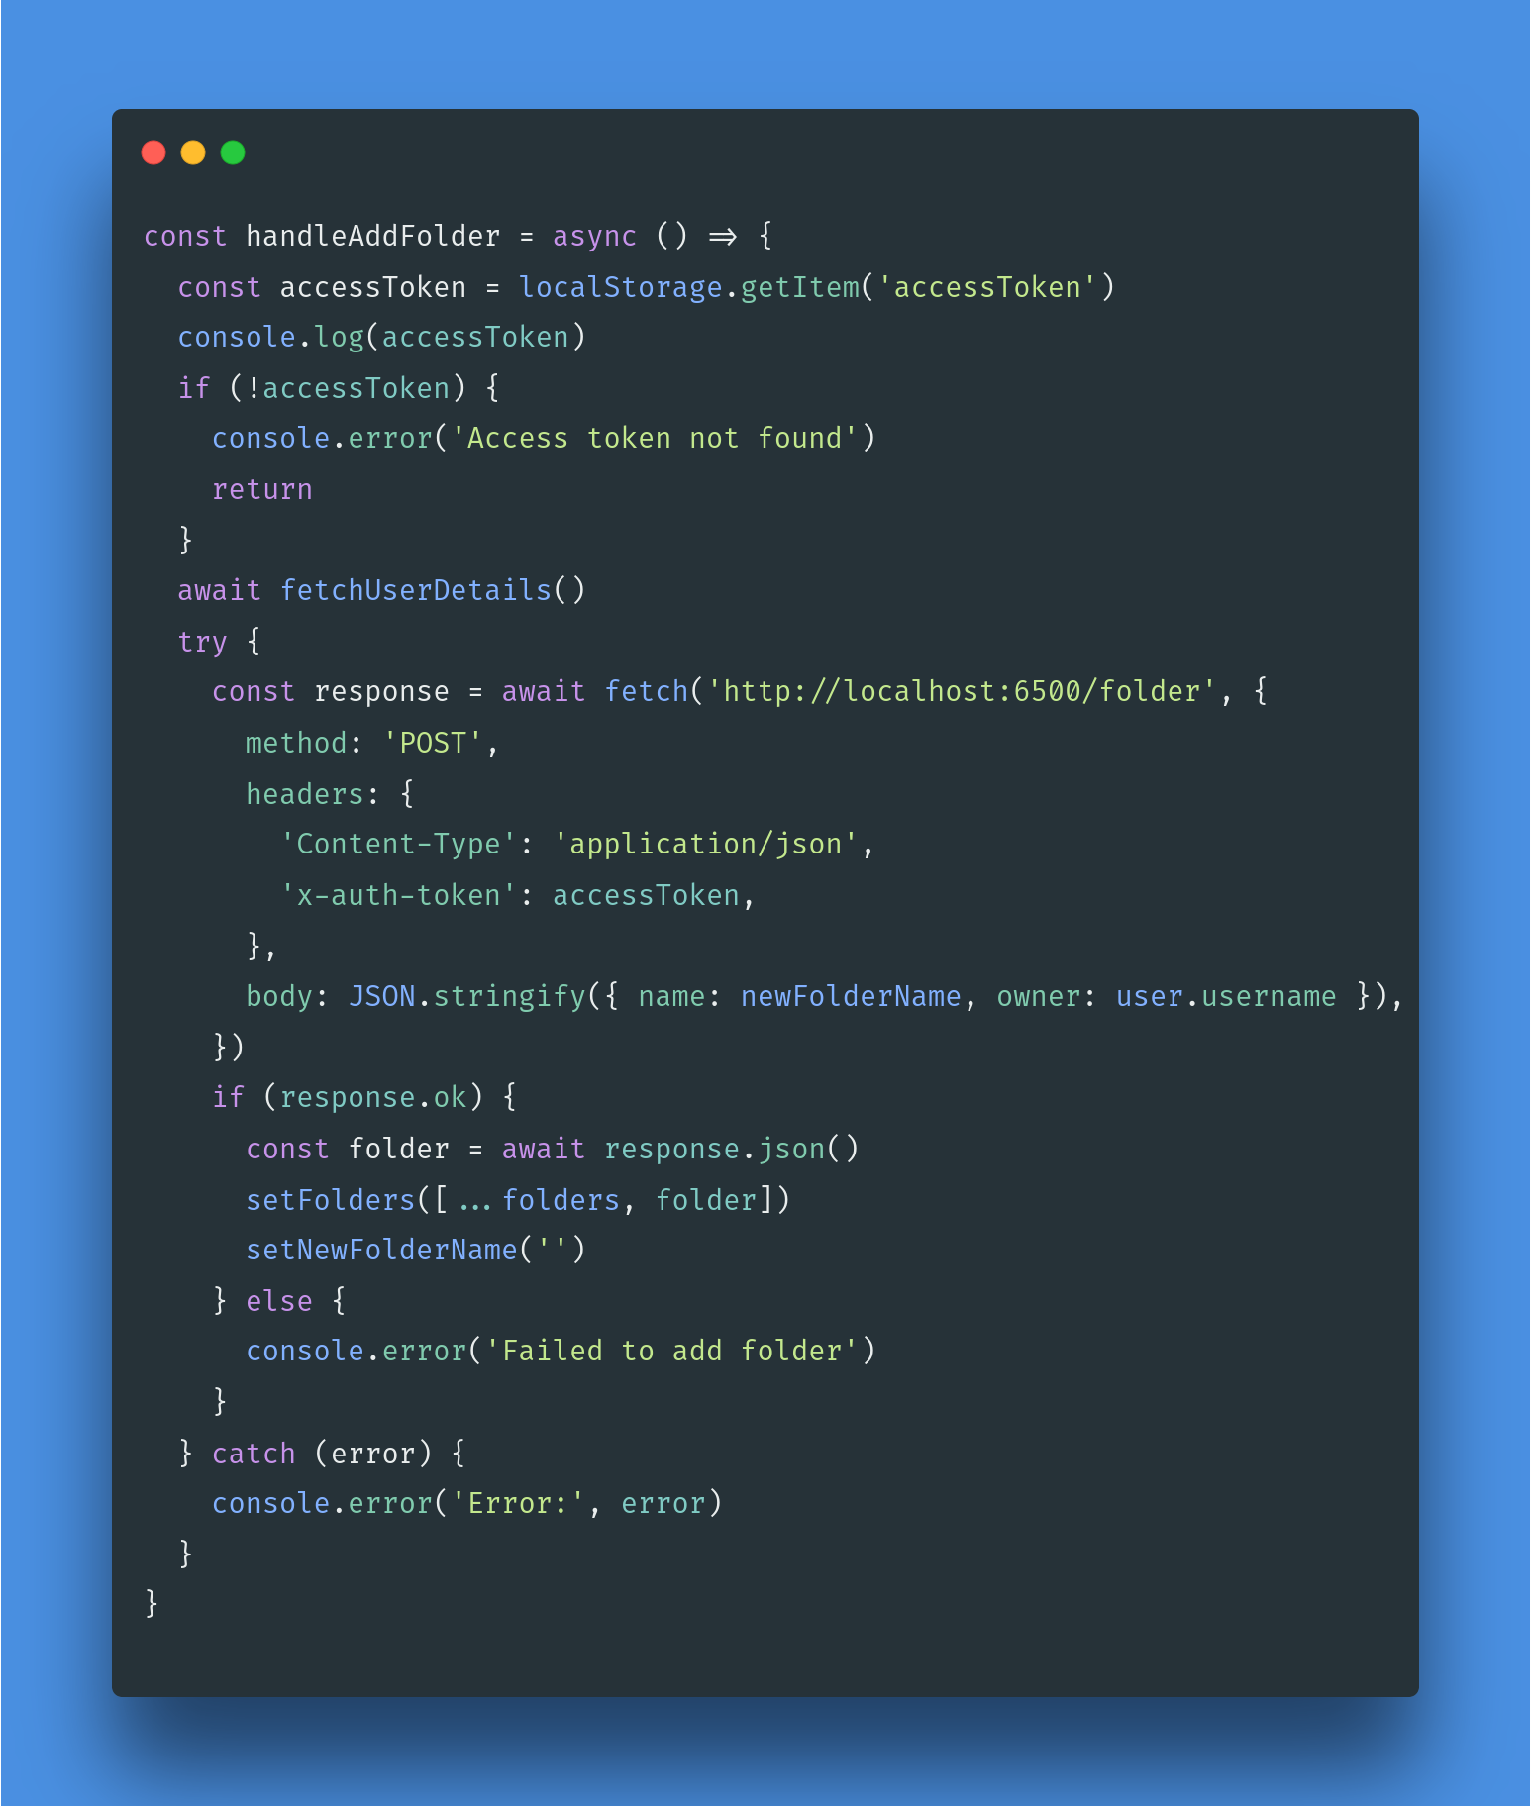

2. Implemented an API to fetch folders created by the currently logged-in user and displayed them on the dashboard.

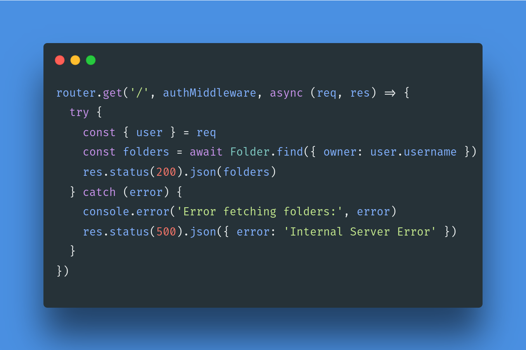

3. Added functionality to navigate to a clicked folder and add files to the selected folder.

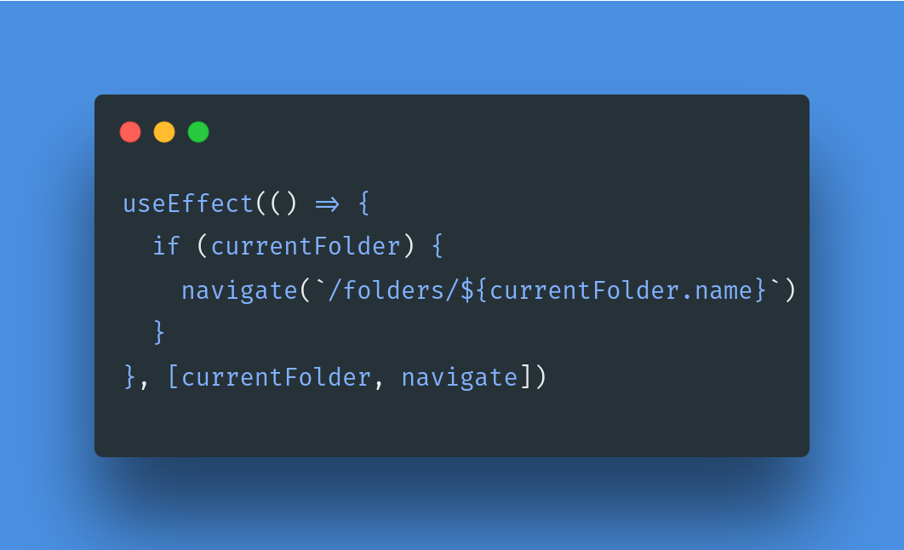

File and Folder Creation:

1. Implemented API endpoint for adding file details (name, owner, creation date, and time) to the database using Multer.

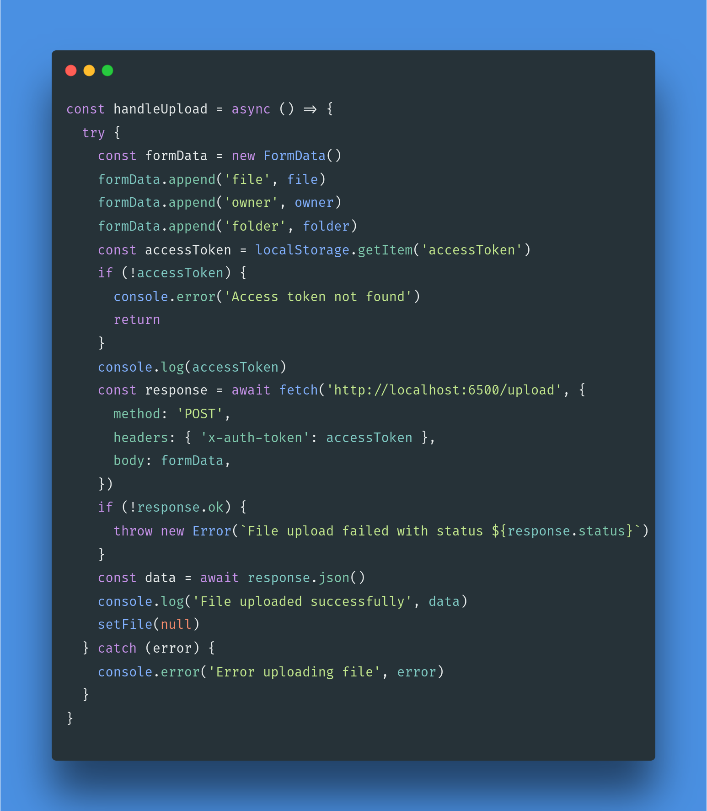

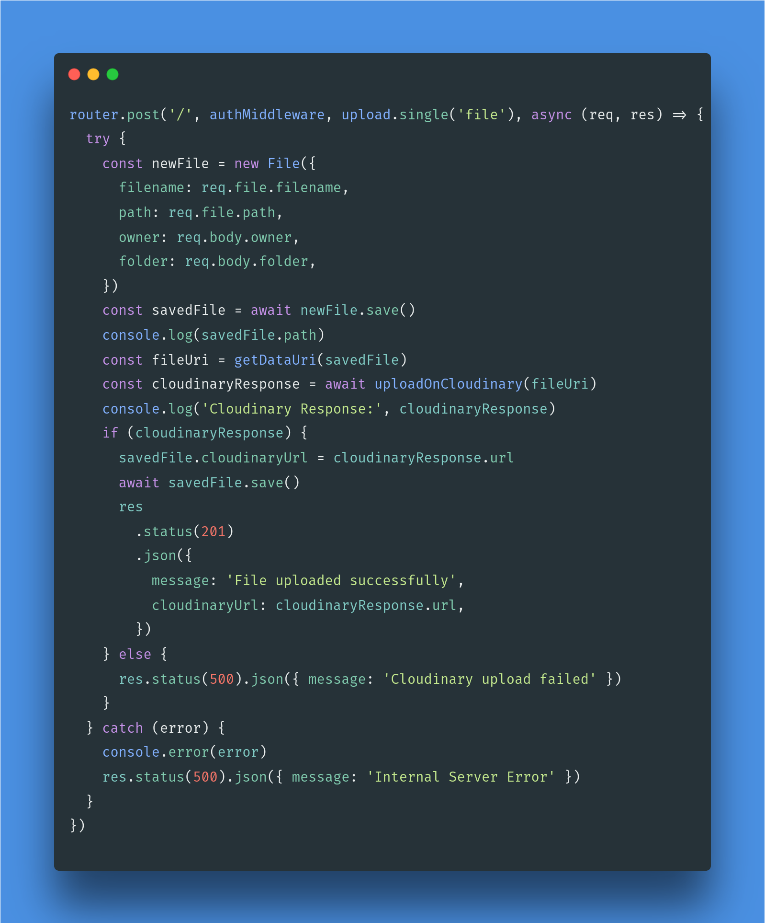

2. Integrated Cloudinary services to save files, creating links for efficient file management.

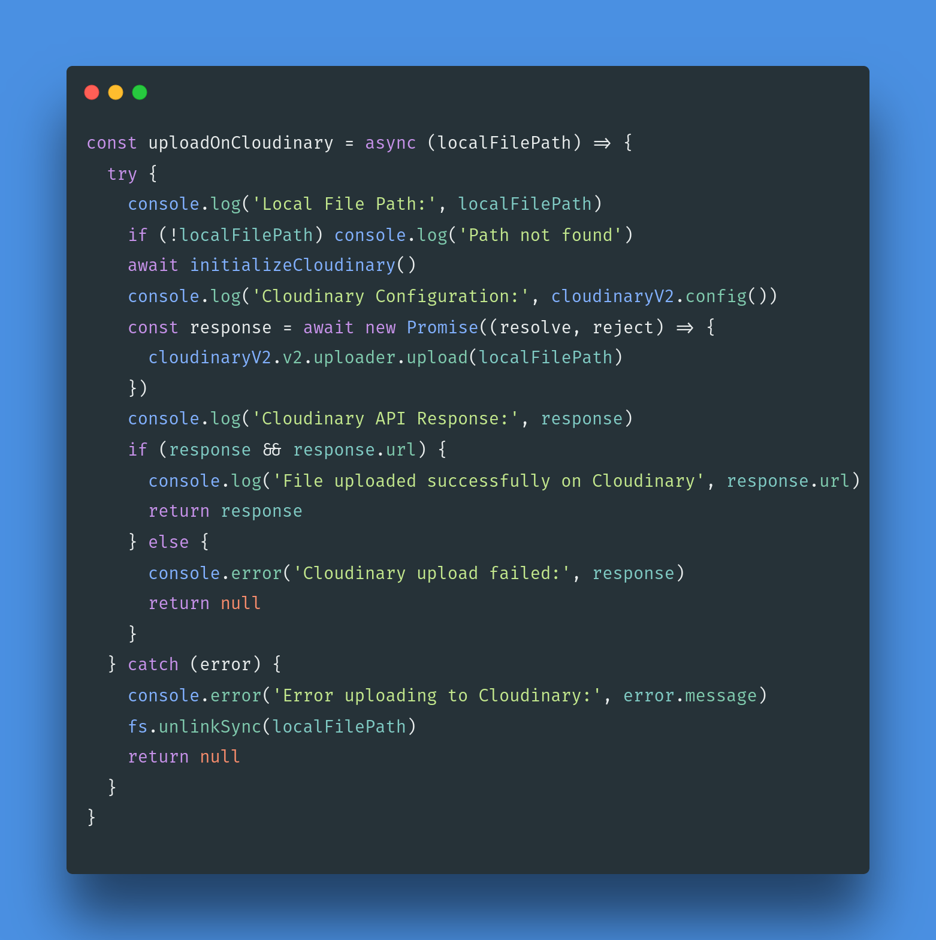

Upcoming Goals:

File Retrieval:

Develop API for fetching all files of the current folder for the currently logged-in user and display them on the dashboard.

Enhanced File Management:

Add functionality for searching and sorting files by name.

UI Enhancement:

Adding UI enhancements to make the experience more user-friendly.

Challenges:

Authentication Error During Folder Retrieval:

1. Encountered authentication errors while fetching folders for the currently logged-in user.
2. Successfully addressed the issue by incorporating authentication into a separate function and ensuring its execution before fetching folders.

Changes to Project Plan:

No significant changes to the original project plan; however, continuous adjustments will be made based on evolving requirements and feedback.
Action Items:

File/Folder Management:

1. Implement CRUD operations for files and folders.
2. Establish secure file upload and download mechanisms.

Performance Monitoring:

1. Implement metrics tracking for key performance indicators.
2. Set up monitoring tools for continuous performance assessment.

Attachments:

Click here to access the GitHub repository for the project.

(All the codes have been already pushed to GitHub)

