AOA User Management Implementation Proposal

The scope of the skeleton
This skeleton gives the general disposition of an Implementation Proposal for a hardware/software product/component. As such, a skeleton cannot cover all kinds of objects, it has to be adapted to the object you are describing.
Explanation to skeleton
The following method is used in the skeleton for marking text to be replaced:
<text> means that the text within angle brackets shall be replaced by relevant text. For example, if the project name is Sirius, <Project name> shall be replaced by Sirius.
The purpose of an IP is to document a technical evaluation done before Gate 2, with the following purposes:
to analyse technical impact of requirements in order to avoid “show-stoppers” and unexpected surprises
to provide a documented basis for design work after Gate 2. (That work shall be documented in functionspecifications/descriptions of function and design specifications/design descriptions.)
to give a reasonably reliable estimation of the development effort
to provide input to the Gate 2 decision to continue or not.
The IP shall contain the following:
Overview of the new/changed functionality.
Brief overview of the suggested implementation (design described to such a level of detail that it can be used for reasoning around).
Estimations of the amount of different documents, drawings, and source code, that has to be produced or changed.
Estimations of required effort, equipment, and other things needed to accomplish an implementation.
There shall be one IP per new or modified function/functional subsystem/component.
Different IPs may be on different level of detail, but as a general rule, do not use more than 4 person-weeks for an IP.
Further users of an IP are:
Product management – to verify that the requirements have been understood by the developers, and that the requirements are good enough to use as basis for development.
Developers – to get to know functions, products and documentation that need to be created or updated, and to give feedback regarding what can be done, how it can/should be done, and how long it will take.
Program/project managers – to plan and negotiate resources and schedules for the design work to be performed.
Contents
1. Introduction 3
1.1 Terminology 3
2. Requirements Covered 3
3. New and/or Changed Functionality 3
3.1 <Use Case Name> - flow of events 3
4. Proposed Implementation 3
4.1 Data model 3
4.2 Interfaces 3
4.3 Design structure 3
4.4 Required changes to other parts 4
4.5 Influenced characteristics 4
4.6 Impact on other products/components 4
4.7 Operation & maintenance 4
4.8 Reuse 4
5. Implementation Activities 4
5.1 New development methods and tools 4
5.2 Impact on delivery center 4
5.3 Production costs 4
6. Deliverables 4
7. Estimation Methods 4
8. Effort Estimation 5
8.1 Software 5
8.2 Hardware 5
8.3 Documents 5
8.4 Total 6
9. Open Issues 6
10. Risks 6
11. References 6
12. Revision 7

Summary
User Management System is a platform where Super/Operator Users can interact with AOA application to perform various activities corresponding to their Role. This would handle all the User related activities and its corresponding Authentication and Authorization mechanism.

Fill in a summary of the content of the document.

Introduction
The UM system will be helpful in fulfilling below of these key features,

- For Login Authentication/Authorization and
- For Role Based Access Control(RBAC) implementation
- Helping the Users to do Master Reset
- To perform Reset/Change passwords
- To handle the User Creation/Deletion and other user related manipulations like User Updates and fetching of User Details
- To maintain Audit Logs & Error Logs for AUM
- Making a secure communication of user information by adopting to Cyber security standards
- To have a Unit testing and Code Coverage metrics

System Diagram:
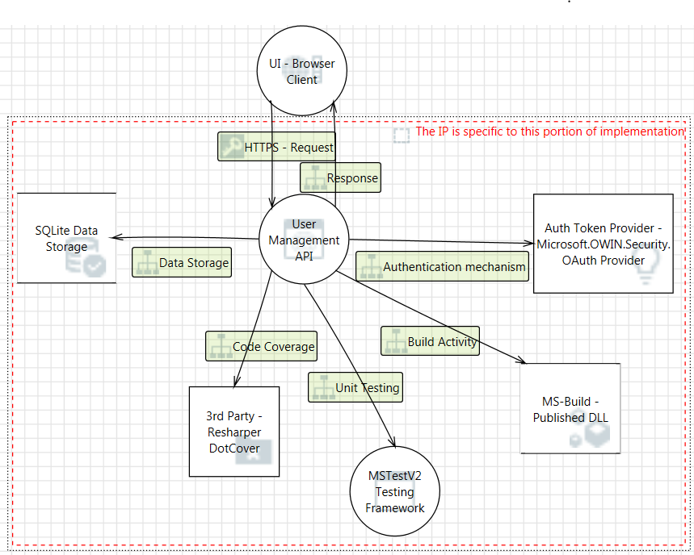

UAM Modules:
- User Module
- Role & Activity Module
- Audit Log Module
Delineate the purpose of the document. Specify the intended audience (see the help text above).
Identify the product/function
for a new product/function, describe briefly what it will do and, if necessary, what it will not do.
for a further development of an existing product/function,
describe briefly what will be added/changed.
identify the product/function version/revision that will be used as starting point – input baseline – for the development.
refer to its existing documentation.
identify the development program/project for which this document is written.

Terminology

List the special terms and definitions used, if any, in alphabetic order. Make references to other documents with definitions.
Term | Definition
Super User | An user who acts as an Admins for the application
Operator User | An operator users is meant for be service engineer
Password Reset | Allowing an existing user to change the Password
Master Reset | All the user information will be deleted and the default user name and Password shall be used for login
User Authentication | To cross verify the User is Authenticated to login to the system
User Authorization | To cross verify the User Role to perform only the authorized activities
Audit Logs | To log all the User related activities in the system
Error Logs | To log any System errors like .Net Exceptions, Memory exceptions, Logical flaw exceptions
Login Counter | To track the User’s Login attempts with invalid credentials
Password History | To store the last three passwords of the User

Requirements Covered

The following product requirements have been addressed in this Implementation Proposal:

Req. Spec. No. | Req. Item ID | Headline and Definition | Where in this doc.
TFS | 28660 | User Authorization | Under New and Changed Functionality Section – Page # 7-12, Proposed Implementation Page # 14-16 & Use Case Model Page # 12
TFS | 28661 | User Access Control | Under New and Changed Functionality Section - Page # 6-10, Proposed Implementation Page # 14-16 & Use Case Model Page #12
TFS | 29317 | New User Creation | Under New and Changed Functionality Section – 6-10, Proposed Implementation Page # 14-16 & Use Case Model Page #12
TFS | 29319 | User Roles | Under New and Changed Functionality Section – 6-10, Proposed Implementation Page # 14-16 & Use Case Model Page #12
TFS | 29331 | Default User | Default User Inclusion will be done directly at the DB Level, Proposed Implementation Page # 14-16 & Use Case Model Page #12
TFS | 29332 | User Deletion | Under New and Changed Functionality Section – 6-10, Proposed Implementation Page # 14-16 & Use Case Model Page #12
TFS | 29333 | Change Password | Under New and Changed Functionality Section - Page No. 6-10, Proposed Implementation Page # 14-16 & Use Case Model Page #12
TFS | 29334 | Update User Information | Under New and Changed Functionality Section – 6-10, Proposed Implementation Page # 14-16 & Use Case Model Page #12
TFS | 30161 | User details modification | Under New and Changed Functionality Section – Page # 6-10, Proposed Implementation Page # 14-16 & Use Case Model Page #12

For each requirement, refer to the location (use case, function, or chapter/section/page) where it is addressed within this document.

New and/or Changed Functionality

Below I have diagrammatically represented the Use Case Model Diagram along with the corresponding Stories associated to it

Use Case Diagrams

User Creation Flow
Description: Post the successful validation of the Super User, the Super user can create either an Operator User(Default by selection) and another Super User

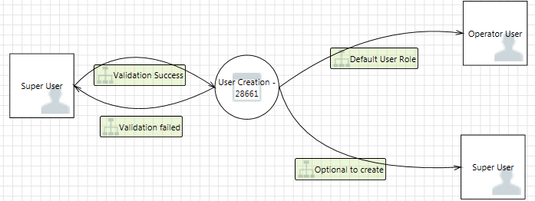

Login Validation

Description:
Lock User Account: After 3 unsuccessful login attempts the User gets locked and the User will not be able to login further.
Password History: To maintain the last 3 passwords of the User
Password Expiration: Passwords gets expired for every 180 Days and the User is enforced to change the password.
Reset Password: To Set the Default Password of the System
Change Password: User will be prompted to change the Password if the User has Default Password. Also the Password Change can be done by the User by themselves.
Password Validation: This handles the min/max requirements for the Password Text where the same will be handled at UI application.

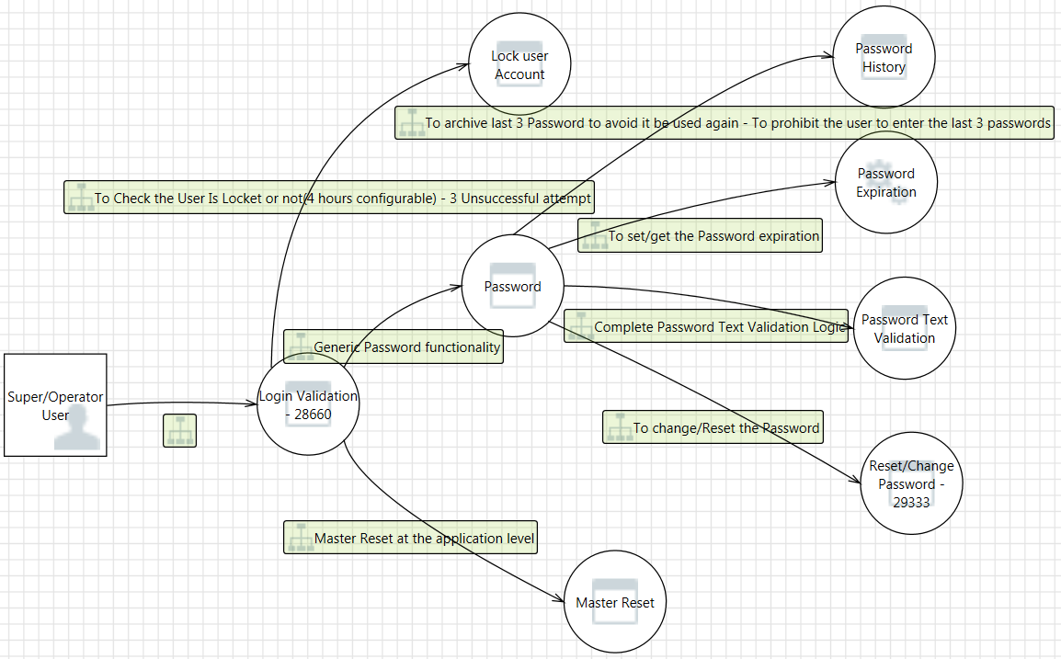

Super User Access Rights

Description: Super user has the rights to Create another User, Delete User and Modify the User. Also he has the permission to View the Logs of the Users in the System.

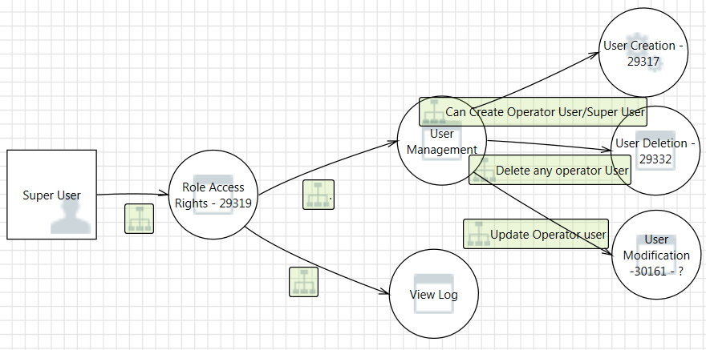

Audit Logging User Events

Description:

The User activities like Login,LogOut, UserCreation, Deletion, Modification, Password Reset, Expiration, Login Attempts, System Exception will all be logged in the Audit Log Table
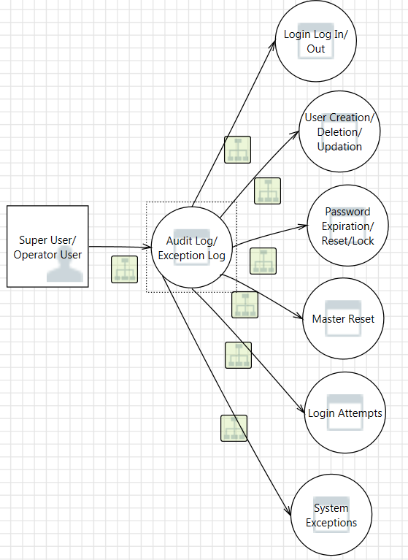

Authentication Mechanism Data flow
Description:
Once the Client passes the EmailID/Password, the System validates the User credentials and generates the Token where the same taken has to be used in all the further requests to the API. Below the Token flow between the systems is diagramatically represented

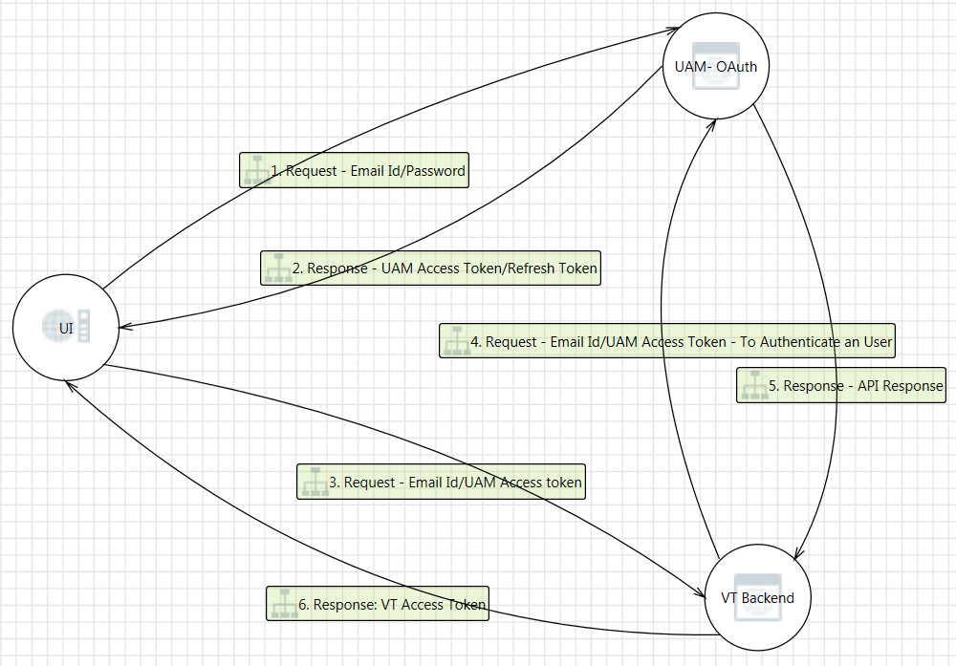

Write a very brief description of function, with just enough detail to make it possible to reason about how it should be implemented in the next chapter. Concentrate on major functionality and/or tricky parts.
For functionality that has a human-machine interface, it is recommended that you describe the new/changed functionality in the form of use cases. Use cases may also be used whenever a description of a flow of events during an interaction between the product/function and its environment is useful.The product/system should be regarded as a black box. (In the next chapter, the use cases are revisited, and the flow of events inside the product/function is described.)
Remember that this chapter should be brief. A full-fledged use case model may be done after Gate 2 if desired, and documented in the Function specification/Description of function.

Use cases are not useful for all kinds of functionality. If this document will not contain use cases, structure this chapter according to the functionality with one section per function, if required. Remember that this chapter should be brief. A full-fledged Function specification/description of function shall be written after Gate 2.

Steps for creating the use cases (cheat sheet – if you are not familiar with this, refer to literature, courses, etc.):
Find actors – user roles and/or external equipment that interacts with the product/function. Give them descriptive names. Describe them in order to avoid misunderstandings.
Find use cases – things that the product/function should be able to do, interaction sequences that provide value to the actors. Give them descriptive names – for an Automated Teller Machine this might be “Withdraw Money”. For process control, it may be for example “Open Valve”, “Present trend”, etc. Describe briefly the purpose of each use case.
Describe the flow of events in a separate section for each use case. A flow of events is simply a step-by-step description of what happens. Use numbered lists of ordinary text.Do not attempt to cover all possible situations; stick to the main flow.
Draw a diagram (or a set of diagrams) showing all actors and use cases, and the relations between them
Use Case Model:

Flow of events
TFS 28660 | https://tfsa.abb.com/tfs/PAMP/Verification%20tools%20on%20Cloud/_workitems?id=28660&_a=edit&triage=true
TFS 28661 | https://tfsa.abb.com/tfs/PAMP/Verification%20tools%20on%20Cloud/_workitems?id=28661&_a=edit&triage=true
TFS 28662 | https://tfsa.abb.com/tfs/PAMP/Verification%20tools%20on%20Cloud/_workitems?id=28662&_a=edit&triage=true
TFS 29317 | https://tfsa.abb.com/tfs/PAMP/Verification%20tools%20on%20Cloud/_workitems?id=29317&_a=edit&triage=true
TFS 29319 | https://tfsa.abb.com/tfs/PAMP/Verification%20tools%20on%20Cloud/_workitems?id=29319&_a=edit&triage=true
TFS 29331 | https://tfsa.abb.com/tfs/PAMP/Verification%20tools%20on%20Cloud/_workitems?id=29331&_a=edit&triage=true
TFS 29332 | https://tfsa.abb.com/tfs/PAMP/Verification%20tools%20on%20Cloud/_workitems?id=29332&_a=edit&triage=true
TFS 29333 | https://tfsa.abb.com/tfs/PAMP/Verification%20tools%20on%20Cloud/_workitems?id=29333&_a=edit&triage=true
TFS 29334 | https://tfsa.abb.com/tfs/PAMP/Verification%20tools%20on%20Cloud/_workitems?id=29334&_a=edit&triage=true
TFS 30161 | https://tfsa.abb.com/tfs/PAMP/Verification%20tools%20on%20Cloud/_workitems?id=30161&_a=edit&triage=true

Proposed Implementation
In this chapter, describe how the changes and/or additions to the product/function are to be implemented, i.e. what must be changed, added, removed, etc. inside the product/function.
Alternative solutions may be specified. Present the alternatives in separate sections within this chapter. Document the pros and cons of all alternatives and any other reasoning around the choice of alternative.

Data model
User Table
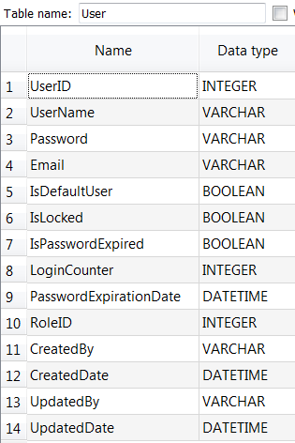

Role Table
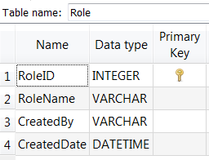

ActivityRight Table
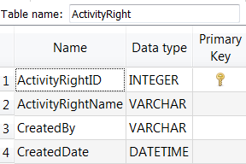

RoleActivityXRef Table
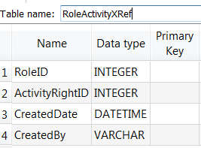

AuditLog Table
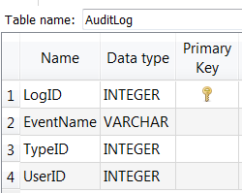
UserPasswordHistory Table
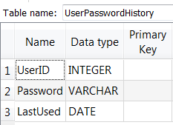

Data model / file structure / directory structure / user categories / security, etc (if applicable).

Interfaces
All the HTTP Response will be enclosed under HTTPResponseMessage
Interface | Feature | Input | Output - HTTPResponseMessage
User Component
/api/User | Fetch | NIL | List<UserBO>
/api/User/{userId} | Fetch | UserID | UserBO
/api/User | Create | UserBO | UserBO
/api/User/{userId} | Update | UserBO | UserBO
/api/User/{userId} | Delete | UserID | HTTResponseMessage(Boolean)
/api/User/MasterReset/{userId} | Master Reset | UserID | HTTResponseMessage(Boolean)
/api/User/ResetPassword/{userId}/{password} | Reset/Change Password | UserID, Password | HTTResponseMessage(Boolean)
/api/UserAuth/UserAuthentication/{userId}/{password} | Authentication | UserID, Password | HTTResponseMessage(UserBO)
Role Component
/api/Role | Fetch | NIL | List<RoleBO>
/api/RoleActivity | Fetch | RoleID | List<ActivityRightBO>
/api/GetUserActivityRights | Fetch | UserID | List<ActivityRightBO>
Audit Log
/api/AuditLog/{FromDateTime}/{ToDateTime} | Fetch | From/To DateTime | List<AuditLog>
/api/AuditLog | Create | AuditLogBO | AuditLogBO

Describe all internal and external interfaces and what they are used for, e.g. user interface, Application Programming Interface, bus interfaces, communication protocols.

Design structure

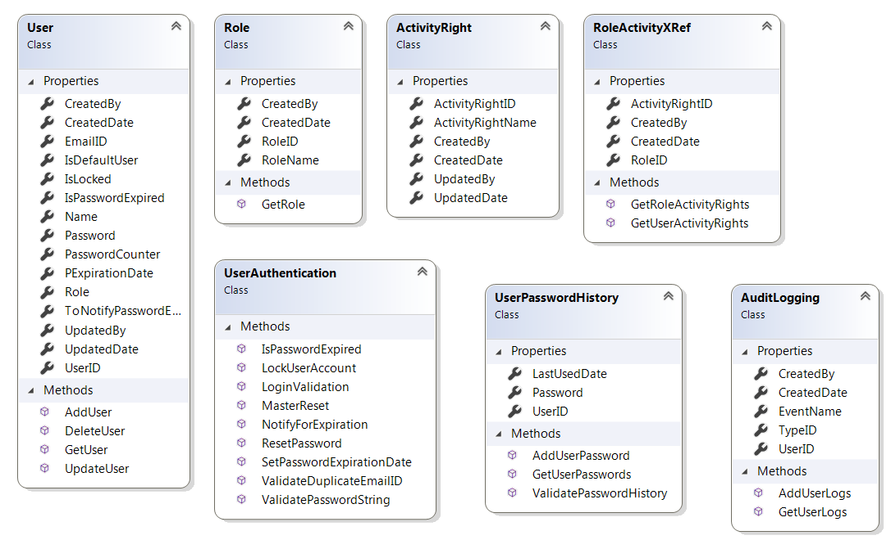
Show and describe a process view (if applicable).
Show and describe included components and/or function blocks.UML Sequence Diagrams is a preferable way to show this.

The impact on performance, resource consumption, network load, etc. should be shown in an understandable way and properly estimated. Examples:
system behavior
processor load
disk load
file system
communication links
throughput
restart time
power consumption, cooling
mechanical changes (size, weight, etc.)
etc.

Impact on other products/components
This involves direct integration with the VT Backend application. So any changes in the Use Role will impact the activity rights of VT Backend application.
Describe the impact, if any, your proposed implementation has on other products/components.

Operation & maintenance
- MSTestV2 Unit Test Methods for every code changes
- Resharper DotCover Code Coverage
- MSBuilds and Deployments
Describe
operation &maintenance of the function covered by this document
security functions
how function change is supported by this proposal
events and alarms
error handling/logging

Reuse
- Reusing this Application:
  - For any new application which involves User Management, the methods which is available in the User Components and Audit Log component can be reused
  - The same MSTestV2 unit testing can be used
  - MSBuildDefinition and Build Configuration approach can be reference for any new project
  - DotCover code coverage approach can be referenced.

Cyber Security Approach
- Secure Data communication over the n/w channel will be established through SSL certificate.
- OWIN OAuth Authentication mechanism
- SHA256 - Salt algorithm will be used for Hash the Passwords and other sensitive data wherever it’s used in the application
- Sensitive Data communication will be channelized through HTTP POST attributes
- Encrypt/Decrypt Webconfig Plain Texts
- Removal of Code Debugging Points
- To list down the Open ports, URL’s in the design documents
- Antivirus endpoint protection at the hosting machine
- Monitoring security updates and Patch of Antivirus
- OSS Scan using Black Duck
- Cyber security Checklist Documentation
- Browser Basic Authentication Setup

Performance
Load Testing has to be performed to get the application threshold and to get the list of concurrent request count it can handle.
Need to check for the number of Web servers to deploy the code and Load Balancer’s feasibility

Capacity:
If the Request/Response duration is not convincing post the Load Test, it would need to increase either the server capacity or an additional servers to enable full-fledged Load Balancer setup

Usability
UAT Testing will be performed at the UI application level. For the API Interface, the usability was determined at the design phase where UI/API meets the common point of consumption.

Describe which parts (classes) that can be reused from other systems.
Describe porting issues, if any.

Implementation Activities

- Code Development – Web API 2.0 and OAuth Development
- Database Development – SQLite Table Schema creation, SQL Query Creation
- Unit Testing – MSTestV2
- Code Coverage – DotCover 2018.1
- Build Automation – MSBuild
Make a brief description of the implementation as a process showing the actions within the relevant products, showing sequences and interactions. Use diagrams if that facilitates understanding.
Make your description thorough enough so that it becomes easy to see that your implementation can be done in the way you propose - without going into all the details exactly how to do it.

New development methods and tools

- .Net WebApi 2.0 for API development
- OAuth Token access mechanism for Authentication/Authorization
- SQLite for Database storage
- Unit Testing using MSTestV2
- Resharper DotCover 2018.1 for the Code Coverage
- MSBuild for Build Automation
- Microsoft Threat Modelling for Use Case Diagrams

Technology and Tools Adoption
- Visual Studio Professional - Is the IDE which is used across for the ABB’s application development.
- SQLite: Is already part of VT Backend application and its lightweight and it doesn’t require any additional configurations to use it. SQLite is a popular choice as embedded database software for local/client storage in application software.
- MSTestV2 – which is a default Unit testing framework available in the Visual Studio when we create an application. There is no external installation required to integrate it. Also MSTestV2 holds good for our requirements.
- Resharper DotCover 2018.1: In cost comparison with Visual Studio Enterprise version DotCover 2018.1 looks a better option to go for Code Coverage. Also it’s an additional plugin to our existing Resharper Software.
Examples of topics to be covered here:
New programming languages (compilers etc.)
Other new tools
Requirements on new or changed instructions, guidelines, and templates

Impact on delivery center

- Resharper DotCover 2018.1 yearly renewal

Describe things that affect
manufacturing
way of delivery
installation
licenses
3rd party products/components
For new hardware, indicate the production costs, preferably in the form of references to existing products. The costs should not be expressed as presumed manufacturing costs.

Deliverables

Give a list of the units/boards/components/objects/modules/executables/DLL:s etc. that will be produced within the development program/project.
“Type” could be EXE, DLL, board, or anything suitable to describe what kind of deliverable it will be.
List what is known (or believed) at this stage. (A similar, more detailed list is written in the project plan.)
Name | Type | Description
User Component | API Interface | This component covers the User related activities which has got listed in the above topic 4.2 Interfaces list
Role Component | API Interface | This component covers the Role based access control through the Activities and Roles
Audit Log | API Interface | This component covers the EventLogs and Error logs which has got listed in the above topic 4.2 Interfaces list
Cyber Security | Security Implementation | To implement OAuth, SHA Salt Algorithm for Hashing, Encryption & Decryption, SSL Certificate integration, Browser Basic Authentication Setup
MSTestV2 | Unit Testing | Creating Unit tests for all methods in Business layer and API Interfaces
Code Coverage – Resharper dotCover | Code/Test Coverage | To get the Code Coverage Metrics
MSBuild | Build Automation | Automating Build activities. Every checkin to the TFS will automatically build the application and gets the Success/Failure output

Estimation Methods
The estimations are done on the basis of functional point analysis where all the individual methods required is listed and estimated based on the actions which it perfoms.

The WBS & the estimations can be found at the below location,
https://tfs-shp.abb.com/sites/PAMP/Analyzers%20on%20ABB%20Ability/Shared%20Documents/Forms/AllItems.aspx?RootFolder=%2Fsites%2FPAMP%2FAnalyzers%20on%20ABB%20Ability%2FShared%20Documents%2FProject%20Documents%2F02%20Delivarables%2FEngineering&FolderCTID=0x0120003F4432114C64EB469B70E6BE7E795CC8&View=%7B3DF7BC54%2D4FB9%2D41CC%2D9E0C%2D53D0646C3A4E%7D

Describe the method or methods that are/were used for the estimations that are documented in the following chapters

Effort Estimation
If your IP contains alternative solutions, present one set of estimations for each of them.

Software

Component/  Function | Plan & Design | Implementation and basic test | CTT (Function  test) | Sum
User Component | 6 | 48 |  | 54
Role Component | 3 | 14.2 |  | 17.2
Audit Log | 3 | 12.6 |  | 15.6
API Interface | 6 | 27 |  | 33
MSTestV2 for all the entire application | 6 | 30 |  | 36
Code Coverage – Resharper dotCover | 2 | 12 |  | 14
MSBuild | 10 | 40.5 |  | 50.5
Cyber Security | 10 | 63.5 |  | 73.5
OSS Scan | 1 | 4 |  | 5
Integration Testing | 3 | 22 |  | 25
DB Design and Development | 8 | 16 |  | 24
Total | 58 | 290 |  | 348

Documents

Note: all affected documents!
Type | Title | Doc. Id | Action | Write | Review
Funcspec | PMT_EST_TMP_9ARD7- 108_WBS_and_Estimation_Template.xlsx |  | new | 8 | 2
Design spec | UAM Design Document |  | new | 10 | 4
Testing Spec | UAM Test Report |  | new | 0
IP Spec | Implementation Proposal Document |  | new | 24 | 8
Cyber Security Checklist | Cyber Security Checklist Filling document |  | New | 3 | 1
Total |  |  |  | 45h | 15h

Total

Software | 382
Hardware | h
Documents | 60h
Grand total | 442h

Open Issues

Below of these items are Not Included in the system considering the below features are not required at this point of time

- User Equipment Mapping

Describe open issues, if any, that are not covered by this proposal.

Risks

Delay in procurement of Resharper DotCover 2018.1 would result in slip of deadlines for Code Coverage Metrics

Performance and Load Testing to be done by the QE engineer. Else UAM will not be able to test the threshold of the application.

Creating Build Automation would consume an extra 30% of time than the normal time as it requires technical exploration from myside as well.

Additional requirement changes or the functionalities later in the design phase apart from the listed elements in the WBS document would result in delay of deliverables.

Describe possible risks and what you propose to do to minimise the effect of them.

References

Ref. No | Document Id no | Title
[1] | TFS | https://tfs-shp.abb.com/sites/PAMP/Analyzers%20on%20ABB%20Ability/Shared%20Documents/Forms/AllItems.aspx?RootFolder=%2Fsites%2FPAMP%2FAnalyzers%20on%20ABB%20Ability%2FShared%20Documents%2FProject%20Documents%2F02%20Delivarables%2FEngineering&FolderCTID=0x0120003F4432114C64EB469B70E6BE7E795CC8&View=%7B3DF7BC54%2D4FB9%2D41CC%2D9E0C%2D53D0646C3A4E%7D
[2] | Coding Standards | https://tfs-shp.abb.com/sites/PAMP/Analyzers%20on%20ABB%20Ability/Shared%20Documents/Project%20Documents/04%20References/C%20sharp%20Style%20Guide.doc
[3] | Cyber Security Standards | http://search.abb.com/library/Download.aspx?DocumentID=9ADB005793&LanguageCode=en&DocumentPartId=&Action=Launch
[4] | Project Plan | https://tfs-shp.abb.com/sites/PAMP/Analyzers%20on%20ABB%20Ability/Shared%20Documents/Project%20Documents/01%20Project%20Management/01%20Gate%20Documents/G2/Analyzers%20on%20ABB%20Ability%20G2%204%20June%202018.pptx
[5] | MRS | https://tfs-shp.abb.com/sites/PAMP/Analyzers%20on%20ABB%20Ability/Shared%20Documents/Project%20Documents/02%20Delivarables/Market%20Requirements/IAMA%20ABB%20Ability%20-%20MRS-TRS%20-4-June-2018.docx
Make references to
documents/information used as input (note that requirements are referred to in the next chapter so they need not be referred to from here)
related implementation proposals.
other documents that the reader may need in order to understand the contents of this document.

Revision

Rev. ind. | Page (P)  Chapt. (C) | Description | Date  Dept./Init.
Naveenkumar Sreedharan | Initial Draft | Created the first draft of implementation proposal for User Management | 05/28/2018/IAMA Digital Products AOA User Management
Naveenkumar Sreedharan | Multiple pages | Revisions done based on the Review comments from Suhas | 05/30/2018/IAMA AOA User Management
Naveenkumar Sreedharan | Multiple pages | Revisions done based on the Review comments from Mini | 06/08/2018/IAMA AOA User Management
Naveenkumar Sreedharan | Multiple pages | Revisions done based on the discussions with Team | 06/14/2018/IAMA AOA User Management
Naveenkumar Sreedharan | Multiple pages | Removed Authentication Secrets functionalities as per the discussion with team | 06/26/2018/IAMA AOA User Management

