Product Implementation Proposal
Hidden Text
Hidden text is used in this skeleton for descriptions how to use the template. Check “Hidden text” under Tools>Options>View to see the hidden text on the screen when editing. Un-check “Hidden text” under Tools>Options>Print to omit the hidden text when printing the document. Delete this text.
The scope of the skeleton
This skeleton gives the general disposition of an Implementation Proposal for a hardware/software product/component. As such, a skeleton cannot cover all kinds of objects, it has to be adapted to the object you are describing.
Explanation to skeleton
The following method is used in the skeleton for marking text to be replaced:
<text> means that the text within angle brackets shall be replaced by relevant text. For example, if the project name is Sirius, <Project name> shall be replaced by Sirius.
The purpose of an IP is to document a technical evaluation done before Gate 2, with the following purposes:
to analyse technical impact of requirements in order to avoid “show-stoppers” and unexpected surprises
to provide a documented basis for design work after Gate 2. (That work shall be documented in functionspecifications/descriptions of function and design specifications/design descriptions.)
to give a reasonably reliable estimation of the development effort
to provide input to the Gate 2 decision to continue or not.
The IP shall contain the following:
Overview of the new/changed functionality.
Brief overview of the suggested implementation (design described to such a level of detail that it can be used for reasoning around).
Estimations of the amount of different documents, drawings, and source code, that has to be produced or changed.
Estimations of required effort, equipment, and other things needed to accomplish an implementation.
There shall be one IP per new or modified function/functional subsystem/component.
Different IPs may be on different level of detail, but as a general rule, do not use more than 4 person-weeks for an IP.
Further users of an IP are:
Product management – to verify that the requirements have been understood by the developers, and that the requirements are good enough to use as basis for development.
Developers – to get to know functions, products and documentation that need to be created or updated, and to give feedback regarding what can be done, how it can/should be done, and how long it will take.
Program/project managers – to plan and negotiate resources and schedules for the design work to be performed.
Contents
1. Introduction 3
1.1 Terminology 3
2. Requirements Covered 3
3. New and/or Changed Functionality 3
3.1 <Use Case Name> - flow of events 3
4. Proposed Implementation 3
4.1 Data model 3
4.2 Interfaces 3
4.3 Design structure 3
4.4 Required changes to other parts 4
4.5 Influenced characteristics 4
4.6 Impact on other products/components 4
4.7 Operation & maintenance 4
4.8 Reuse 4
5. Implementation Activities 4
5.1 New development methods and tools 4
5.2 Impact on delivery center 4
5.3 Production costs 4
6. Deliverables 4
7. Estimation Methods 4
8. Effort Estimation 5
8.1 Software 5
8.2 Hardware 5
8.3 Documents 5
8.4 Total 6
9. Open Issues 6
10. Risks 6
11. References 6
12. Revision 7

Summary
User Management System acts as a bridge between the Super Users/Operators and Verification Tools Backend application to perform various activities corresponding to their Role.

Fill in a summary of the content of the document.

Introduction
The UM system will be helpful in fulfilling below of these key features,

- For Login Authentication/Authorization and
- To maintain the User Authentication Secrets
- Helping the Users to do Master Reset
- To perform Reset/Change passwords
- To handle the User Creation/Deletion and other user related manipulations like User Updates and fetching of User Details
- To maintain Audit Logs & Error Logs

Below of these items are Not Included in the system considering the below features are not required at this point of time

- Role Management
- Activity Management
- User Equipment Mapping

Delineate the purpose of the document. Specify the intended audience (see the help text above).
Identify the product/function
for a new product/function, describe briefly what it will do and, if necessary, what it will not do.
for a further development of an existing product/function,
describe briefly what will be added/changed.
identify the product/function version/revision that will be used as starting point – input baseline – for the development.
refer to its existing documentation.
identify the development program/project for which this document is written.

Terminology

List the special terms and definitions used, if any, in alphabetic order. Make references to other documents with definitions.
Term | Definition
Super User | An user who acts as an Admins for the application
Operator User | An operator users is meant for be service engineer
Password Reset | Allowing an existing user to change his Password
Master Reset | All the user information will be deleted and the default user name and Password shall be used for login
User Authentication | To cross verify the User is Authenticated to login to the system
User Authorization | To cross verify the User Role to perform only the authorized activities
Audit Logs | To log all the User related activities in the system
Error Logs | To log any System errors like .Net Exceptions, Memory exceptions, Logical flaw exceptions
Login Counter | To track the User’s Login attempts with invalid credentials
Password History | To store the last three passwords of the User
Authentication Secret | The User specific Question and Answer which is used to Unlock/Reset the User’s account

Requirements Covered

The following product requirements have been addressed in this Implementation Proposal:
Req. Spec. No. | Req. Item ID | Headline and Definition | Where in this doc.
TFS | 28660 | User Authorization | Under New and Changed Functionality Section – Page # 6-10, Proposed Implementation Page # 12-15 & Use Case Model Page # 11
TFS | 28661 | User Access Control | Under New and Changed Functionality Section - Page # 6-10, Proposed Implementation Page # 12-15 & Use Case Model Page #11
TFS | 28662 | Data Authorization | Under New and Changed Functionality Section – 6-10, Proposed Implementation Page # 12-15 & Use Case Model Page #11
TFS | 29317 | New User Creation | Under New and Changed Functionality Section – 6-10, Proposed Implementation Page # 12-15 & Use Case Model Page #11
TFS | 29319 | User Roles | Under New and Changed Functionality Section – 6-10, Proposed Implementation Page # 12-15 & Use Case Model Page #11
TFS | 29331 | Default User | Default User Inclusion will be done directly at the DB Level, Proposed Implementation Page # 12-15 & Use Case Model Page #11
TFS | 29332 | User Deletion | Under New and Changed Functionality Section – 6-10, Proposed Implementation Page # 12-15 & Use Case Model Page #11
TFS | 29333 | Change Password | Under New and Changed Functionality Section - Page No. 6-10, Proposed Implementation Page # 12, 13 & Use Case Model Page #11
TFS | 29334 | Update User Information | Under New and Changed Functionality Section – 6-10, Proposed Implementation Page # 12-15 & Use Case Model Page #11
TFS | 30161 | User details modification | Under New and Changed Functionality Section – Page # 6-10, Proposed Implementation Page # 12-15 & Use Case Model Page #11

For each requirement, refer to the location (use case, function, or chapter/section/page) where it is addressed within this document.

New and/or Changed Functionality

Below I have diagrammatically represented the Use Case Model Diagram along with the corresponding Stories associated to it

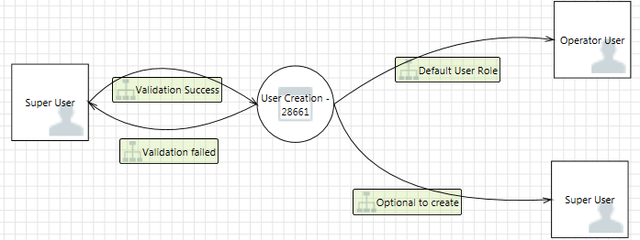

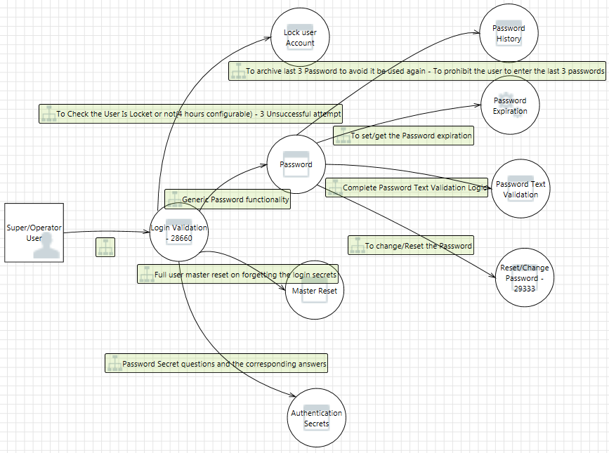
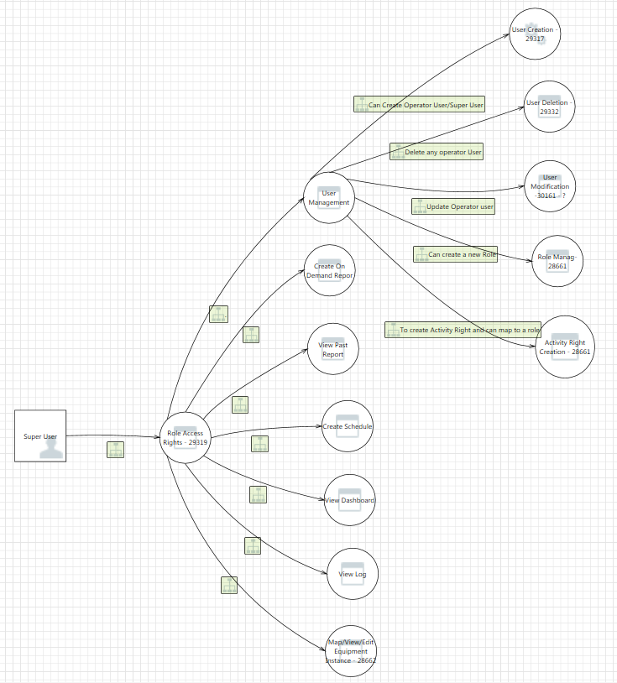
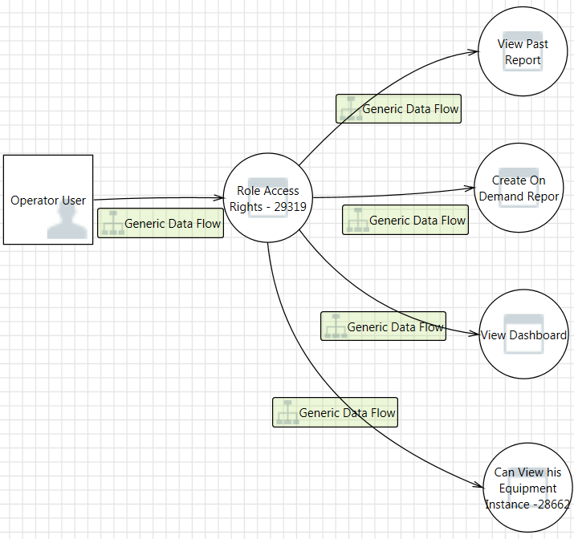

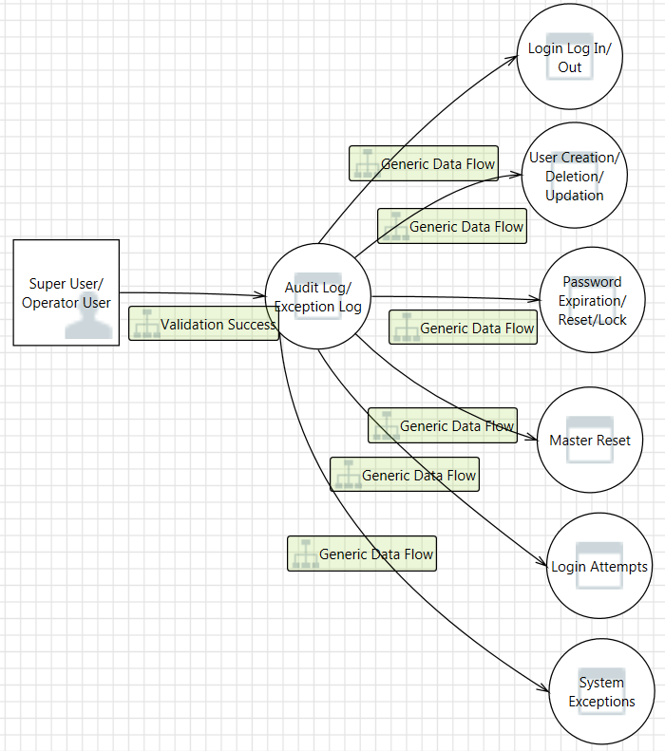

Authentication Mechanism:
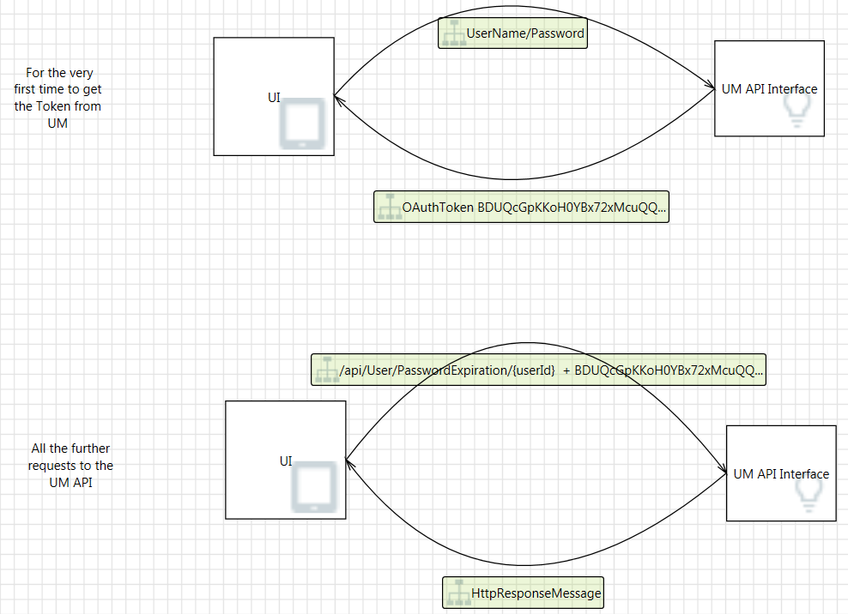
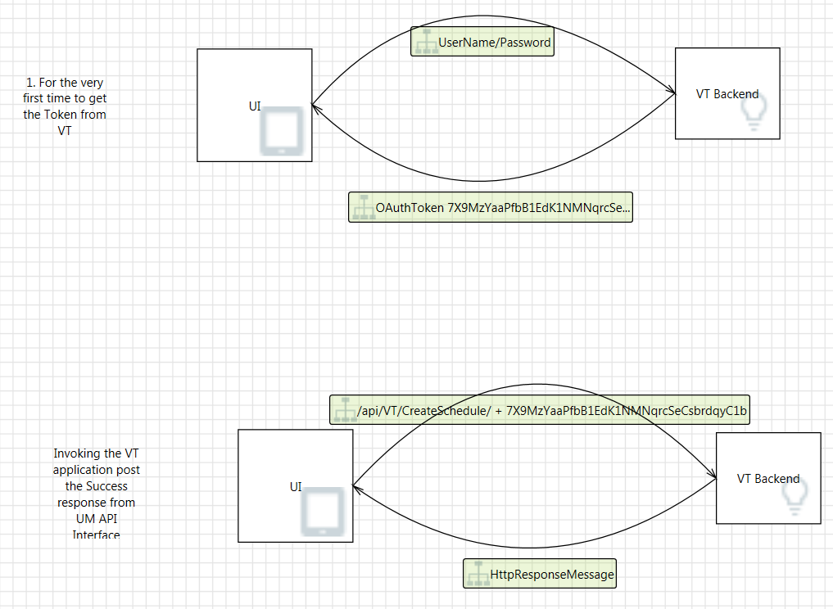

Write a very brief description of function, with just enough detail to make it possible to reason about how it should be implemented in the next chapter. Concentrate on major functionality and/or tricky parts.
For functionality that has a human-machine interface, it is recommended that you describe the new/changed functionality in the form of use cases. Use cases may also be used whenever a description of a flow of events during an interaction between the product/function and its environment is useful.The product/system should be regarded as a black box. (In the next chapter, the use cases are revisited, and the flow of events inside the product/function is described.)
Remember that this chapter should be brief. A full-fledged use case model may be done after Gate 2 if desired, and documented in the Function specification/Description of function.

Use cases are not useful for all kinds of functionality. If this document will not contain use cases, structure this chapter according to the functionality with one section per function, if required. Remember that this chapter should be brief. A full-fledged Function specification/description of function shall be written after Gate 2.

Steps for creating the use cases (cheat sheet – if you are not familiar with this, refer to literature, courses, etc.):
Find actors – user roles and/or external equipment that interacts with the product/function. Give them descriptive names. Describe them in order to avoid misunderstandings.
Find use cases – things that the product/function should be able to do, interaction sequences that provide value to the actors. Give them descriptive names – for an Automated Teller Machine this might be “Withdraw Money”. For process control, it may be for example “Open Valve”, “Present trend”, etc. Describe briefly the purpose of each use case.
Describe the flow of events in a separate section for each use case. A flow of events is simply a step-by-step description of what happens. Use numbered lists of ordinary text.Do not attempt to cover all possible situations; stick to the main flow.
Draw a diagram (or a set of diagrams) showing all actors and use cases, and the relations between them
Use Case Model:

<Use Case Name> - flow of events

The use case begins when the <actor> <description of stimuli>
According to <certain values/states/other conditions> the system performs <description of the flow of events>
The use case ends when (the <actor> has <received>)

TFS 28660 | https://tfsa.abb.com/tfs/PAMP/Verification%20tools%20on%20Cloud/_workitems?id=28660&_a=edit&triage=true
TFS 28661 | https://tfsa.abb.com/tfs/PAMP/Verification%20tools%20on%20Cloud/_workitems?id=28661&_a=edit&triage=true
TFS 28662 | https://tfsa.abb.com/tfs/PAMP/Verification%20tools%20on%20Cloud/_workitems?id=28662&_a=edit&triage=true
TFS 29317 | https://tfsa.abb.com/tfs/PAMP/Verification%20tools%20on%20Cloud/_workitems?id=29317&_a=edit&triage=true
TFS 29319 | https://tfsa.abb.com/tfs/PAMP/Verification%20tools%20on%20Cloud/_workitems?id=29319&_a=edit&triage=true
TFS 29331 | https://tfsa.abb.com/tfs/PAMP/Verification%20tools%20on%20Cloud/_workitems?id=29331&_a=edit&triage=true
TFS 29332 | https://tfsa.abb.com/tfs/PAMP/Verification%20tools%20on%20Cloud/_workitems?id=29332&_a=edit&triage=true
TFS 29333 | https://tfsa.abb.com/tfs/PAMP/Verification%20tools%20on%20Cloud/_workitems?id=29333&_a=edit&triage=true
TFS 29334 | https://tfsa.abb.com/tfs/PAMP/Verification%20tools%20on%20Cloud/_workitems?id=29334&_a=edit&triage=true
TFS 30161 | https://tfsa.abb.com/tfs/PAMP/Verification%20tools%20on%20Cloud/_workitems?id=30161&_a=edit&triage=true

Proposed Implementation

In this chapter, describe how the changes and/or additions to the product/function are to be implemented, i.e. what must be changed, added, removed, etc. inside the product/function.
Alternative solutions may be specified. Present the alternatives in separate sections within this chapter. Document the pros and cons of all alternatives and any other reasoning around the choice of alternative.

Data model
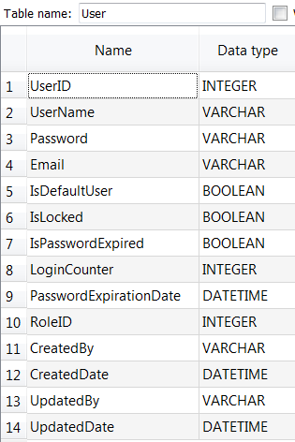

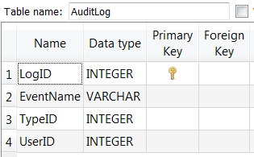

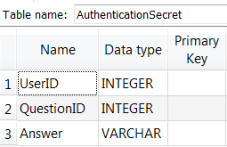

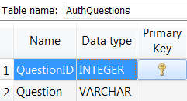

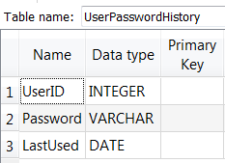

Data model / file structure / directory structure / user categories / security, etc (if applicable).

Interfaces

Interface | Input | Output - HTTPResponseMessage
User Component
/api/User | NIL | List<UserBO>
/api/User/{userId} | UserID | UserBO
/api/User | UserBO | UserBO
/api/User/{userId} | UserBO | UserBO
/api/User/{userId} | UserID | HTTResponseMessage(Boolean)
/api/User/MasterReset/{userId} | UserID | HTTResponseMessage(Boolean)
/api/User/ResetPassword/{userId}/{password} | UserID, Password | HTTResponseMessage(Boolean)
/api/UserAuth/UserAuthentication/{userId}/{password} | UserID, Password | HTTResponseMessage(Boolean)
Authentication Secret
/api/AuthenticationSecret | NIL | List<SecretQuestions>
/api/AuthenticationSecret/Verify | UserAuthSecretBO | HTTResponseMessage(Boolean)
/api/AuthenticationSecret/MapUserSecretAnswer | UserAuthSecretBO | UserAuthSecretBO
Audit Log
/api/AuditLog/{FromDateTime}/{ToDateTime} | From/To DateTime | List<AuditLog>
/api/AuditLog | AuditLogBO | AuditLogBO

Describe all internal and external interfaces and what they are used for, e.g. user interface, Application Programming Interface, bus interfaces, communication protocols.

Design structure

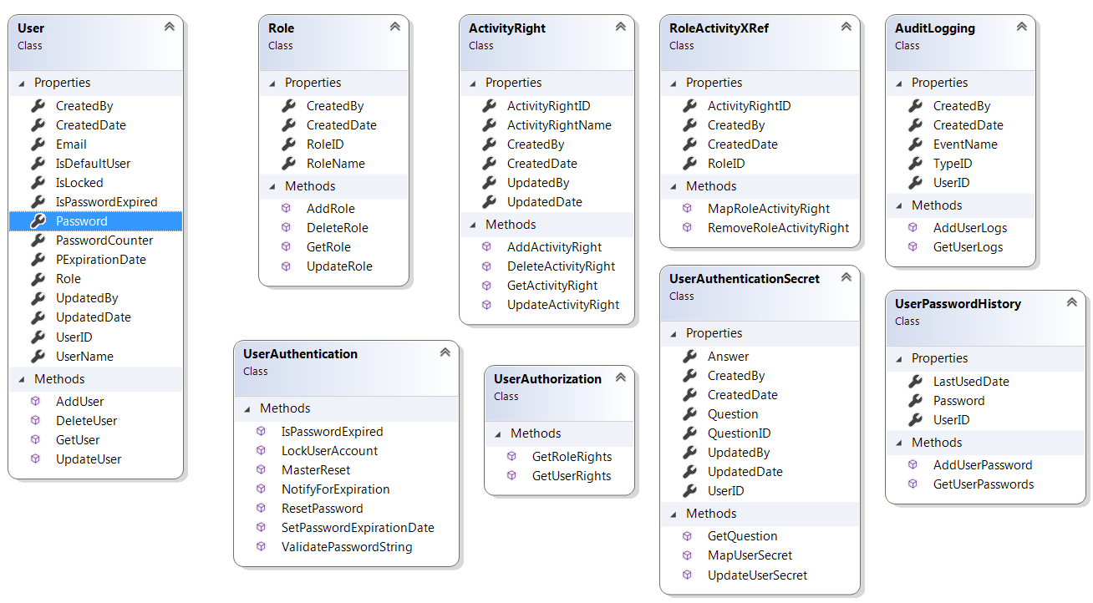

Show and describe a process view (if applicable).
Show and describe included components and/or function blocks.UML Sequence Diagrams is a preferable way to show this.

Required changes to other parts

Mention all other parts of the system (e.g. products, interfaces, functions) that are influenced by your IP and how each part would have to be modified.

Influenced characteristics

The impact on performance, resource consumption, network load, etc. should be shown in an understandable way and properly estimated. Examples:
system behavior
processor load
disk load
file system
communication links
throughput
restart time
power consumption, cooling
mechanical changes (size, weight, etc.)
etc.

Impact on other products/components

Describe the impact, if any, your proposed implementation has on other products/components.

Operation & maintenance

- MSTestV2 Unit Test Methods for every code changes
- Resharper DotCover Code Coverage
- Log4Net Event Logging
- MSBuilds and Deployments

Describe
operation &maintenance of the function covered by this document
security functions
how function change is supported by this proposal
events and alarms
error handling/logging

Reuse

Describe which parts (classes) that can be reused from other systems.
Describe porting issues, if any.

Implementation Activities

- Code Development – Web API 2.0 and OAuth Development
- Database Development – SQLite Table Schema creation, SQL Query Creation
- Unit Testing – MSTestV2
- Code Coverage – DotCover 2018.1
- Build Automation – MSBuild
- Log4Net Integration

Make a brief description of the implementation as a process showing the actions within the relevant products, showing sequences and interactions. Use diagrams if that facilitates understanding.
Make your description thorough enough so that it becomes easy to see that your implementation can be done in the way you propose - without going into all the details exactly how to do it.

New development methods and tools

- .Net WebApi 2.0 for API development
- OAuth Token access mechanism for Authentication/Authorization
- SQLite for Database storage
- Log4Net for Logging the Audit Logs and System Exceptions
- Unit Testing using MSTestV2
- Resharper DotCover 2018.1 for the Code Coverage
- MSBuild for Build Automation
- Log4Net Integration
- Microsoft Threat Modelling for Use Case Diagrams

Examples of topics to be covered here:
New programming languages (compilers etc.)
Other new tools
Requirements on new or changed instructions, guidelines, and templates

Impact on delivery center

- Resharper DotCover 2018.1 yearly renewal

Describe things that affect
manufacturing
way of delivery
installation
licenses
3rd party products/components

Production costs

For new hardware, indicate the production costs, preferably in the form of references to existing products. The costs should not be expressed as presumed manufacturing costs.

Deliverables

Give a list of the units/boards/components/objects/modules/executables/DLL:s etc. that will be produced within the development program/project.
“Type” could be EXE, DLL, board, or anything suitable to describe what kind of deliverable it will be.
List what is known (or believed) at this stage. (A similar, more detailed list is written in the project plan.)
Name | Type | Description
User Component | API Interface | This component covers the User related activities which has got listed in the above topic 4.2 Interfaces list
Authentication Secret Component | API Interface | This component covers the User Secret Questions related activities which has got listed in the above topic 4.2 Interfaces list
Audit Log | API Interface | This component covers the EventLogs and Error logs which has got listed in the above topic 4.2 Interfaces list
Log4Net Implementation | Logging | It’s an open source component which needs an integration in the project
MSTestV2 | Unit Testing | Creating Unit tests for all methods in Business layer and API Interfaces
Code Coverage – Resharper dotCover | Code/Test Coverage | To get the Code Coverage Metrics
MSBuild | Build Automation | Automating Build activities. Every checkin to the TFS will automatically build the application and gets the Success/Failure output

Estimation Methods

Describe the method or methods that are/were used for the estimations that are documented in the following chapters

Effort Estimation

If your IP contains alternative solutions, present one set of estimations for each of them.

Software

Component/  Function | Design | Implementation and basic test | CTT (Function  test) | Sum
User Component | 3h | 30h |  | 33h
Authentication Secret Component | 3h | 16h |  | 19h
Audit Log | 3h | 8h |  | 11h
Log4Net Implementation | 3h | 8h |  | 11h
MSTestV2 for all the entire application | 3h | 20h |  | 23h
Code Coverage – Resharper dotCover | 3h | 8h |  | 11h
MSBuild | 8h | 20h (Yet to be explored. High level estimation provided) |  | 28h
Total | 26h | 110h |  | 136h

Hardware

Type of action | Amount of work | Comment
Mechanical design | h
Board design | h
Test and verification | h

Documents

Note: all affected documents!
Type | Title | Doc. Id | Action | Write | Review
Funcspec | PMT_EST_TMP_9ARD7- 108_WBS_and_Estimation_Template.xlsx |  | new | 5h
Design spec |  |  | change
TTPlan |  |  | rewrite
TTDescript. | Individual functional Estimation |  | remove
Total |  |  |  | 5h

Total

Software | 136h
Hardware | h
Documents | 5h
Grand total | 141h

Open Issues

Below of these items are Not Included in the system considering the below features are not required at this point of time

- Role Management
- Activity Management
- User Equipment Mapping

Describe open issues, if any, that are not covered by this proposal.

Risks

Describe possible risks and what you propose to do to minimise the effect of them.

References
Ref. No | Document Id no | Title
[1] | API Interface List | https://tfs-shp.abb.com/sites/PAMP/Analyzers%20on%20ABB%20Ability/_layouts/15/xlviewer.aspx?id=/sites/PAMP/Analyzers%20on%20ABB%20Ability/Shared%20Documents/Project%20Documents/02%20Delivarables/Engineering/UserManagementAPIDocumentation.xlsx
[2] | Class Schema and functionality | https://tfs-shp.abb.com/sites/PAMP/Analyzers%20on%20ABB%20Ability/Shared%20Documents/Project%20Documents/02%20Delivarables/Engineering/UMLUpdated.PNG
[3]
[4]
[5]
[6]
[7]
Make references to
documents/information used as input (note that requirements are referred to in the next chapter so they need not be referred to from here)
related implementation proposals.
other documents that the reader may need in order to understand the contents of this document.

Revision
Rev. ind. | Page (P)  Chapt. (C) | Description | Date  Dept./Init.
Naveenkumar Sreedharan | Initial Draft | Created the first draft of implementation proposal for User Management | 05/28/2018/IAMA Digital Products User Management

