### Name**: Bhavya Bhaskar** Registration Number: **22BCE7958** Project Title: **Chatbot for Simple Question**

### **Project Description:**

This project implements a **simple rule-based chatbot** in Python that can answer predefined questions with fixed responses. The chatbot works by matching the user’s input question to a list of stored questions in a dictionary and returning the corresponding answer. It uses straightforward string matching and does not require any advanced natural language processing or machine learning techniques, making it easy to understand and extend.

#### **How it Works:**

1. **User Input:** The user types a question or command.
2. **Response Matching:** The chatbot looks up the question in its dictionary.
3. **Answer or Fallback:** If the question is found, the chatbot replies with the predefined answer. If not found, it returns a default message stating it does not understand.
4. **Add New Q&A:** When the user types add, the chatbot prompts the user to enter a new question and its answer, which is added to the dictionary for immediate use.

### **Source Code:**

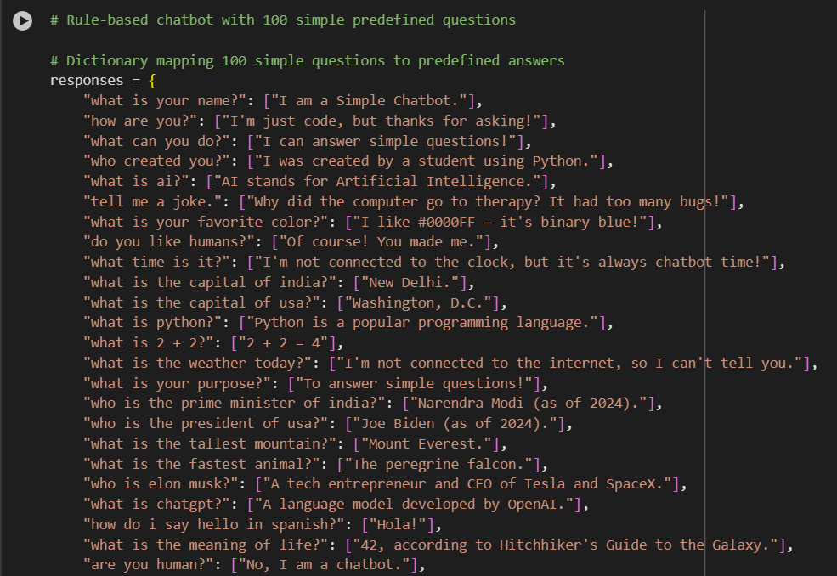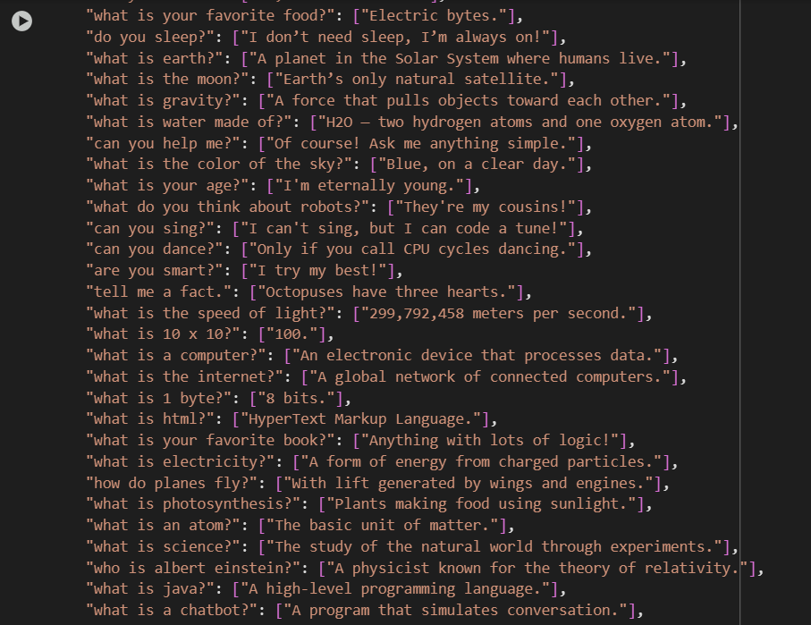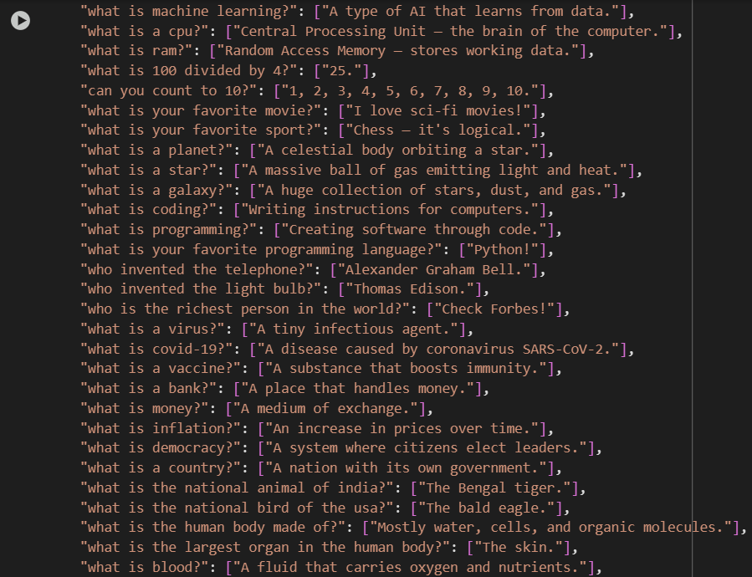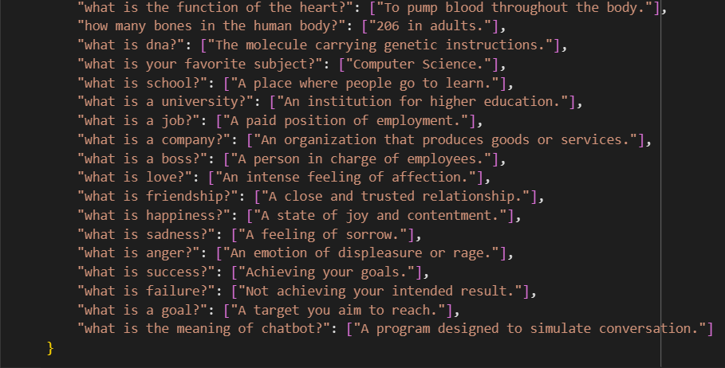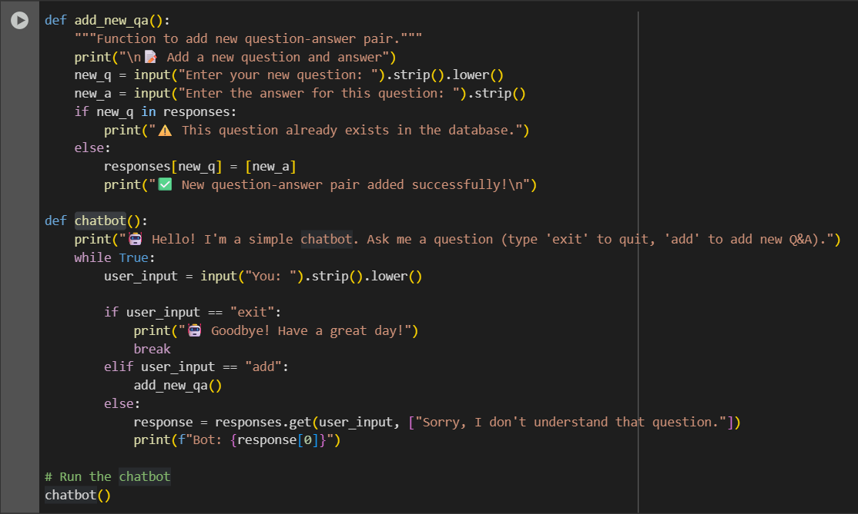

### **Output:**

