Bhavya Goyal  BCA Student | AI Automation | Digital Marketing | Web, IoT & Product Projects | Student Leadership  Phone: 8384042750 / 8130292170 | Email: 7bhavyagoyal@gmail.com | Location: Delhi, India  | LinkedIn: www.linkedin.com/in/bhavya-goyal-252154372 | GitHub: https://github.com/BhavyaGoyal7 | 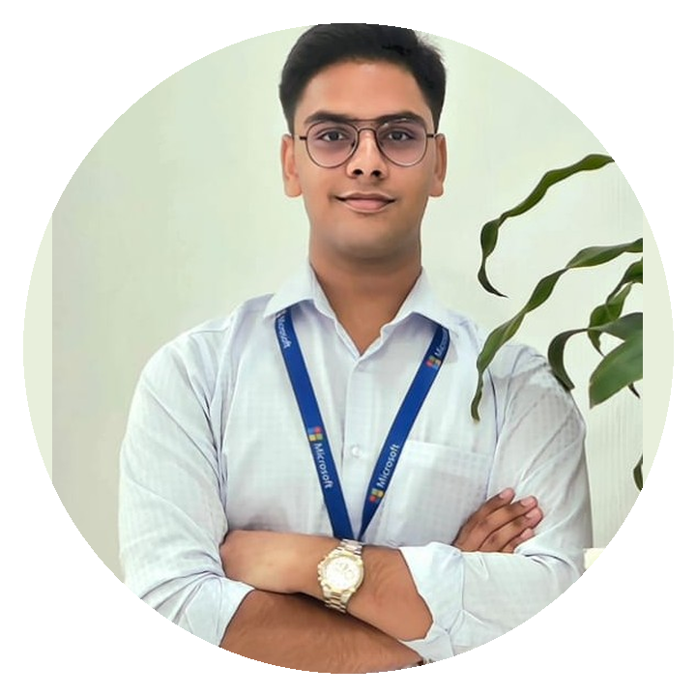
EDUCATION  Bachelor of Computer Applications (BCA)  Jagan Institute of Management Studies (JIMS) / Jagannath Community College (JCC), Rohini, Delhi  2025 - 2028  Digital Marketing, Web Page & Digital Multimedia Information Resources Design  Hansraj College | 92 Percentile  2025 - 2026  Senior Secondary - Class XII, Commerce  Score: 85% | PP International School  Secondary - Class X  Score: 87% | PP International School  TOOLKIT  PROGRAMMING & WEB  Python • C / C++ • HTML • CSS • JavaScript • WordPress  AI & AUTOMATION  AI Tools • Prompting • n8n • API Integration • AI Agents • Workflow Design  DIGITAL MARKETING  SEO • Semrush • Google Search Console • Content Strategy • Canva • Campaign Thinking  IOT & HARDWARE  Arduino IDE • NodeMCU • ESP8266/ESP32 • Proteus • Sensors • Circuit Simulation  TOOLS  Git/GitHub • VS Code • Microsoft Excel • Notion • Whimsical • PowerPoint  CERTIFICATIONS  • Digital Marketing with AI Prompting - Hansraj College Digital Marketing Academy | 92 Percentile  • Digital Marketing with AI Prompting - Apar Technologies  • Advanced Microsoft Excel - Nice Institute  • Semrush SEO Sales Certification - Semrush Academy  • AI in Accounting 101: CAIRA Essentials - Miles Education  LEADERSHIP & TEAM  • Turns scattered ideas into structured projects, milestones, PPTs, demos, documentation, and public learning posts.  • Comfortable coordinating with teams, participating in events, and presenting technical or product concepts in a student-friendly way.  • Strong curiosity across AI, IoT, marketing, web, servers, and product development; learns by building instead of only watching tutorials.  ABS Innovatives - Team Lead  • Leads planning, roles, documentation, hackathon/seminar prep, and presentations.  Team: Anisha - Developer/Coder | LinkedIn: xxxx  Shreya - Assets & Quality Review | LinkedIn: xxxx  Events: Hackathons, seminars, tech communities, and upcoming planned events. | PROFILE SNAPSHOT  BCA student building a portfolio across AI automation, digital marketing, website development, IoT simulation, and student-led product thinking. Built and managed the Chatkaraa website during the Hansraj College digital marketing program while treating it as a long-term dream brand/startup. Currently leads ABS Innovatives, coordinating team roles, hackathon/seminar participation, planning, documentation, and presentations while strengthening BCA fundamentals through coding, electronics simulation, and automation tools.  PORTFOLIO PROJECTS  Chatkaraa Website & Digital Growth Project  WordPress, SEO, Digital Marketing | Hansraj College program project + long-term dream brand  • Built and managed a responsive business website for Chatkaraa using WordPress, page customization, content structure, product sections, and basic SEO setup.  • Applied digital marketing concepts including SEO, site content planning, brand positioning, and visibility improvement during the Hansraj digital marketing program.  • Positioned the project beyond assignment work by treating Chatkaraa as a future entrepreneurial brand with product, website, social, and market-building potential.  Proteus Electronics Simulation Portfolio - 41 Projects  Proteus, Arduino fundamentals, input-output logic, sensors/actuators, embedded simulation  • Designed and simulated 41 varied electronics projects in Proteus, covering input-output control, sensor logic, interface behaviour, alerts, and embedded workflow experiments.  • Explored automation and non-automation circuit ideas to strengthen Arduino logic, component behaviour, testing, troubleshooting, and practical circuit thinking.  • Built confidence in translating BCA and IoT concepts into visual, testable hardware simulations before physical implementation.  Startup OS for Hackathon Teams  Ongoing product concept | ABS Innovatives workflows, documentation, AI-assisted planning  • Designing a structured operating system for hackathon teams, starting with ABS Innovatives, to organize ideas, tasks, roles, deadlines, pitch content, documentation, and submissions.  • Focuses on reducing confusion during fast-paced competitions by combining team coordination, project tracking, templates, and AI-assisted planning.  • Shows leadership-oriented thinking by solving a real student-team problem through product design, workflow clarity, and repeatable processes.

Bhavya Goyal  Leadership, achievements, career direction, and additional project highlights | Portfolio CV  Page 2 / Highlights
ADDITIONAL PROJECT HIGHLIGHT  AI, IoT & Public Learning Portfolio  Arduino/NodeMCU learning, local AI ideas, seminars, documentation, project habit  • Documents technical learning through a public Arduino/IoT growth journey covering LCDs, I2C, sensors, NodeMCU/OLED, rechargeable power planning, and hands-on experimentation.  • Explores AI automation, local assistant concepts, API workflows, and practical tools that connect software, hardware, marketing, and productivity systems.  • Builds projects with a learner-builder mindset: research, test, document, improve, and explain the working in a clear student-friendly way.  CAREER DIRECTION  BCA-focused portfolio direction: AI automation, digital marketing systems, web/product development, IoT simulation, hackathon participation, and student-team leadership through ABS Innovatives.  BEST FIT ROLES  • AI Automation Intern  • Digital Marketing / SEO Intern  • Web & WordPress Intern  • IoT / Product Project Trainee  • Student Project Coordinator | ACHIEVEMENTS & PARTICIPATION  • First ElevenLabs Meetup in India at Microsoft R&D Noida: hands-on learning across TTS, STT, voice tools, dubbing, workflows, media generation; won prize/T-shirt in the event competition.  • ISRO participation and two years of astronomy learning, reflecting long-term interest in space science, research-oriented thinking, observation, and exploration.  • Participates with ABS Innovatives in hackathons, seminars, and technology communities, including ElevenLabs at Microsoft R&D Noida, Notion at Webbee Global Noida, JIMS Sector-5/college events, and upcoming events planned ahead.  • Extracurricular exposure through Verve Fashion Show and Kuch Cook Hota Hai, supporting confidence, stage presence, coordination, and campus involvement.  LEADERSHIP SUMMARY  Learner-builder and team lead who can move from idea to execution: research, structure, assign roles, prototype, document, present, and improve with team feedback.

