Game Design Document

Fill up the following document

1. Write the title of your project.

Breakout Brick Wall

1. What is the goal of the game?

Break the brick wall to win.

1. Write a brief story of your game.

There will be a ball and a paddle. The ball will start from the paddle and when it hits the bricks the bricks break and the score increases. When all the bricks are broken you win the game. If the ball misses the paddle and falls down the life decreases by 1 and if all the three lives are finished you loose the game.

1. Which are the playing characters of this game?

* Playing characters are the ones who respond to the user based on the input from the user.
* Cars, monkeys, dinos, wizards, etc., are the playing characters in the game.

|  |  |  |
| --- | --- | --- |
| Number | Character Name | What can this character do? |
| 1 | The paddle | Move horizontal so the ball bounces on it and doesn’t fall down. |
| 2 |  |  |
| 3 |  |  |
| 4 |  |  |
| 5 |  |  |
| 6 |  |  |
| 7 |  |  |
| 8 |  |  |

1. Which are the Non-Playing Characters of this game?

* Non-Playing characters are the ones that don't have an action or behavior when the user interacts with the game.
* Hurdles, stones, bananas, coins, etc., are non-playing characters in the game.

|  |  |  |
| --- | --- | --- |
| Number | Character Name | What can this character do? |
| 1 | The ball | Breaks the bricks |
| 2 | The bricks | They will break when the ball touches it. |
| 3 |  |  |
| 4 |  |  |
| 5 |  |  |
| 6 |  |  |
| 7 |  |  |
| 8 |  |  |

Draw your imagination of this game. What does this game look like?

* Draw the game either on your computer or on paper.
* Add images of the game scenes to show each of the playing and non-playing characters at least once.

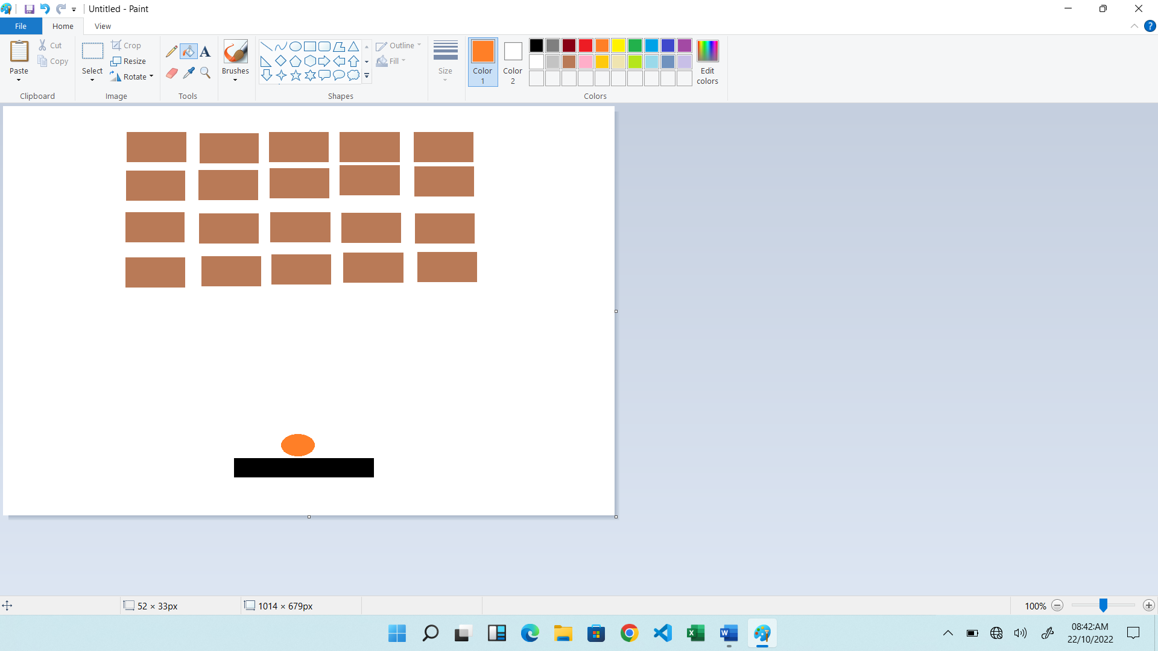

How do you plan to make your game engaging?

The speed of the ball increses as score increases. Also the bricks will be moving horizontally.