Facial Recognition
Bhavya Kohli
October 2021

Introduction
The aim of this study was to develop an approach to find out whether two given images were of the same person. I tried to attempt this using two methods – one, using the face_recognition library, and two, using Convolutional Neural Networks.

Using the face_recognition library
The face_recognition library provides a convenient way of comparing two faces, whether they are within the same image or are in two different images. It utilizes dlib’s state of the art face recognition model built using deep learning. The module can be used to load images and detect faces in those images, and can then be used to compare any two images using the “encoding” of the image.
The image encoding obtained using the module can be used to track facial features such as the eyes, eyebrows, nose, mouth and general face outline. Comparing the encodings of two images accounts for all these structures and only then computes the final result.

Image preprocessing
Loading images was done using the matplotlib imread function for consistency with the subsequent imshow function calls, and face detection was performed using the opencv library, using the Haar cascade detector. Face detection was possible using the face_recognition module itself, but it had many failure cases and the opencv method was preferred. On detecting the face locations the faces were suitably cropped using array slicing. All loaded images were also resized to be of the same size for fulfilling the input shape consistency requirements in the Convolutional Neural Network approach, but they also improved performance using the face_recognition method. Functions were defined for performing each of these tasks and were linked to each other to give a clean look.

Brief overview of the workflow

Challenges Faced
The opencv face detection hyperparameter scaleFactor had to be tuned, which posed a challenge because of the average time it took to complete one run.

Experimenting with architectures
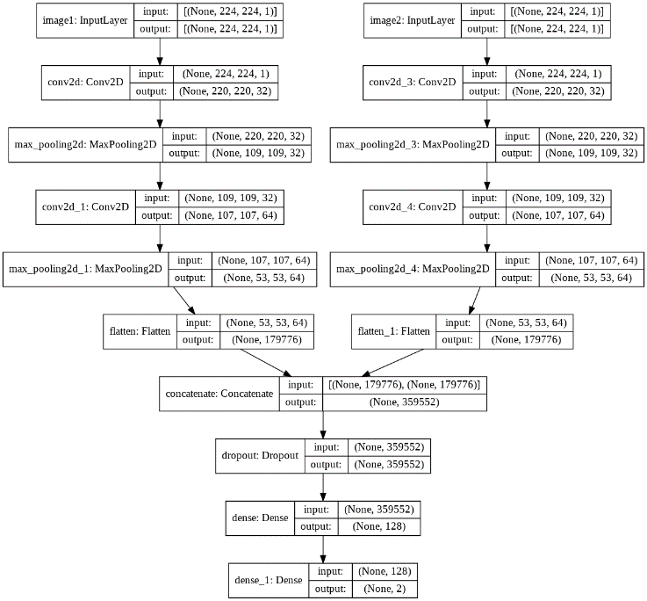
My first attempt at the problem statement was using a Convolutional Neural Network architecture to predict whether the two input images were “correlated” or not. Using sufficient training samples this correlation would be recognized by the model and the output would then signify whether the faces in the two input images are of the same person or not.
For the task, after tuning hyperparameters I used the following architecture, using parallel models which are combined together using a concatenate later followed by a dense layer(s) and finally the output layer, which has 2 nodes because of the categorical nature of the labels. The labels “0” and “1” were converted to a one-hot encoded scheme and hence were represented as a 2x1 vector.

