**Car-Dekho data-set.**

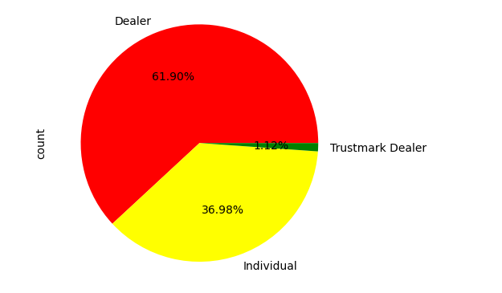

Based on the pie chart analysis of the Online Vehicle Booking Market, the data reveals that dealers dominate the market with a substantial share of 61.90%. This indicates that the majority of vehicle bookings are handled through dealerships, which suggests a strong preference or trust among consumers for professional dealer services. Individual sellers account for 36.98% of the market, reflecting a significant segment where buyers are engaging directly with car owners, possibly driven by the appeal of potentially lower prices or direct negotiations. Trustmark dealers, although representing a small fraction at 1.12%, indicate a niche market segment that is likely focused on certified pre-owned vehicles, emphasizing quality and reliability assurances. This distribution highlights the competitive landscape and consumer preferences within the online vehicle booking market, suggesting that while traditional dealers hold the majority, there is a notable opportunity for growth in both individual and Trustmark dealer segments.

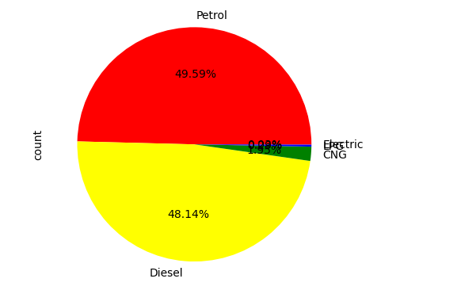

In conclusion, the pie chart suggests that the Online Vehicle Booking Market is predominantly driven by traditional fuel types (petrol and diesel), with a minor yet noteworthy presence of CNG and electric vehicles. This distribution underscores the importance of focusing on petrol and diesel vehicles for immediate market strategies while also recognizing the growing potential of alternative fuel vehicles.

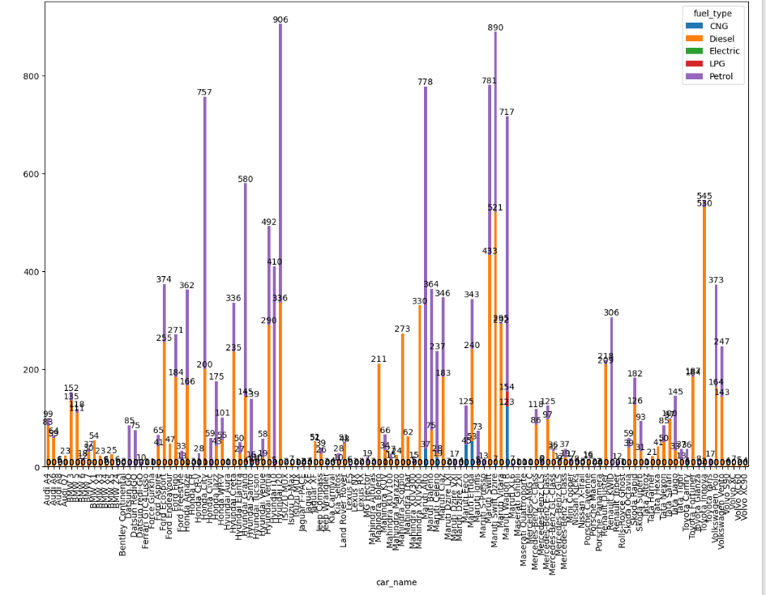

Based on the bar graph analysis of car names and fuel types in the Online Vehicle Booking Market, Hyundai i20 and Maruti Swift Dzire emerge as the most popular vehicles, with 906 and 890 bookings respectively. These two models significantly outperform other cars, which average around 500 bookings. This indicates a strong consumer preference for these specific models, likely due to factors such as brand reputation, fuel efficiency, affordability, and overall value. The dominance of Hyundai i20 and Maruti Swift Dzire suggests that they are highly trusted and sought after in the market, making them key models for dealers and individual sellers to focus on. The data highlights the importance of these top-performing vehicles in driving market trends and consumer choices within the online vehicle booking industry.

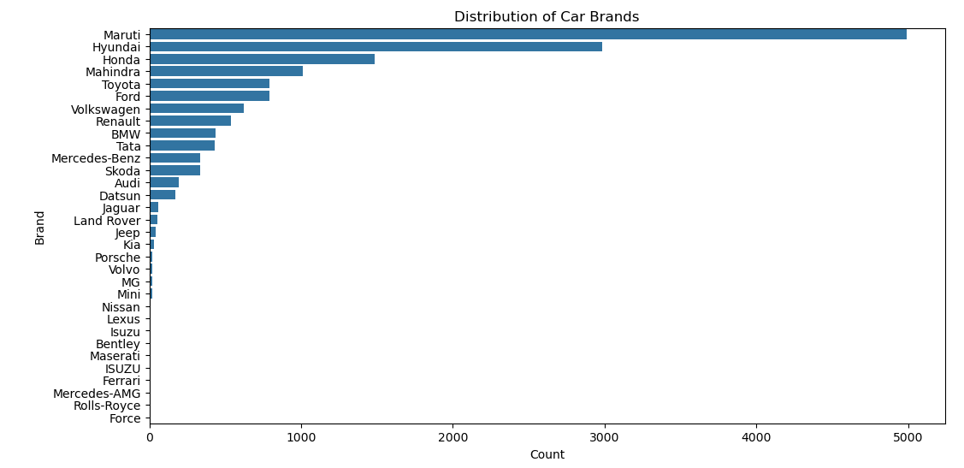

Based on the chart showing the distribution of car brands in the Online Vehicle Booking Market, Maruti stands out with the highest count, exceeding 5000 bookings. This indicates that Maruti is the most preferred brand among consumers, likely due to its strong market presence, reputation for reliability, affordability, and extensive service network. The overwhelming preference for Maruti suggests that it plays a crucial role in the online vehicle booking market, making it a dominant force that shapes consumer behaviour and market dynamics. For stakeholders, this insight emphasizes the importance of focusing on Maruti models to meet consumer demand and capitalize on its popularity. Other brands, while still significant, trail behind, highlighting the competitive advantage Maruti holds in this sector.

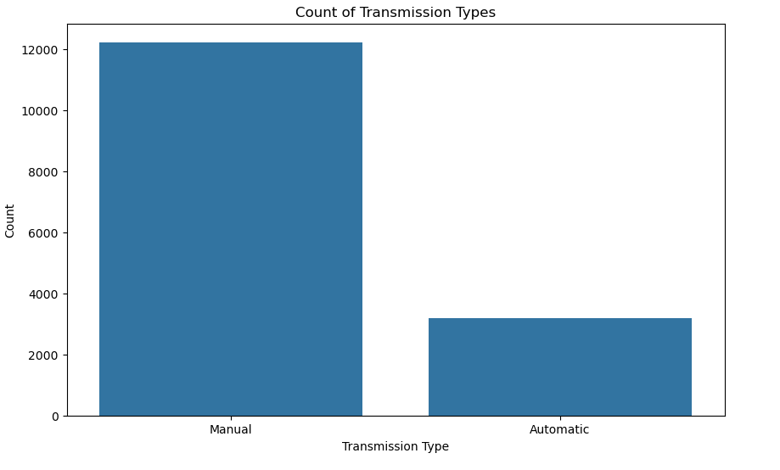

The market is currently skewed towards manual transmission vehicles, but the notable presence of automatic transmission cars highlights an opportunity for growth in this segment. Dealers and sellers should continue to focus on offering a wide range of manual transmission vehicles while also expanding their inventory of automatic cars to cater to evolving consumer preferences and capture a larger share of the market.

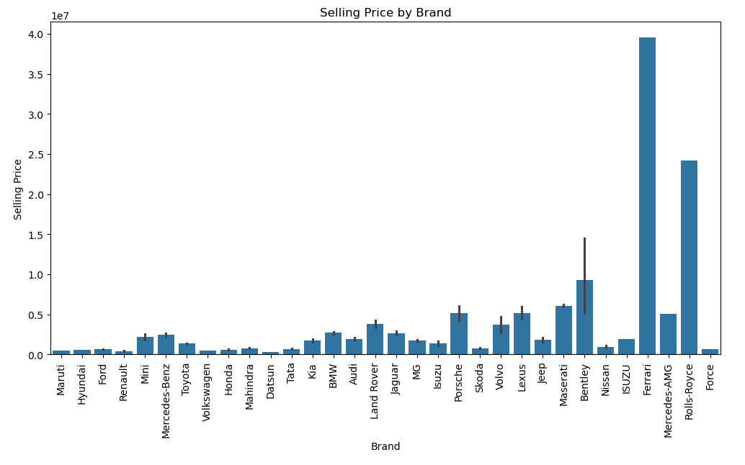

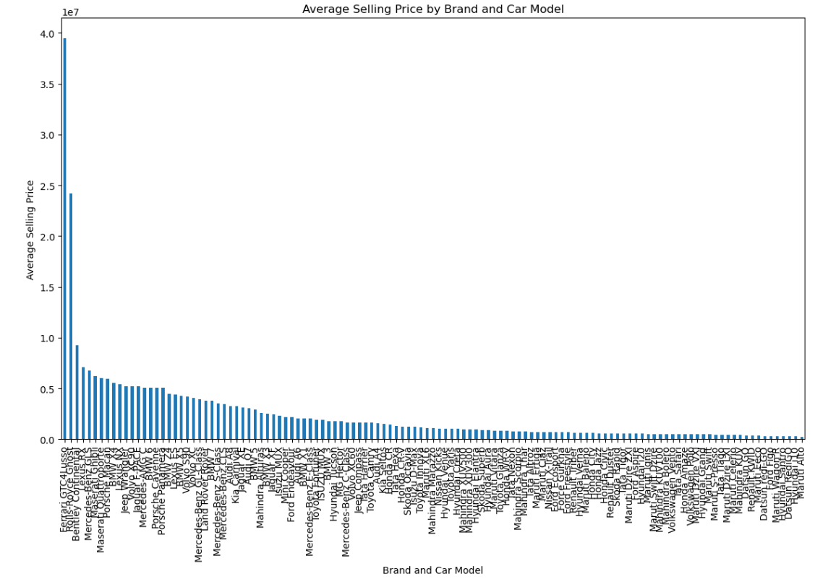

The graphs suggests that while the overall market is diverse, there is a lucrative segment for luxury car brands like Ferrari and Rolls-Royce. For sellers and dealers, this underscores the importance of targeting high-net-worth individuals and positioning these premium brands effectively to maximize profitability. Additionally, it indicates that the online vehicle booking platform can cater to a wide range of consumer segments, from budget-conscious buyers to luxury car enthusiasts.

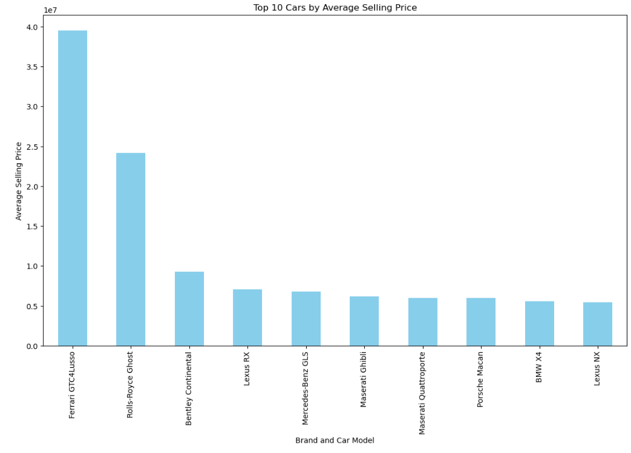

Here are the top 10 cars based on average selling prizes.

From the analysis of the Online Vehicle Booking Market, several key conclusions can be drawn. The market exhibits a diverse range of consumer preferences and trends, with clear indications of strong demand for specific brands, such as Maruti, and transmission types, predominantly manual. Maruti emerges as the most popular brand, reflecting its widespread consumer trust and affordability. Manual transmission cars dominate the market, emphasizing their popularity due to lower costs and higher fuel efficiency. Additionally, luxury brands like Ferrari and Rolls-Royce command significantly higher selling prices, highlighting a niche market for affluent buyers seeking premium vehicles. Overall, the dataset underscores the importance of understanding and catering to diverse consumer segments, from budget-conscious buyers favouring practicality to high-end consumers seeking luxury and exclusivity in their vehicle purchases. This comprehensive understanding is essential for stakeholders in the online vehicle booking market to effectively target their offerings and maximize market penetration and profitability.