CLOUD COMPUTING PROJECT
Name: Bhavya Sarvaiya
Topic:
Building a Streaming pipeline with Analytics and No SQL Database

- Introduction:

This project demonstrates the implementation of a real-time streaming data pipeline using Microsoft Azure services. The system ingests streaming data, processes it using Stream Analytics, stores it in SQL and NoSQL databases, and visualizes insights through Power BI dashboards.

- Problem Statement:

Traditional batch systems cannot handle continuous real-time data efficiently. This project aims to build a scalable cloud-based streaming architecture capable of ingesting, processing, storing, and visualizing live data efficiently.

3. System Architecture:

The system consists of four layers: Ingestion (Azure Event Hub), Processing (Azure Stream Analytics), Storage (Azure SQL Database and Azure Cosmos DB), and Visualization (Power BI). Data flows from Event Hub to Stream Analytics and is then routed to SQL and NoSQL databases before being visualized

- Technologies Used:

• Microsoft Azure
• Azure Event Hub
• Azure Stream Analytics
• Azure SQL Database
• Azure Cosmos DB
• Power BI

5. Steps and Implementation Screenshots
Below are the step-by-step implementation screenshots with brief explanations

Data Pre Processing:

1. File Upload in Google Colab
This screenshot shows the CSV dataset (All_Clickstream.csv) being uploaded into Google Colab using files.upload(). The file is successfully saved and ready for preprocessing.

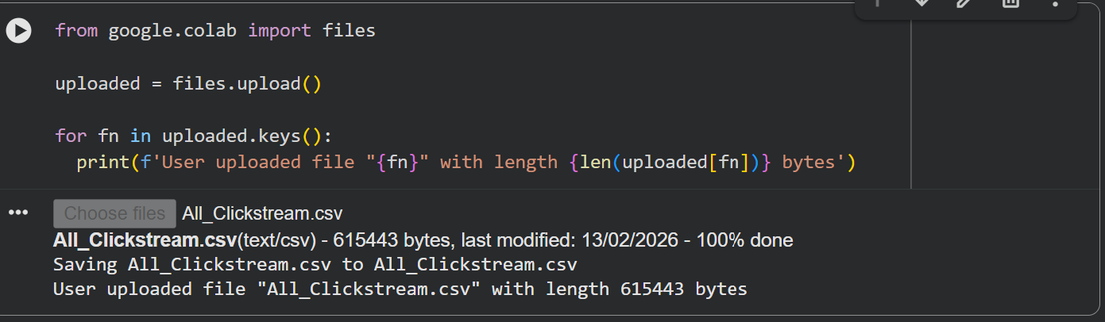

2. Reading Dataset and Inspecting Structure
The dataset is loaded using pandas.read_csv() and the first few rows, column names, and shape are displayed. This helps understand the dataset structure and confirms it contains 12,104 rows and 6 columns.

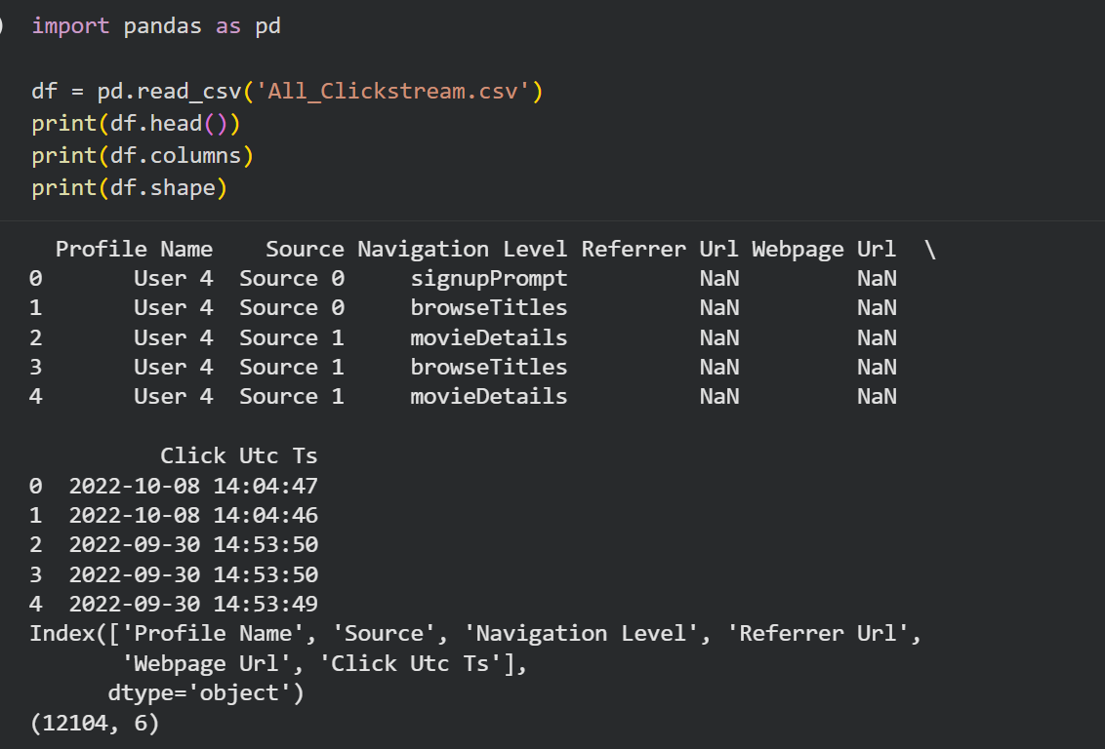

3. Checking Missing Values
The df.isnull().sum() function is used to identify missing values in each column. It shows that Referrer Url and Webpage Url contain a large number of null values.
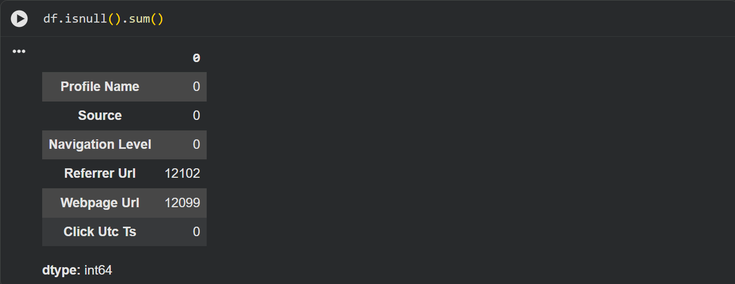
4. Converting Timestamp and Sorting Data
The Click Utc Ts column is converted into datetime format and the dataset is sorted chronologically. This ensures proper time-based streaming simulation.
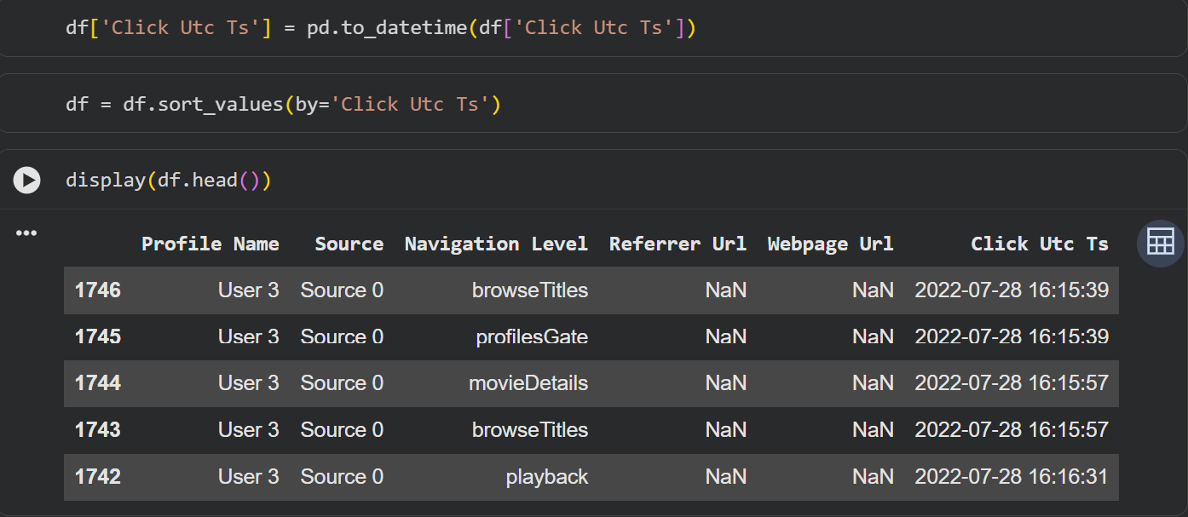

5. Creating Streaming Data Subset
A new dataframe df_stream is created by selecting relevant columns for streaming. Column names are renamed to user_id, source, navigation, and event_time for standardization.
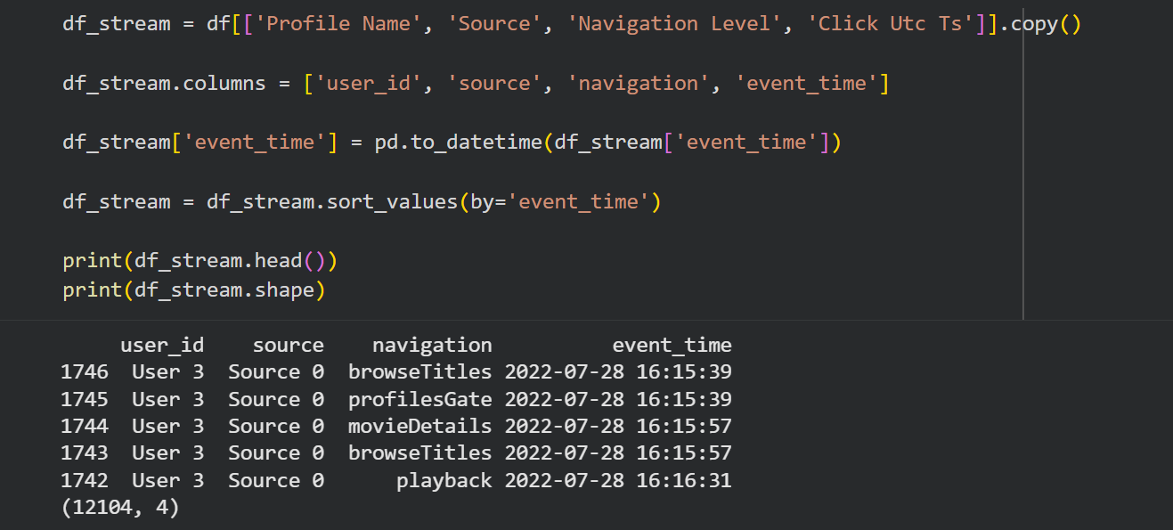

6. Verifying Cleaned Streaming Data
Null values in the streaming dataset are checked again using isnull().sum(). The result confirms that the streaming dataset contains no missing values.
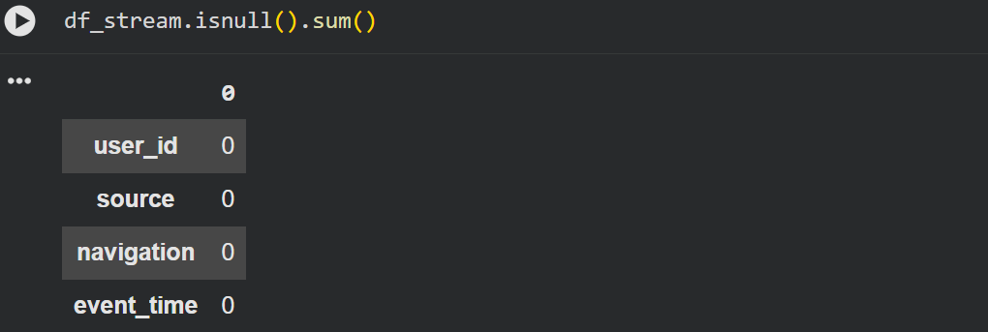

7. Identifying Event Time Range
The minimum and maximum timestamps of the dataset are calculated. This determines the time span of user activity data used for replay simulation.
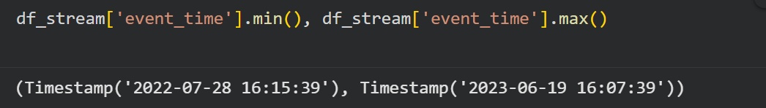

8. Introducing Replay Delay Mechanism
The time.sleep() function is introduced to simulate streaming behavior. This prepares the dataset for controlled real-time replay.
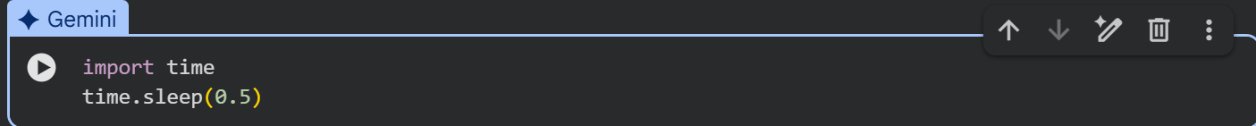

9. Calculating Time Differences Between Events
A new column time_diff is created using .diff() to calculate the time difference (in seconds) between consecutive events. Missing values are replaced with zero.

10. Applying Compression Factor for Faster Replay
A compression factor (60x faster replay) is applied to reduce actual time gaps. A new column replay_delay is calculated to simulate accelerated streaming.
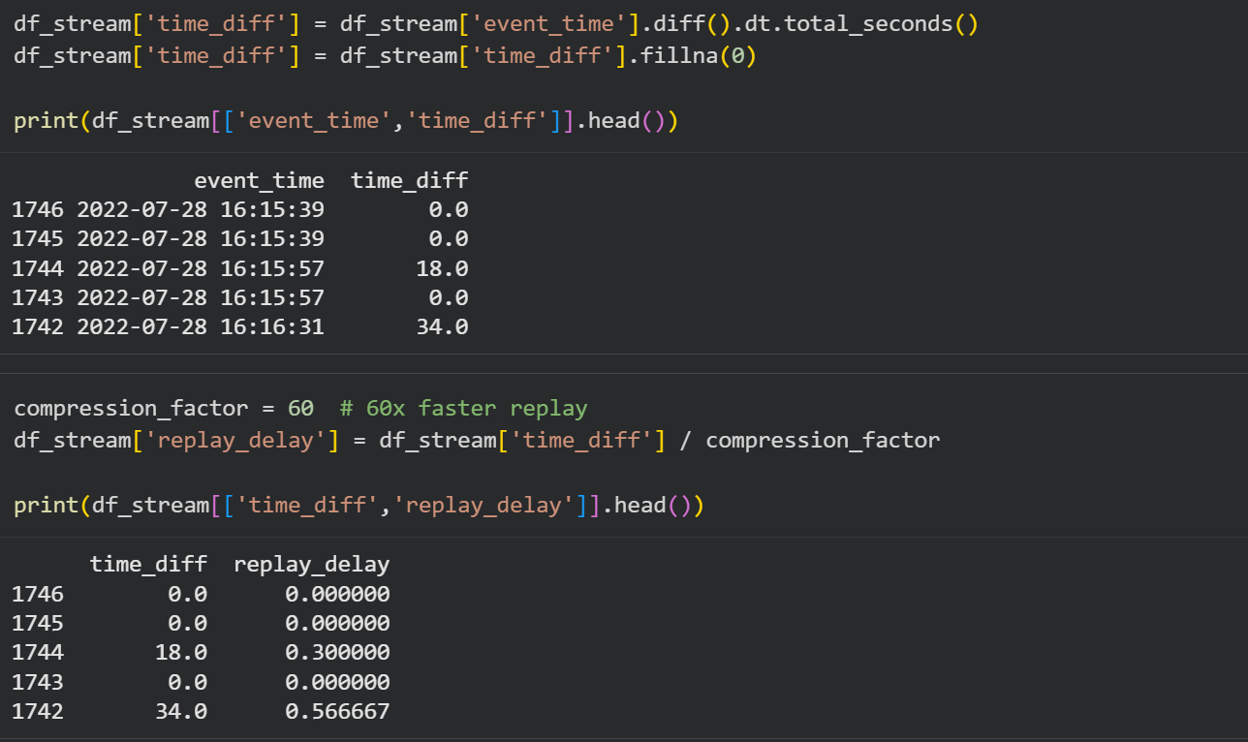

11. Statistical Summary of Time Differences
The describe() function is used on time_diff to analyze statistical distribution including mean, standard deviation, and maximum delay between events.
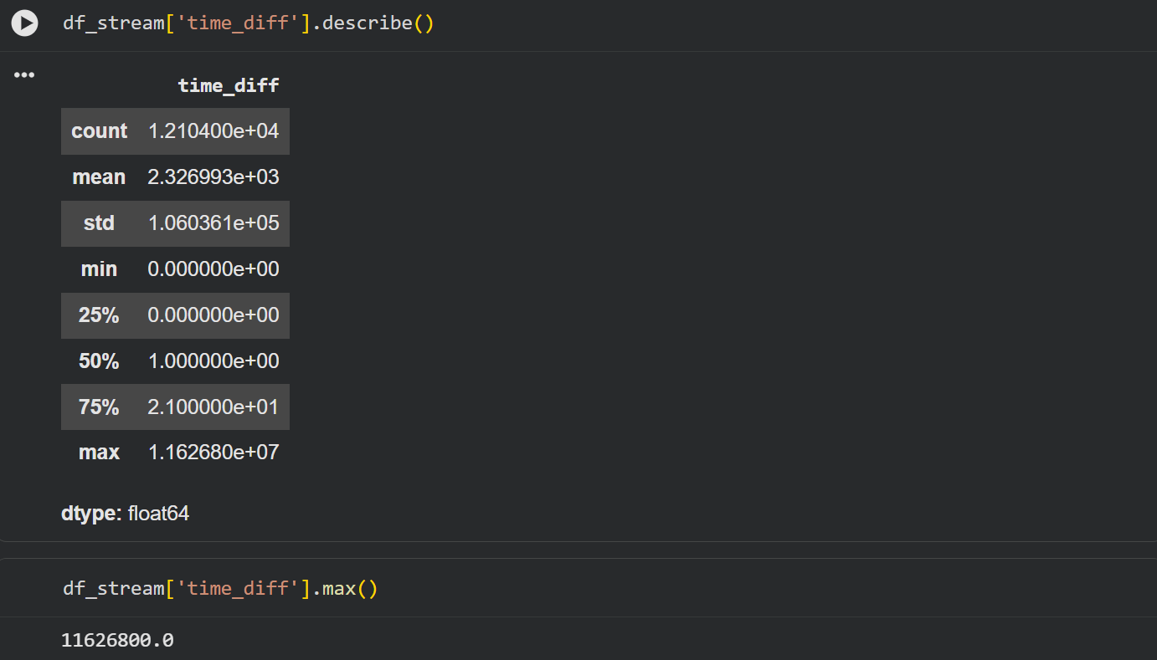

12. Limiting Maximum Replay Delay
The replay delay is capped to a maximum of 2 seconds using .clip(upper=2). This ensures smooth and controlled streaming simulation without long pauses.

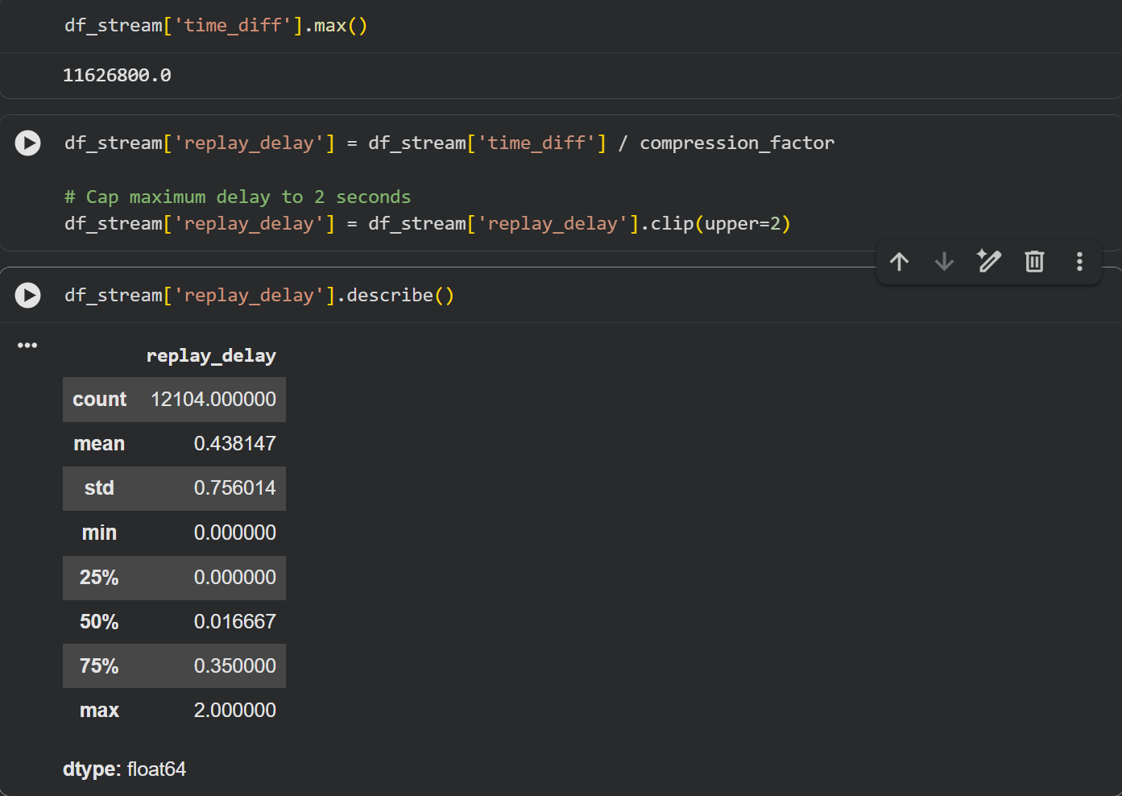
13. Creating Resource Group
This screenshot shows the creation of a new Resource Group named Streaming-platform-rg under the Azure for Students subscription. The resource group logically organizes all Azure resources for this project.
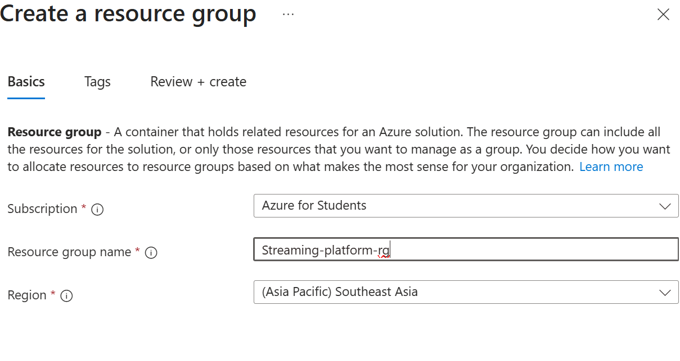

14. Event Hub Namespace Deployment Completed
This screen confirms that the Event Hub Namespace (streaming-platform-ns) was successfully deployed. It indicates that the messaging infrastructure setup is complete.
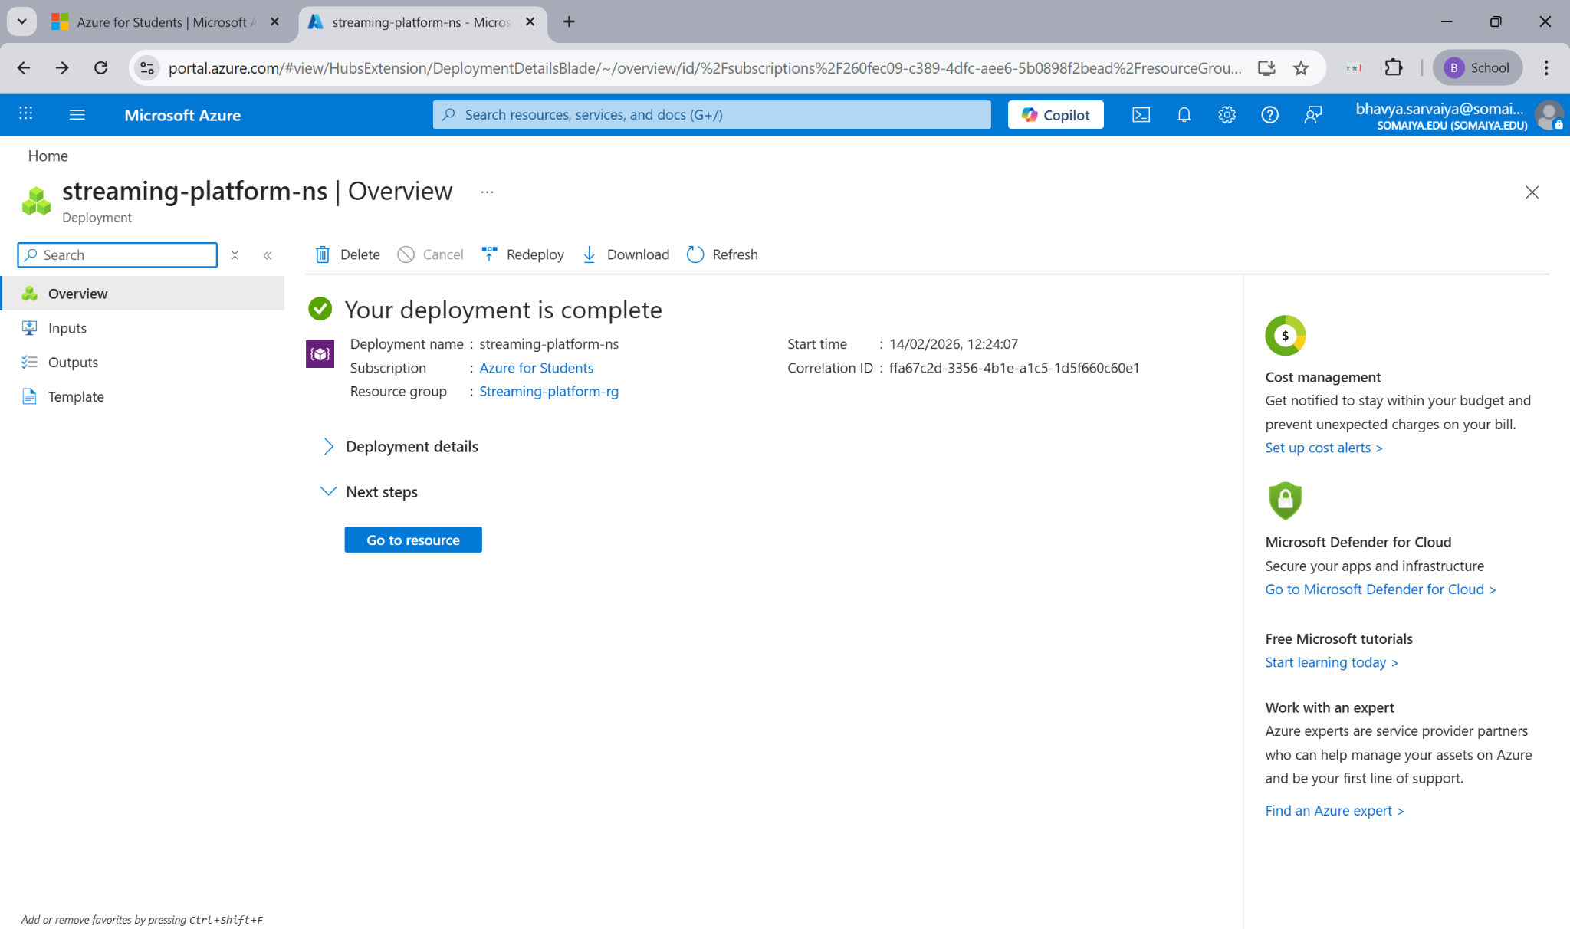

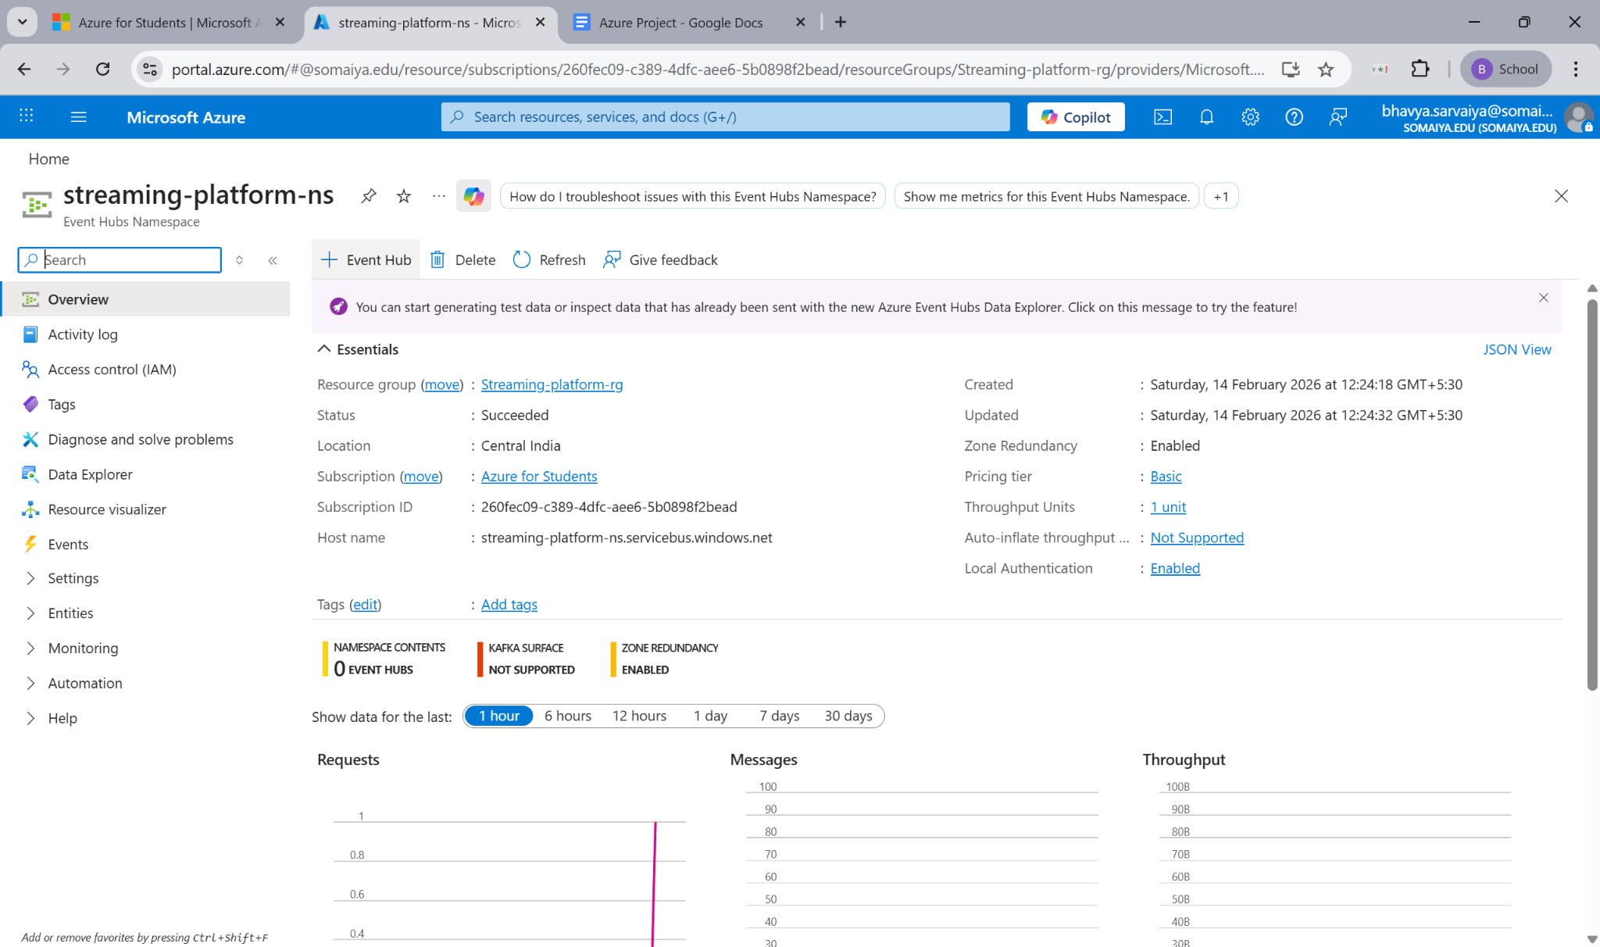

15. Creating Event Hub (clickstreamhub)
This screenshot shows the configuration of the Event Hub named clickstreamhub with 4 partitions and 1-hour retention. Partitions enable parallel processing of streaming data.

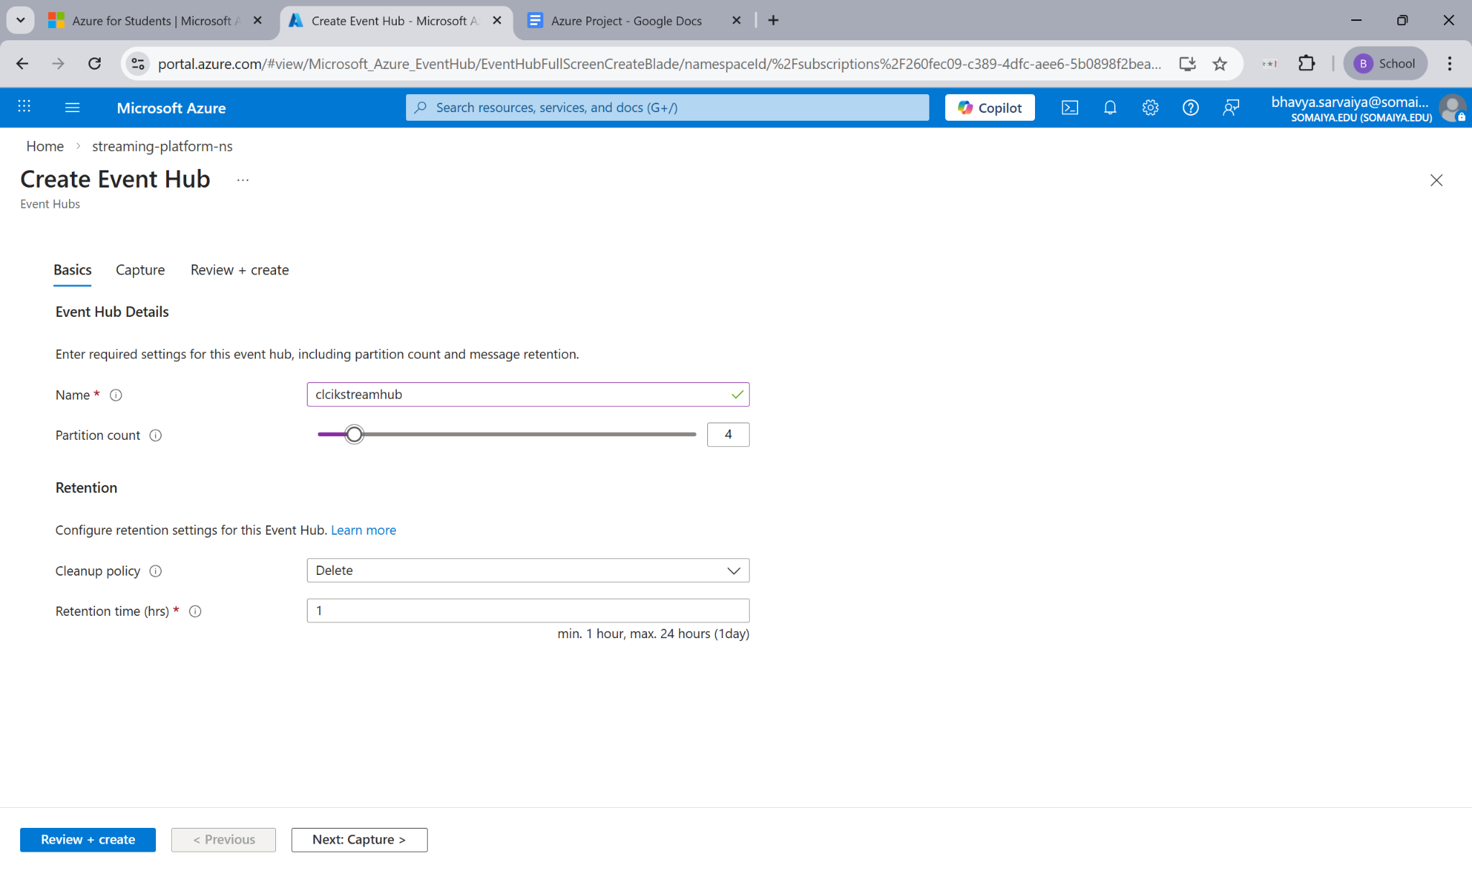
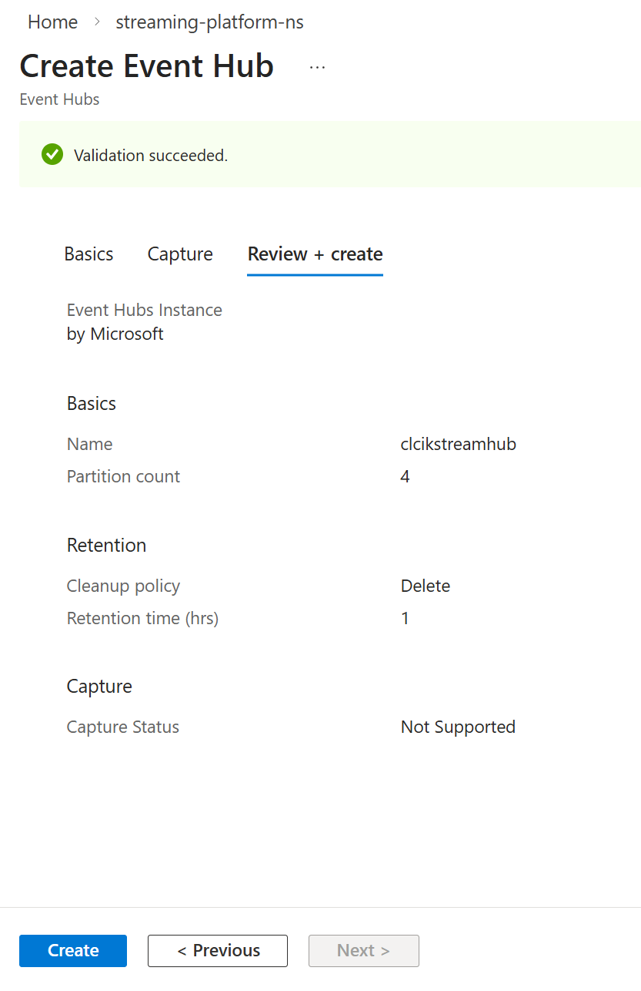

16. Shared Access Policies (Connection String Retrieval)
This page shows the RootManageSharedAccessKey policy under Shared Access Policies. The connection string from here is used to securely send streaming data to the Event Hub.

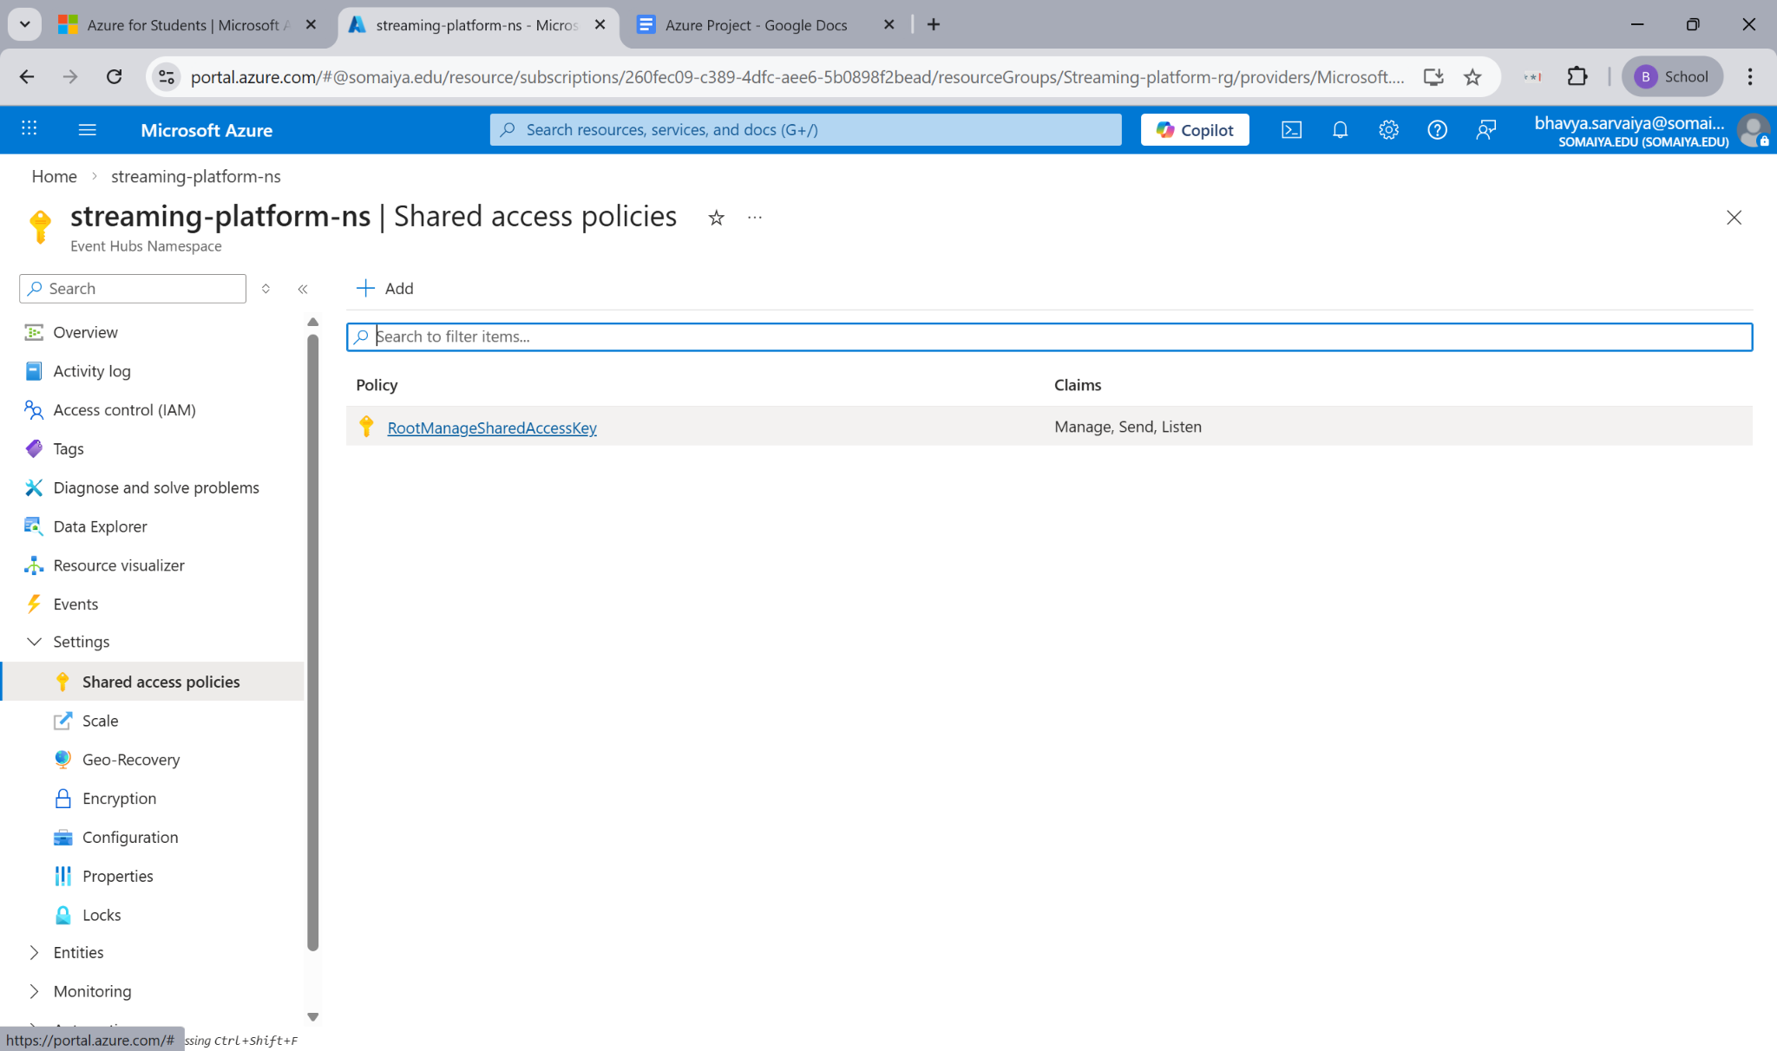

17. Installing Azure Event Hub Python SDK
The pip install azure-eventhub command installs the required Python SDK in Google Colab. This allows the notebook to connect and send events to Azure Event Hub.

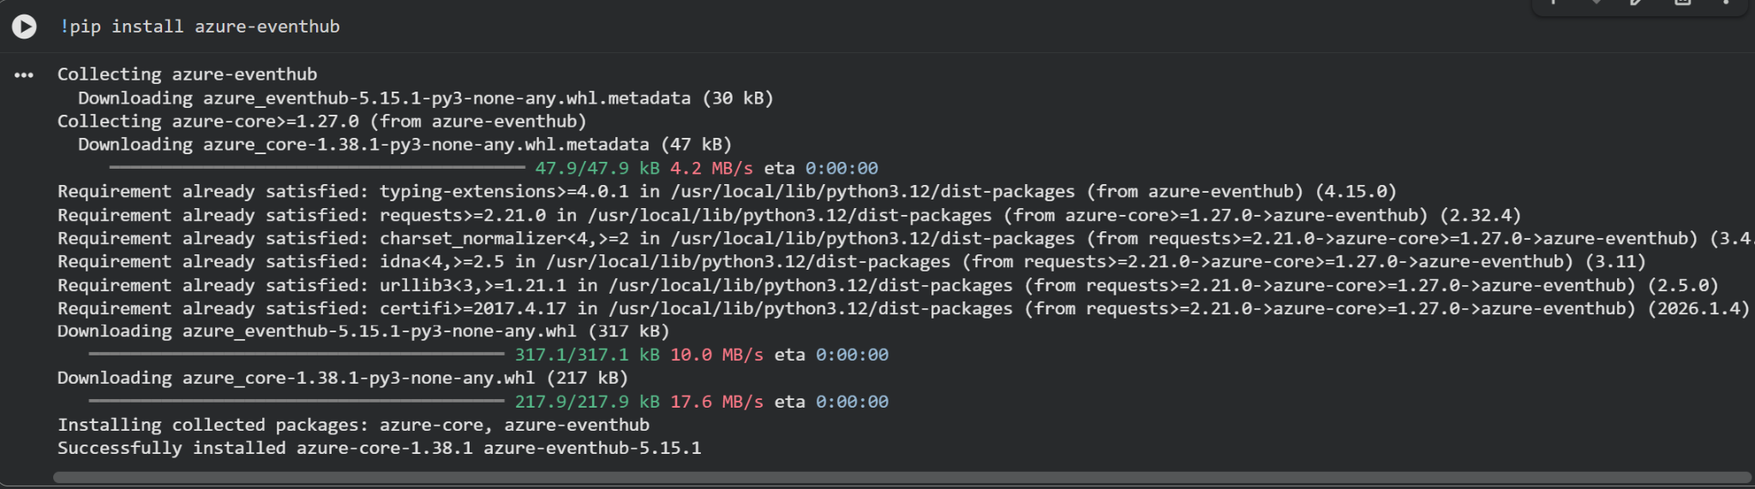

18. Streaming Data to Event Hub (Producer Code)
This code creates an EventHubProducerClient using the connection string and sends JSON-formatted events to the Event Hub. The time.sleep() function simulates real-time streaming behavior.

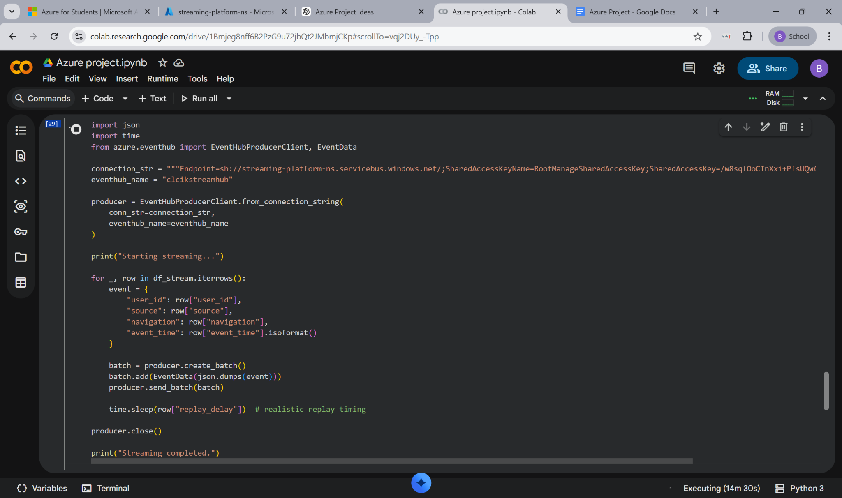

19. Confirming Ingestion Through Metrics (Detailed View)
This graph displays the total sum of incoming messages (in thousands), confirming high-volume streaming data ingestion.

Ingestion Layer Completed — At this stage, data is successfully flowing from Google Colab to Azure Event Hub.

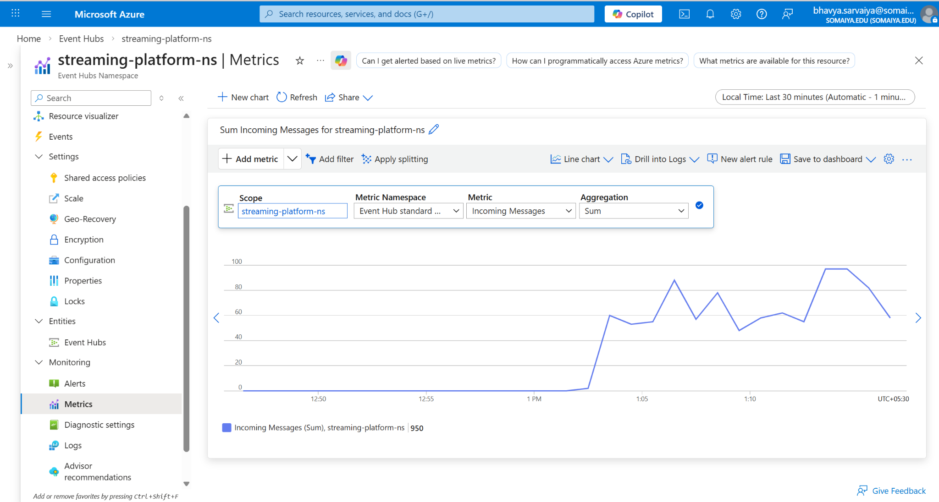
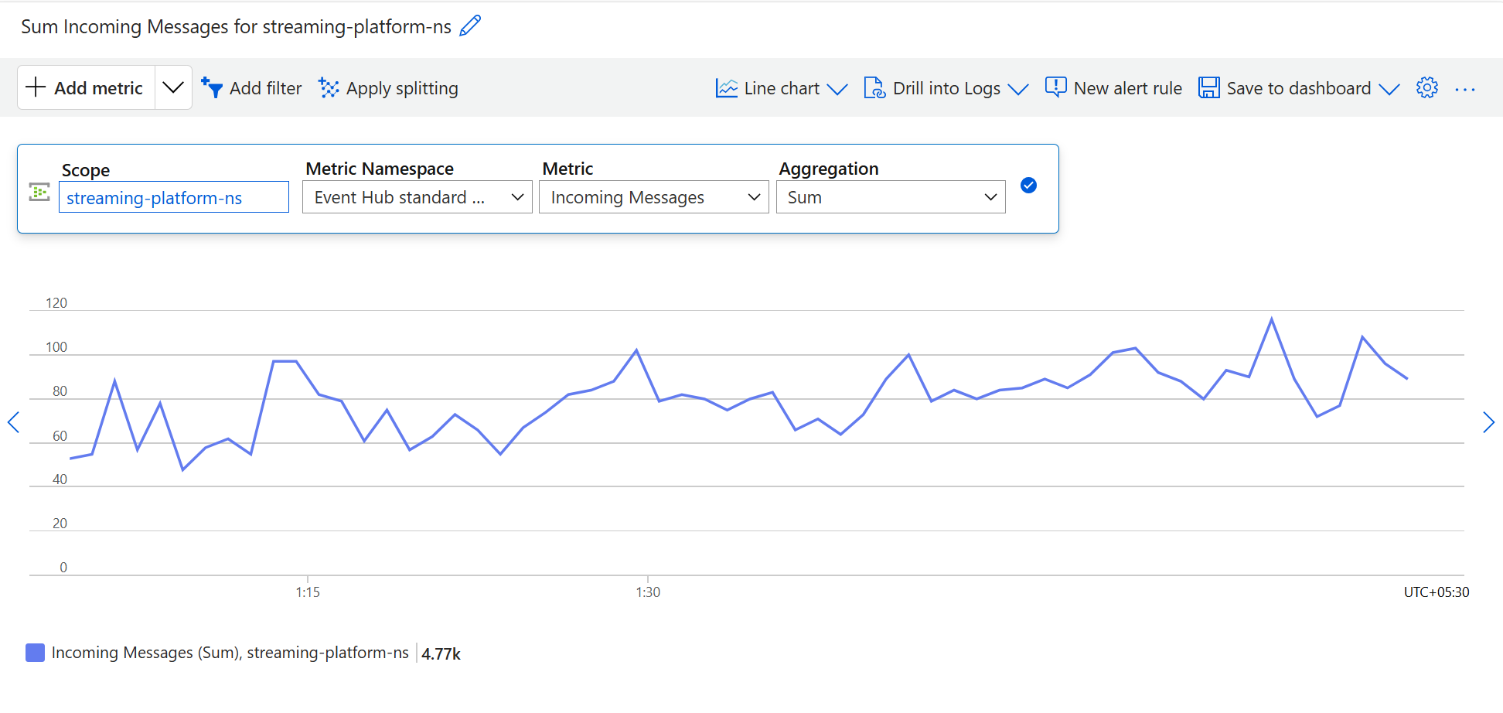

20. Creating Azure Stream Analytics Job
This screenshot shows the overview page of the newly created Stream Analytics job. It confirms that the job is deployed under the correct resource group and is ready for configuration.

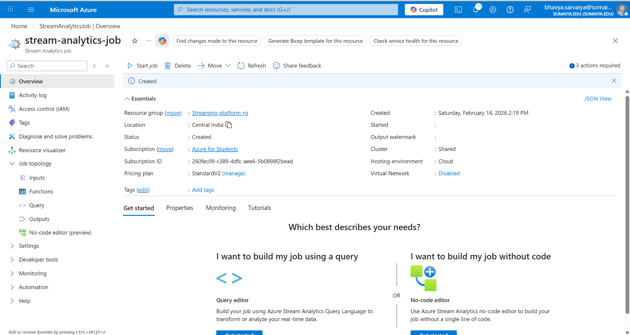

21. Adding Event Hub as Input
A new input (clickstreaminput) is added to the Stream Analytics job. The source type is selected as Event Hub to consume real-time streaming data.

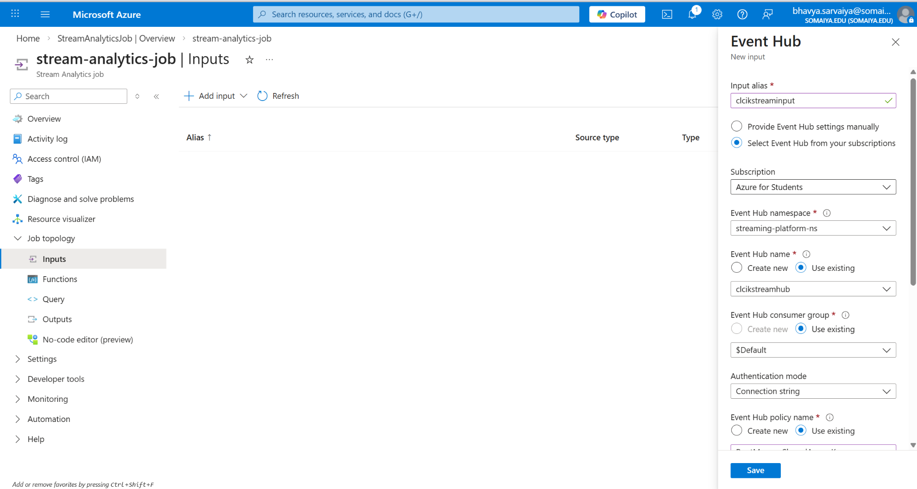
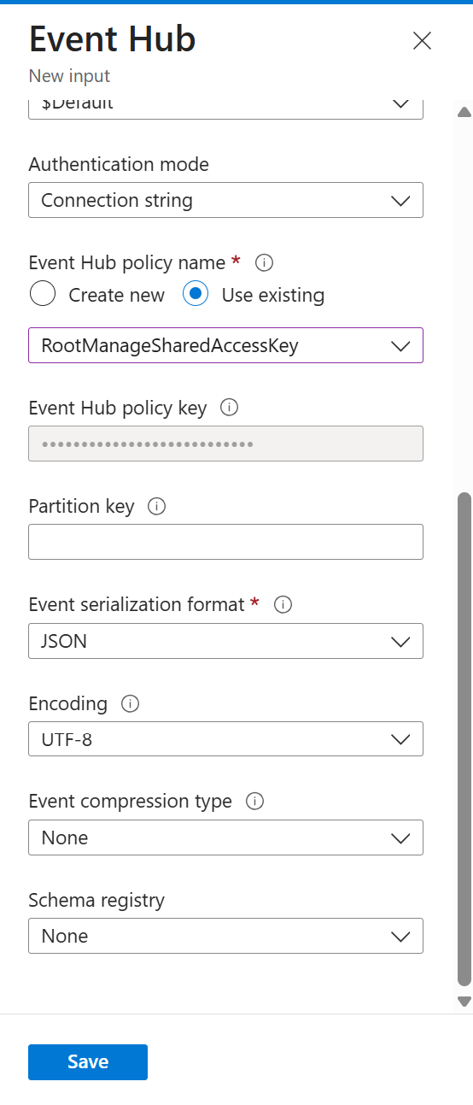
22. Input Successfully Added and Tested
The input is successfully added and tested. This confirms that Stream Analytics can connect to the Event Hub and receive streaming events.

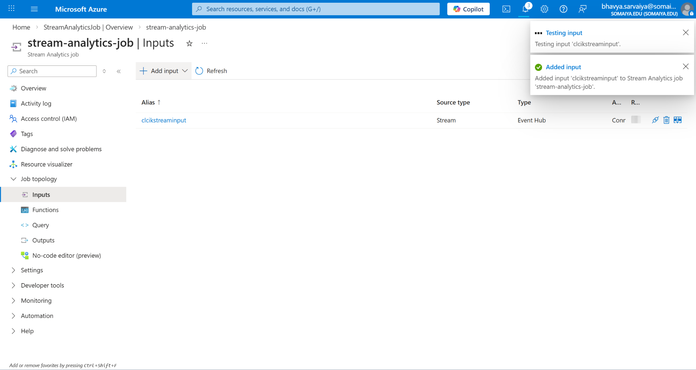

23. Cosmos DB Deployment Completed
This screenshot confirms that the Azure Cosmos DB account deployment has completed successfully.

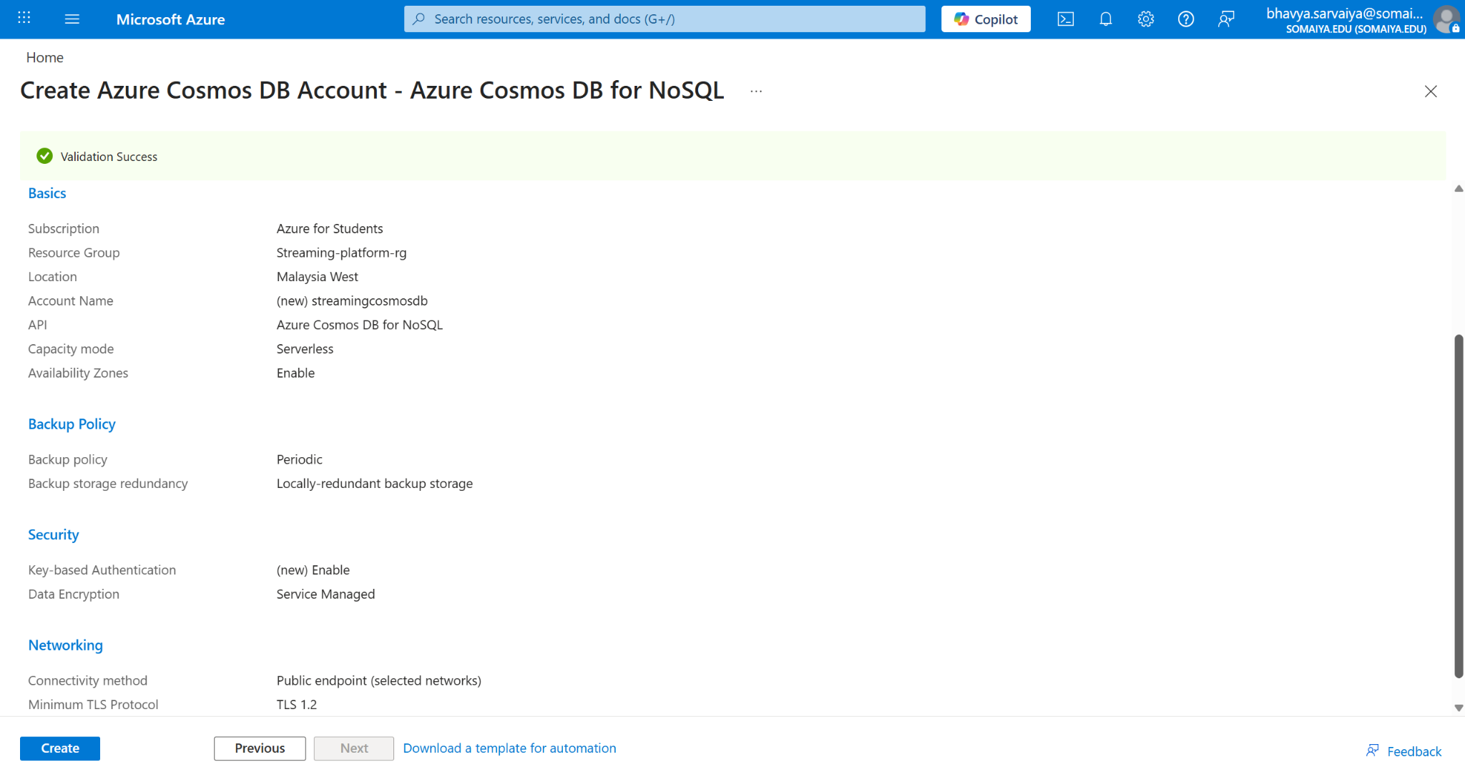
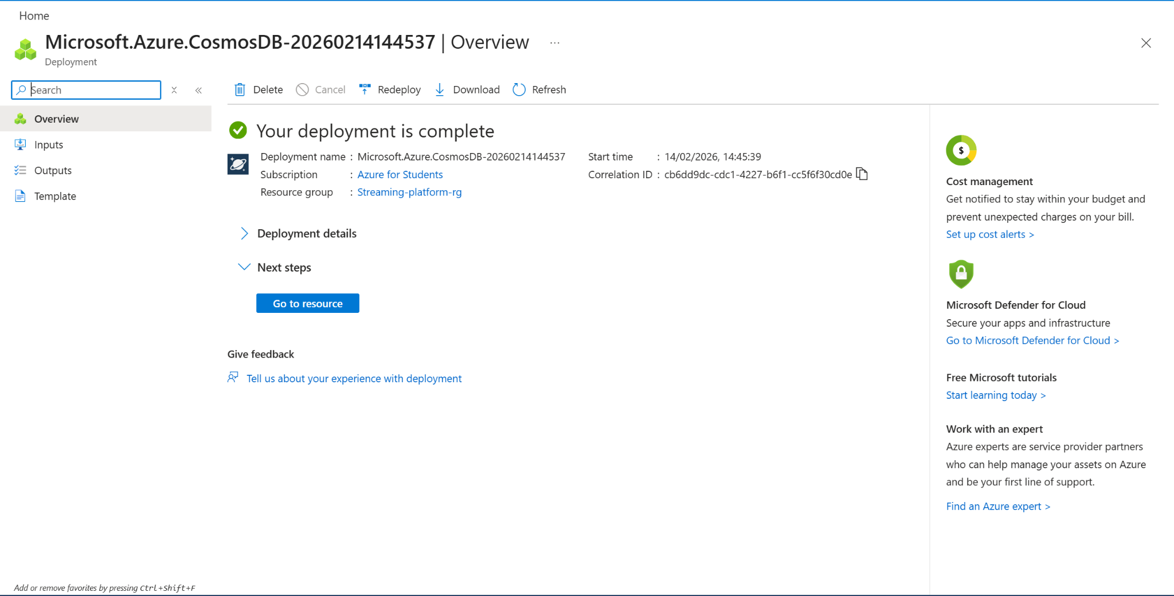

24. Creating Cosmos DB Container
A new container clickstreamdata is created with /ProfileName as the partition key to ensure scalable and efficient data distribution.

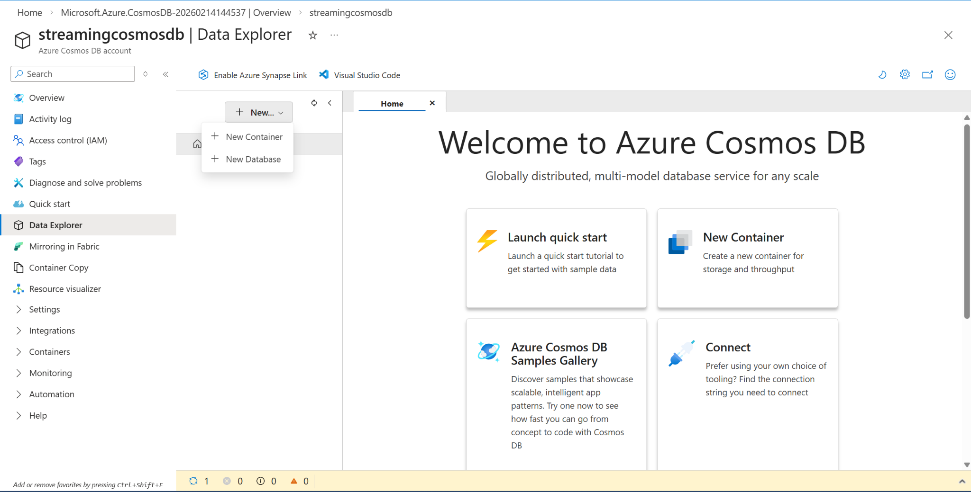
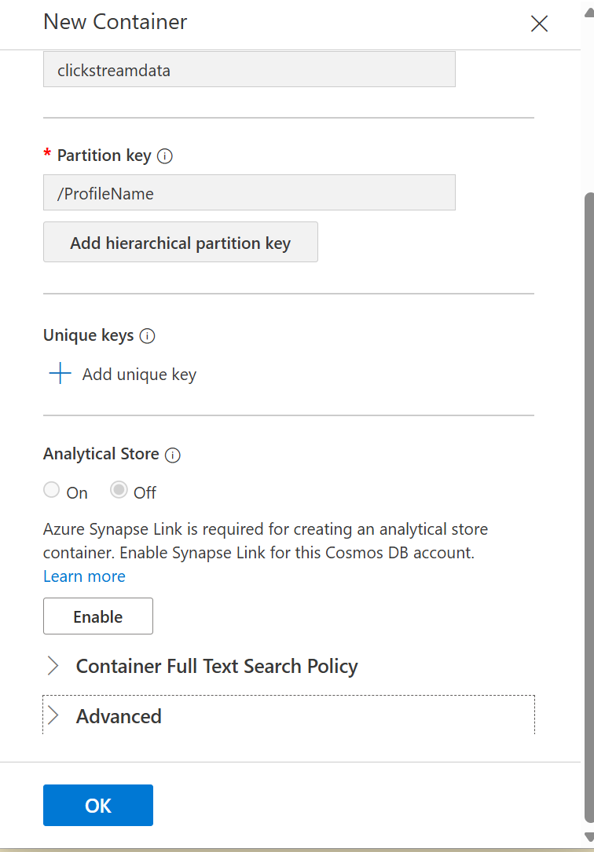
25. Cosmos DB Container Successfully Created
The database and container are visible in Data Explorer, confirming successful setup and readiness for data insertion.

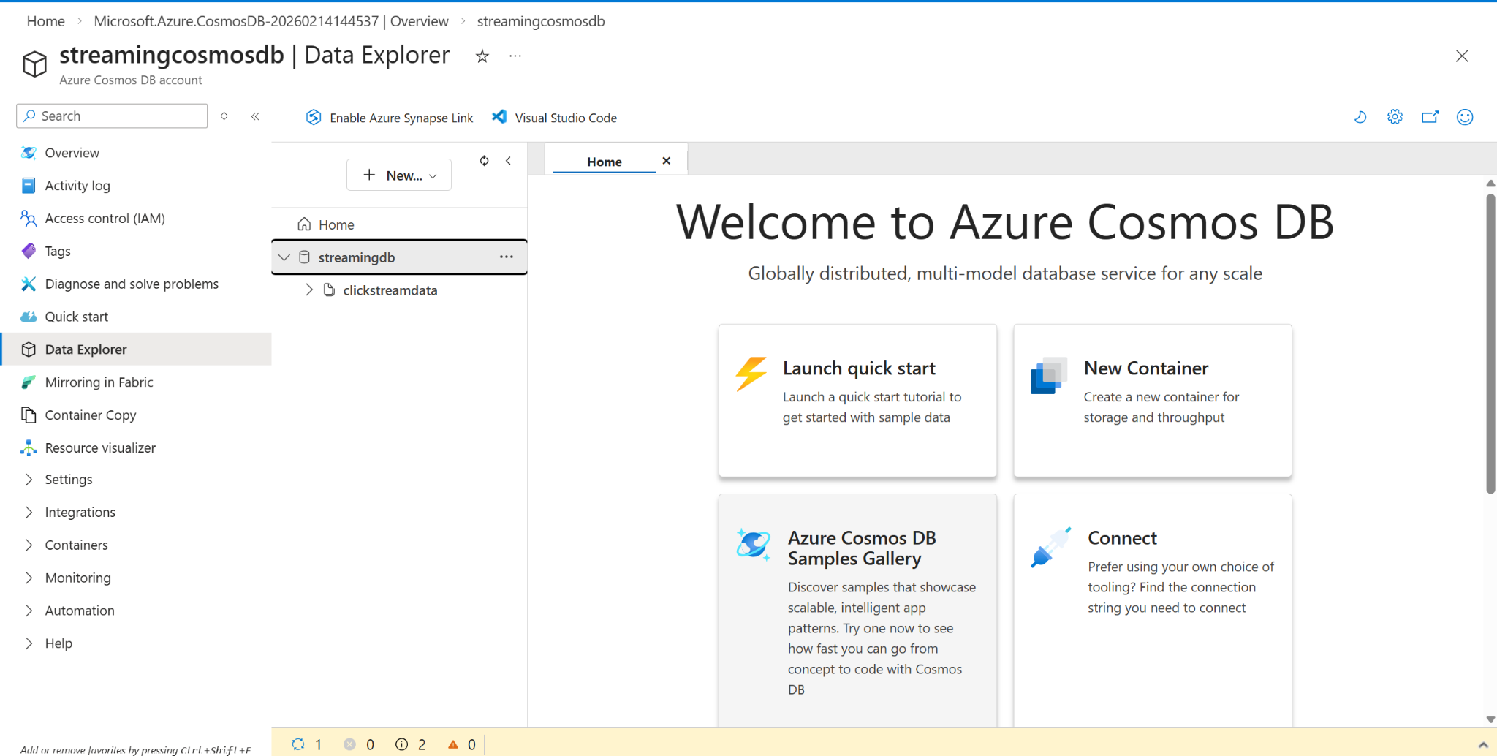

26. Configuring SQL Database Output
Azure SQL Database is configured as an output sink to store structured streaming data in relational format.

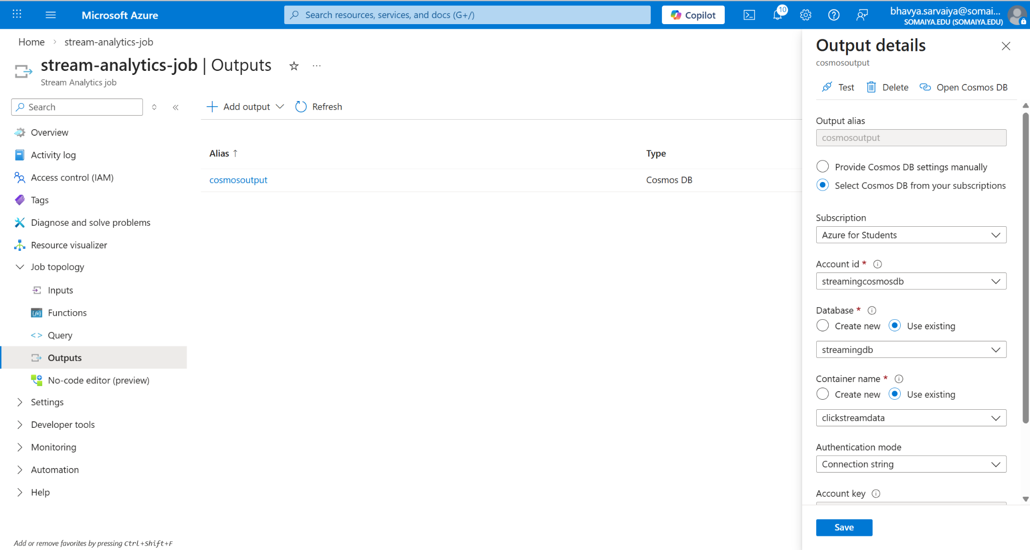

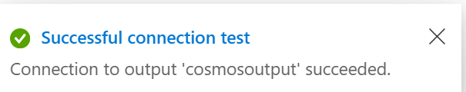

27. Writing Stream Analytics Query
The SQL-like query is written inside Stream Analytics to select and process required fields from the Event Hub input.

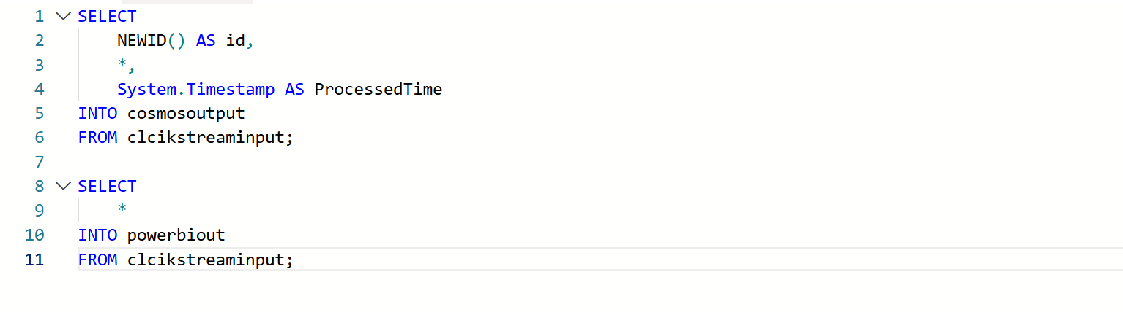

28. Starting the Stream Analytics Job
The Stream Analytics job is started, activating real-time processing of events from Event Hub.

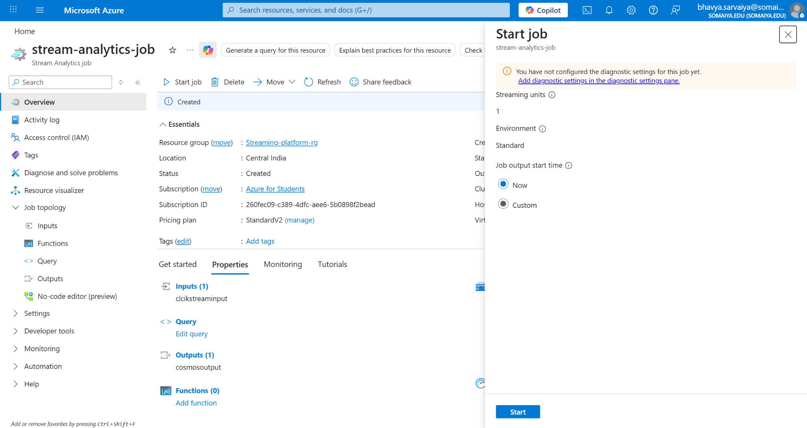

29. Stream Analytics Job Running Successfully
The job status shows “Running,” confirming successful real-time data processing and routing to outputs.

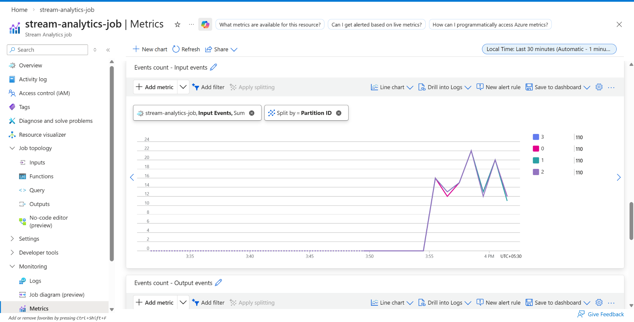
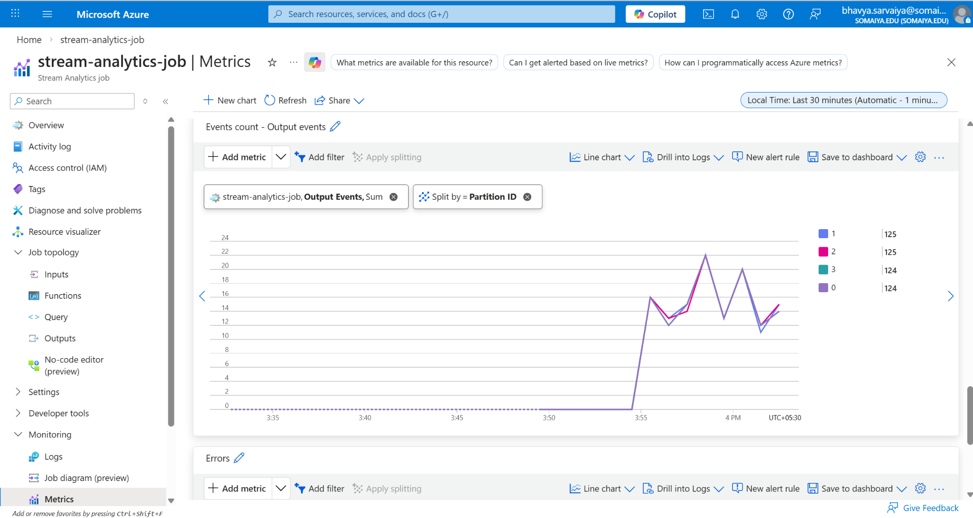

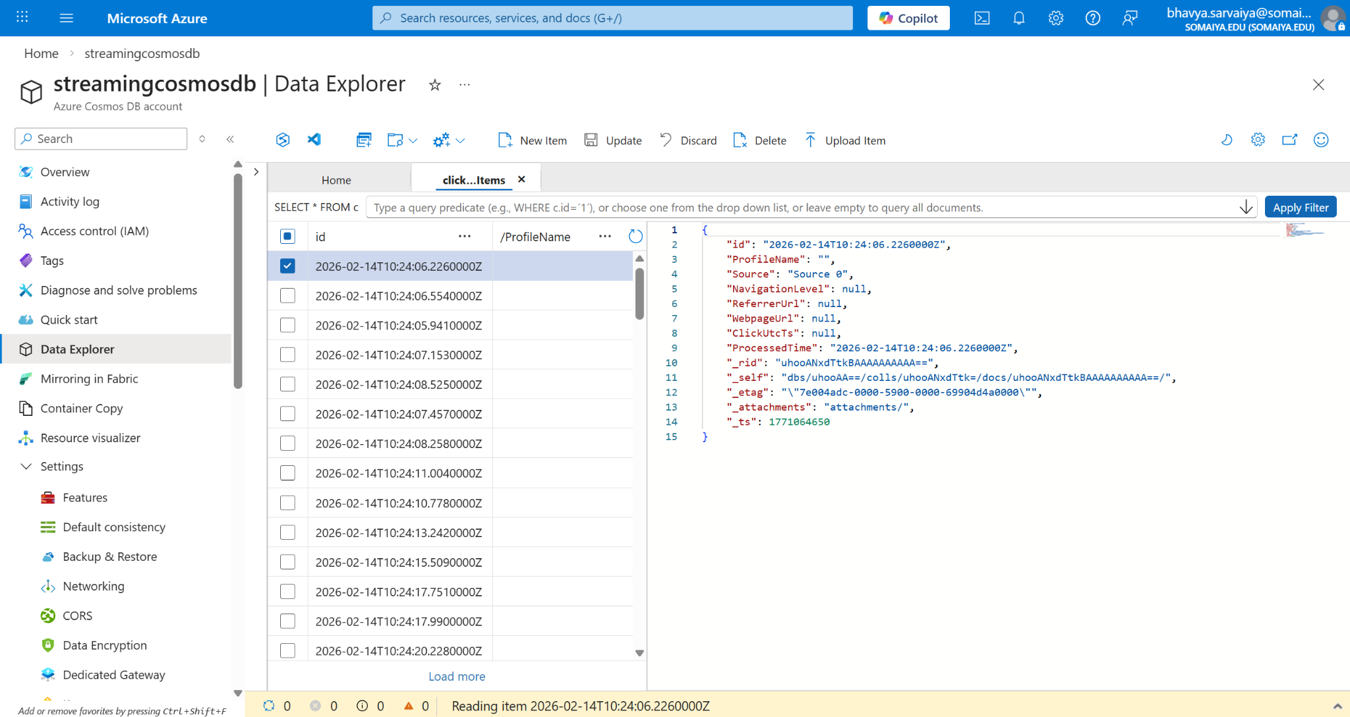

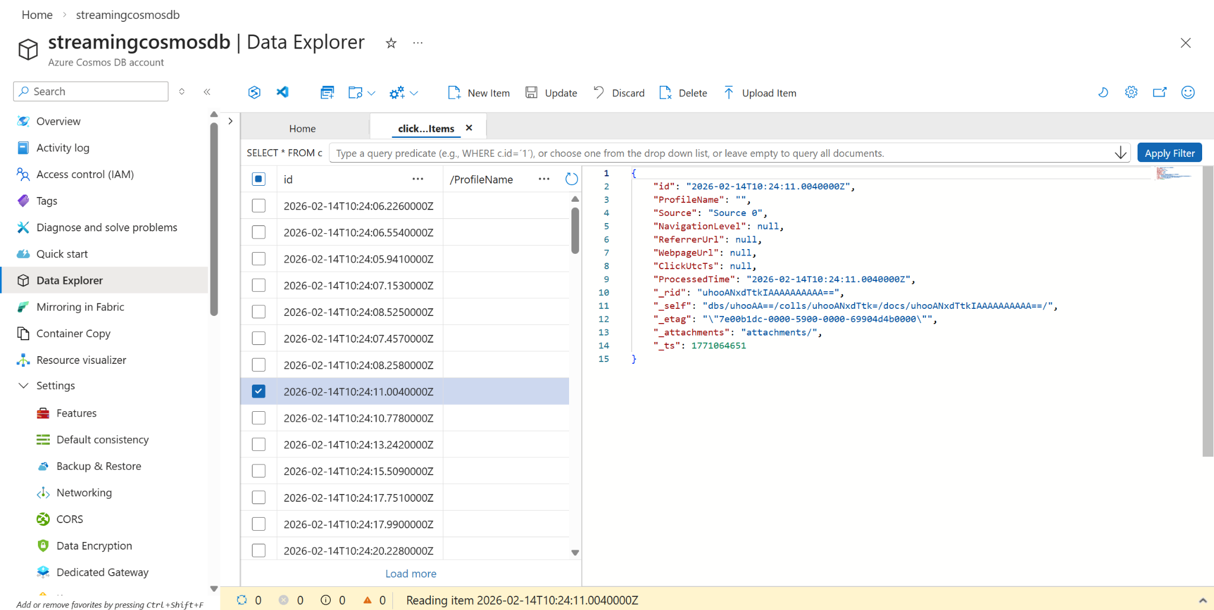

30. Configuring Power BI as Output in Stream Analytics
This screenshot shows the configuration of Power BI as an output sink in the Stream Analytics job. The dataset name clickstreamDataset and table name clickstreamTable are defined for streaming data visualization.

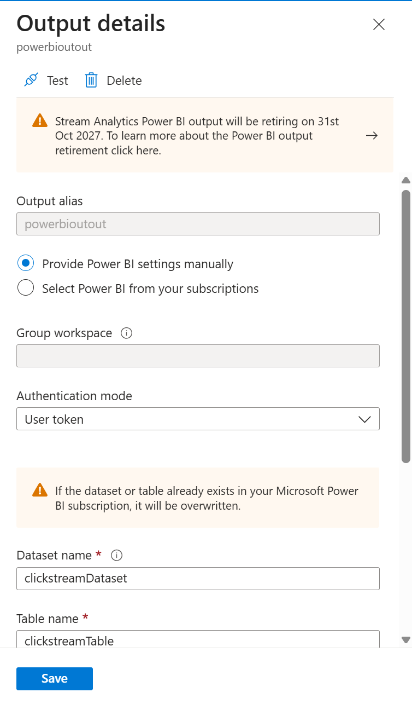

31. Power BI Dataset Successfully Created
In Power BI Service (My Workspace), the dataset clickstreamDataset appears automatically. This confirms successful integration between Stream Analytics and Power BI.

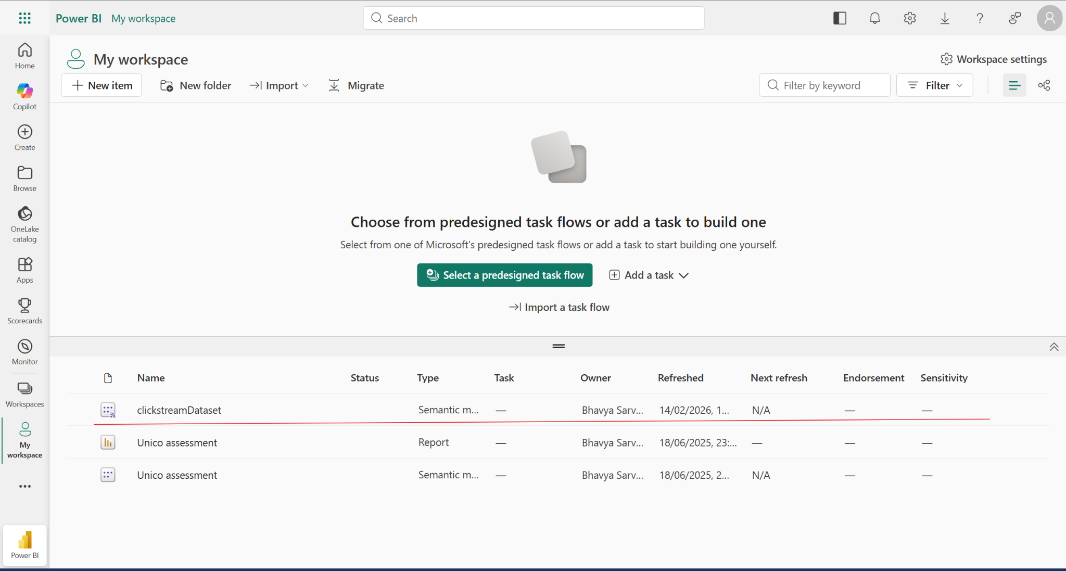

32. Live Streaming Visualization in Power BI
The line charts and bar graphs dynamically update based on incoming streaming data. This confirms real-time analytics and visualization are working successfully.

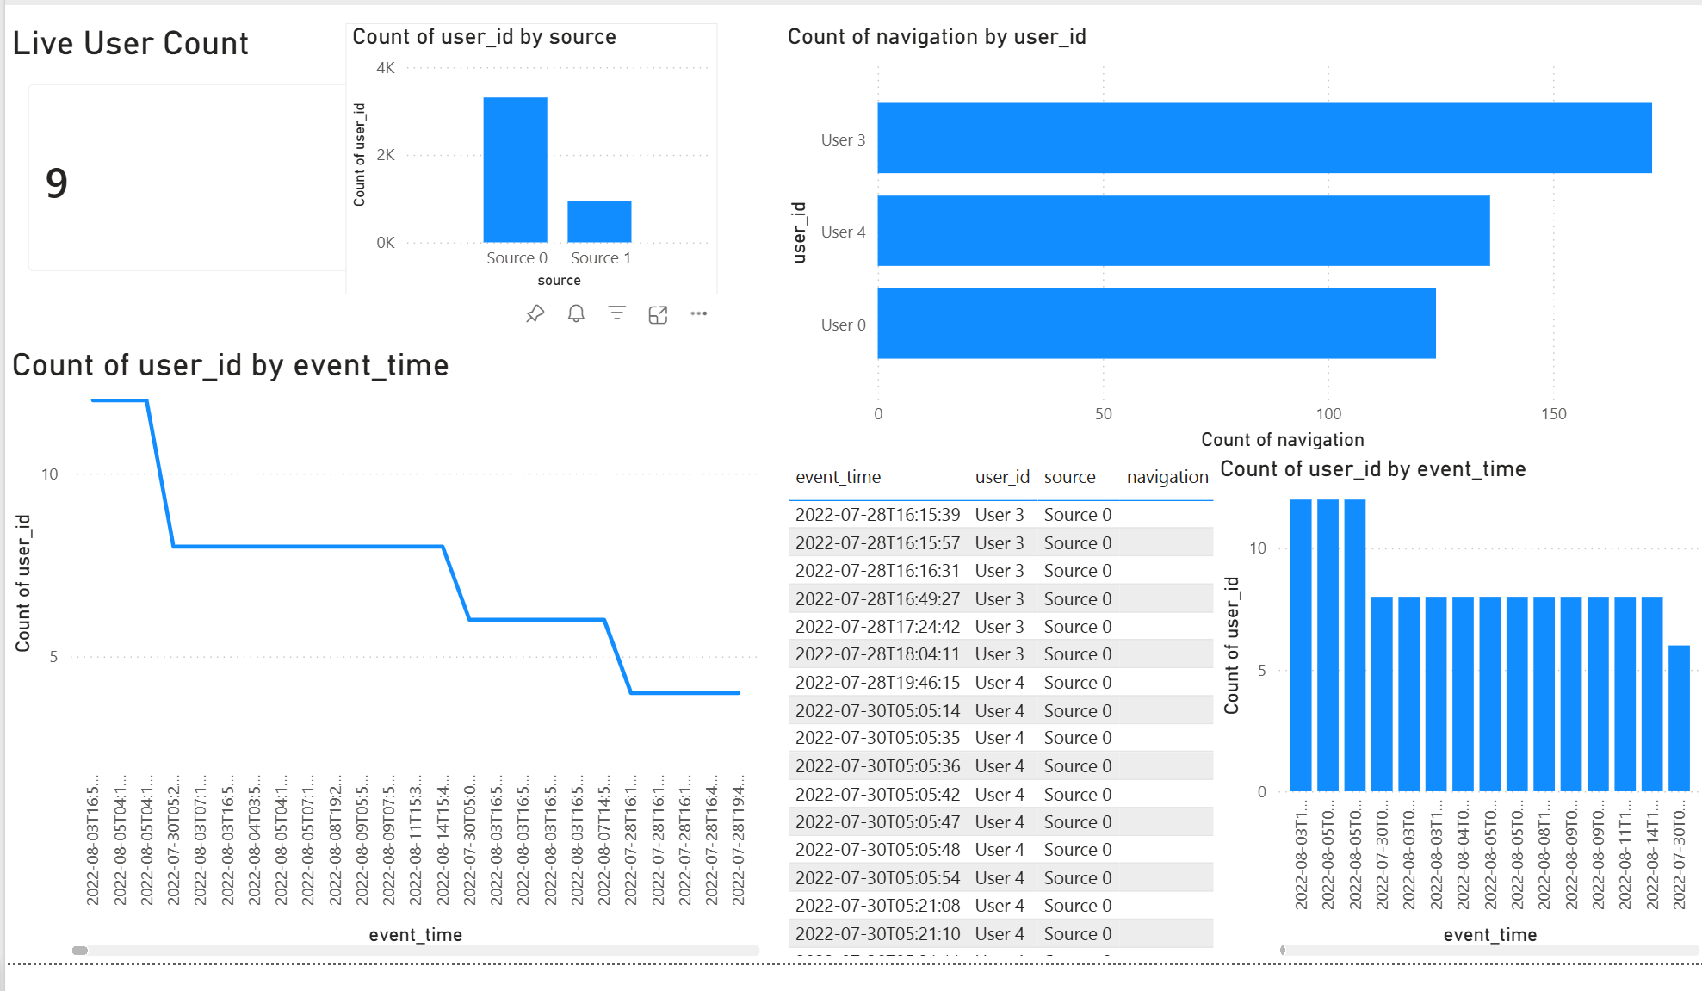
End-to-End Pipeline Successfully Executed
At this stage, the entire architecture is functional:
- Data streamed from Google Colab
- Ingested into Event Hub
- Processed by Stream Analytics
- Stored in SQL & Cosmos DB
- Visualized in Power BI
Real-Time Streaming Pipeline Successfully Completed.

Conclusion:

This project successfully implemented a complete end-to-end real-time streaming data pipeline using Microsoft Azure cloud services. The system was designed to ingest clickstream data, process it in real time, store it in both relational and NoSQL databases, and visualize insights through an interactive Power BI dashboard.
Azure Event Hub efficiently handled real-time data ingestion, while Azure Stream Analytics processed streaming events using SQL-based queries. The processed data was routed to Azure SQL Database for structured storage and Azure Cosmos DB for scalable NoSQL storage. Finally, Power BI enabled real-time visualization, providing meaningful insights such as live user count, navigation trends, and source-based activity analysis.
The successful integration of multiple Azure services demonstrates the power of cloud-native architectures in building scalable, reliable, and real-time analytics solutions. This project enhanced practical understanding of event-driven systems, stream processing, cloud database management, and business intelligence reporting.
Overall, the system proves that modern cloud platforms like Microsoft Azure can efficiently handle real-time data processing requirements for modern data-driven applications.

