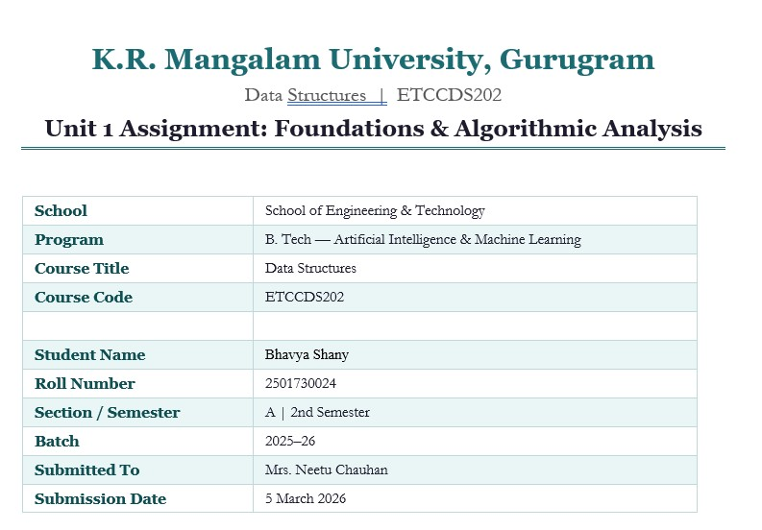

What is an ADT (Abstract Data Type)?
An ADT (Abstract Data Type) is like a blueprint or a contract. It tells us WHAT operations a data structure should support, but does NOT say HOW those operations are carried out inside. For example, a Stack ADT says you can push, pop, peek, check if empty, and check size — but the actual storage could use a list, array, or linked list. The user of the ADT does not need to know the internal details.

Stack Operations and Why They Are O(1)
A Stack works on the LIFO principle — Last In, First Out. Think of a stack of plates: you always add or remove from the top. All Stack operations are O(1) (constant time) because:
- push(x): We simply append to the end of the list. Python list append is O(1).
- pop(): We remove from the end of the list. Python list pop() from end is O(1).
- peek(): We just look at the last element using index -1. This is O(1).
- is_empty(): We check if len == 0. Checking length is O(1).
- size(): We return len(items). Again O(1).
None of these operations need to loop through the entire list. That is why all Stack operations are O(1) regardless of how many items are in the stack.

Use of Stack in This Toolkit
The StackADT is used in three places in this toolkit: (1) To store Tower of Hanoi moves, (2) to store mid-indices visited during Binary Search, and (3) as a standalone demo in Part A. This shows how a Stack can act as a helpful 'memory' for tracking steps in an algorithm.

Part B: Factorial & Fibonacci — Complexity Analysis

Factorial (Recursive)
The recursive factorial function calls itself n times (for factorial(n), it calls factorial(n-1), factorial(n-2), ... down to factorial(0)).

Complexity | Value | Explanation
Time — Big-O | O(n) | n recursive calls, one multiplication each
Time — Big-Omega | O(n) | Even in best case, we need n calls
Time — Big-Theta | Theta(n) | Always exactly n calls — tight bound
Space — Big-O | O(n) | Call stack holds n frames at peak depth

Fibonacci — Naive vs Memoized
Why Naive Fibonacci is Slow: In naive recursive Fibonacci, the same sub-problems are calculated over and over. For example, to calculate fib(5), we calculate fib(3) twice, fib(2) three times, fib(1) five times, and so on. This leads to an exponential explosion in function calls. The call tree for fib(n) has roughly 2^n nodes.
Why Memoized Fibonacci is Fast: Memoization stores the answer of each fib(k) the first time it is calculated, in a dictionary. The next time fib(k) is needed, we simply look it up instead of recalculating. This means each value from 0 to n is calculated exactly once — making it linear.
Version | Time Complexity | Space Complexity | Paradigm
Naive Recursive | O(2^n) — Exponential | O(n) — call stack depth | Plain Recursion
Memoized | O(n) — Linear | O(n) — memo dict + stack | Dynamic Programming

Call Count Comparison (from output.txt):

n | fib_naive answer | Naive Calls | fib_memo answer | Memo Calls
5 | 5 | 15 | 5 | 9
10 | 55 | 177 | 55 | 19
20 | 6765 | 21,891 | 6765 | 39
30 | 832040 | 2,692,537 | 832040 | 59
Notice: For n=30, naive needs over 2.6 million calls while memoized only needs 59 calls! This perfectly demonstrates why memoization (Dynamic Programming) is so powerful.

Part C: Tower of Hanoi — Complexity Analysis

How the Recursion Works:
Tower of Hanoi is a classic recursion problem. To move n disks from Source to Destination:

- Step 1: Move the top (n-1) disks from Source to Auxiliary peg (using Destination as helper).
- Step 2: Move the largest disk directly from Source to Destination.
- Step 3: Move the (n-1) disks from Auxiliary to Destination (using Source as helper).
Base case: If n = 1, just move disk 1 directly from Source to Destination. No more recursion needed.

Why Number of Moves = 2^n - 1:
Let T(n) = number of moves for n disks.
T(1) = 1 (base case — just 1 move)
T(n) = T(n-1) + 1 + T(n-1) = 2 x T(n-1) + 1
Solving this: T(n) = 2^n - 1

For N=3: T(3) = 2^3 - 1 = 8 - 1 = 7 moves. This matches our output exactly!

Complexity | Value | Explanation
Time — Big-O | O(2^n) | Total moves = 2^n - 1, which is exponential
Space — Big-O | O(n) | Maximum recursion depth is n (call stack)

Part D: Recursive Binary Search — Complexity Analysis

How Divide & Conquer Works Here:
Binary Search is a perfect example of Divide and Conquer. At each step, we divide the problem in half:
- Look at the middle element of the sorted array.
- If it matches the key — we are done!
- If key is smaller — search only the LEFT half (ignore right half entirely).
- If key is larger — search only the RIGHT half (ignore left half entirely).
- Repeat until found or the search range becomes empty (low > high).

Recurrence Relation:
T(n) = T(n/2) + O(1)
Each recursive call works on half the array — T(n/2). The comparison at each step takes constant time — O(1). Solving this recurrence gives us O(log n).

Case | What Happens | Time Complexity
Best Case | Key is at the middle on first try | O(1)
Average Case | Key found after a few halvings | O(log n)
Worst Case | Key at the very end or not present — keep halving till | 1Oe(leomg enn) t

Space | Recursive call stack depth = number of halvings | O(log n)
Example: For an array of 128 elements, binary search needs at most log2(128) = 7 comparisons. A linear search would need up to 128 comparisons. This shows how powerful O(log n) is!

Part E: Paradigm Reflection

Binary Search — Divide & Conquer
Binary Search is Divide and Conquer because it follows the classic 3-step D&C; strategy: Divide — split the array into two halves by finding the middle. Conquer — recursively search only the relevant half. Combine — the result is directly returned (no merging step needed here). Each step reduces the problem size by half, which is the defining feature of D&C.;
Real-life example of Divide & Conquer: Finding a word in a physical dictionary. You open to the middle page, decide if your word comes before or after, then repeat on the relevant half.
You don't look at every page!

Memoized Fibonacci — Dynamic Programming
Naive Fibonacci has a serious problem called overlapping sub-problems — it recalculates the same values many times. Dynamic Programming (DP) solves this by storing the answer to each sub-problem the first time it is solved (this is called memoization). When the same
sub-problem appears again, we simply look up the stored answer in O(1) instead of
re-computing it. This is the core idea of DP: solve each sub-problem once and remember the result.
Real-life example of Dynamic Programming: Calculating the shortest route in a GPS navigation app. The shortest path to city C via city B is stored so it doesn't need to be recalculated every time it appears in a longer route.

Tower of Hanoi — Recursion
Tower of Hanoi is a pure recursion problem. It has a clear base case and a smaller sub-problem at each step:
  - Base case: If there is only 1 disk (n=1), just move it directly. No further recursion.
  - Smaller sub-problem: Moving n disks is reduced to moving (n-1) disks — a smaller version of the same problem.
  - Trust the recursion: We trust that hanoi(n-1, ...) correctly moves n-1 disks, and we just need to handle the nth disk.
Real-life example of Greedy Algorithm (conceptual): Making change with coins. A cashier giving change always picks the largest coin possible first (e.g., first a Rs.10 coin, then Rs.5, then Rs.1). At each step, the locally best choice is made without reconsidering. This greedy approach works well for standard coin denominations.

Thank You
Made by-
Bhavya Shany
2501730024
B.tech CSE Ai and Ml

