PROJECT DOCUMENTATION
Azure Batch for an Engineering
Simulation Workload
Cloud-based parallel processing prototype

Project Information | Details
Institution | Koneru Lakshmaiah Education Foundation (KLEF)
Department | Department of Computer Science and Engineering
Team | T177
Project Theme | Azure for Students • Azure Batch • 300 simulation tasks

Team Member | Student ID
Ch. Sri Neha | 2400031988
A. Keerthi | 2400032168
B. Shavya Sri | 2400032179
K. Sri Sai Pavan | 2400032315

Document Scope
This documentation is based on the final project presentation and records the project introduction, problem statement, objectives, SimFlow prototype, Azure Batch architecture, Azure resources, compute pool, Batch job, task submission, execution monitoring, final results, limitations, conclusion, and future scope.
The project presentation keeps the standalone SimFlow prototype and the Azure Batch implementation separate. SimFlow demonstrates the engineering application concept, while Azure Batch demonstrates cloud batch processing.
The numerical workload is a demonstration workload rather than a production engineering solver. The demonstrated results therefore represent workload execution and completion rather than physical engineering predictions.

Table of Contents
1. Introduction
2. Problem Statement
3. Project Objectives
4. Engineering Use Case / Prototype
5. Prototype Simulation
6. Proposed Azure Architecture
7. Azure Resources Used
8. Azure Batch Account
9. Compute Pool Configuration
10. Batch Job
11. Task Submission
12. Execution Monitoring
13. Final Task Results
14. Prototype and Azure Implementation
15. Advantages and Applications
16. Limitations and Cost Considerations
17. Conclusion
18. Future Scope
19. Appendix: Screenshot Evidence

1. Introduction
Engineering simulations often require many independent runs with different input parameters. Running a large set of independent calculations on a single machine can be time-consuming.
Azure Batch provides a managed way to create compute pools, jobs and tasks, and schedule those tasks across compute nodes. This project demonstrates that workflow using a controlled numerical simulation workload.
A separate SimFlow Workload prototype demonstrates the application-side concept through inputs, scenarios, processing and completion.

2. Problem Statement
A simulation study may require hundreds of independent scenarios or parameter combinations. Sequential execution can increase turnaround time and makes scaling difficult.
- A large engineering workload may contain hundreds of independent simulation cases.
- Sequential processing can increase overall completion time.
- Independent tasks can be distributed across a small pool of compute nodes.
- Azure Batch can schedule queued tasks onto available compute nodes.

3. Project Objectives
- Create an Azure Batch account and a compute pool.
- Create a Batch job for the simulation workload.
- Generate and submit 300 independent simulation tasks.
- Monitor task execution and verify completion.
- Demonstrate how the same pattern can support larger engineering simulation studies.

4. Engineering Use Case / Prototype
Stage | Prototype Representation
Inputs | Number of simulations according to user requirements
Scenarios | 300 independent simulation cases
Processing | Numerical simulation for each case
Results | Completion of jobs as requested
The prototype is a standalone conceptual workload called SimFlow Workload. It demonstrates the engineering workload concept and does not need to connect to Azure for the stated project scope.
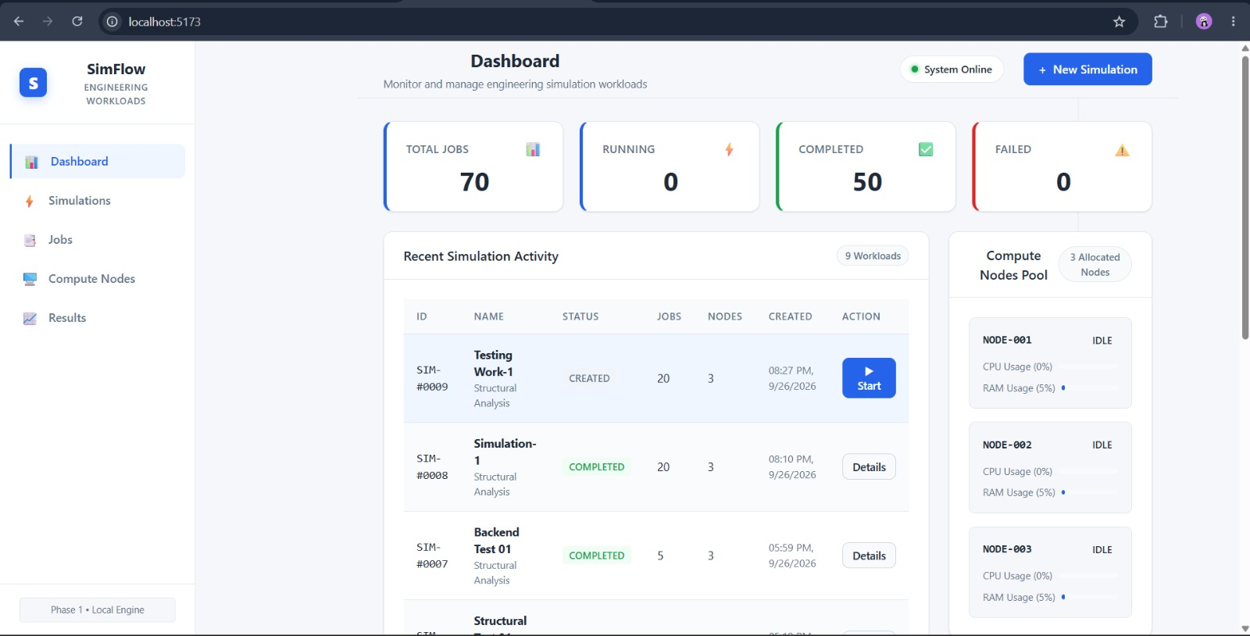
Figure 1. SimFlow prototype dashboard from the final presentation.

5. Prototype Simulation
The SimFlow prototype provides a visual representation of engineering simulation workloads, including workload status and compute-node information. It demonstrates the application concept independently of the Azure infrastructure.
Figure 2. SimFlow workload monitoring view.

6. Proposed Azure Architecture
The proposed architecture uses Azure Portal or Cloud Shell to create and manage resources. An Azure Batch account contains a compute pool. A Batch job is associated with the pool, and the job contains 300 independent simulation tasks.
Component | Configuration
Azure Batch Account | engsimbatch2026neha
Compute Pool | simulation-pool
VM Size | Standard_D2s_v3
Dedicated Nodes | 2
Batch Job | simulation-job
Tasks | simulation-task-001 through simulation-task-300

7. Azure Resources Used
Resource | Value
Subscription | Azure for Students
Resource Group | RG-Engineering-Simulation
Batch Account | engsimbatch2026neha
Region | India South Central
Pool | simulation-pool
VM Size | Standard_D2s_v3
Dedicated Nodes | 2
Batch Job | simulation-job
Tasks | 300

8. Azure Batch Account
The actual Azure implementation used the Batch account named engsimbatch2026neha. The Azure Portal evidence shows the account online in India South Central under the Azure for Students subscription and RG-Engineering-Simulation resource group.
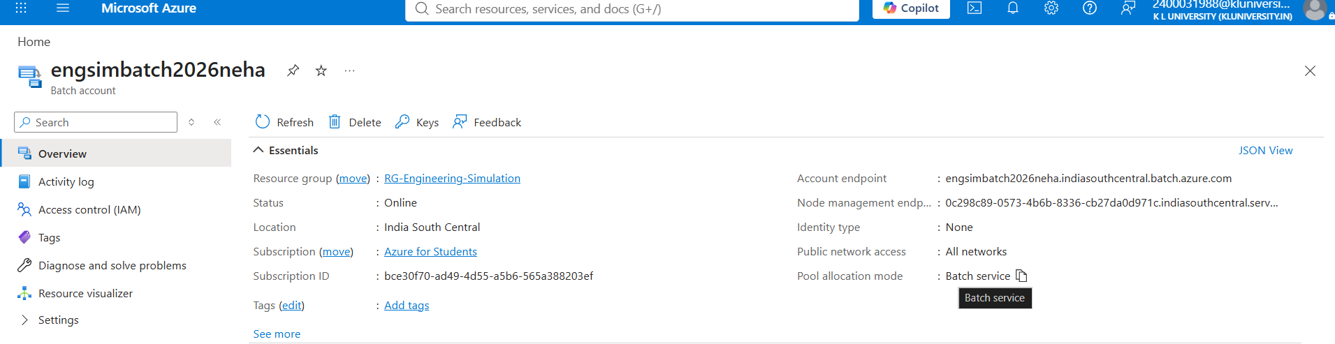
Figure 3. Azure Batch account overview.

9. Compute Pool Configuration
The actual workload used simulation-pool with two dedicated nodes. The pool used Standard_D2s_v3 virtual machines, providing four vCPUs in total. The pool was shown in a Steady allocation state.
Property | Value
Pool ID | simulation-pool
Dedicated nodes | 2
Spot/low-priority nodes | 0
Current vCPUs | 4
VM size | STANDARD_D2S_V3
Allocation state | Steady
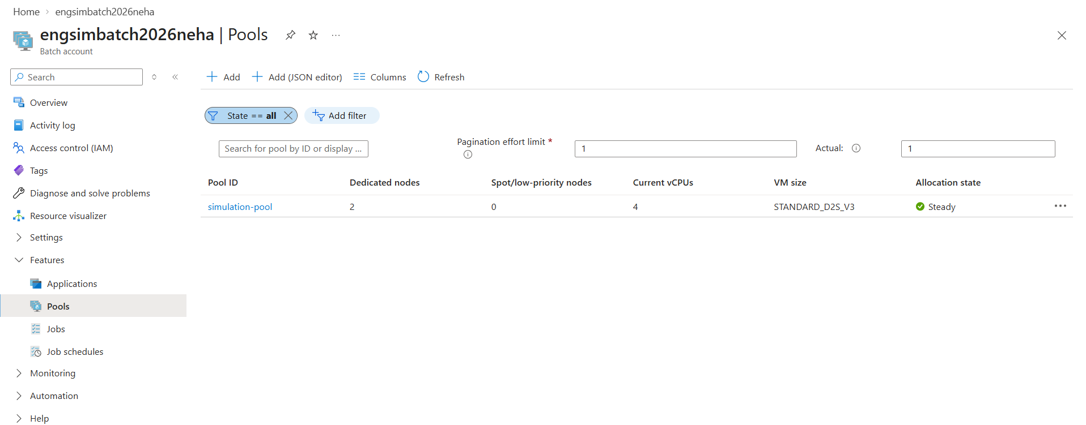
Figure 4. Azure Batch pool configuration.

10. Batch Job
A Batch job named simulation-job was created and linked to simulation-pool. The job provides the logical grouping for the 300 independent simulation tasks.
Property | Value
Job ID | simulation-job
State shown | Active
Linked pool | simulation-pool
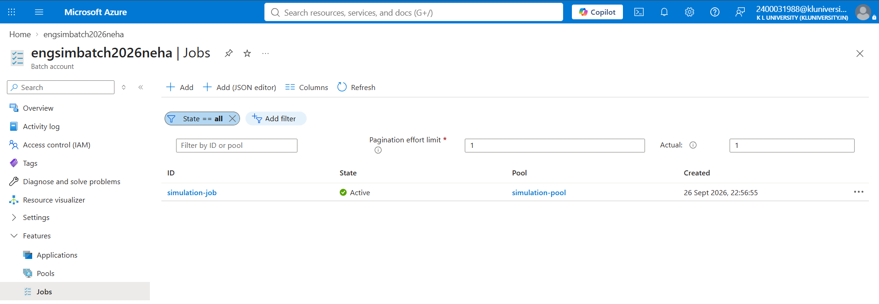
Figure 5. Azure Batch Jobs view.

11. Task Submission
The workload consists of 300 independent simulation tasks named simulation-task-001 through simulation-task-300. Each task represents a repeated numerical calculation performed independently.
- Tasks were submitted in three batches of 100 tasks.
- Each task used a non-admin task identity on the Ubuntu compute nodes.
- Two dedicated nodes were used to keep the educational demonstration small and cost-conscious.
- Azure Batch placed queued tasks onto available compute nodes.
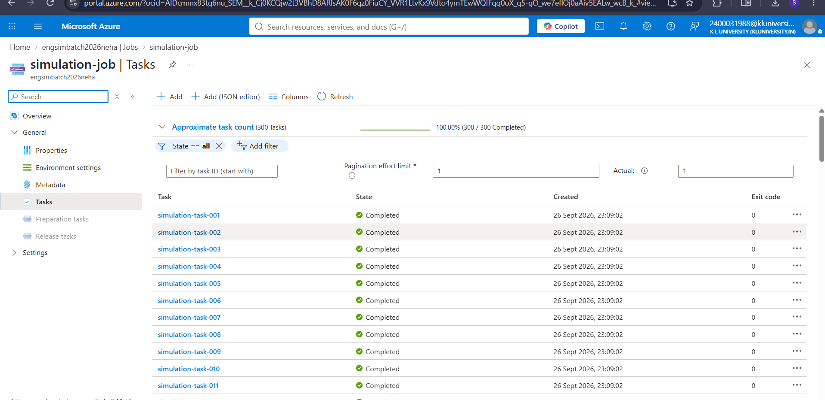
Figure 6. Azure Batch task monitoring and completion progress.

12. Execution Monitoring
Azure Portal was used to monitor the workload. The final task-list evidence shows an approximate task count of 300 and a completion indicator of 100% (300/300 completed).
Figure 7. Azure Batch execution monitoring.

13. Final Task Results
The final presentation includes task evidence for tasks 284–300. These tasks are displayed as Completed and show exit code 0.
Metric | Reported Value
Simulation tasks submitted | 300
Dedicated compute nodes | 2
Tasks completed | 100% shown
Displayed final tasks | 284–300
Displayed exit code | 0
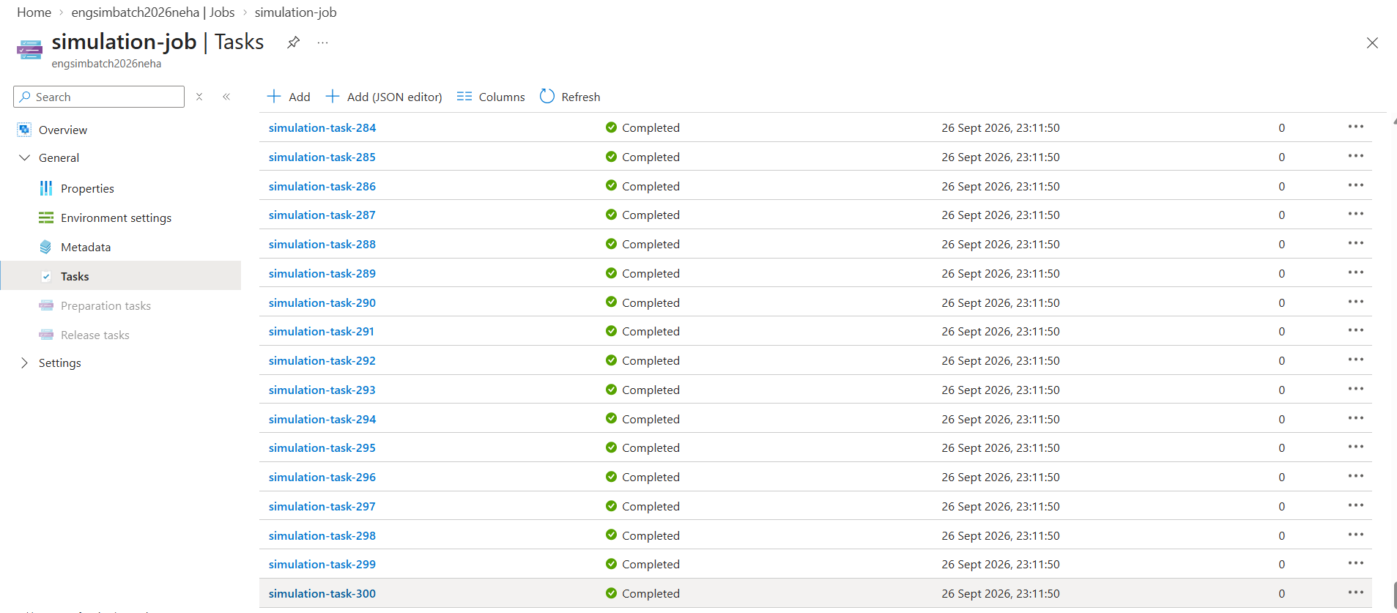
Figure 8. Final task evidence for tasks 284–300.

14. Prototype and Azure Implementation
Prototype: SimFlow Workload | Azure Implementation
Demonstrates engineering application concept. | Demonstrates cloud batch processing.
Shows inputs, scenarios, processing and results. | Azure Batch account + compute pool.
Standalone conceptual prototype. | Batch job + 300 independent tasks.
Does not need to connect to Azure for the defined scope. | Monitoring and completion verification.
Keeping these components separate allows the project to demonstrate both the application concept and the cloud batch-processing workflow without presenting the prototype as an Azure-connected engineering solver.

15. Advantages and Applications
- Parallel task execution: independent simulation cases can be scheduled across compute nodes.
- Scalability: the Batch pattern can be expanded by increasing compute resources when appropriate.
- Managed scheduling: Azure Batch handles task queuing and assignment to available nodes.
- Potential applications include structural analysis, thermal simulations, manufacturing parameter sweeps, aerospace studies, and other independent numerical workloads.

16. Limitations and Cost Considerations

16.1 Limitations
- The numerical workload is a demonstration workload, not a production engineering solver.
- The prototype and Azure implementation are separate.
- Demonstration results should not be interpreted as physical engineering predictions.

16.2 Cost / Resource Approach
- Azure for Students subscription was used.
- A small two-node pool was selected instead of hundreds of nodes.
- The configuration was sufficient to demonstrate Batch scheduling while limiting resource usage.

17. Conclusion
An Azure Batch environment was created for an engineering simulation workload. A compute pool with two Standard_D2s_v3 nodes was configured, a Batch job was created, and 300 independent tasks were submitted.
Azure Portal evidence shows 300 tasks at 100% completion, with the displayed final tasks returning exit code 0. The project demonstrates the basic cloud workflow for scaling independent simulation computations.
The SimFlow prototype complements the Azure work by demonstrating the standalone engineering workload concept, while Azure Batch demonstrates the distributed cloud execution workflow.

18. Future Scope
- Replace the demonstration numerical workload with a validated engineering simulation solver.
- Use realistic engineering input files and parameter sets for each scenario.
- Collect task outputs into Azure Storage for centralized result analysis.
- Experiment with larger pools and autoscaling for larger workloads.
- Connect the standalone prototype to the cloud workflow if future project scope requires integration.

19. Appendix: Screenshot Evidence
The following evidence is taken from the final presentation and can be used during project review.
Appendix — SimFlow prototype dashboard.
Appendix — Azure Batch account.
Appendix — Azure compute pool.
Appendix — Azure Batch job.
Appendix — Azure task monitoring.
Appendix — Final task results.

References
- Final project presentation: Azure Batch for an Engineering Simulation Workload, Team T177, KLEF, Department of Computer Science and Engineering.
- Azure Portal screenshots and resource configuration evidence included in the final project presentation.

