**Circuit Diamgram:**

***Switch controlled patrened***

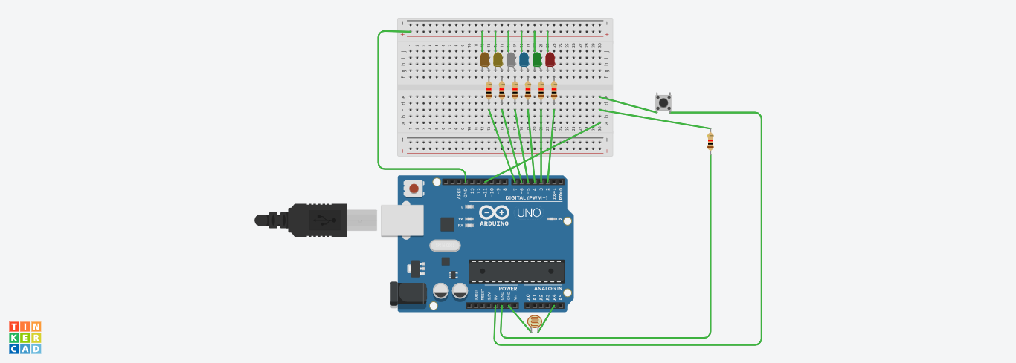

**THEORY:**

As per the circuit diagram, we have made a voltage divider circuit using LDR and 10k resistor. The voltage divider output is feed to

the analog pin of the Arduino.

The analog Pin senses the voltage and gives some analog value to Arduino. The analog value changes according to the resistance of LDR.

So, as the light falls on the LDR the resistance of it get decreased and hence the voltage value increase.

Intensity of light ↓ - Resistance↑ - Voltage at analog pin↓ - Light turns ON

**LEARNING AND OBSERVATIONS:**

As per the Arduino code, if the analog value falls below 400 we consider it as dark and the light turns ON. If the value comes above 400

we consider it as bright and the light turns OFF.

**PROBLEMS AND TROUBLESHOOTING:**

You should take care whether the board in the arduino\uno or not and also selection of port in tools. This is the main problem where we

Get

**PRECAUTIONS:**

While installing led’s in bread board we should take care whether the ’n’ terminals of LDR is connected or not.Here the ‘n’ terminals

should be connected similarly, we should check whether the ‘p’ terminals are connected or not.In this case ‘p’ terminals should not be

connected .

Install the wires properly in both bread board and arduino board.

**LEARNING OUTCOMES:**

With this experiment we can learn that how LED start glowing when its dark and LED is off when its in sunlight.