**Synopsis**

**on**

**‘Student Project Distribution System’**



**Submitted By:**

**Bhavyakumar Chaudhary (06-0202-2016)**

**Guided By:**

**Dr. D. K. Parmar (Major Guide)**

**___________________________**

**Prof. N. M. Veghad(Minor Guide)**

**___________________________**

**Level Zero diagram:**

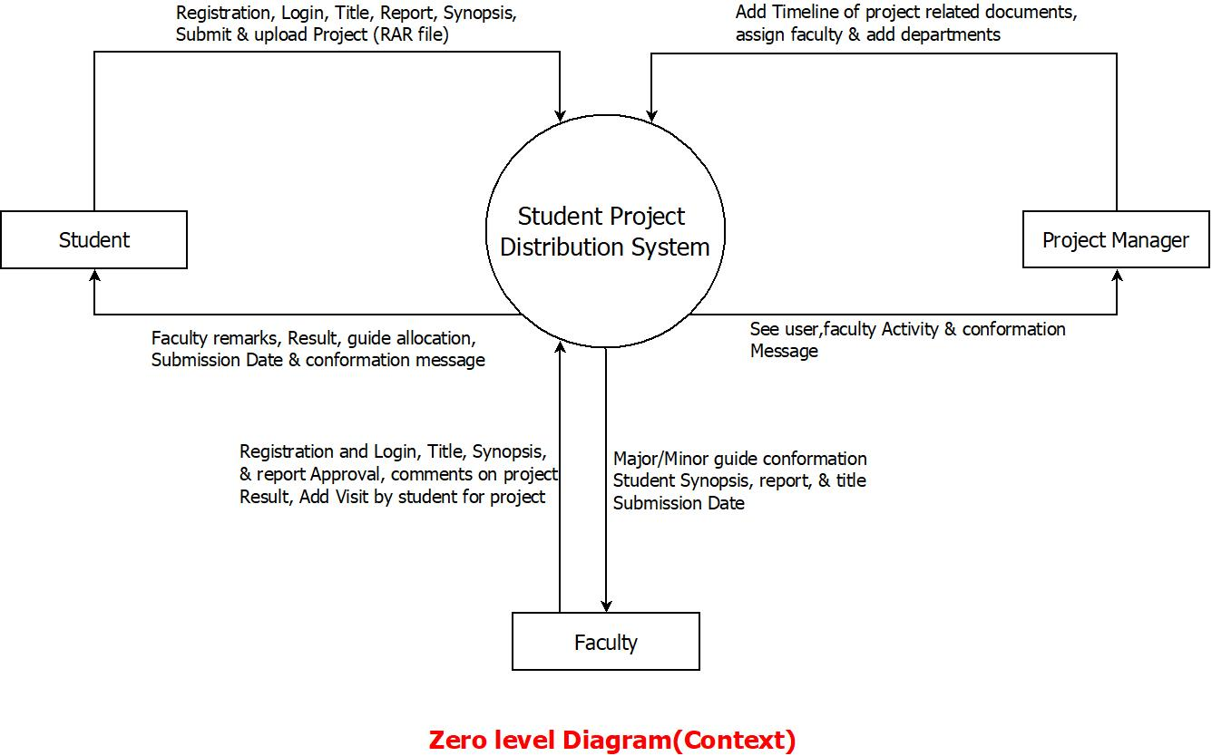

**ER diagram:**

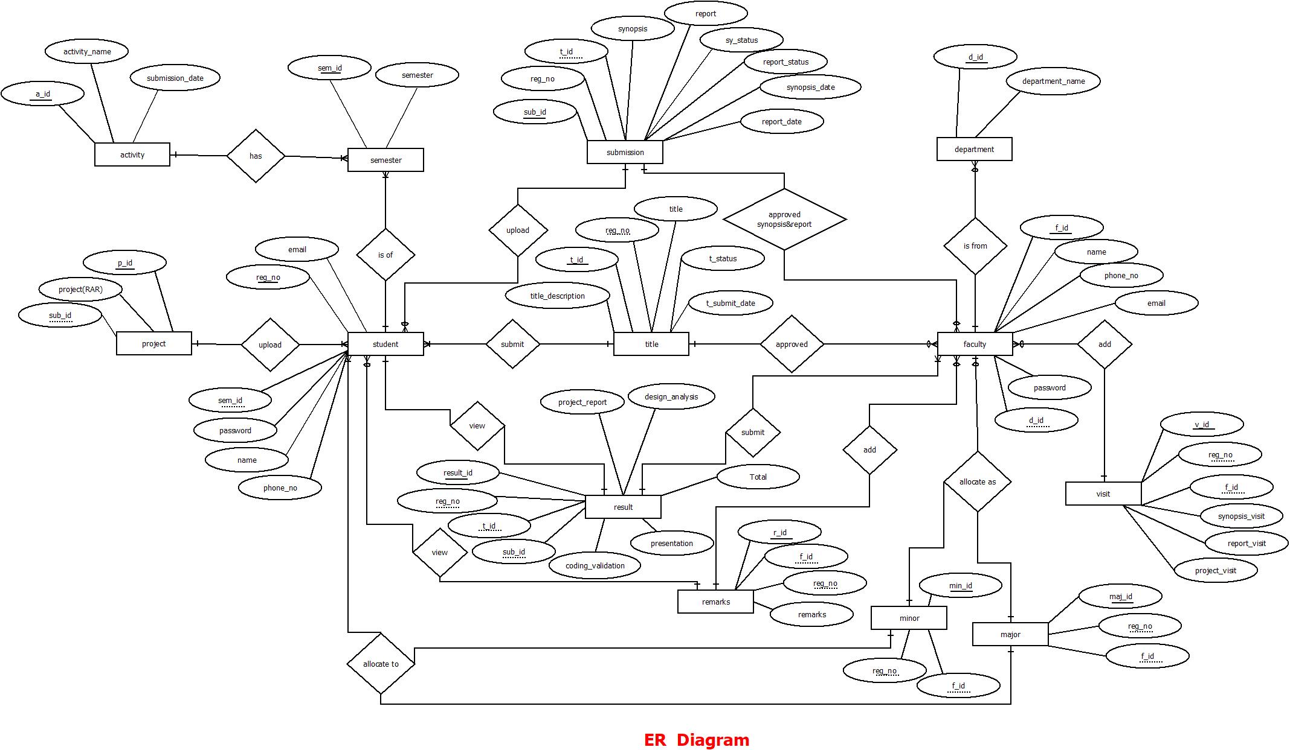

**Data Dictionary:**