**Synopsis**

**on**

**‘Student Project Distribution System’**



**Submitted By:**

**Bhavyakumar Chaudhary (06-0202-2016)**

**Guided By:**

**Dr. D. K. Parmar (Major Guide)**

**___________________________**

**Prof. N. M. Veghad(Minor Guide)**

**___________________________**

## 

**Plateform/Hardware and software:**

## Hardware:

* Processor: Core i3 3.70GHz
* RAM: 8GB

## Software/Language:

* Language**:** PHP (Core).
* Operating System:Windows 8.1.
* Back End: MySQL Server.

**Level Zero diagram:**

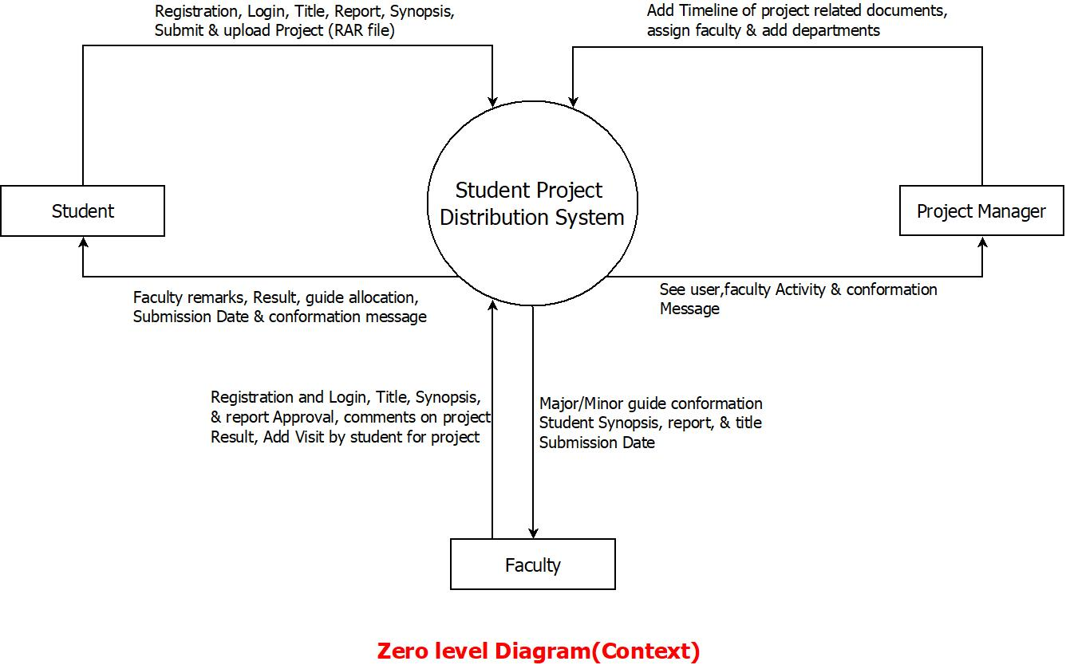

**ER diagram:**

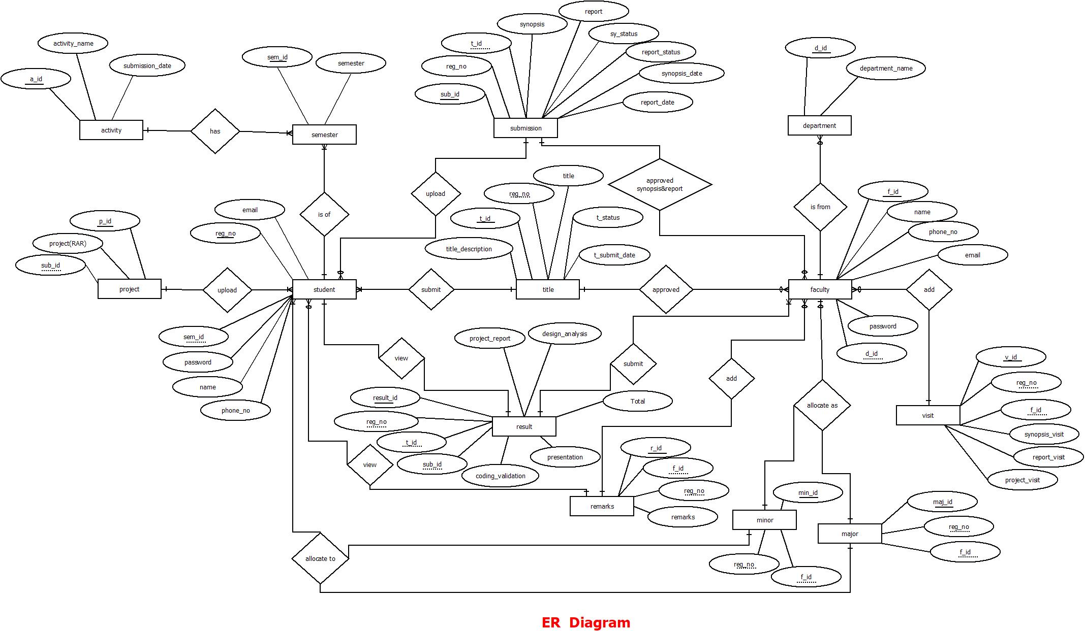

**Data Dictionary:**

**Semester:**

|  |  |  |  |  |  |
| --- | --- | --- | --- | --- | --- |
| Sr. no. | Field | Data Type | Size | Constraint | Description |
| 1 | sem_id | int | 11 | PK | Semester id |
| 2 | semester | int | 5 | Not NULL | Semester Number |

**Student:**

|  |  |  |  |  |  |
| --- | --- | --- | --- | --- | --- |
| Sr. no. | Field | Data Type | Size | Constraint | Description |
| 1 | reg_no | varchar | 20 | PK | Registration No. of student |
| 2 | sem_id | int | 11 | FK | It is from semester table |
| 3 | name | varchar | 30 | Not NULL | Name of the student |
| 4 | email | varchar | 50 | Not NULL | Email address of the student |
| 5 | phone_no | varchar | 15 | Not NULL | Mobile No. of the student |
| 6 | password | varchar | 50 | Not NULL | Password of student for the system |

**Department:**

|  |  |  |  |  |  |
| --- | --- | --- | --- | --- | --- |
| Sr. no. | Field | Data Type | Size | Constraint | Description |
| 1 | d_id | int | 11 | PK | Department id |
| 2 | department | varchar | 50 | Not NULL | Name of the department |

**Activity:**

|  |  |  |  |  |  |
| --- | --- | --- | --- | --- | --- |
| Sr. no. | Field | Data Type | Size | Constraint | Description |
| 1 | a_id | int | 11 | PK | Id of the activity |
| 2 | activity_name | varchar | 50 | Not NULL | Name of the Activity in project |
| 3 | submission_date | date |  | Not NULL | Date of submit that activity |

**Faculty:**

|  |  |  |  |  |  |
| --- | --- | --- | --- | --- | --- |
| Sr. no. | Field | Data Type | Size | Constraint | Description |
| 1 | f_id | int | 11 | PK | Id of the Faculty |
| 2 | d_id | Int | 11 | FK | Department id |
| 3 | name | varchar | 30 | Not NULL | Name of the Faculty |
| 4 | email | varchar | 50 | Not NULL | Email address of the faculty |
| 5 | phone_no | varchar | 15 | Not NULL | Mobile No. of the faculty |
| 6 | password | varchar | 50 | Not NULL | Password of faculty for the system |

**MajorGuide:**

|  |  |  |  |  |  |
| --- | --- | --- | --- | --- | --- |
| Sr. no. | Field | Data Type | Size | Constraint | Description |
| 1 | maj_id | int | 11 | PK | Id of the major guide |
| 2 | reg_no | varchar | 20 | FK | Registration No. of student it is from student table |
| 3 | f_id | varchar | 20 | FK | Id of the Faculty it is from faculty table |

**MinorGuide:**

|  |  |  |  |  |  |
| --- | --- | --- | --- | --- | --- |
| Sr. no. | Field | Data Type | Size | Constraint | Description |
| 1 | min_id | int | 11 | PK | Id of the minor guide |
| 2 | reg_no | varchar | 20 | FK | Registration No. of student it is from student table |
| 3 | f_id | int | 11 | FK | Id of the Faculty it is from faculty table |

**Title:**

|  |  |  |  |  |  |
| --- | --- | --- | --- | --- | --- |
| Sr. no. | Field | Data Type | Size | Constraint | Description |
| 1 | t_id | int | 11 | PK | Id of the Titles |
| 2 | reg_no | varchar | 20 | FK | Registration No. of student it is from student table |
| 3 | title | varchar | 100 | Not NULL | Name of the Title for project |
| 4 | title_decscription | varchar | 300 | Not NULL | Whole Description of the title |
| 5 | t_submit_date | date | - | Not NULL | That date when title is finalized |
| 6 | t_status | int | 1 | Default value is 0 | Flag for title status |

**Remark:**

|  |  |  |  |  |  |
| --- | --- | --- | --- | --- | --- |
| Sr. no. | Field | Data Type | Size | Constraint | Description |
| 1 | r_id | int | 11 | PK | Id of the Faculty |
| 2 | reg_no | varchar | 20 | FK | Registration No. of student it is from student table |
| 3 | f_id | int | 11 | FK | Id of the Faculty it is from faculty table |
| 4 | remark | varchar | 200 | Not NULL | Remark from the guides for the project |

**Submission:**

|  |  |  |  |  |  |
| --- | --- | --- | --- | --- | --- |
| Sr. no. | Field | Data Type | Size | Constraint | Description |
| 1 | sub_id | int | 11 | PK | Id of the submission |
| 2 | reg_no | varchar | 20 | FK | Registration No. of student it is from student table |
| 3 | t_id | int | 11 | FK | Id of the Titles it is from title table |
| 4 | synopsis | varchar | 50 | Not NULL | Path of Synopsis |
| 5 | report | varchar | 50 | Not NULL | Path of Report |
| 6 | synopsis_date | date | - | Not NULL | That date when synopsis is submitted |
| 7 | report_date | date | - | Not NULL | That date when report is submitted |
| 8 | sy_status | int | 1 | Default value is 0 | Flag for synopsis status |
| 9 | report_status | int | 1 | Default value is 0 | Flag for report status |

**Project:**

|  |  |  |  |  |  |
| --- | --- | --- | --- | --- | --- |
| Sr. no. | Field | Data Type | Size | Constraint | Description |
| 1 | p_id | int | 11 | PK | Id of the project |
| 2 | sub_id | int | 11 | FK | Id of the submission |
| 3 | project | varchar | 50 | FK | Path of the project |

**Visit:**

|  |  |  |  |  |  |
| --- | --- | --- | --- | --- | --- |
| Sr. no. | Field | Data Type | Size | Constraint | Description |
| 1 | v_id | int | 11 | PK | Id of the visit of the  student |
| 2 | reg_no | varchar | 20 | FK | Registration No. of student it is from student table |
| 3 | f_id | int | 11 | FK | Id of the Faculty it is from faculty table |
| 4 | synopsis_visit | int | 2 | Not NULL | Visit by the student  To guide for synopsis |
| 5 | report_visit | int | 2 | Not NULL | Visit by the student  To guide for report |
| 6 | project_visit | int | 2 | Not NULL | Visit by the student  To guide for project |

**Result:**

|  |  |  |  |  |  |
| --- | --- | --- | --- | --- | --- |
| Sr. no. | Field | Data Type | Size | Constraint | Description |
| 1 | result_id | int | 11 | PK | Id of the result of student |
| 2 | reg_no | varchar | 20 | FK | Registration No. of student it is from student table |
| 3 | t_id | int | 11 | FK | Id of the Titles it is from title table |
| 4 | sub_id | int | 11 | FK | Id of the submission  It is from submission table |
| 5 | project_report | int | 2 | Not NULL | Mark of the student for report in project |
| 6 | design_analysis | int | 2 | Not NULL | Mark of the student for design and analysis in project |
| 7 | coding_validation | int | 2 | Not NULL | Mark of the student for coding and validation in project |
| 8 | presentation | int | 2 | Not NULL | Mark of the student for presentation skill in project |
| 9 | UI_design | int | 2 | Not NULL | Mark of the student for User Interface design in project |
| 10 | total | int | 3 | Not NULL | Total of this five skill marks |