**Synopsis**

**on**

**‘Student Project Distribution System’**



**Submitted By:**

**Bhavyakumar Chaudhary (06-0202-2016)**

**Guided By:**

**Dr. D. K. Parmar (Major Guide)**

**___________________________**

**Prof. N. M. Vegad(Minor Guide)**

**___________________________**

Contents

1. Title 3

2. Introduction 3

3. Objectives 3

4. Existing System: 3

5. Hardware and Software Requirements 3

6. Interfaces 4

7. Modules 4

8. Literature Review 5

9. Design 8

a) Data Flow Diagram 8

i. Context Level Diagram 8

ii. Level-1 Data Flow Diagram 9

b) Entity Relationship Diagram 11

c) Database Diagram 12

10. Data Dictionaries 13

1. Semester: 13

2. Student: 13

3. Department: 13

4. Activity: 14

5. Faculty: 14

6. MajorGuide: 15

7. MinorGuide: 15

8. Title: 15

9. Remark: 16

10. Submission: 16

11. Project: 17

12. Visit: 17

13. Result: 18

11. References: 19

# Title

* Student Project Distribution System

# Introduction

* Project Distribution done right now, is managed with paperback and is a tedious task. But with this proposed system the project distribution including the selection of topic to submission of project will be managed with this system. And also Submission of report & synopsis for project uploaded using this proposed system. And Students get their result for project on this web application.

# Objectives

* To create project, assign project to student, assign guide to student, submission of synopsis and report, generate report of activity using this web application.

# Existing System:

* Student project distribution system have a many types of operations like Timelines of project related documents (Submission dates of documents), Title submission, Synopsis submission, Report submission and result generation of project etc. The existing system is paper based system so faculty of college is more time for finding how many students submit the project related documents. And student submits their project related documents.

# Hardware and Software Requirements

* Hardware
* 4, 8 GB RAM (for effective working)
* Dual Core i3 3.70GHz Processor (for effective working)
* Keyboard : 101 Keys
* Mouse : Optical Mouse
* Software
* Language: PHP (Core).
* Operating System: Windows 8.1 or 10
* Back End: MySQL Server.

# Interfaces

1. Project Manager

* The Project Manager will have see all the activity and assign guide to student as major and minor.

1. Student

* The students submit title to their major and minor guide. Also submit synopsis and report to their guide. And announced result will be shown by student.

1. Faculty

* The faculties will be assigned by project manager as major and minor guides. They will provide guidelines for project to student. And also marks of presentation will also be given by the faculty.

1. Clerk

* In this proposed system, Clerk role is to add departments. Add semester, add timeline of the project related documents. And also final result of S/US is announced by clerk.

# Modules

1. Login &Registration module:

* In this module, login is done by username or email and password. Registration done by faculty and student. Email is their username and they sets password for the system.

1. Guide assigning module:

* Guide allocation done by the project manager as major and minor.

1. Title submission module:

* Submit the title by student according to their guides. And select one title for project.

1. Synopsis& Report submission module:

* Synopsis & report are submitted by student to their respective guides. And approved by guide for presentation. Remark is also given by faculty.

1. Result generation module:

* Generation of result by faculty as per skill like project report, coding &validation, design & analysis, UI design, presentation.

1. Final project uploadation module:

* Final project is uploaded by student on proposed system for the history of project.

1. Visit for project to guide Module:

* In this module, Student visit how many times for project, synopsis and report so based on this result or marks are created.

# Literature Review

1. **PHP:**

* Hypertext Preprocessor (or simply PHP) is a [general-purpose programming language](https://en.wikipedia.org/wiki/General-purpose_programming_language) originally designed for [web development](https://en.wikipedia.org/wiki/Web_development). It was originally created by [Rasmus Lerdorf](https://en.wikipedia.org/wiki/Rasmus_Lerdorf" \o "Rasmus Lerdorf) in 1994. The PHP [reference implementation](https://en.wikipedia.org/wiki/Reference_implementation) is now produced by The PHP Group. PHP originally stood for Personal Home Page, but it now stands for the [recursive initialism](https://en.wikipedia.org/wiki/Recursive_initialism) PHP: Hypertext Preprocessor PHP code may be executed with a [command line interface](https://en.wikipedia.org/wiki/Command-line_interface) (CLI), embedded into [HTML](https://en.wikipedia.org/wiki/HTML) code, or used in combination with various [web template systems](https://en.wikipedia.org/wiki/Web_template_system), web [content management systems](https://en.wikipedia.org/wiki/Content_management_system), and [web frameworks](https://en.wikipedia.org/wiki/Web_framework). PHP code is usually processed by a PHP [interpreter](https://en.wikipedia.org/wiki/Interpreter_(computing)) implemented as a [module](https://en.wikipedia.org/wiki/Plugin_(computing)) in a web server or as a [Common Gateway Interface](https://en.wikipedia.org/wiki/Common_Gateway_Interface) (CGI) executable. The web server outputs the results of the interpreted and executed PHP code, which may be any type of data, such as generated HTML code or binary image data. PHP can be used for many programming tasks outside of the web context, such as [standalone](https://en.wikipedia.org/wiki/Computer_software) [graphical applications](https://en.wikipedia.org/wiki/Graphical_user_interface) and robotic [drone](https://en.wikipedia.org/wiki/Unmanned_aerial_vehicle) control.

1. **MySQL:**

* MySQL is an [open-source](https://en.wikipedia.org/wiki/Open-source_software) [relational database management system](https://en.wikipedia.org/wiki/Relational_database_management_system) (RDBMS). Its name is a combination of "My", the name of co-founder [Michael Widenius](https://en.wikipedia.org/wiki/Michael_Widenius)'s daughter, and "[SQL](https://en.wikipedia.org/wiki/SQL)", the abbreviation for [Structured Query Language](https://en.wikipedia.org/wiki/Structured_Query_Language).
* MySQL is [free and open-source software](https://en.wikipedia.org/wiki/Free_and_open-source_software) under the terms of the [GNU General Public License](https://en.wikipedia.org/wiki/GNU_General_Public_License), and is also available under a variety of [proprietary](https://en.wikipedia.org/wiki/Proprietary_software) licenses. MySQL was owned and sponsored by the [Swedish](https://en.wikipedia.org/wiki/Sweden) company [MySQL AB](https://en.wikipedia.org/wiki/MySQL_AB" \o "MySQL AB), which was bought by [Sun Microsystems](https://en.wikipedia.org/wiki/Sun_Microsystems) (now [Oracle Corporation](https://en.wikipedia.org/wiki/Oracle_Corporation)). In 2010, when Oracle acquired Sun, Widenius [forked](https://en.wikipedia.org/wiki/Fork_(software_development)) the [open-source](https://en.wikipedia.org/wiki/Open-source) MySQL project to create [MariaDB](https://en.wikipedia.org/wiki/MariaDB" \o "MariaDB).
* MySQL is offered under two different editions: the [open source](https://en.wikipedia.org/wiki/Open-source_software) MySQL Community Server and the proprietary [Enterprise Server](https://en.wikipedia.org/wiki/MySQL_Enterprise).[[72]](https://en.wikipedia.org/wiki/MySQL#cite_note-72) MySQL Enterprise Server is differentiated by a series of proprietary extensions which install as server plugins, but otherwise shares the version numbering system and is built from the same code base.
* MySQL Enterprise Edition includes the most comprehensive set of advanced features, management tools and technical support to achieve the highest levels of MySQL scalability, security, reliability, and uptime. It reduces the risk, cost, and complexity in developing, deploying, and managing business-critical MySQL applications.

1. **XAMPP:**

* XAMPP  is a [free and open-source](https://en.wikipedia.org/wiki/Free_and_open-source) [cross-platform](https://en.wikipedia.org/wiki/Cross-platform) [web server](https://en.wikipedia.org/wiki/Web_server) [solution stack](https://en.wikipedia.org/wiki/Solution_stack) package developed by Apache Friends, consisting mainly of the [Apache HTTP Server](https://en.wikipedia.org/wiki/Apache_HTTP_Server), [MariaDB](https://en.wikipedia.org/wiki/MariaDB" \o "MariaDB) [database](https://en.wikipedia.org/wiki/Database), and [interpreters](https://en.wikipedia.org/wiki/Interpreter_(computing)) for scripts written in the [PHP](https://en.wikipedia.org/wiki/PHP) and [Perl](https://en.wikipedia.org/wiki/Perl) [programming languages](https://en.wikipedia.org/wiki/Programming_language). Since most actual web server deployments use the same components as XAMPP, it makes transitioning from a local test server to a live server possible.
* XAMPP's ease of deployment means a [WAMP](https://en.wikipedia.org/wiki/WAMP) or [LAMP](https://en.wikipedia.org/wiki/LAMP_(software_bundle)) stack can be installed quickly and simply on an operating system by a developer. With the advantage a number of common add-in applications such as [WordPress](https://en.wikipedia.org/wiki/WordPress" \o "WordPress) and [Joomla!](https://en.wikipedia.org/wiki/Joomla!" \o "Joomla!) can also be installed with similar ease using [Bitnami](https://en.wikipedia.org/wiki/Bitnami" \o "Bitnami).
* XAMPP also provides support for creating and manipulating databases in [MariaDB](https://en.wikipedia.org/wiki/MariaDB" \o "MariaDB) and [SQLite](https://en.wikipedia.org/wiki/SQLite" \o "SQLite) among others.

1. **Sublime Text 3:**

* Sublime Text 3 is a [proprietary](https://en.wikipedia.org/wiki/Proprietary_software) [cross-platform](https://en.wikipedia.org/wiki/Cross-platform) [source code editor](https://en.wikipedia.org/wiki/Source_code_editor) with a [Python](https://en.wikipedia.org/wiki/Python_(programming_language)) [application programming interface](https://en.wikipedia.org/wiki/Application_programming_interface) (API). It natively supports many [programming languages](https://en.wikipedia.org/wiki/Programming_languages) and [markup languages](https://en.wikipedia.org/wiki/Markup_languages), and functions can be added by users with [plugins](https://en.wikipedia.org/wiki/Plugins" \o "Plugins), typically community-built and maintained under [free-software licenses](https://en.wikipedia.org/wiki/Free_software_licenses).
* The dark background on Sublime Text is intended to reduce eyestrain and increase the amount of contrast with the text. Sublime Text will offer to complete entries as the user is typing depending on the language being used. It also auto-completes variables created by the user. Goto Anything," quick navigation to files, symbols, or lines. "Command palette" uses adaptive matching for quick keyboard invocation of arbitrary commands

# Design

## Data Flow Diagram

* The data flow diagram (DFD) is one of the most important tools used by system analysts. Data flow diagrams are made up of a number symbols, which represent system components. Most data flow modeling methods use four kinds of symbols. These symbols are used to represent four kinds of system components such as Processes, data stores, data flows and external entities.
* Circles in DFD represent processes. Data Flow is represented by a thin line in the DFD and each data store has a unique name and rectangle represents external entities. Unlike detailed flow chart, Data Flow Diagrams do not supply detailed description of the modules but graphically describes a system’s data and how the data interact with the system.
* An arrow identifies the data flow in motion. It is a pipeline through which information is flown like the rectangle in the flowchart. A circle stands for process that converts data into information. An open-ended box represents a data store, data at rest or a temporary repository of data. A square defines a source or destination of system data.

### Context Level Diagram

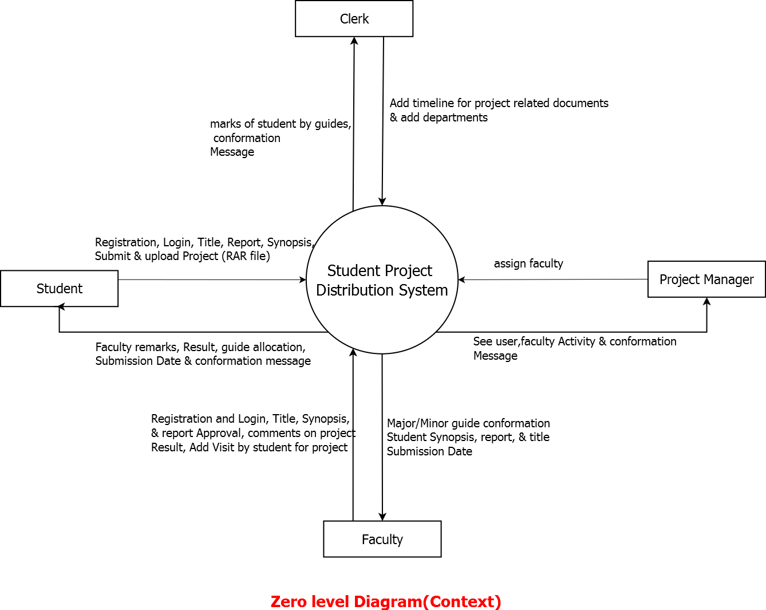

### Level-1 Data Flow Diagram

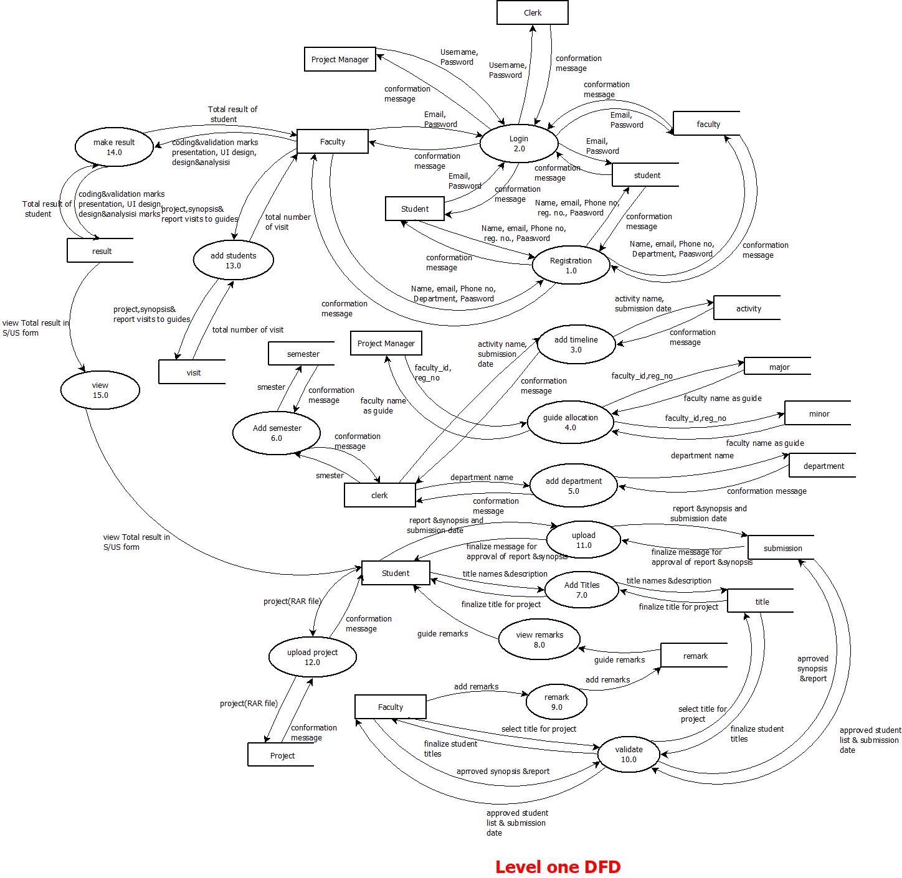

## Entity Relationship Diagram

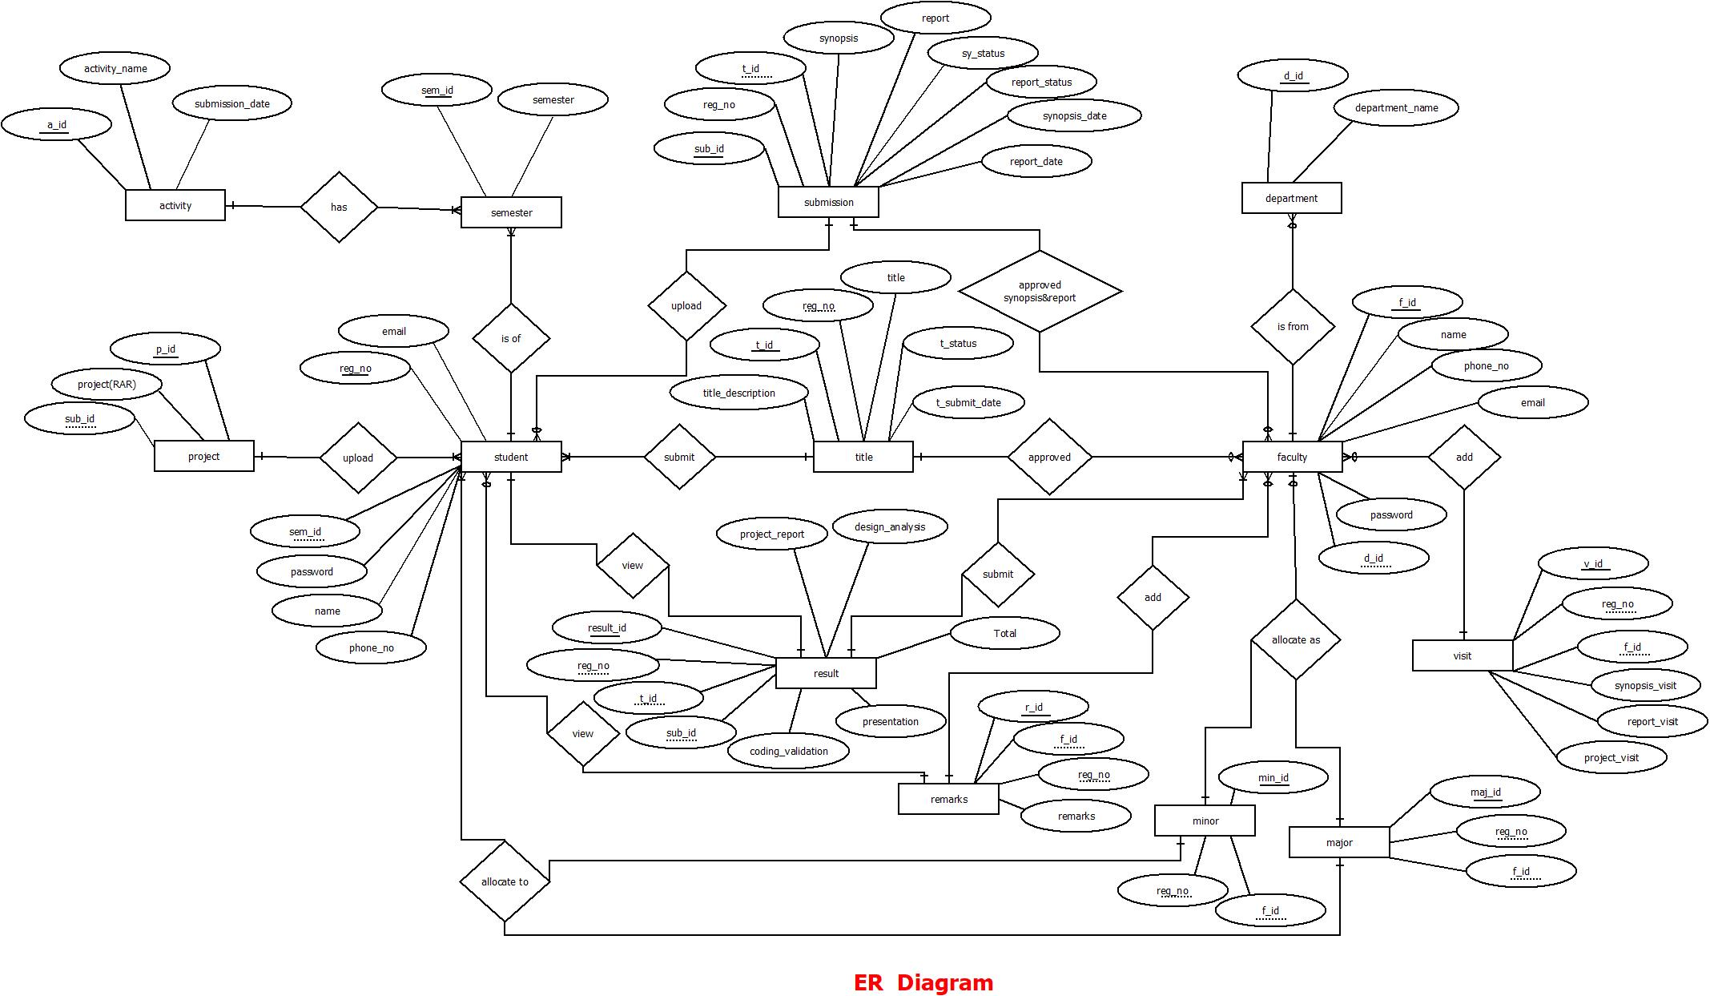

## Database Diagram

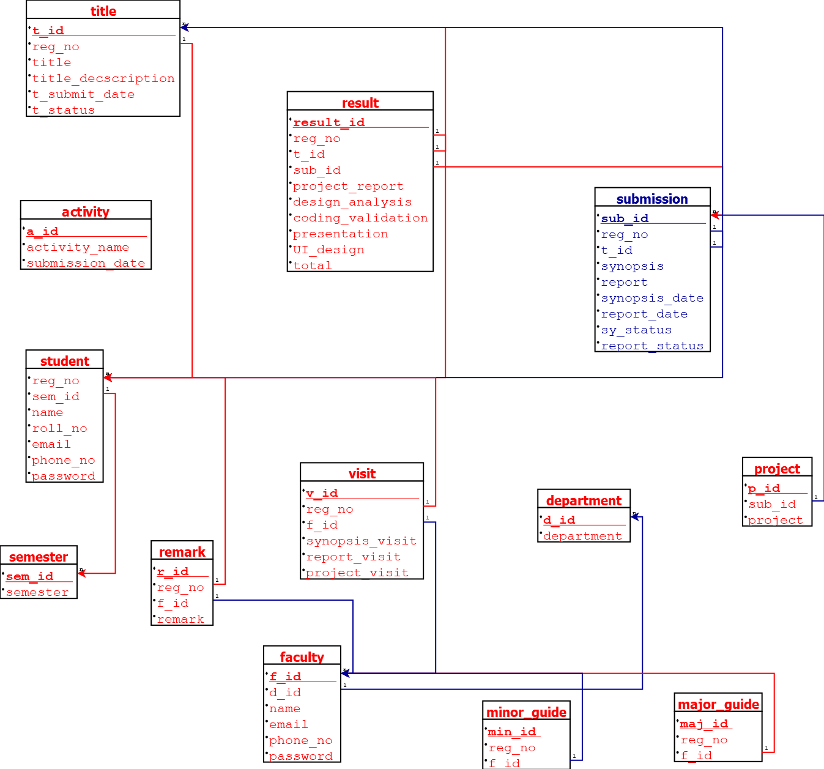

# Data Dictionaries

## Semester:

Description: Clerk has add semester who performed project.

|  |  |  |  |  |  |
| --- | --- | --- | --- | --- | --- |
| Sr. no. | Field | Data Type | Size | Constraint | Description |
| 1 | sem_id | int | 11 | PK | Semester id |
| 2 | semester | int | 5 | Not NULL | Semester Number |

## Student:

Description: Student registered with their semester. And then using this email and password logged in this web application.

|  |  |  |  |  |  |
| --- | --- | --- | --- | --- | --- |
| Sr. no. | Field | Data Type | Size | Constraint | Description |
| 1 | reg_no | varchar | 20 | PK | Registration No. of student |
| 2 | sem_id | int | 11 | FK | It is from semester table |
| 3 | name | varchar | 30 | Not NULL | Name of the  student |
| 4 | roll_no | int | 3 | Not NULL | Roll number of student |
| 5 | email | varchar | 50 | Not NULL | Email address of  the student |
| 6 | phone_no | varchar | 15 | Not NULL | Mobile No. of the student |
| 7 | password | varchar | 50 | Not NULL | Password of  student for the  system |

## Department:

Description: Clerk has add department which have project.

|  |  |  |  |  |  |
| --- | --- | --- | --- | --- | --- |
| Sr. no. | Field | Data Type | Size | Constraint | Description |
| 1 | d_id | int | 11 | PK | Department id |
| 2 | department | varchar | 50 | Not NULL | Name of the department |

## Activity:

Description: Clerk has add submission dates for project relate documents.

|  |  |  |  |  |  |
| --- | --- | --- | --- | --- | --- |
| Sr. no. | Field | Data Type | Size | Constraint | Description |
| 1 | a_id | int | 11 | PK | Id of the activity |
| 2 | activity_name | varchar | 50 | Not NULL | Name of the Activity in project |
| 3 | submission_date | date |  | Not NULL | Date of submit that activity |

## Faculty:

Description: Faculty registered with their department. And then using this email and password logged in this web application.

|  |  |  |  |  |  |
| --- | --- | --- | --- | --- | --- |
| Sr. no. | Field | Data Type | Size | Constraint | Description |
| 1 | f_id | int | 11 | PK | Id of the Faculty |
| 2 | d_id | Int | 11 | FK | Department id |
| 3 | name | varchar | 30 | Not NULL | Name of the Faculty |
| 4 | email | varchar | 50 | Not NULL | Email address of the faculty |
| 5 | phone_no | varchar | 15 | Not NULL | Mobile No. of the  faculty |
| 6 | password | varchar | 50 | Not NULL | Password of faculty for the system |

## MajorGuide:

Description: Project manager assign faculty to students as major guides for project.

|  |  |  |  |  |  |
| --- | --- | --- | --- | --- | --- |
| Sr. no. | Field | Data Type | Size | Constraint | Description |
| 1 | maj_id | int | 11 | PK | Id of the major guide |
| 2 | reg_no | varchar | 20 | FK | Registration No. of student it is from student table |
| 3 | f_id | int | 11 | FK | Id of the Faculty it is from faculty table |

## MinorGuide:

Description: Project manager assign faculty to students as minor guides for project.

|  |  |  |  |  |  |
| --- | --- | --- | --- | --- | --- |
| Sr. no. | Field | Data Type | Size | Constraint | Description |
| 1 | min_id | int | 11 | PK | Id of the minor guide |
| 2 | reg_no | varchar | 20 | FK | Registration No. of student it is from student table |
| 3 | f_id | int | 11 | FK | Id of the Faculty it is from faculty table |

## Title:

Description: Student submit their title to its guide.

|  |  |  |  |  |  |
| --- | --- | --- | --- | --- | --- |
| Sr. no. | Field | Data Type | Size | Constraint | Description |
| 1 | t_id | int | 11 | PK | Id of the Titles |
| 2 | reg_no | varchar | 20 | FK | Registration No. of student it is from student table |
| 3 | title | varchar | 100 | Not NULL | Name of the Title for project |
| 4 | title_decscription | varchar | 300 | Not NULL | Whole Description of the title |
| 5 | t_submit_date | date | - | Not NULL | That date when title is finalized |
| 6 | t_status | int | 1 | Default value is 0 | Flag for title status |

## Remark:

Description: Remarks or comments of faculty is stored in this table.

## 

|  |  |  |  |  |  |
| --- | --- | --- | --- | --- | --- |
| Sr. no. | Field | Data Type | Size | Constraint | Description |
| 1 | r_id | int | 11 | PK | Id of the Faculty |
| 2 | reg_no | varchar | 20 | FK | Registration No. of student it is from student table |
| 3 | f_id | int | 11 | FK | Id of the Faculty it is from faculty table |
| 4 | remark | varchar | 200 | Not NULL | Remark from the guides for the project |

## Submission:

Description: Student submit their report and synopsis in this table. Conformed by its guide.

|  |  |  |  |  |  |
| --- | --- | --- | --- | --- | --- |
| Sr. no. | Field | Data Type | Size | Constraint | Description |
| 1 | sub_id | int | 11 | PK | Id of the  submission |
| 2 | reg_no | varchar | 20 | FK | Registration No. of student it is from student table |
| 3 | t_id | int | 11 | FK | Id of the Titles it is from title table |
| 4 | synopsis | varchar | 50 | Not NULL | Path of Synopsis |
| 5 | report | varchar | 50 | Not NULL | Path of Report |
| 6 | synopsis_date | date | - | Not NULL | That date when synopsis is submitted |
| 7 | report_date | date | - | Not NULL | That date when report is submitted |
| 8 | sy_status | int | 1 | Default value is 0 | Flag for synopsis status |
| 9 | report_status | int | 1 | Default value is 0 | Flag for report status |

## Project:

Description: Student uploads their final project in this table for history

|  |  |  |  |  |  |
| --- | --- | --- | --- | --- | --- |
| Sr. no. | Field | Data Type | Size | Constraint | Description |
| 1 | p_id | int | 11 | PK | Id of the project |
| 2 | sub_id | int | 11 | FK | Id of the  submission |
| 3 | project | varchar | 50 | FK | Path of the project |

## Visit:

Description: Student visit to guides that added by guides in this table.

|  |  |  |  |  |  |
| --- | --- | --- | --- | --- | --- |
| Sr. no. | Field | Data Type | Size | Constraint | Description |
| 1 | v_id | int | 11 | PK | Id of the visit of the  student |
| 2 | reg_no | varchar | 20 | FK | Registration No. of student it is from student table |
| 3 | f_id | int | 11 | FK | Id of the Faculty it is from faculty table |
| 4 | synopsis_visit | int | 2 | Not NULL | Visit by the student  To guide for synopsis |
| 5 | report_visit | int | 2 | Not NULL | Visit by the student  To guide for report |
| 6 | project_visit | int | 2 | Not NULL | Visit by the student  To guide for project |

## Result:

Description: Faculty add marks as per this table fields. And the total of that marks is getting by student.

|  |  |  |  |  |  |
| --- | --- | --- | --- | --- | --- |
| Sr. no. | Field | Data Type | Size | Constraint | Description |
| 1 | result_id | int | 11 | PK | Id of the result of student |
| 2 | reg_no | varchar | 20 | FK | Registration No. of student it is from student table |
| 3 | t_id | int | 11 | FK | Id of the Titles it is from title table |
| 4 | sub_id | int | 11 | FK | Id of the submission  It is from submission table |
| 5 | project_report | int | 2 | Not NULL | Mark of the student for report in project |
| 6 | design_analysis | int | 2 | Not NULL | Mark of the student for design and analysis in project |
| 7 | coding_validation | int | 2 | Not NULL | Mark of the student for coding and validation in project |
| 8 | presentation | int | 2 | Not NULL | Mark of the student for presentation skill in project |
| 9 | UI_design | int | 2 | Not NULL | Mark of the student for User Interface design in project |
| 10 | total | int | 3 | Not NULL | Total of this five skill marks |

# References:

* https://1000projects.org/online-project-management-system-educational- institutes.html
* https://en.wikipedia.org/wiki/MySQL
* https://en.wikipedia.org/wiki/XAMPP
* https://en.wikipedia.org/wiki/Sublime_Text
* https://www.w3schools.com/php/
* College of AIT, AAU, Anand System for Project.