–––
College of
Agricultural Information Technology

AAU, Anand.



Seminar Report
On

Advance Methods for Weed Control

Submitted By : Guided By:
Name: Bhavyakumar Chaudhary Dr. D.R. Kathiriya
Reg.no:06-0202-2016 __________________

Contents
1) Introduction: 3
2) What is Weed Control? 3
3) What is Weed Management? 4
4) Characteristics of Weeds 4
5) Harm full Effects of weeds 4
6) Principles of weed Management 4
7) Methods For Weed Control 5
7.1) Preventative Weed Control 5
7.2) Cultural Weed Control 6
7.3) Mechanical Weed Control 10
7.4) Biological Weed Control 12
7.5) Chemical Weed Control 14
8) Uses of Information Technology In Weed Control: 17
9) Robot for Weed control 20
10) Conclusion 21
11) References 21

- Introduction:

- Weeds are unwanted and undesirable plants which interfere with the utilization of land and water resources and thus adversely affect human welfare. They can also be referred as plants out of place.
- Weeds compete with the beneficial and desired vegetation in crop lands, forests, aquatic systems etc. and poses great problem in non-cropped areas like industrial sites, road/rail lines, air fields, landscape plantings, water tanks and water ways etc.,
- Weeds are an important factor in the management of all land and water resources, but its effect is greatest on agriculture. The losses caused by weeds exceed the losses caused by any other category of agricultural pests. Of the total annual loss in agriculture produce, weeds account for 45%, insect 30%, disease 20% and other pests 5%.

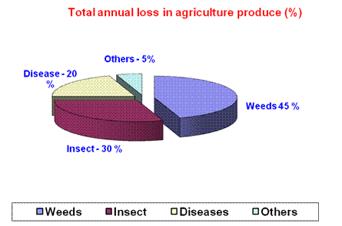
- What is Weed Control?

- Weed control is the process of limiting infestation of the weed plant so that crops can be grown profitably.

- What is Weed Management?

- Weed management includes prevention, eradication and control by regulated use, restricting invasion, suppression of growth, prevention of seed production and complete destruction.
- Characteristics of Weeds

- Weed species are more competitive than the cultivated crops.
- They are capable of thriving under stress condition.
- They produce enormous seeds in flushes.
- All seeds of weed mature simultaneously, earlier than the crop seed.
- The Weed seeds are easily germinated; they undergo pollination very easily.
- Weed seed remain dormant and viable for many years.
- They spread vegetatively and able to regenerate lost part.
- Harm full Effects of weeds

- Weeds compete with crop for space, light, moisture, nutrients and carbon dioxide. Thus, they reduce the yield and quality of the crop.
- Weed interfere with agricultural operations. Sowing with seed drill is not possible if the weed infestation is high.
- Affect quality of farm produce and livestock product such as milk.
- Weeds harbor pests and diseases, which attack the crops.
- Weeds may produce chemicals that harm the crop.
- Cause health problems to human beings e.g. parthenium causes allergy. Some weeds are poisonous to people and/or animals.
- Increase cost of cultivation due to weeding problem.
- Reduce the land value (if weeds like Cynodon, parthenium, Kans, etc. is present in the field).
- They may pose a fire hazard when dry.

- Principles of weed Management
- Correct identification of the weed species present is the first step, before appropriate control methods could be selected. Annual weeds may be destructed before flowering by any of the following techniques e.g. stale seedbed or using pre or post emergence selective herbicides. Biannual weeds may be destroyed by digging, flooding or by translocated herbicides. Perennial weeds are reduce by destruction of aerial shoots through digging, flooding or by application of translocated herbicides or adopting fallowing.
- Timeliness of weeding: One year seeding causes ten years weeding. Timing of weeding is as important as the actual weeding itself. There is a critical period for weed control during the life cycle of a crop. Weed control in the early stages of crop growth is usually more important than weed control in late stages of crop growth. For example, the critical period for controlling weeds in maize is during the first six weeks after planting, when maize is becoming established and its canopy has not yet fully developed. This means maize should remain weed-free from the 3-leaf stage to the 14-leaf stage. To avert significant yield loss, maize should be weeded twice during the season in low rainfall areas. In high rainfall areas, it should be weeded three times during the season.
- Methods For Weed Control
- Preventative Weed Control
- Cultural Weed Control
- Mechanical Weed Control
- Biological Weed Control
- Chemical Weed Control

  - Preventative Weed Control
- Preventative weed control refers to any control method that aims to prevent weeds from being established in a cultivated crop, a pasture, or a greenhouse.
- Examples of preventative weed control would be using certified weed free seed, only transporting hay that is weed free, making sure farm equipment is cleaned before moving from one location to another, and screening irrigation water to prevent weed seeds from traveling along irrigation ditches.
  - Cultural Weed Control
- Cultural weed control refers to any technique that involves maintaining field conditions such that weeds are less likely to become established and/or increase in number.
- Examples of cultural weed control would be crop rotation, avoiding overgrazing of pastures or rangeland, using welladapted competitive forage species, and maintaining good soil fertility.
- It Includes the following method:

- Crop rotation
- Crop rotation involves alternating different crops in a systematic sequence on the same land. It is an important strategy for developing a sound long term weed control program.
- Weeds tend to thrive with crops of similar growth requirements as their own and cultural practices designed to contribute to the crop may also benefit the growth and development of weeds.
- Monoculture, that is growing the same crop in the same field year after year, results in a build-up of weed species that are adapted to the growing conditions of the crop.
- When diverse crops are used in a rotation, weed germination and growth cycles are disrupted by variations in cultural practices associated with each crop (tillage, planting dates, crop competition, etc.).
- Within a rotation, crop choice will determine both the current and the potential future weed problems that a grower will face. Traditionally, potato (Solanum tuberosum L.) Was included in the rotation to reduce weed problems before a less competitive crop was grown.
- For an organic grower, crop choice is complicated further by the need to consider soil fertility levels within the cropping sequence and to include fertility building periods in the rotation. Variations in crop and weed responses to soil nutrient levels can also play an important part in weed management.
- The inclusion of a fallow period in the rotation in known to reduce perennial weeds. It is best to alternate legumes with grasses, spring planted crops with fall planted crops, row crops with close planted crops and heavy feeders with light feeders.
- Cover crops
- Rapid development and dense ground covering by the crop will suppress weeds. The inclusion of cover crops such as rye, red, clover, buckwheat and oilseed radish or over wintering crops like winter wheat or forages in the cropping system can suppress weed growth.
- Highly competitive crops may be grown as short duration 'smother' crops within the rotation. Additionally, cover crop residues on the soil surface will suppress weeds by shading and cooling the soil.
- When choosing a cover crop, consideration should always be given to how the cover crop will affect the succeeding crop. In addition, decomposing cover crop residues may release allele chemicals that inhibit the germination and development of weed seeds.

- Mulching
- Mulching or covering the soil surface can prevent weed seed germination by blocking light transmission preventing seed germination.
- Allelopathic chemicals in the mulch also can physically suppress seedling emergence. There are many forms of mulches available. Listed are three common ones.

- Living mulch
- Living mulch is usually a plant species that grows densely and low to the ground such as clover. Living mulches can be planted before or after a crop is established. It is important to kill ad till in, or manage living mulch so that it does not compete with the actual crop.
- A living mulch of Portulaca oleracea from broadcast before transplanting broccoli suppressed weeds without affecting crop yield. Often, the primary purpose of living mulch is to improve soil structure, aid fertility or reduce pest problems and weed suppression may be merely an added benefit.
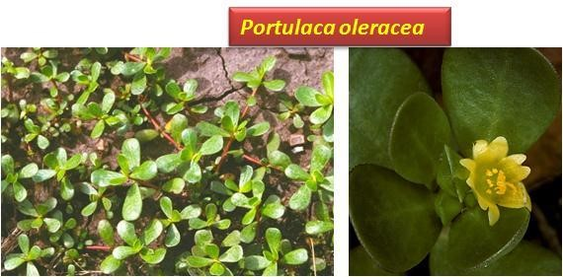

- Organic mulches
- Such materials as straw, bark, and composted material can provide effective weed control. Producing the material on the farm is recommended since the cost of purchased mulches can be prohibitive, depending on the amount needed to suppress weed emergence.
- An effective but labor-intensive system uses newspaper and straw. Two layers of newspaper are placed on the ground, followed by a layer of hay. It is important to make sure the hay does not contain any weeds seeds. Organic mulches have the advantage of being biodegradable. Cut rye grass mulch spread between planted rows of tomatoes and peppers was more economic than cultivation.
- Fresh bark of conifers and oak as well as rapeseed straw gave good control of weeds when they were laid as mulches under the trees in apples orchards. Materials such as black polyethylene have been used for weed control in a range of crops in organic production systems.
- Plastic mulches have been developed that filter out photosynthetically active radiation, but let through infrared light to warm the soil. These infrared transmitting mulches have been shown to be effective at controlling weeds.

- Planting patterns
- Crop population, spatial arrangement, and the choice of cultivar (variety) can affect weed growth.
- For example, studies have shown that narrow row widths and a higher seeding density will reduce the biomass of later emerging weeds by reducing the amount of light available for weeds located below the crop canopy. Similarly, fast growing cultivars can have a competitive edge over the weeds.

- Tillage system
- Tillage systems alter the soil seed bank dynamics and depth of burial of weed seeds. Studies have found that almost 75% of the seedbank was concentrated in the upper 5 cm of soil in notill fields. In the moldboard plough system however, the seedbank is more uniformly distributed over depth. Other conservation tillage systems are intermediate to these two systems.
- Weed seedling emergence is often more uniform shallow buried weed seeds and may result in better weed control. Weed seeds closer to the soil are more likely to be eaten or damaged by insects, animals, other predators and disease causing organisms.

- Sanitation
- It is possible to prevent many new weeds from being introduced onto the farm and to prevent existing weeds from producing large quantities of seed. The use of clean seed, mowing weeds around the edges of fields or after harvest to prevent weeds from going to seed, and thoroughly composting manure before application can greatly reduce the introduction of weed seeds and difficult weed species.
- It is even possible to selectively hand-eradicate isolated outbreaks of new weeds, effectively avoiding future infestations. Planting clean, high-quality seed is essential to crop success. Other sanitation factors to consider would include thorough cleaning of any machinery which might have been used in weedy fields, and the establishment of hedgerows to limit windblown seeds.

  - Mechanical Weed Control

- Mechanical removal of weeds is both time consuming and labour-intensive but is the most effective method for managing weeds. The choice of implementation, timing, and frequency will depend on the structure and form of the crop and the type and number of weeds. Cultivation involves killing emerging weeds or burying freshly shed weed seeds below the depth from which they germinate.
- It is important to remember that any ecological approach to weed management begins and ends in the soil seed bank. The soil seedbank is the reserve of weed seeds present in the soil. Observing the composition of the seedbank can help a farmer make practical weed management decisions. Burial to 1 cm depth and cutting at the soil surface are the most effective ways to control weed seedlings mechanically.
- Mechanical weeders include cultivating tools such as hoes, harrows, tines and brush weeders, cutting tools like mowers and stimmers, and dual-purpose implements like thistle-bars. The choice of implement and the timing and frequency of its use depends on the morphology of the crop and the weeds.
- Implements such as fixed harrows are more suitable for arable crops, whereas inter-row brush weeders are considered to be more effective for horticultural use. The brush weeder is mainly used for vegetables such as carrots, beetroot, onions, garlic, cerely and leeks. The optimum timing for mechanical weed control is influenced by the competitive ability of the crop and the growth stage of the weeds.
- Hand hoes, push hoes and hand-weeding are still used when rouging of an individual plant or patch of weed is the most effective way of preventing the weed from spreading. Hand weeding may also be used after mechanical inter-row weeding to deal with weeds left in the crop row.
- Blind, 'over-the top' cultivation controls very small weeds, just germinated or emerged, before and sometimes after planting. The entire surface of the fields is worked very shallow using flex-time cultivators (e.g. Lely weeder or rotary hoes, Interrow cultivations with a rotary hoe in pinto beans (Phaseolus vulgaris L.) gave adequate weed control without reducing plant stand or injuring the crop.
- The hoe-ridger is specifically designed to achieve intra-row control in sugar beet, Thistle-bars are simple blades used to undercut perennial weeds with minimal soil disturbance. The brush weeder, or brush hoe, is used primarily for inter-row weeding of vegetable crop.
- Shallow between-row cultivators such as basket-weeders, beet-hoes, or small sharp sweeps are used to cut off and upper small weeds after the crop is up. These can get very close to the crop when it's small, without moving much soil into the row, and may be the only tools used on delicate crops like leafy greens, As vigorous crops grown, soil can be thrown into the row to bury in – row weeds using rolling cultivates (e.g. Lilliston), spyder wheels (e.g. Bezzerides), large sweeps or hilling disks.

  - Biological Weed Control

- Allelopathy
- Allelopathy is the direct or indirect chemical effect of one plant on the germination, growth or development of neighboring plants. It is now commonly regarded as component of biological control. Species of both crops and weeds exhibit this ability. Allelopathic crops include barley, rye, annual ryegrass, buckwheat, oats, sorghum, Sudan sorghum hybrids, alfalfa, wheat, red clover, and sunflower. Vegetables, such as horseradish, carrot and radish, release particularly powerful allelopathic chemicals from their roots. Suggestions have been made that allelochemicals and other natural products or their derivatives could form the basis of bioherbicides. However, it is unclear whether the application of natural weed killing chemicals would be acceptable to the organic standard authorities.
- The allelopathic effect can be used to an advantage when oats are sown with a new planting of alfalfa. Allopathy from both the alfalfa and the oats will prevent the planting from being choked with weeds in the first year. Buckwheat is also well known for its particularly strong weed suppressive ability. Planting buckwheat on weed problem, fields can be an effective cleanup technique. Some farmers allow the buckwheat to grow for only about six week before plowing under. This not only suppress and physically destroys, weeds; it also release phosphorus and conditions the soil.

- Beneficial organisms
- Little research has been conducted on using predatory r parasitic microorganisms or insects to manage weed populations. However, this may prove to be a useful management tool in the future. Natural enemies that have so far been successful include a weevil for the aquatic weed salvinia, a rust for skeleton weed and probably the most famous, a caterpillar (Cactoblastis sp.) to control prickly pear. There is also considerable research effort aimed at genetically engineering fungi (myco-herbicides) and bacteria so that they are more effective at controlling specific weeds. Mycoherbicides are a preparation containing pathogenic spores applied as a spray with standard herbicide application equipment.
- Weeds are subject to disease and insect attacks just as crop are. Most biological control of weeds occurs in range or non-crop areas. As a result, biological control has little relevance for vegetable growers. Geese have been used for weed control in trees, vine, and certain row crops. Most types of geese will graze weeds, but Chinese weeder geese are considered the best for row crops.
- Chinest weeder geese are smaller than other types and tend to walk around delicate crop plants rather than over them.
- Geese prefer grass species and rarely eat crops. If confined, geese will even dig up and eat Johnson grass and Bermuda grass rhizomes. Care must be taken to avoid placing geese near any grass crops such as corn, sorghum, or small grains, as this is their preferred food. Fruiting vegetables, such as tomatoes when they begin to colour, might also be vulnerable, so geese would have to be removed from tomato fields at certain times. Geese require drinking water, shade during hot weather, and protection from dogs and other predators.

- Use of biocontrol agents for weed control

Name of the weed | Bioagent
Cyperus rotundus | Bactra verutana
Ludwigia parviflora | Haltica cynea (Steel blue beetle)
Parthenism hysterophorus | Zygrogramma bicolarata
Lantana camara | Crocidosema lantana, Teleonnemia scrupulosa
Opuntia dilleni | Dactylopius tomentosus, D. Indicus (cochineal scale insect)
Eichhornea crassipes | Neochetina eichhornea, N. Bruchi (Hyachinth weevil) Sameodes alliguttalis (hyancinth moth)
Salvinia molesta | Crytobagus singularis (weevil) Paulinia acuminate (grass hopper), Samea mutiplicalis
Alternanthera philoxaroides | Agasides hygrophilla (flea beetle) Amynothrips andersoni
Tribulus terrestris | Microlarinus lypriformis, M. lareynii
Solanum elaegnifolium | Frumenta nephalomicta

  - Chemical Weed Control
- Chemical weed control refers to any technique that involves the application of a chemical (herbicide) to weeds or soil to control the germination or growth of the weed species. In economic terms, chemical control of weeds is a very large industry and there are scores of examples of chemical weed control products.
- Common examples of chemicals used to control weeds in forages are 2, 4-DB; EPTC; bromoxynil; and paraquat.

- Soil application
➢ Soil surface application:
- Herbicides are usually applied to soil surface to form a uniform herbicide layer. The applied herbicides, due to their low solubility may penetrate only few centimeters into the soil. Weeds germinating in the top layers are killed due to incidental absorption of herbicides.
- Eg. Triazines, ureas and anilide.

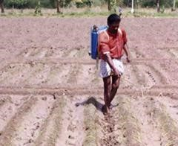

- Soil incorporation:
- Some herbicides are applied to soil surface and incorporated into the soil either by tillage or irrigation for their effectiveness.
- Eg. volatile herbicides viz., aniline and carbamate
- Sub-surface application:

- Perennial weeds like Cyperus rotundus and Cynodon dactylon are controlled by injecting herbicides to the lower layers of the soil at several points.

- Band application:

- Herbicides are applied as narrow bands over or along the crop row. The weeds in between the crop rows can be controlled by intercultivation or band application of herbicide. This method is useful where labour is expensive and intercultivation is possible.
- Eg. Weeds in maize can be controlled effectively by spraying atrazine on seed row at the time of sowing.

- Foliar Application
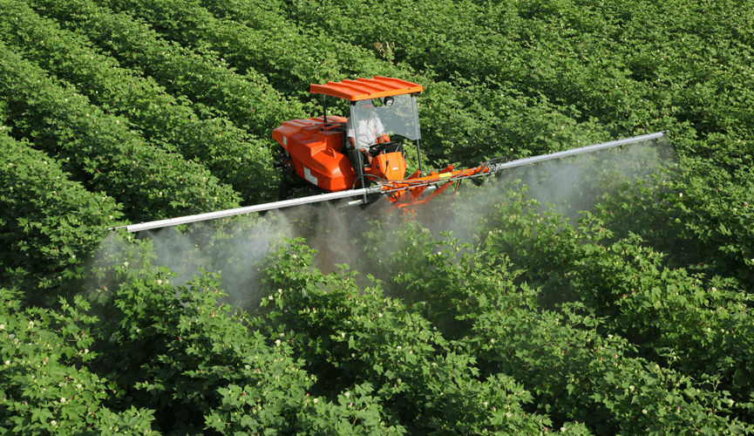

- Herbicide are applied directly to weeds between crop rows, avoiding the crop foliage. Care is taken to avoid spray fluid falling on the crop.
- Eg. Late weeds in cotton can be controlled by spraying non selective herbicide by directed spray.

- Advantages and disadvantages of weed management tools

Tool | Advantages | Disadvantages
Cultivation/ hoeing | - effective, especially on small weeds  - non-selective - controls all emerged growth  - equipment readily available | - may damage soil structure  - may spread perennial weeds  - may damage trees/roots - provides only short-term control
Mulching | - effective if properly managed - non-selective - suppresses all emerging weeds  - holds soil moisture as well  - provides long-term control | - availability of mulch  - cost of mulch/application  - attractive to rodents  - may affect tree nutrition  - must be free of weed seeds
Mowing | - rescue treatment  - quick suppression  - equipment available  - reduce seed spread | - weeds may still compete  - quick regrowth  - several movings required  - may damage young trees
Herbicides | - effective | - require 2% soil organic matter
 | - easy to apply  - can be selective  - timely | - directed spray equipment  - effects on pest complex  - cost varies

  - Advantages and disadvantages of herbicide control categories

Category | Advantages | Disadvantages
Burndown | - controls all emerged  weeds - inexpensive  - widely available - can target critical weedfree period | - may damage trees if absorbed  (systemic)  - early weeds compete with trees  - perennial weeds are not killed - new seedlings germinate after application
Soil residual | - reliable control - effective for longer periods  - can target critical weedfree period - cost effective  - broad spectrum  - longer window to apply | - may cause tree injury  - not safe on low organic matter soil  - may have tree-age restriction - may leave residues after orchard  removal  - may require incorporation  - applied before weed problems
are known
- may affect soil biology
Selective | - can target critical weedfree period  - targets specific weeds  - minimizes herbicide use  - generally safe for trees | - does not control a broad spectrum of weeds  - often an extra application  - additional expense  - timing is critical

- Uses of Information Technology In Weed Control:

- The applicability of remote sensing for determining the spatial distribution of weeds within arable fields has been examined for satellite airborne and field scanner systems.
- For the remote sensing technology to be successful in the detection and subsequent mapping of weeds, two requirements:
- There are suitable differences in spectral reflectance or texture between weeds and their background soil or plant canopy.
- The remote sensing instruments have appropriate spatial and spectral resolution to detect the presence of weed plants.
- For the information about weed detection and extent to be delivered to farmers, the option of following such a requirement is overpowered by time constraints and the cost of acquiring such high spatial resolution Imagery. In order for the farmer to make appropriate management decisions, weed detection and extent must be mapped prior to the time when the weeds will hinder the crop’s growth, so that a suitable eradication process can take place.

- Timing of Data Collection
- Early season. It is difficult to use remote sensing to determine weeds early in the season when they are small because soil dominates the reflectance characteristics of most pixels. As the season progresses, weedy areas can be identified (Figurer.1). Weeds could be detected between 20% canopy cover through 85% canopy cover. After full canopy cover, weedy areas could not be clearly distinguished in the images.

a.  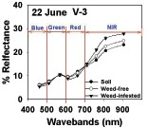 | b.  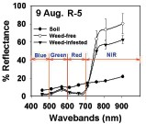
c.  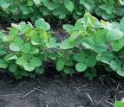 | d.  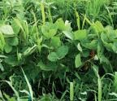

Fig.1
- The charts (a&b) show present reflectance from weed-free and weedy areas in a field. The pictures show (c) a weed-free area where were Plant at V4 and canopy cover was about 30%, and (d) a weed-infested area in the field.
- Plant canopy cover was about 30% and total canopy cover was close to 90%. The difference in reflectance shown in (a) and (b) between weedfree and weed infested areas was due to more green vegetation covering the soil.

High-resolution weed infested area  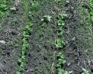 | High-resolution weed-free area  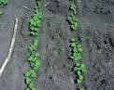
Low-resolution weed-infested area   | Low-resolution weed-free area  

Fig.2
- A comparison between weed-infested and weed-free areas in a field using high and low resolution images. The high resolution images (a) provide images that are seen with our eyes.
- The gray images (b) show how these areas may appear when taken with a low-resolution remote sensor.

- The higher reflectance values from weed-infested areas are due to the higher canopy cover in weed-infested areas, with plants growing both within and between rows (Figure 2). Reflectance values from weed-free areas, where plants were still relatively small, were low and very similar to bare soil until the plant canopy dominated the pixel.
- The timeframe of midJune through July for collecting remote sensing imagery is practical because corrective treatments can be applied in a timely manner before the crop gets too tall. One problem with this timeframe is cloud cover. Remote sensing cannot be obtained when the sky is cloudy. Satellites may pass over your area at best once or twice a week, or as infrequently as once every 2 weeks. Therefore, finding a sunny day to collect the imagery is sometimes a challenge. If you intend to use satellite imagery during this time, a back-up plan of using remote sensing collected by an airplane may be needed. Scheduling an airplane to collect imagery is more flexible, making it easier to take the picture when the sun is shining.
- Other factors to consider when using remote sensing to scout for weeds include (1) cloud cover and (2) importance of ground-truthing the image. Satellite imagery cannot be collected under cloud cover. Also, when an anomalous area in an image suggests weeds are present, the area must be checked to confirm that the area actually contains weeds.
- Robot for Weed control

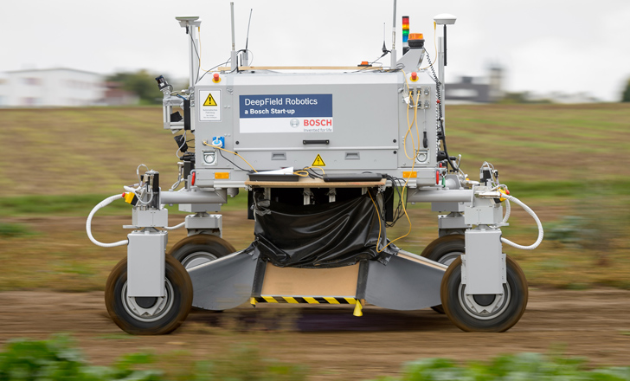
- Given the scale of farming today, treating weeds chemically is really the only practical way for humans to keep them under control, because you can use tractors or airplanes to cover large areas in a short amount of time. But all of those necessarily deadly (to weeds) chemicals then get on the plants we don’t want to kill (because we want to eat them), as well as getting washed into the soil. The most organic and eco-friendly way of dealing with weeds is the old-fashioned way: physically removing them. “Physical removal” can mean pulling weeds out completely, but that involves both grasping the weed and doing something with it.
- The stamping tool is 1-centimeter-wide, and it drives weeds about 3 cm into the soil. It’s designed to detect (through leaf shape) and destroy small weeds that have just sprouted, although for larger weeds, it can hammer them multiple times in a row with a cycle time of under 100 ms. Testing on a real carrot crop, which has carrots spaced about 2 cm apart and an average of 20 weeds per meter growing very close to the carrots themselves, the robot had no trouble at all. The maximum capability of the system is about 1.75 weeds per second at a speed of 3.7 cm/s and a weed density of 43 weeds per meter, but at lower weed densities, the speed can be cranked up to 9 cm/s.
- Conclusion

- The convenience of using one method instead of another depends on local attitudes and constraints such as availability of money and labour, access to technical means (e.g. seeds, fertilizers, herbicides), environmental, social and economic features that may limit the range of feasible agronomic choices (e.g. length of the growing season, rainfall and temperature patterns, soil mineralization rate, farm and market structure, cultural heritage, existence of advisory services, etc.).
- This obviously implies that farmers must be educated to acquire a higher level of knowledge and technical skills. Simple solutions, such as mono-cropping and reliance on herbicides as the only direct weed-control method may be successful in the short term, but are never rewarding in the long term.
- References

- http://eagri.org/eagri50/AGRO304/index.html
- http://www.omafra.gov.on.ca/english/crops/facts/weedman.html
- http://www.fs.fed.us/eng/rsac/invasivespecies/
- http://ageconsearch.umn.edu/bitstream/24341/1/cp03dr01.pdf
- Agronomy Basics and Applied- (Gajendra Singh tomar).

