Dr. Consultation

1. Bulk Slot Management
- Bulk Slot Creation: Doctors could create multiple slots for a given period in one action (e.g., for an entire week or month).
- Bulk Slot Editing: Allow bulk editing of multiple slots at once (changing slot durations, availability, or start times).
- Copy Schedule: Doctors might want to copy a previous week's or day's schedule to simplify management.

2. Recurring Slots
- Slot Recurrence: Instead of manually setting slots every week, allow doctors to set recurring slots (e.g., every Monday from 9 AM to 1 PM).
- Block Recurring Slots: Add the option to temporarily block recurring slots for vacations or other reasons without deleting them entirely.

3. Emergency or Priority Slots
- Priority Slots: Enable a doctor to designate some slots as "priority" for urgent cases or special appointments.
- Emergency Booking: Allow emergency slots that are not shown to regular patients but are open for special bookings (e.g., last-minute or priority appointments).

4. Slot Restrictions
- Patient Type Restriction: Doctors may want to create slots only available for specific types of patients (e.g., new patients, follow-up patients).
- Appointment Type Restriction: Some slots could be restricted to certain appointment types (e.g., consultations, check-ups, etc.).

5. Slot Customization for Special Days
- Holiday and Special Event Slots: For holidays or special events, doctors may have unique working hours. Allow doctors to customize slots specifically for these days.
- Exception Management: Create exceptions for specific dates (e.g., block out certain hours during an event or meeting).

6. Notifications and Reminders
- Slot Reminders: Notify doctors ahead of their slots or at the beginning of their day’s schedule.
- Rescheduling Notifications: Send notifications when patients cancel or reschedule appointments.
- Auto-Reminders: Remind doctors of upcoming slots and allow them to adjust the schedule quickly.

7. Reporting and Analytics
- Slot Utilization Report: Provide insights on how many slots are used versus those that go unfilled.
- Patient Attendance Analytics: Track patterns in patient attendance (e.g., no-show rates) to optimize the doctor’s schedule.

8. Slot Visibility Settings
- Hidden Slots: Create slots visible only to specific types of users (e.g., for internal staff or VIP patients).
- Temporary Unavailability: Let doctors temporarily hide certain slots (without deletion) in case of sudden schedule changes.

9. Handling Downtime or Breaks
- Doctor Breaks: Add functionality for doctors to insert breaks or buffer times between slots directly within their schedule.
- Overtime Handling: Allow doctors to extend their working hours for a given day if necessary.

10. Slot-based Pricing
- Variable Pricing: If the doctor provides different services at different times, you can allow them to set different pricing for specific slots (e.g., higher charges for late-night consultations).

11. Integration with Doctor’s Dashboard
- Slot Overview on Dashboard: Doctors can see a quick overview of their available and booked slots from their dashboard.
- Quick Slot Modifications: Allow doctors to quickly modify slots (duration, enable/disable, etc.) directly from their dashboard.

Application Overview

- Admin Panel
- Manage Doctors
- Manage Slots (Creation, Deletion, Duration, Availability)
- View Slot Reports and Analytics

- Doctor Dashboard
- View Slots
- Manage Slots (Enable/Disable, Recurring, Emergency, Breaks)
- Slot Customization (Duration, Priority, Visibility)
- Notifications & Reminders

- Patient Side
- Browse Doctors
- Select Available Slot
- Book Appointment
- Reschedule or Cancel Appointment

2. Admin Panel

- Manage Doctors
- Add/Remove Doctors
- Assign Default Slot Durations
- Set Weekly/Custom Schedule
- View Doctor Activity (Slots Utilized, Cancellations)

- Manage Slots
- Bulk Slot Creation
- Bulk Slot Deletion
- Recurring Slot Configuration
- Assign Default Time and Duration
- Block/Unblock Slots for Holidays or Special Events
- View Reports on Slot Utilization
- Timezone Management

- Reports & Analytics
- Slot Utilization Reports (Filled vs Unfilled)
- Doctor Performance Overview (Number of Booked Slots, No-shows)
- Patient Attendance Reports (No-show Rates, Reschedule Rates)
- Export Slot and Booking Data

3. Doctor Dashboard

- View Slot Schedule
- Daily/Weekly View
- View Available and Booked Slots

- Manage Slots
- Create/Edit Slots
- Enable/Disable Slots
- Slot Duration Settings (10, 15, 30 min, etc.)
- Customize Slots for Special Days or Events
- Set Slot Recurrence (Daily/Weekly)
- Set Breaks or Buffer Times between Slots
- Set Emergency or Priority Slots
- Assign Patient Type or Appointment Type to Slots
- Bulk Slot Management (Edit/Delete)

- Notifications & Reminders
- Get Reminders for Upcoming Slots
- Notifications for Reschedules or Cancellations
- Alerts for No-show Patients
- Ability to Reopen Canceled Slots

- Slot Analytics
- Number of Slots Utilized vs Canceled
- Patient Attendance Patterns
- Slot Overlap Detection (Conflicts in Schedule)

4. Patient Side

- Browse Doctors
- Filter Doctors by Specialty/Location/Availability
- View Doctor's Profile (Bio, Experience, Availability)

- Select Available Slot
- View Available Slots (Color-coded for Availability)
- See Slot Details (Duration, Type, Priority)
- Check Real-time Slot Availability

- Book Appointment
- Select Date and Time
- Provide Patient Details (Personal, Medical, Contact Info)
- Receive Confirmation Email/Whats-app
- View Booking in Patient Portal (if applicable)

- Reschedule or Cancel Appointment
- Option to Reschedule or Cancel from Patient Portal
- Receive Notification of Rescheduled Slots Availability

5. Workflow Overview

Admin Workflow

- Admin logs in to the admin panel.
- Admin adds doctors, assigns default slot durations, and schedules.
- Admin creates default weekly slots for doctors.
- Admin manages slots in bulk (creating, deleting, enabling, disabling).
- Admin views slot reports and analytics to monitor utilization and doctor performance.
- Admin exports slot and booking data if needed.

Doctor Workflow

- Doctor logs in to their dashboard.
- Doctor views the current schedule and available/blocked slots.
- Doctor creates or edits slots (sets duration, recurrence, or priority).
- Doctor enables/disables slots based on availability.
- Doctor sets special slots for emergency or VIP appointments.
- Doctor receives notifications about upcoming slots or cancellations.
- Doctor adjusts schedule (creates breaks, blocks off holidays, changes duration).
- Doctor views slot analytics to understand usage and no-show rates.

Patient Workflow

- Patient browses available doctors (filters by specialty, location, or availability).
- Patient selects a doctor and views available time slots.
- Patient books a slot and fills in personal and appointment details.
- Patient receives booking confirmation via email or Whats App.
- Patient can reschedule or cancel the appointment through the patient portal.
- If a patient cancels, the slot becomes available for other bookings.

6. Slot Life cycle

1. Slot Creation
- Admin/Doctor sets up slots with defined timings, duration, and recurrence.
- Slots are created for upcoming days/weeks based on default settings.

2. Slot Modification
- Doctors can enable, disable, or modify slot details (duration, visibility).

3. Slot Booking
- Patients select available slots and confirm the booking.
- Once booked, the slot is locked for that time.

4. Slot Cancellation/Rescheduling
- Patients can cancel or reschedule appointments, making the slot available again.
- Doctors can manually reopen slots marked for cancellation.

5. Slot Analytics & Reporting
- Admin and doctors receive detailed insights on slot utilization and patient attendance.

7. Possible Conditions Where Doctor Might Manipulate Slots
- Emergencies: Doctor needs to block off or hold certain slots temporarily.
- Break Time Adjustments: Adding or extending breaks between busy periods.
- Special Events: Adjusting the schedule around holidays, conferences, or personal leave.
- Overbooked Slots: Doctor needs to handle cancellations or reopen slots for last-minute bookings.
- No-shows: Adjust slots when patients fail to attend, making them available for others.

1.If the doctor wants to add holidays for this there will be a separate page named as “Manage Holidays”. In this page, doctor can select the dates on which he will not be present and when the doctor saves, these dates will be marked as holidays. And both user and doctor will get a message “Holiday on this date”.
2.After setting default slots, if doctor wants to update/add/remove slot for a particular date it can be done through Manage Slots page.

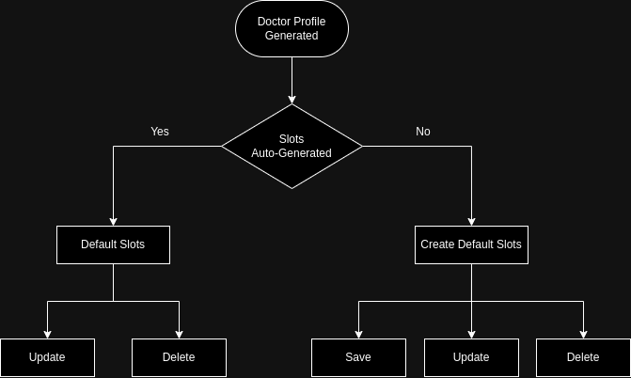
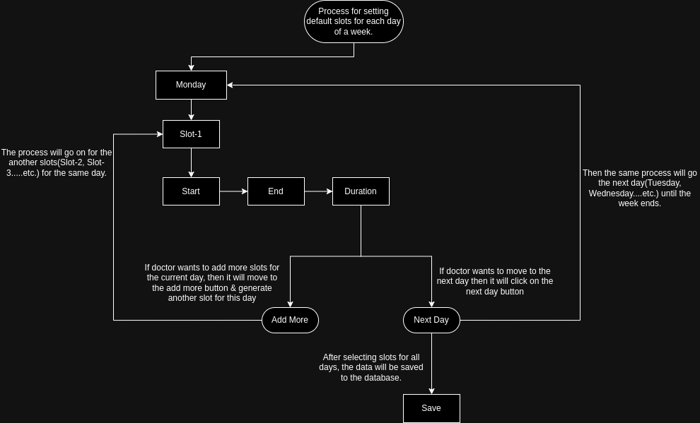
FLOW-DIAGRAM :-
