Proposal for Real Estate Application
Version- 1.0
18TH December 2024

The website we are scoping is aimed at a Real Estate Management System to facilitate the buying, selling, renting, and exploration of various property types, including houses, flats, villas, office spaces, and PG accommodations. The main objective of this system is to simplify the real estate process by providing users with an intuitive platform for property management and reducing the manual workload associated with traditional methods. The system will handle diverse functionalities such as property listings, advanced search and filtering, communication between parties, payment integration, and documentation management. It will also include features like agent and agency management, reviews and ratings, and an admin panel for centralized control. This software is designed to overcome inefficiencies like manual property handling and scattered communications, providing a seamless experience for buyers, sellers, agents, and landlords. The platform should work efficiently to support users in tasks such as booking property tours, managing agreements, and accessing secure transactions, all within a single, user-friendly application.

Prepared By:
Bhavya Lohami




Dear Project Owner,
We at LogicSpice, a service provider with a proven record of accomplishment in various web technologies and desktop utilities, would be keen to offer our services for your assignments. We have an excellent track record and vast experience in developing small to global conglomerate web applications, covering single-tier to n-tier networking environments on client-server architecture with state-of-the-art graphical interface.

About Us
Anchored by industry-experienced professionals, LogicSpice Consultancy is an IT solution provider and is engaged in application development and e-business solutions development, website development, Smart device application development, support and maintenance services. We are based at Jaipur, India.
The Proposed Project
The website we are scoping is aimed at a Real Estate Management System for managing property transactions, including buying, selling, renting, and exploring properties such as houses, flats, villas, office spaces, and PG accommodations. The main objective of this automated system is to simplify the complexities of the real estate process and reduce the manual workload for all stakeholders involved. The platform will efficiently handle property listings, advanced search and filtering, communication, payment processing, and document management. As a solution to the inefficiencies of traditional property handling and scattered communication, this software will centralize these processes into a seamless experience. The system will also provide essential features like agent and agency management, reviews and ratings, and a robust admin panel. With a centralized structure, the system administrator will manage all operations within a single, intuitive application, ensuring an efficient and hassle-free experience for users.

Objective
Our focus is to develop an application that evolves with user needs, enable fast deployment, and offer secure, automated payment transactions. The platform aims to provide an easy, user-friendly, and reliable way for buyers, sellers, and investors to search for, manage, and invest in properties. This website/app will empower property owners, agents, and landlords to showcase their listings effectively while allowing buyers and tenants to find their ideal properties conveniently. The platform will also encourage property investments by offering an intuitive and secure solution for transactions and negotiations.

Project Executive Summary
The motto of the proposed web solution is to provide an online platform for individuals and businesses to manage their real estate needs efficiently. The proposed system will allow property owners, agents, and landlords to centralize and manage their listings, communications, and transactions seamlessly. This system will help streamline processes such as property search, rent agreement management, and booking property tours. It will also enable tenants and buyers to easily browse properties, negotiate prices, and make secure payments. Notifications for key activities, such as new inquiries or booking confirmations, will ensure that all stakeholders stay informed. The system should be user-friendly, making it accessible to everyone, from first-time renters to seasoned real estate investors.

Executive Profile:
- With the growth of the internet, innovative platforms have emerged, enabling users and businesses to streamline operations and create new opportunities for income generation.
- The website will offer a perfect solution for real estate management, providing buyers, sellers, and agents with a centralized system to handle property listings, transactions, and communications efficiently.
- By integrating advanced features and tools, the platform will empower its users to adapt to the fast-paced demands of the real estate market while fostering trust and security in property transactions.
Company Profile
LogicSpice has been a reliable name in anything and everything that has something to do with the Internet industry and works closely with its clients. That’s how we know and understand their needs and wants. We have the perfect tools and the most creative team to implement your ideas and even give you a sight of some that have not crossed your mind yet. Simply put, we put the highest value to our clients. That’s why our movement is always geared towards client’s satisfaction. We never rest until we see wide smiles on our clients’ faces, signaling fulfillment in what we have done to their business.

These are the parameters that we follow:
Imagination: LogicSpice authored some of the brightest ideas ever known. Our minds are working 24/7 and are constantly embracing change as it unfolds.
Qualifications: Our bright e-marketing ideas are backed up by advanced technology. We are equipped not just with bright minds but the right tools as well.
Trustworthiness: We are staffed with competent professionals who certainly know what they are doing.
Compliance: LogicSpice never rests on its laurels.

Technical Solution Proposed
The web solution for a user-centric and user-oriented real estate platform will be a client-server application designed to provide seamless property transactions and management:
- One Central Repository Database: A unified database to store and manage all property listings, user profiles, transactions, communications, reviews, and analytics securely and efficiently.
- One Server Application with Four User Modes:
  - Admin Mode: Provides comprehensive control for managing platform operations, including user accounts, property listings, advertisements, payments, reviews, and analytics. Admins can approve or reject listings, oversee communication records, and manage promotional activities or advertisements on the platform.
  - Customer(Buyer/Tenant) Mode: Allows registered users to explore properties, save favorites, send inquiries, schedule property tours, negotiate with sellers or agents, and securely complete transactions for booking/renting. Buyers can also leave reviews and ratings for properties or agents.
  - Seller (Owner/Broker/Agent) Mode: Enables sellers, property owners, and brokers/agents to list properties for selling/renting with detailed information, manage their listings, respond to inquiries, negotiate with customers, and track transactions. Sellers and agents can also view analytics related to their listings and manage their profiles, including reviews and ratings.
  - Visitor Mode: Permits unregistered users to browse property listings, search using filters, view basic details of properties, and explore platform features without the ability to communicate, book, or transact until registered.
  - Sub-Admin Mode(Optional): Sub-admin will be able to access the admin panel on behalf of the main admin.
Design Specification
- The planned web solution would provide a modern, clean, elegant, easy to navigate and user-friendly layout with a simple and attractive color scheme exactly as per the requirement so that it would be able to draw the user’s attention with prime and updated information available on it.
- We will provide an exotic look for your website that will give an eye-catching appearance to users over the site.
- The web application would be developed using the standard resolution size i.e. 1024x768 but we always welcome our client comments and ideas and work according to the client specification. If you have any comments regarding this we are open to discuss with you.
- The website will be responsive and we will use the bootstrap method in order to make this website responsive. As this method has its own standards, the design of websites may vary on different screen sizes, so the presentation of design may differ according to screen size.

Responsive Design
This website will be responsive and we will use the bootstrap method in order to make this website responsive. As this method has its own standards, the design of websites may vary on different screen sizes, so the presentation of design may differ according to screen size.
User Modes
The Website will have mainly 4 kinds of user modes i.e.
- Visitor Mode
- Customer(Buyer/Tenant) Mode
- Seller (Owner/Broker/Agent) Mode
- Admin Mode
- Sub-Admin Mode(Optional)
User with their various modules incorporated to provide desired functionality as:-

Visitor Mode
Homepage Module
This module will allow users to view the homepage or welcome page when they visit the real estate application. The following sections will be available:
- Search for Properties Section
  - Visitors can select property preferences, such as buy, rent, or PG options.
  - Users can enter location details, budget range, and property type. Once the search button is clicked, they will be navigated to the property listing pages displaying relevant properties.
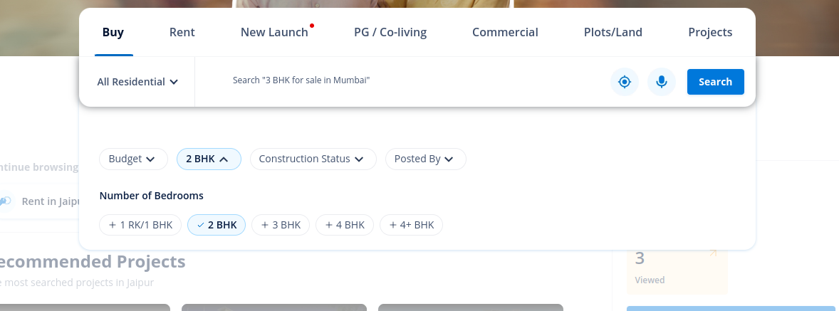
- Property Details Listing
  - Displays a list of properties matching the search criteria.
  - Filters available to narrow results by property type (house, villa, flat, office, etc.), furnishing status (furnished, semi-furnished, unfurnished), and amenities (parking, swimming pool, gym, etc.) etc.
  - Visitors can sort properties according to increasing or decreasing prices.
  - Visitors can view property details such as price, size, number of rooms, and available amenities.
  - Clicking on a property will navigate the visitor to its detailed page with images, descriptions, and agent/owner contact details or an option from where the visitor can chat with the agent/owner via messaging.
  - If the visitor wishes to inquire or book a tour, they will be navigated to the login page.
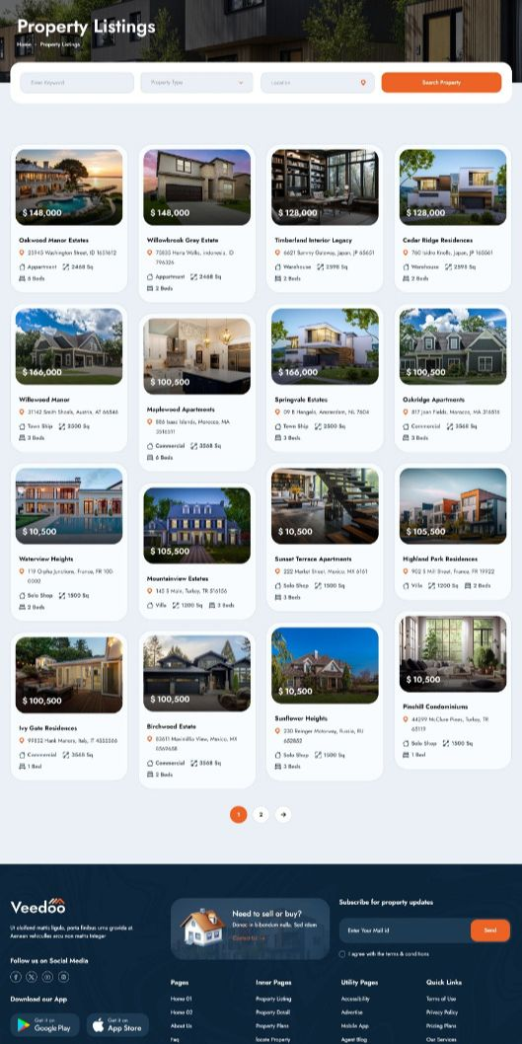

- Welcome to Our Platform
  - A visually appealing section featuring high-quality images of properties and a brief introduction to the platform's purpose and benefits.
- Platform Features
  - A section to showcase features like advanced search filters, secure payments, digital agreements, and property reviews.
- Awards and Recognitions
  - A section to display awards and recognitions received by the platform or its featured agents/partners.

- Customer Reviews
  - A dedicated section featuring testimonials and ratings from previous customers or users, providing social proof and trust for new visitors.

Advertisement Section

Introduce an unobtrusive advertisement space to showcase relevant services and partnerships, enhancing platform monetization without disrupting user experience.

Advertisement Placement:

Strategically located on the homepage, such as in banners, side panels, or between sections.

Advertisement Types:

Third-party Services: Promote affiliated services like movers, interior designers, mortgage providers, or legal consultants etc.

Partnership Promotions: Highlight collaborations with property management firms or other real estate-related businesses.

Visitor Engagement:

Clicking on an advertisement redirects visitors to a detailed page about the service or promotion.



Featured Listings Section
This is a dedicated section designed to highlight premium property listings for increased visibility and targeted engagement.
- Purpose:
  - Showcase selected premium properties for buying, renting, or PG accommodations, marked as "Featured" to draw quick attention.
  - Provide location-specific visibility for featured properties based on user interest.
- Placement:
  - Displayed prominently on the homepage and property listing pages. Featured listings will appear:
    - Below the search section on the homepage.
    - At the top of relevant property search results.
    - In location-specific sections showcasing properties based on selected cities or neighborhoods.
- Location-Based Display:
  - Featured listings are organized according to localities or locations relevant to visitors' interests.
  - Example:
    - "Featured Properties in New York"
    - "Premium Listings in Downtown Los Angeles"
    - "Exclusive Rentals in Manhattan"
  - This ensures users see top properties in areas they are actively searching or exploring.
- Listing Features:
  - Property Preview:
    - Includes key details such as property images, location, price, size, and a short description.
  - "Featured" Badge:
    - Properties are prominently labeled with a "Featured" tag to distinguish them from regular listings.
  - Priority Visibility:
    - Featured listings appear at the top of location-based search results, giving them prime visibility.

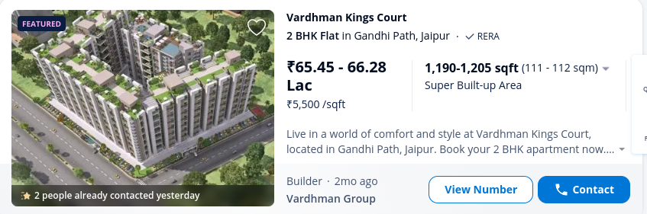

- Subscribe Section
  - A form for visitors to subscribe to the newsletter. Admins can use this feature to send updates about new listings, offers, or relevant property trends.
  - The form will include the following fields:
    - Name
    - Email Address
    - Contact Number


Customer(Buyer/Tenant) Mode
Sign-Up Module
For buyers/tenants (customers) to access the platform and engage in property transactions, they need to register. The sign-up form should include the following fields:
- First Name
- Last Name
- Email Address
- Country/Region
- Password
- Confirm Password
Users must agree to the Terms and Conditions by checking a box. Upon submitting the form, their account is created. They must activate their account via an activation link sent to their registered email address.
Login Module
Customers can log in using their credentials. Login is possible only after account activation via the email link. Required fields:
- Email Address
- Password
Error messages will appear for incorrect credentials, e.g., "Incorrect Email Address or Password."
Forgot Password Module
This module allows users to reset their password by entering their registered email address. A reset link is sent to their email, guiding them through the password reset process.
Dashboard Module
After logging in, customers will see a personalized dashboard that provides an overview of their activities on the platform. The dashboard displays:
- Name and Profile Picture: A quick identification of the user.
- Property Activities: Information about their past inquiries.
- Saved Properties and Searches: Easy access to their favorite listings and search preferences.
The dashboard also includes these key sections:
- My Listings/Inquiries: Shows details of properties they’ve inquired about, including the property type, date of inquiry, and current status.
- Favorites: A quick-access list of properties they’ve saved for future reference.
- Notifications: Updates and alerts related to their saved properties or ongoing inquiries.
My Profile Module
This module allows customers to manage and update their profiles, including:
- First Name
- Last Name
- Country/Region
- Contact Number
- Address (using Google Maps API for approximate location)
- DOB and Age
- Gender
- Profile Image
The profile image and links to Dashboard, My Profile, Saved Properties, and Notifications are accessible via the header.

Search Module
The search module empowers customers to efficiently find properties that match their preferences. Customers can apply a variety of filters to tailor their search:
- Property Type: Specify the type of property such as Residential, Commercial, House, Apartment, or Plot.
- Location: Enter desired locations, neighborhoods, or cities to narrow down results.
- Price Range: Set minimum and maximum price limits to suit their budget.
- Size/Area: Define the preferred size or square footage of the property.
- Amenities: Choose from features like parking spaces, gardens, swimming pools, elevators, or balconies.
- Number of Rooms: Select the desired number of bedrooms, bathrooms, or other spaces.
- Property Status: Filter by availability (For Sale, For Rent, or Newly Listed properties).
- Rating/Review: Filter by the ratings of the properties.
Search Results Display:
Once the search criteria are applied, customers will see a detailed list of matching properties, which includes:
- High-quality images of the property.
- Key property details such as price, size, number of rooms, and available amenities.
- A brief description of the property’s features.
- A “Contact Seller” button for inquiries or scheduling a visit.
For an enhanced user experience, the module also provides:
- Save for Later: Customers can bookmark properties to review later in their dashboard.
- Sort and View Options: Sort results by relevance, price, or location, and toggle between grid or list views.
- Interactive Map: A visual map feature to explore properties based on their geographic locations.
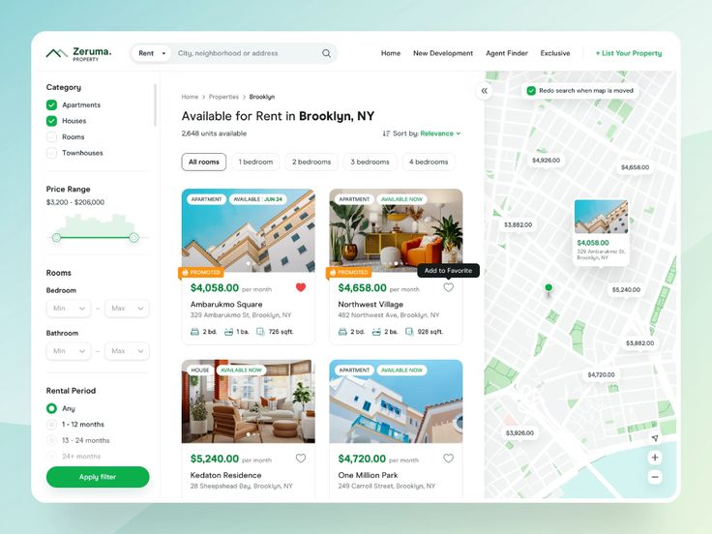

Messaging Module
This module allows buyers (customers) to directly communicate with property sellers. It enables a seamless messaging experience, helping buyers ask questions about properties, request seller contact details (if not shared publicly), and schedule property visits.

Core Features:
- Initiating a Message:
  - Contact Seller Button: On the property detail page, there is a "Contact Seller" button that leads the buyer to the messaging interface.
  - Messaging Window: Once the buyer clicks the "Contact Seller" button, they can open the chat interface where they can start a conversation with the seller.
- Chat Interface:
  - Real-Time Messaging: Buyers and sellers can exchange messages in real time.
  - Message History: All past interactions are visible, allowing both parties to keep track of conversations.
  - Message Text Box: The buyer can type and send text messages to the seller. They can ask questions about the property, clarify details, or inquire about availability.
  - Multimedia Sharing: Both the buyer and seller can send images, videos, and documents for property-related inquiries (e.g., floor plans, images, inspection reports).
- Request for Seller Contact Info:
  - If Seller Has Disabled Contact Sharing: If the seller has opted to hide their contact information in the listing, buyers can request the contact details (phone number, email, etc.) through the chat.
  - Contact Request Button: If the buyer needs to contact the seller outside of the platform, they can click a button that requests the seller’s contact details.
  - Seller Approval: The seller can choose to share or deny the contact details. If the seller agrees, the contact information is sent directly to the buyer’s messaging interface.
- Property Visit Scheduling:
  - Request for Viewing Appointment: The buyer can request a visit time via the chat interface, proposing a date and time for the property viewing.
  - Calendar Integration: The seller can confirm or suggest alternative times for the visit. Optionally, integration with a calendar system (e.g., Google Calendar) can allow the seller and buyer to schedule and confirm appointments.
  - Confirmation of Visit: Once both parties agree on the timing, the visit is confirmed and added to the buyer’s dashboard.
- Notifications:
  - Message Notifications: When a new message is received, both the buyer and seller receive a notification on the platform and via email (optional).
  - View Confirmation: Both parties are notified when a message is read.
- Admin Moderation:
  - Message Filtering: Admins have the ability to monitor conversations to ensure no inappropriate or harmful content is exchanged. Messages containing offensive or inappropriate language can be flagged for moderation.
  - Reporting Abuse: If either the buyer or seller experiences inappropriate behavior, they can report the conversation to the platform admins for review.
- Message History Storage:
  - All messages are stored in the system and accessible by both buyers and sellers. This serves as a record of communications for reference, disputes, or clarification of agreements.
  - Archiving Messages: After the transaction is complete, messages related to specific listings can be archived for future reference.

Review and Ratings Module
Customers can leave reviews and ratings for properties they’ve booked or purchased. Fields include:
- Rating (stars)
- Review text
- Feedback
- Option to upload images or videos
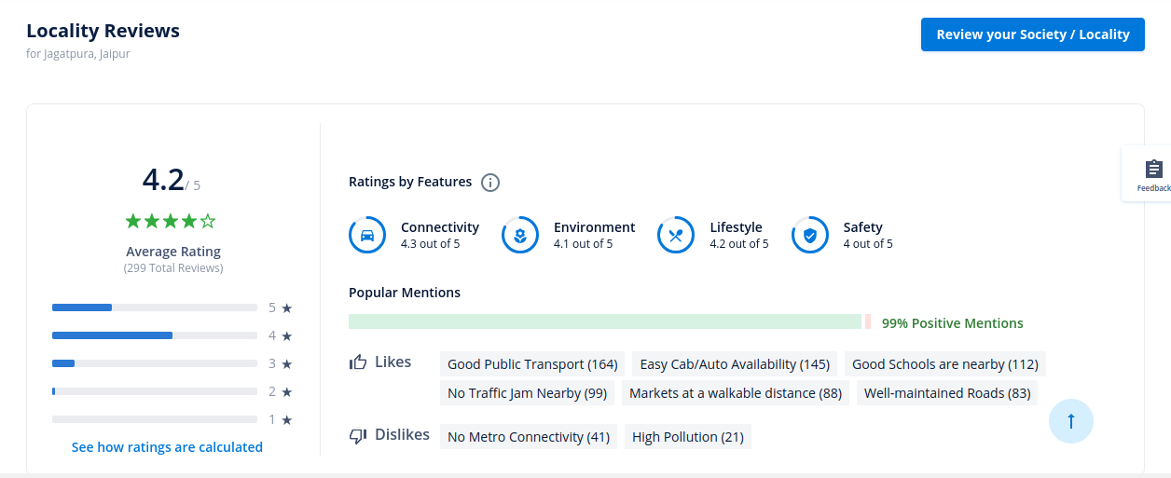
Admins can moderate reviews and remove inappropriate ones.
Email Notification Module
Customers will receive email notifications for:
- Registration confirmation
- Property booking confirmations
- Follow-ups on inquiries

Seller (Owner/Broker/Agent) Mode
Sign-Up Module
Sellers can register on the platform by providing:
- First Name
- Last Name
- Email Address
- Phone Number
- Business Name (Optional)
- Role (Owner, Broker, or Agent)
- Password and Confirm Password
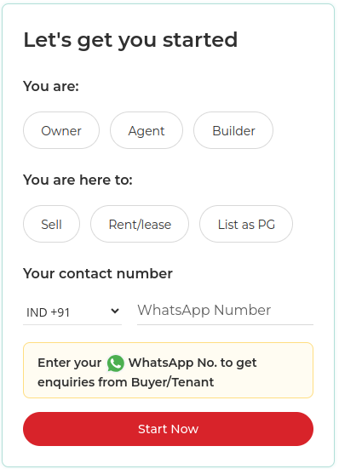
- Checkbox for agreeing to Terms and Conditions.
After submitting the form an email verification link will be sent for account activation. Admin may also approve the account manually after review.

Login Module
Sellers log in with their credentials:
- Email Address
- Password
Displays “Incorrect Email Address or Password” if credentials are invalid. Access is granted only for verified and approved accounts.
Forgot Password Module
This module allows sellers to reset their password by entering their registered email address. A reset link is sent to their email, guiding them through the password reset process.
Dashboard Module
Sellers’ personalized dashboard includes:
- Profile Overview: Name, role (Owner/Broker/Agent), and profile image.
- Performance Metrics: Total properties listed, inquiries received, properties sold/rented.
- Listings Overview: Summary of active, pending, and inactive listings.
- Recent Activity: Notifications for new inquiries or review/feedback.
- Quick Links: Buttons to create new listings, manage inquiries, and view payment history.

Property Listing Management
A robust module for managing property listings:
- Add New Property
Sellers can add detailed property information:
  - Title
  - Type (Apartment, Villa, Commercial Space, Plot, etc.)
  - Price
  - Size/Area
  - Location (with map integration)
  - Images and Videos (upload with captions)
  - Amenities and Features (e.g., parking, pool, elevator access)
  - Status (For Sale, For Rent, or Pending Approval)
  - Description
- Edit/Delete Listings
Sellers can update or remove existing listings.
- Track Listing Performance
  - View property page visits and inquiries received.
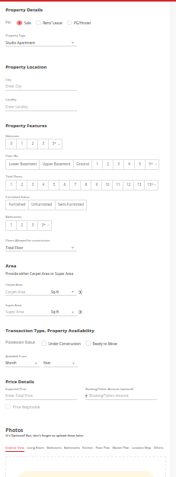
  - Insights into buyer interest trends.
- Property Status
Sellers can toggle between Active, Inactive, or Pending statuses for each property.
- Drafting Property
If the seller pauses/stops in between the process of adding a property, the details of that property will be saved (drafted). He will see a draft for properties that are not fully filled out.

Inquiry Management
The Inquiry Management module enables property sellers to manage and respond to buyer inquiries effectively. It provides tools for communication, scheduling, and maintaining inquiry history, making the process smoother for both buyers and sellers.
- New Inquiries:
  - View Inquiries: Sellers can view a list of all new inquiries related to their properties. Each inquiry includes:
    - Buyer’s Name and Profile Picture (for identification)
    - Message Content: Buyer’s message, including questions, requests for more information, or property visit inquiries.
    - Property Details: The property the inquiry is related to (with brief details like price, location, and key features).
    - Timestamp: Date and time when the inquiry was received.
    - Contact Request Status: If the buyer requested contact information, it will appear here for the seller to approve or deny.
  - Notifications: Sellers receive a notification (on the platform and via email) whenever a new inquiry is made for their listing.
- Communication Tools:
  - Send Replies: Sellers can respond to buyer inquiries in real-time via the messaging interface. The platform includes an easy-to-use chat interface with:
    - Text Replies: Sellers can type messages and send them instantly.
    - Multimedia Support: Sellers can share images, videos, documents, or additional property details (e.g., floor plans, photos, etc.).
  - Request for Contact Details: If a buyer has requested the seller’s contact information, the seller can:
    - Approve/Deny the Request: The seller can decide whether to share their phone number or email with the buyer. If approved, the contact details will be sent through the messaging interface.
  - Property Visit Scheduling: Sellers can schedule property visits through the inquiry management interface:
    - Suggest Visit Times: Sellers can propose multiple available times for a visit.
    - Confirm or Reschedule: If the buyer suggests a time, the seller can confirm or propose alternative visit times.
    - Calendar Integration: Optionally, sellers can integrate the system with their calendar (e.g., Google Calendar) to manage scheduling effectively.
- Inquiry History:
  - Archive Past Inquiries: Sellers can access an archive of all inquiries related to their properties, including past conversations and scheduled visits.
  - Inquiry Status: The seller can track the status of each inquiry (e.g., Pending, Responded, Visit Scheduled, Follow-up Required).
  - History of Contact Requests: The seller can view past requests for contact information and how they were handled.
  - Search & Filter: Sellers can filter inquiries by property, buyer name, or status (e.g., New, Closed) to streamline management.
- Inquiry Details:
  - Buyer Profile: For each inquiry, the seller can access a brief profile of the buyer, including:
    - First Name, Last Name, Country/Region
    - Contact Information: If the buyer has opted to share it.
    - Past Interactions: Any previous inquiries made by the buyer, especially if they’re interested in multiple properties listed by the seller.
  - Property Info: Quick access to the listing details, ensuring the seller can respond accurately with property information.
- Notifications and Alerts:
  - Instant Notifications: Sellers are notified immediately when a new inquiry arrives. They receive a pop-up or dashboard alert, along with an email notification.
  - Follow-Up Reminders: Sellers can set reminders to follow up with buyers if they have not responded to the inquiry within a specific time frame.
- Admin Moderation (Optional for Seller Protection):
  - Message Moderation: Admins can monitor and moderate messages to ensure there is no inappropriate or abusive language in the communication. They can intervene in case of reported issues.
  - Report Inappropriate Behavior: Sellers can flag messages or requests from buyers that appear suspicious or inappropriate. Admins will investigate and take necessary actions.

Transactions and Payment History
Sellers can track all financial transactions related to their listings:
- Completed Transactions: Details of purchased subscription plans.
- Payment History:
  - Transaction ID
  - Subscription Plan Details
  - Renew Subscription Options

Review and Ratings Module
Buyers can rate and review sellers based on their experience. Sellers can:
- View all reviews received for their properties.
- Respond to reviews to maintain good customer relationships.
- Flag inappropriate reviews for admin moderation.

Email and Notification System
Sellers receive notifications for:
- Account approval or rejection.
- Listing approval or comments.
- New inquiries or scheduled property visits.
- Property sold/rented confirmations.
- Payment updates.

Analytics Module
A dedicated section for performance tracking:
- Property Performance: Individual property views, inquiries, and buyer actions.
- Earnings Summary: Total revenue generated from sales/rentals.
- Inquiries Trend: Monthly breakdown of inquiries received.
My Profile Module
Sellers can view and edit their profile:
- Personal Details: Name, Email, Phone Number.
- Business Information: Business Name(Optional), Role (Owner/Broker/Agent).
- Profile Image Upload.
- Contact Preferences: Availability for calls, emails, or messages.
- Share contact details or not with listed properties.
Packages and Subscriptions (Optional)
For premium sellers, this module provides options to:
- Subscribe to paid plans for better visibility.
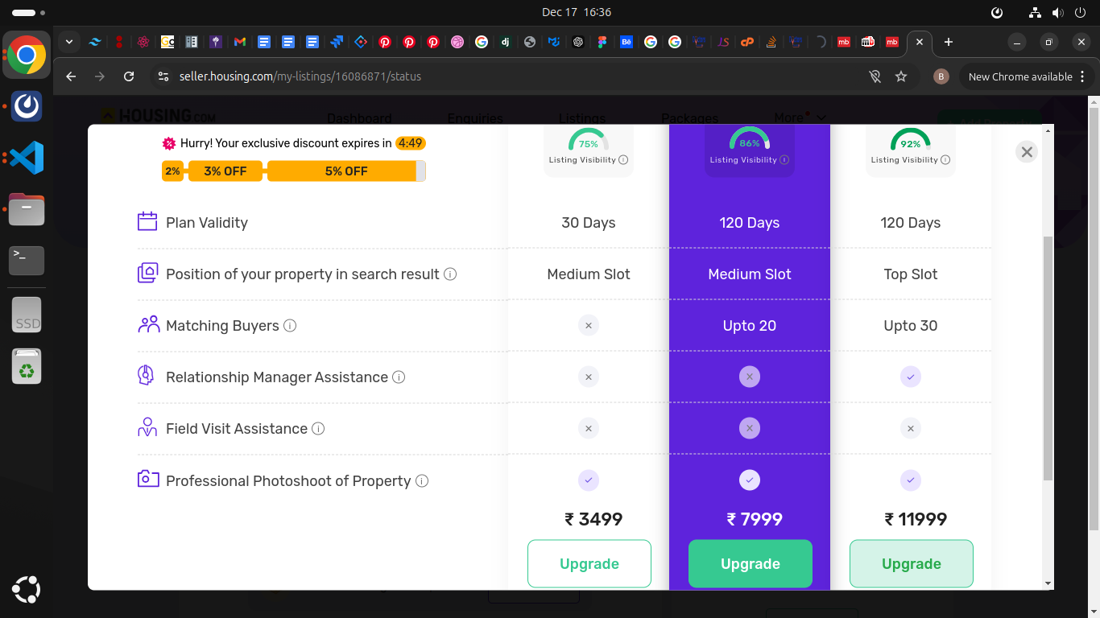
- Unlock features like featured listings or priority inquiries etc.

Admin Mode
Login Module
Admins log in with:
- Email Address
- Password
Displays “Incorrect Email Address or Password” if credentials are invalid.
Forgot Password Module
This module allows sellers to reset their password by entering their registered email address. A reset link is sent to their email, guiding them through the password reset process.
Dashboard Module
Admins can view an overview of platform activity:
- Key Metrics: Total users (Sellers and Customers), active listings, inquiries received, and revenue generated.
- Quick Links: Shortcuts to user management, listings, and analytics.
- Alerts and Notifications: Pending approvals, flagged reviews, or support requests.
- Activity Feed: Recent system-wide actions (e.g., new user registrations, property additions).
User Management
- Seller Management:
  - View a list of all sellers with details (name, email, role, total listings, and account status).
  - Approve or reject new seller registrations.
  - Deactivate or reactivate seller accounts.
  - Manage subscription plans for premium features.
- Customer Management:
  - View customer details (name, email, contact information).
  - Block or suspend accounts for policy violations.
  - Handle customer queries or complaints.

Property Management
- Listing Approval:
  - Review new property listings and approve, reject, or request edits.
  - Admin can set auto-approvals for listing properties.
  - Automated flagging for incomplete or inappropriate listings.
- Listing Overview:
  - Search and filter properties by type, status (active, pending, sold/rented), or seller.
  - Deactivate or remove listings violating policies.
- Featured Listings:
  - Assign properties as featured for better visibility.
  - Set promotional pricing for featured slots.
Advertisement Module
Manage advertisements for featured properties or promotional campaigns. Admin can:
- Approve/Reject advertisement requests.
- Set advertisement durations and positions (e.g., homepage banners, sidebars).
- Monitor performance through basic metrics (views, clicks).
Inquiry Monitoring
Admins can:
- Access all customer inquiries for audit purposes.
- Monitor communication between customers and sellers.
- Intervene in disputes or flagged interactions.
Reviews and Ratings Management
Admins oversee reviews and ratings to ensure platform credibility:
- Approve or reject flagged reviews.
- Take action against sellers with consistent negative reviews.

Payment and Subscription Management
Centralized control over financial activities:
- Payment Monitoring:
  - Track transactions (subscription payments, commissions).
  - View payment details (transaction ID, seller/customer, property details, and status).
- Subscription Management:
  - Set pricing tiers for premium seller packages.
  - Manage active subscriptions and send renewal reminders.
Platform Analytics
- User Activity:
  - Track registrations, logins, and active/inactive users.
  - Identify top-performing sellers and customers.
- Property Insights:
  - Overview of properties listed, sold/rented, or pending.
  - Trends in demand based on property types or locations.
- Revenue Analytics:
  - Total earnings from subscription fees and commissions.
  - Breakdown of monthly or annual revenue.

Notifications and Alerts
Admins receive alerts for:
- New user registrations pending approval.
- Listings flagged by users or the system.
- Unusual activity or security breaches.
- Monthly performance summaries.
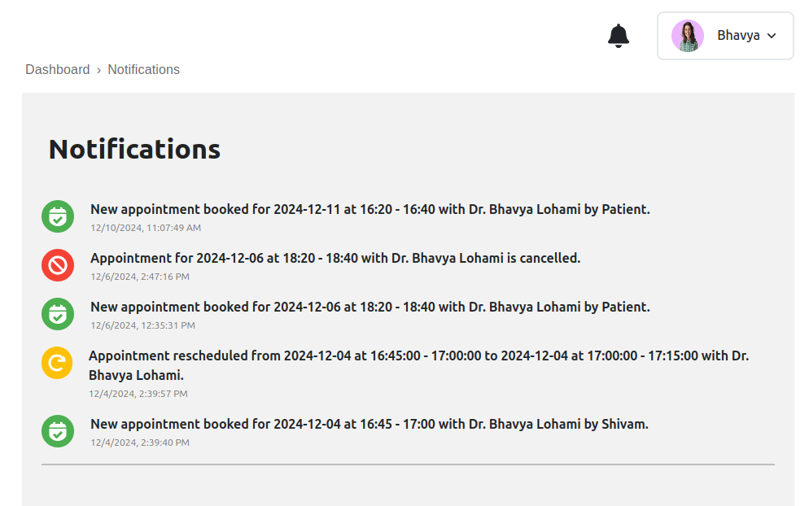
Content Management
Admins can manage platform-wide content, including:
- Terms and Conditions: Update legal and operational policies.
- FAQs: Maintain a comprehensive knowledge base for users.
- Support Resources: Provide help documents or video tutorials.

System Configuration
The System Configuration module is essential for managing the overall settings and functionality of the platform. It ensures flexibility and adaptability to the platform's evolving needs, providing comprehensive control over roles, permissions, and platform-wide configurations.
Role Management
- Define Access Levels:
Administrators can define specific access levels for sub-admins or team members, restricting or allowing access to certain functionalities. Examples include:
  - Granting access to manage property listings, user accounts, or reports.
  - Restricting access to sensitive modules like financial transactions or analytics.
- Create and Assign New Roles:
  - Define custom roles for extended admin capabilities based on platform needs.
  - Example roles include:
    - Content Manager: Manages property content and featured properties.
    - Support Admin: Handles user inquiries and disputes.
    - Analytics Viewer: Views platform performance metrics and generates reports.
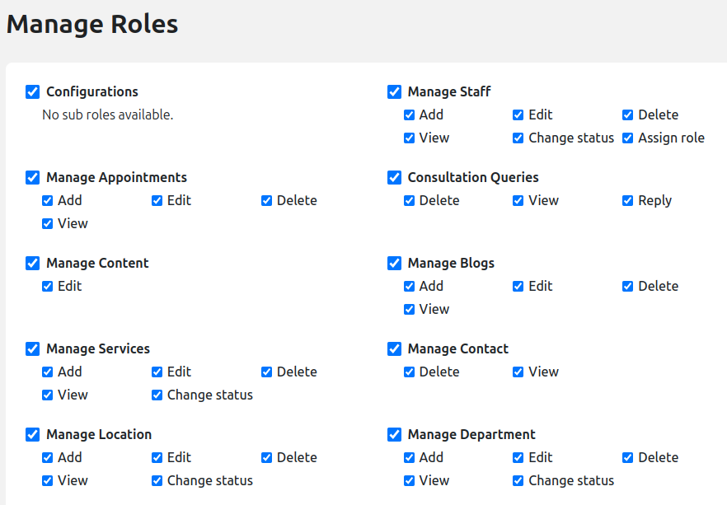
  - Assign roles to team members with unique permissions to avoid overlaps or unauthorized actions.

Platform Settings
- Update Branding Elements:
  - Logos and Colors: Easily update the platform’s logo and primary color scheme to align with rebranding efforts or aesthetic upgrades.
  - Taglines and Descriptions: Customize platform taglines or descriptions displayed on the homepage or promotional content.
  - Awards/Achievements: Highlight platform achievements, certifications, or awards in dedicated sections to enhance credibility.
  - Blogs/Services/Departments etc: Add, edit and delete blogs, services, departments etc. to showcase them on the website.
  - News-Letter Management: Admin can send new updates to the users who have subscribed to the newsletter for letting them know about the new features or listings on the website.
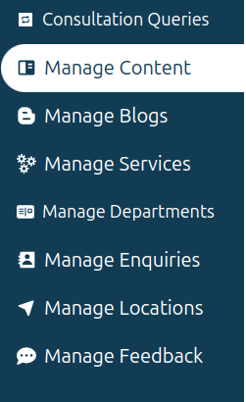
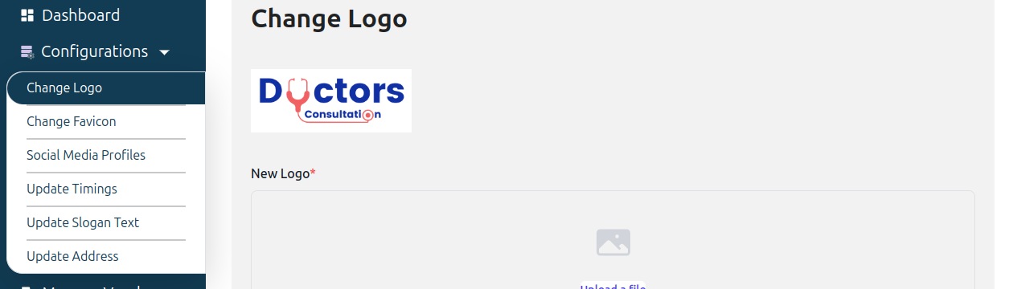

- System-Wide Configuration:
  - Time Zones: Set the default time zone for the platform, allowing users to view booking and transaction times accurately.
  - Currencies: Define the default currency or enable multiple currencies based on the platform’s operational regions.

Sub-Admin Mode
Sub-admin will be able to access the admin panel on behalf of the main admin.
Sub-admins can manage all the assigned roles to them, functionality wise it will be the same as admin features. The Sub-Admins whose accounts are deactivated then those sub-admins should not be able to access the software. They will get an error that your account is temporarily deactivated, please contact admin.

Data Flow Diagram
Admin Journey Flow-Chart:

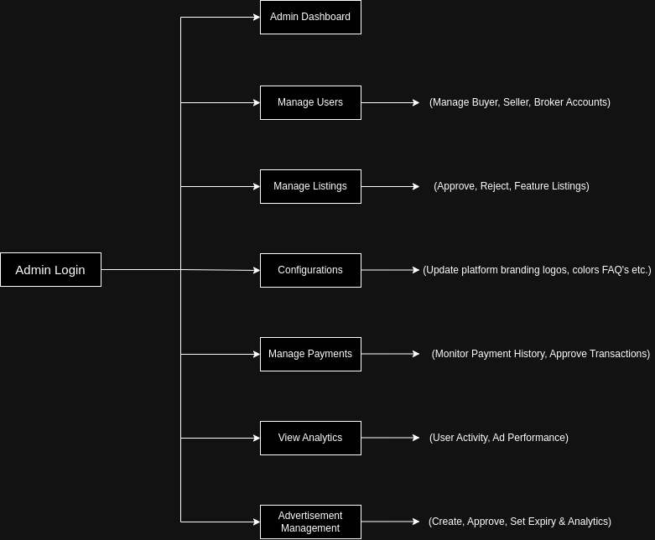

Owner/Broker Journey Flow-Chart:
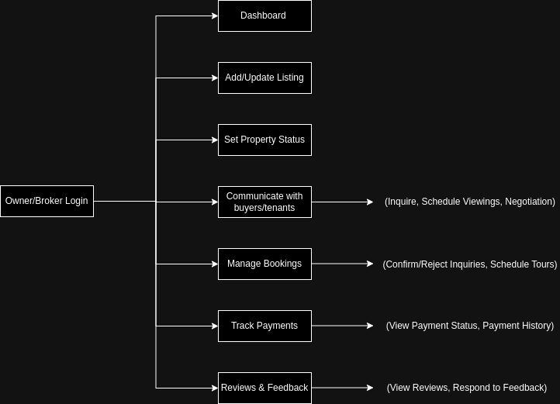
User Journey Flow-Chart:
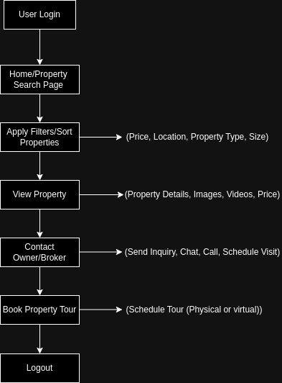

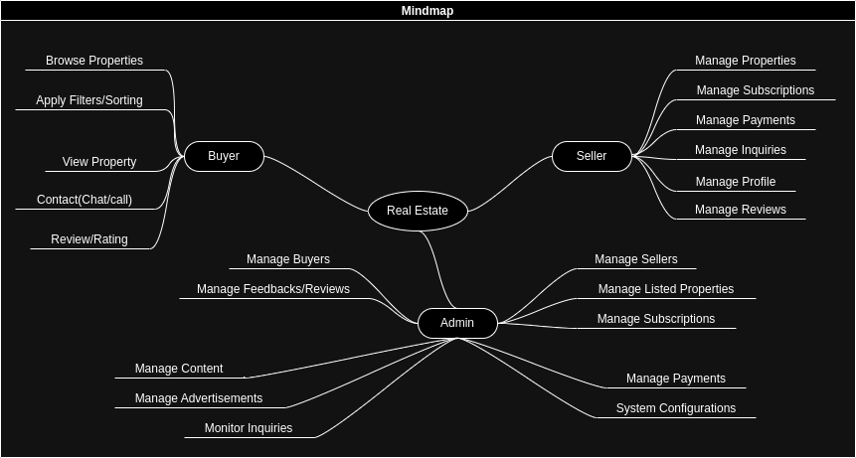
Mind Map

