Manage Roles and Responsibilities

It permits vendors to enroll new users, with the ability to assign them to a particular role, such as Doctor and Staff, and permit/detailed access to an explicitly defined role for each and every page or function of the system. In each of the pages, the action control will also permit/limit certain functionality like add, edit, and delete etc.

Workflow
- Vendor Registers a New User:
  - The vendor inputs the details of a new user and registers them in the system.
- Assign Role:
  - The vendor assigns one of the predefined roles to the user:
    - Doctor
    - Staff
- Grant Access to Pages:
  - The vendor selects which pages the user can access, such as:
    - Configurations
    - Manage Users/Staffs/Doctors
    - Manage Appointments
    - Manage Slots
    - Manage Holidays
    - Consultation Queries
    - Manage Content
    - Manage Blog
    - Manage Service
    - Manage Department
    - Manage Contact
    - Manage Profile
    - Change Password
    - Notification
- Define Functionalities within Each Page:
  - For each page granted access, the vendor specifies the functionalities the user can perform:
    - Add
    - Edit
    - Delete etc.

Detailed Role and Access Management

1. Pages and Actions
Page | Actions
Configurations | Add, edit, or delete configurations for system settings.
Manage Users/Staffs/Doctors | Register new users, edit user details, deactivate users, and assign/reassign roles.
Manage Appointments | Add new appointments, edit existing ones, or cancel appointments.
Consultation Queries | Respond to patient queries, forward queries to doctors, or archive resolved queries.
Manage Content | Add, edit, or delete website/app content (e.g., terms, policies).
Manage Blog | Create, edit, or delete blog posts.
Manage Service | Add, update, or remove service offerings.
Manage Department | Add new departments, update department details, or delete departments.
Manage Slots/Holidays | Add or update or delete slots(slot-timings or slot-availability) and holidays.
Manage Profile | Update profile information (e.g., name, email, phone).
Change Password | Change account password.
Notification | View, mark as read, or delete notifications.

2. Role-Based Access Examples
- Doctor:
  - Access Pages: Manage Appointments, Consultation Queries, Manage Profile, Notification.
  - Functionalities:
    - In Manage Appointments: Add and edit appointments only.
    - In Manage Slots/Holidays: Add, edit or delete slots or holidays.
    - In Consultation Queries: Respond to patient queries but cannot delete them.
- Staff:
  - Access Pages: Manage Appointments, Manage Users/Staffs/Doctors, Notification.
  - Functionalities:
    - In Manage Appointments: Add, edit, and delete appointments.
    - In Manage Slots/Holidays: Add, edit or delete slots or holidays as per Doctor’s needs(if needed).
    - In Manage Users: View user details but cannot add or delete users.

Vendor’s Role in Access Control
- Registering Users:
  - Vendors are responsible for creating user accounts and assigning initial roles.
- Assigning Page Access:
  - Vendors can allow or restrict access to specific pages based on the user’s role.
- Assigned Pages Functionalities:
  - Within each accessible page, vendors specify the permitted actions (e.g., Add only, Add and Edit, or Full Access).
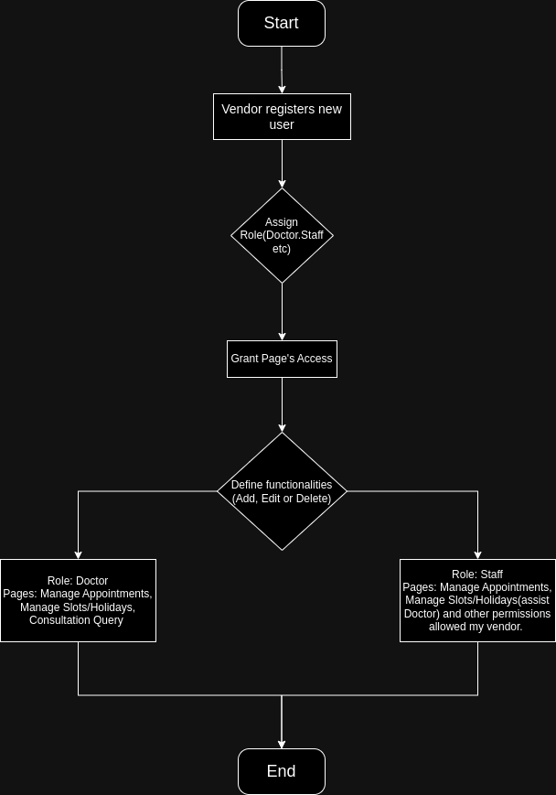
Flow Chart

