**DAILY ONLINE ACTIVITIES SUMMARY**

|  |  |  |  |  |  |  |  |  |
| --- | --- | --- | --- | --- | --- | --- | --- | --- |
| **Date:** | **23/05/2020** | | | | | **Name:** | **BHAVYA.S** | |
| **Sem & Sec** | **4th SEM ‘A’ Section** | | | | | **USN:** | **4AL18CS014** | |
| **Online Test Summary** | | | | | | | | |
| **Subject** | | **Data Communication(18CS46)** | | | | | | |
| **Max. Marks** | | **30** | | **Score** | | | **26** | |
| **Certification Course Summary** | | | | | | | | |
| **Course** | **Introduction to Programming** | | | | | | | |
| **Certificate Provider** | | | **Great Learning** | | **Duration** | | | **1.5 Hours** |
| **Coding Challenges** | | | | | | | | |
| **Problem Statement:1****.** **Write a C program to implement SRTF process scheduling.**  **Input: A set of processes with their burst time and arrival time**  **Output: The processes scheduled based on the arrival time and a smaller burst time.** | | | | | | | | |
| **Status: Completed** | | | | | | | | |
| **Uploaded the report in GitHub** | | | | | **YES** | | | |
| **If yes Repository name** | | | | | <https://github.com/Bhavyamahadev/lockdown-coding> | | | |
| **Uploaded the report in slack** | | | | | **YES** | | | |

**Online Test Details:**

The online test was from module 1and 2 which was about the Introduction to Data Communication, Networks models, Introduction to Physical Layer-1, Digital Transmission, Physical Layer-2. There were 30 questions and the duration was 40 minutes. The questions were optimal and were easy. The score that I got in the test is 26/30.

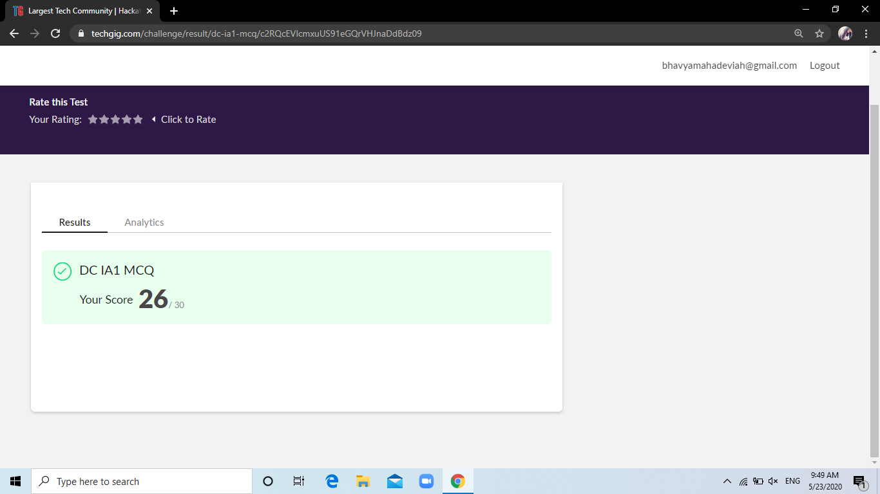

**Certification Course Details:**

**Name of the course**: Introduction to Programming

**Certificate Provider**: Great Learning

This course has 3 sections and the total duration is 5.5 hours.

Today I went through the third section of the course that explained about Python Pandas and Matplotlib. I have gone through the Introduction to Pandas, Pandas series objects, Introduction to Pandas Dataframe, Pandas Functions and Introduction to Matplotlib.

**Snapshot:**

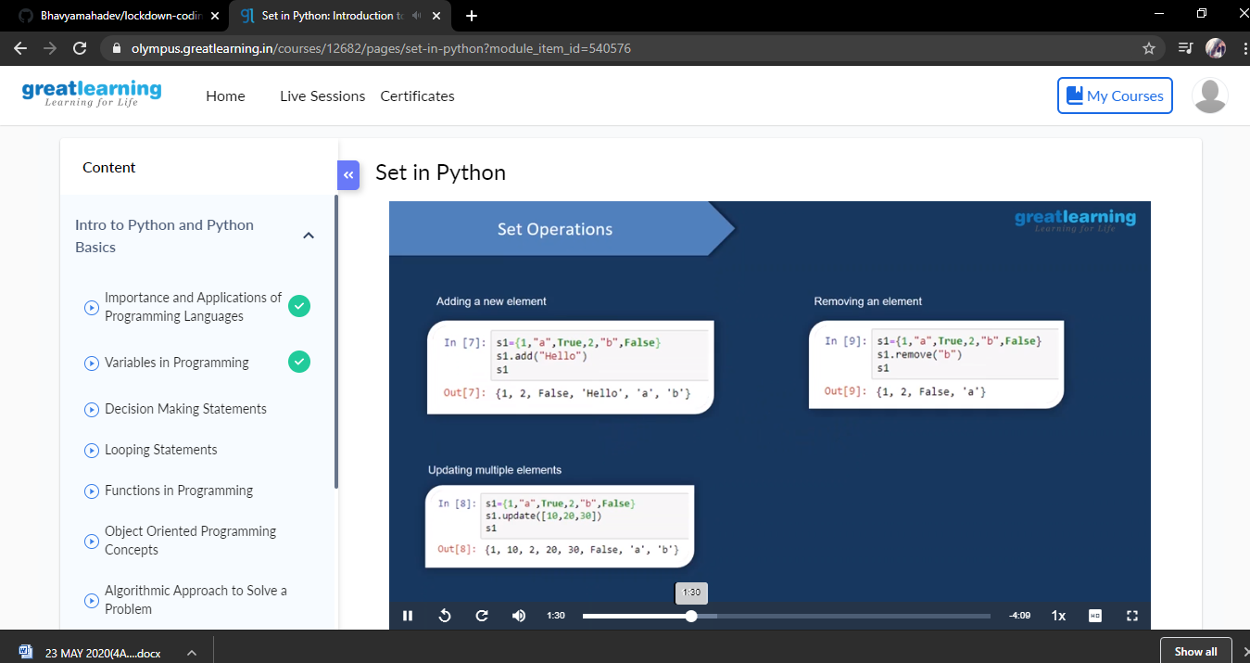

**Online Coding Details:**

Problem 1: (using C language) To implement SRTF process scheduling.

Input: A set of processes with their burst time and arrival time

Output: The processes scheduled based on the arrival time and a smaller burst time.

