**DAILY ONLINE ACTIVITIES SUMMARY**

|  |  |  |  |  |  |  |  |  |
| --- | --- | --- | --- | --- | --- | --- | --- | --- |
| **Date:** | 21/05/2020 | | | | | **Name:** | BHAVYA.S | |
| **Sem & Sec** | 4TH&A | | | | | **USN:** | 4AL18CS014 | |
| **Online Test Summary** | | | | | | | | |
| **Subject** | | MICRO PROCESSOR AND EMBEDDED SYSTEM | | | | | | |
| **Max. Marks** | | 30 | | **Score** | | | 19 | |
| **Certification Course Summary** | | | | | | | | |
| **Course** | Python for machine learning | | | | | | | |
| **Certificate Provider** | | | Great learning | | **Duration** | | | 1 Hours |
| **Coding Challenges** | | | | | | | | |
| **Problem Statement:** 1. Write a C Program to Reverse a Linked List (SLL) in groups of given size.  2. To find the duplicate number from the array | | | | | | | | |
| **Status:** Completed | | | | | | | | |
| **Uploaded the report in Github** | | | | | YES | | | |
| **If yes Repository name** | | | | | <https://github.com/Bhavyamahadev/lockdown-coding> | | | |
| **Uploaded the report in slack** | | | | | YES | | | |

**Online Test Details:**

The online test was from module 1 which was about Introduction to MICROPROCESSOR AND EMBEDDED SYSTEM. There were 30 questions which lasted for 30 minutes. The questions were easy. I scored 19 out of 30.

**Snapshot**:

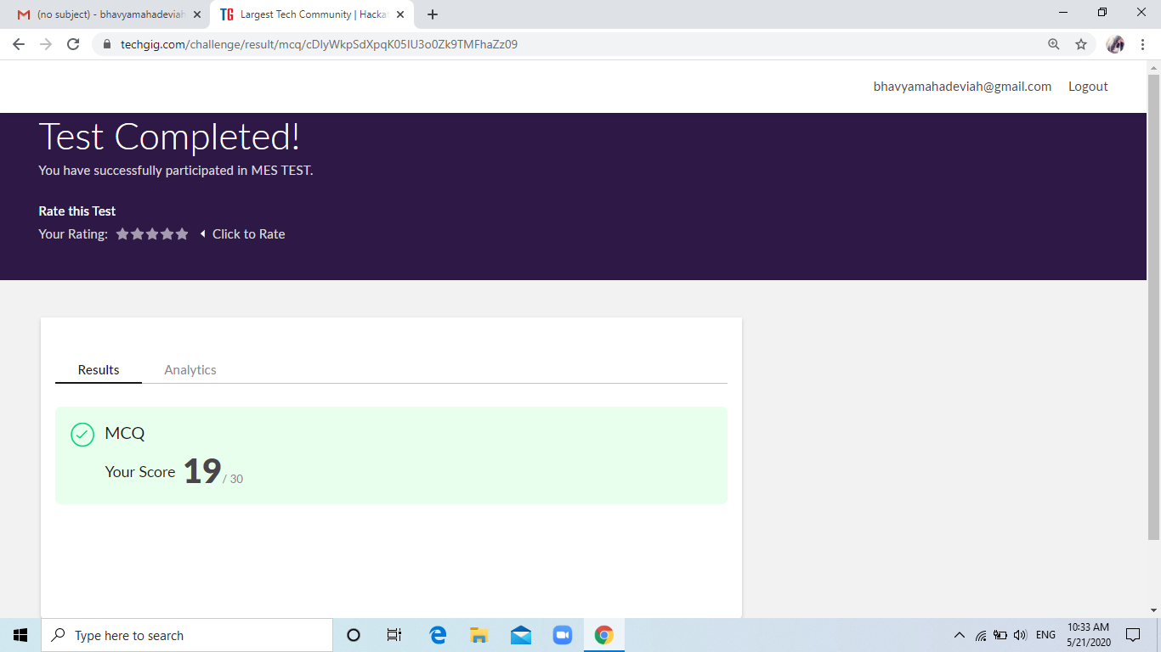

**Certification Course Details:**

**Name of the course**: Python for machine learning

**Certificate Provider**: Great learning

This course has 19 sections and the total duration is 24 hours.

In the third day I went through the second section of the course and learnt the different data structures available in python and heir usages.

**Snapshot:**

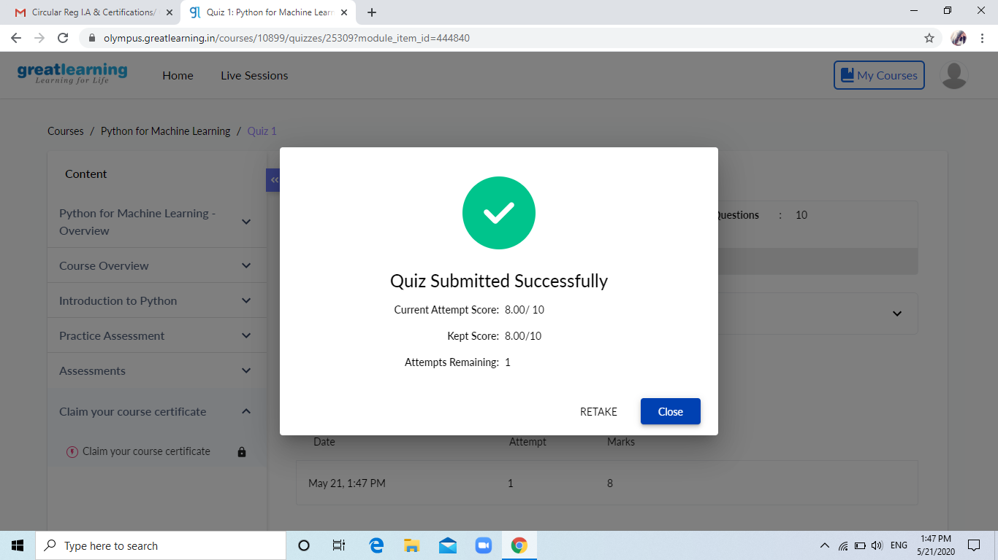

|  |
| --- |
|  |

Online Coding summary:

1.Write a c program to create singly linked list(SLL) with n elements and reverse the element using c.

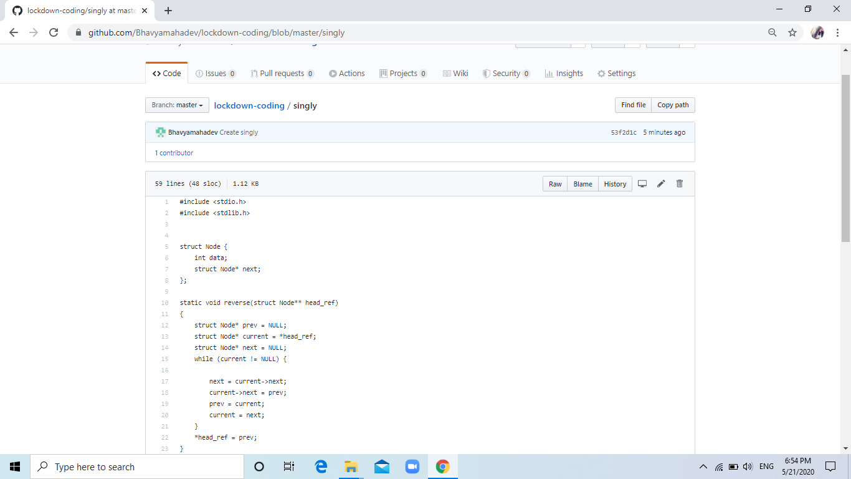

2. Write a C program to construct a singly linked list by removing duplicate elements in the sorted linked list  
Description:  
Take a sorted list and traverse the list. Compare the current node element with next adjacent node. If it is same then delete second element, if not retain. Finally print the resulting list.  
Sample output:  
Given list {1,2,2,3,3,3,4}  
Resulting list{1,2,3,4}

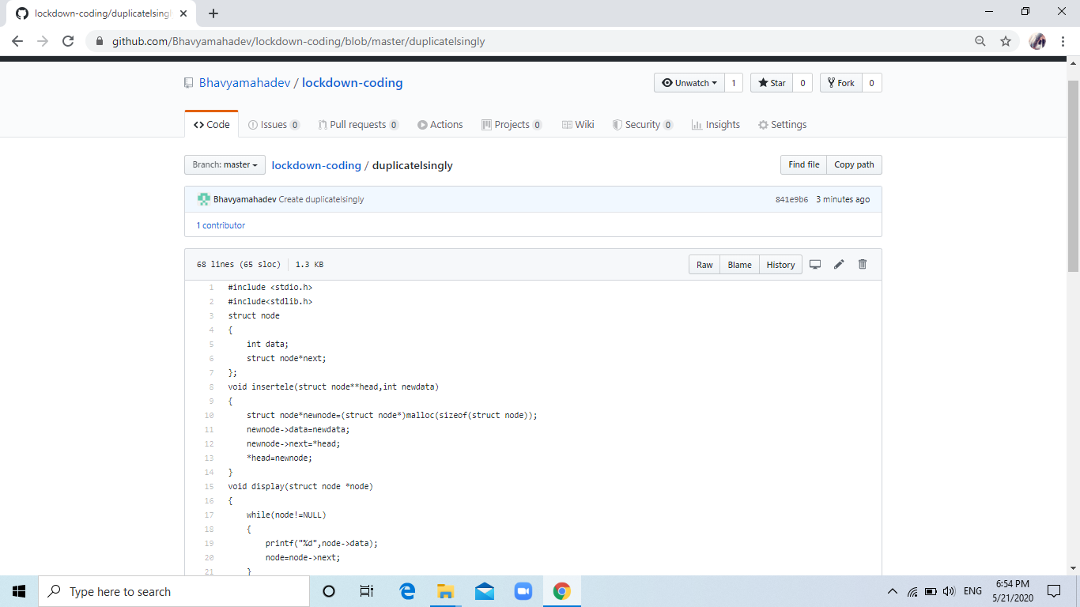

3. Write a C program to implement SRTF process scheduling.  
Input: A set of processes with their burst time and arrival time  
Output: The processes scheduled based on the arrival time and a smaller burst time.

