**Visvesvaraya Technological University**

Jnana Sangama, Belgaum- 590 018



## **A**

**MINI-PROJECT REPORT**

**ON**

**“BUS RESERVATION SYSTEM”**

Submitted in partial fulfillment of BE (ISE) prescribed by VTU

SUBMITTED BY,

**BHAVYA.M.S (4VM16IS005)**

**BHOOMIKA.N (4VM16IS007)**

**K.SURABHI (4VM16IS014)**

**P.PALLAVI (4VM16IS025)**

**VARSHITHA.R (4VM16IS043)**

UNDER THE GUIDANCE OF

**BINDUSHREE.V**

Assistant Professor



**Department of Information Science and Engineering**

**VidyaVikas Institute of Engineering and Technology**

Bannur Road, Alanahally, Mysuru, Karnataka-570028

**2017-2018**

**Vidya Vikas Institute of Engineering and Technology**

Bannur Road, Alanahally, Mysuru, Karnataka-570028

**DEPARTMENT OF INFORMATION SCIENCE AND ENGINEERING**



**CERTIFICATE**

Certified that the Project entitled “ BUS RESERVATION SYSTEM” carried out by Mr./Ms.Bhavya.M.S(4VMI6IS005) , Bhoomika.N(4VM16IS007), K.Surabhi(4VM16IS014), P.Pallavi(4VM16IS025), Varshitha.R(4VM16IS043), a bonafide student of 3rd semester ISE in partial fulfillment for the award of Bachelor of Engineering in VIDYA VIKAS INSTITUTE OF ENGINEERING AND TECHNOLOGY of the Visvesvaraya Technological University, Belgaum during the year 2017-18 It is certified that all corrections/suggestions indicated for Internal Assessment have been incorporated in the Report deposited in the departmental library. The project report has been approved as it satisfies the academic requirements in respect of project prescribed for the said Degree.

BINDUSHREE.V DRAKSHAYINI.K.B RAJALAKSHMI.M.C

Project Guide Co Guide Head of the Department

**ACKNOWLEDGEMENT**

The satisfaction and euphoria that accompany the successful completion of any task would be incomplete without the mention of the people who made it possible, whose consistent guidance and encouragement crowned my efforts with success.

We consider myself proud to be a part of **Vidya Vikas Institute of Engineering and Technology** family , the institution which stood by our way in all our endeavours.

We would like to thank my guide **Bindushree V,** Assistant Professor, Department of Information Science and Engineering, for her inspiration, guidance, constant supervision, direction and discussions in successful completion of this project.

We express my sincere thanks to **Prof. Rajalakshmi,** Head of the Department of Information Science and Engineering, for her support and encouragement.

We wish to express my gratitude to **Dr. Ravi Shankar**, Principal, **Vidya Vikas Institute of Engineering Technology**, Mysore for providing a congenial working environment.

We are thankful to the Department of Information Science and Engineering teaching faculty members and non-teaching faculty members for their co-operation extended towards this work.

**Name of the Students**

**BHAVYA.M.S**

**BHOOMIKA.N**

**K.SURABHI**

**P.PALLAVI**

**VARSHITHA.R**

**Contents**

**Abstract1**

**Chapter 1:**2

1.1 : Introduction2

1.2 : Objectives2

**Chapter 2:3**

2.1 : Proposed system3

2.2 : Requirements3

**Chapter 3:4-10**

3.1 : Program4-9

3.2 : Output10

**Chapter 4:11**

4.1 : Conclusion11

4.2 : Reference11

**Abstract**

* Existing system is totally on book and thus a great amount of manual work has to be done.
* Needs a lot of working staff and extra attention on all the records.
* Finding out details regarding any information is very difficult, as the user has to go through all the books manually.
* Hence this system helps to overcome all these problems.
* This project helps in eliminating the manual reservation system by providing all the details online.
* It helps in the booking of ticket easily rather than doing it manually.
* It shows the available seats and the prices within no time.
* It contains information about the passenger.
* It also provides security to all the information.
* Future work of this project can include the following .
* Providing special concession to physically disabled customers.
* Same rate of tickets during festival season even if the demand is high.
* Reduced rate if two way travel.
* Providing discount to regular customers.
* No third party involvement.
* Cancellation charges 40% deducted.

**Chapter 1:**

1.1 - Introduction

* The main aim of developing this project is to provide details of buses, seats available, and cost of the ticket easily.
* This system can manage bus details, customer details and details of the seats.
* The main objective of this project is to provide the better work efficiency, security, accuracy, reliability and feasibility.

1.2 - Objectives

* The main objective of this system is to eliminate the manual reservation system.
* Making the reservation system fast, user friendly and avoid the unnecessary delay in reservation.
* Searching information about reservation date, etc can be accessed with just one click.
* The data should be stored in computer rather than storing it manually.

**Chapter 2:**

2.1 - Proposed system

* This system is very simple in design, requires very low system resources and will work in almost all configurations.
* It also provides security for the information and minimum time is needed.
* Any person across the world can access this service.
* It is user friendly and availability of seats can be enquired very easily.
* Passengers can also cancel their tickets easily.
* Ensures data accuracy and provides better service.

2.2 – Requirements

* Software Requirements:

Operating System: Windows XP

Developing tool: VB6

Data base: MS access

* Hardware Requirements:

Processor: Pentium IV 2GHZ and above

RAM: 2GB RAM

Monitor keyboard mouse: 15” colour monitor

Coding language: C

Storage space: 10GB or higher

**Chapter 3:**

3.1 - Program

* The C functions used in this program are:

I/O functions – stdio.h

Mathematics functions – math.h

Book ticket

Display

Cancel ticket

* There are three classes of tickets they are general ticket, sleeper coach and AC coach.
* A unique PNR number is given to every passenger. This PNR number is used to cancel the ticket.
* Structure, array and file pointers are used in this program.

#include<stdio.h>

#include<math.h>

int nop;

int n,i,j=0;

struct tick

{

long int pnr;

int age;

char name[20];

}ti;

void main()

{

int ch;

printf("\n\n\n\n\n\n\n\n\n\n\n\t\t\t\t\t\t\t-----welcome-----\n\n\n\t\t\t\t\t\t");

system("pause");

while(1)

{

system("cls");

printf("\n1.Book ticket");

printf("\n2.My bookings");

printf("\n3.Cancel ticket");

printf("\n4.Exit");

printf("\n Enter your choice...");scanf("%d",&ch);

switch(ch)

{

case 1 : bookticket();

break;

case 2 : display();

break;

case 3 : cancelticket();

break;

case 4 : exit(0);

default : printf("\nWrong option entered..\n");

break;

}

}

}

int passenger()

{

FILE *fp;

fp = fopen("btick", "a");

printf("Enter number of passengers - ");scanf("%d",&n);

nop=n;

for(i=0;i<n;i++)

{

printf("------------------------------\n");

printf("passenger %d name - ",i+1);scanf("%s",&ti.name);

printf("passenger Age - ");scanf("%d",&ti.age);

ti.pnr= rand ();

fwrite(&ti, sizeof(ti), 1, fp);

}

fclose(fp);

system("pause");

return 0;

}

int bookticket()

{

int ch;

float total;

int coach[3]={50,100,200};

printf("\n1.General ticket\n");

printf("2.Sleeper coach");

printf("\n3.AC coach\n");

printf("Enter your choice - ");scanf("%d",&ch);

if(ch==1)

{

passenger();

printf("\nTicket booked .....\n");

total=nop*coach[0];

printf("Total=%f ",total);

j++;

}

else if(ch==2)

{

passenger();

printf("\nTicket booked .....\n");

total=nop*coach[1];

printf("Total=%f ",total);

j++;

}

else if(ch==3)

{

passenger();

printf("\nTicket booked .....\n");

total=nop*coach[2];

printf("Total=%f ",total);

j++;

}

else

{

printf("Wrong option entered...\n");

}

system("pause");

}

void display()

{

system("cls");

FILE *fp1;

fp1 = fopen("btick", "r");

printf("\n__________Bookings________\n");

printf("\n\nName\tAge\tPNR\n");

while (fread(&ti, sizeof(ti), 1, fp1))

{

printf("\t\n%s\t%d\t%d\n",ti.name,ti.age,ti.pnr);

}

printf("\n");

fclose(fp1);

system("pause");

}

int searchpnr( int r)

{

FILE *fp;

fp = fopen("btick", "r");

while (!feof(fp))

{

fread(&ti, sizeof(ti), 1, fp);

if (r == ti.pnr)

{

fclose(fp);

return 1;

}

}

fclose(fp);

return 0;

}

void cancelticket()

{

system("cls");

FILE *fpo;

FILE *fpt;

int r, s;

printf("Enter the PNR :");

scanf("%d", &r);

if (searchpnr(r) == 0)

{

printf("Ticket with PNR %d is not available in the file\n", r);

system("pause");

}

else

{

fpo = fopen("btick", "r");

fpt = fopen("TempFile", "w");

while (fread(&ti, sizeof(ti), 1, fpo))

{

s = ti.pnr;

if (s != r)

fwrite(&ti, sizeof(ti), 1, fpt);

}

fclose(fpo);

fclose(fpt);

fpo = fopen("btick", "w");

fpt = fopen("TempFile", "r");

while (fread(&ti, sizeof(ti), 1, fpt))

fwrite(&ti, sizeof(ti), 1, fpo);

printf("\nTICKET DELETED\n");

system("pause");

fclose(fpo);

fclose(fpt);

}

}

3.2 - Output:

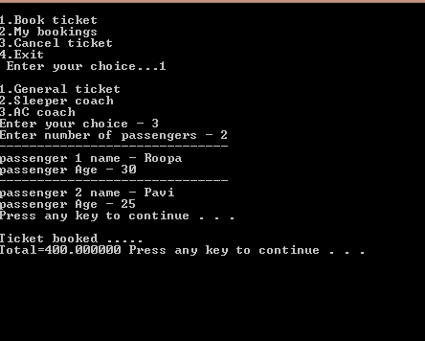

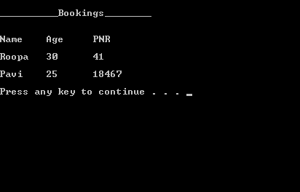

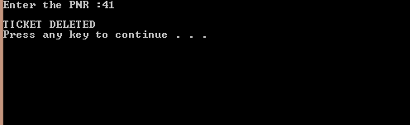

**Chapter 4:**

4.1 - Conclusion

* Online system enables the customer to check availability of the bus ticket, buy bus ticket and pay for it.
* It is easier for the customer to get bus ticket online instead of standing in the queue to get it.
* This system will be available for 24 hours and efficient in reservation.
* It has no hidden costs in fares.
* It is user friendly and accurate.

4.2 - Reference

www.Dreamtravel.com

www.Shivajivarma.com

www.Slideshare.net