#include <stdio.h>

#include <string.h>

void replaceWords(char \*text) {

char \*pos;

while ((pos = strstr(text, "hte")) != NULL) {

memcpy(pos, "the", 3);

}

while ((pos = strstr(text, "recieve")) != NULL) {

memcpy(pos, "receive", 7);

}

}

int main() {

char text[100];

printf("Enter text: ");

fgets(text, sizeof(text), stdin);

replaceWords(text);

printf("Corrected text: %s", text);

return 0;

}

OUTPUT ;

Example 1:

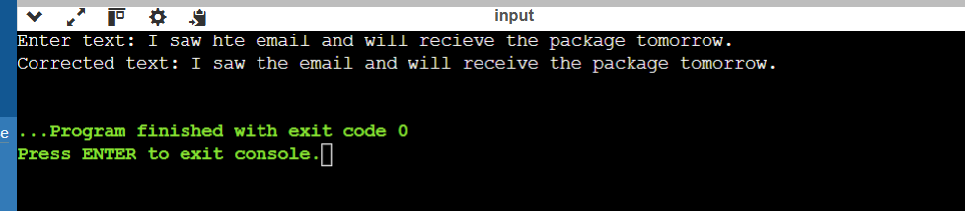

Example 2:

