Bhavyansh Sharma

19BCE1282

1)Make a create user url and send json data

Output

Confirmation !

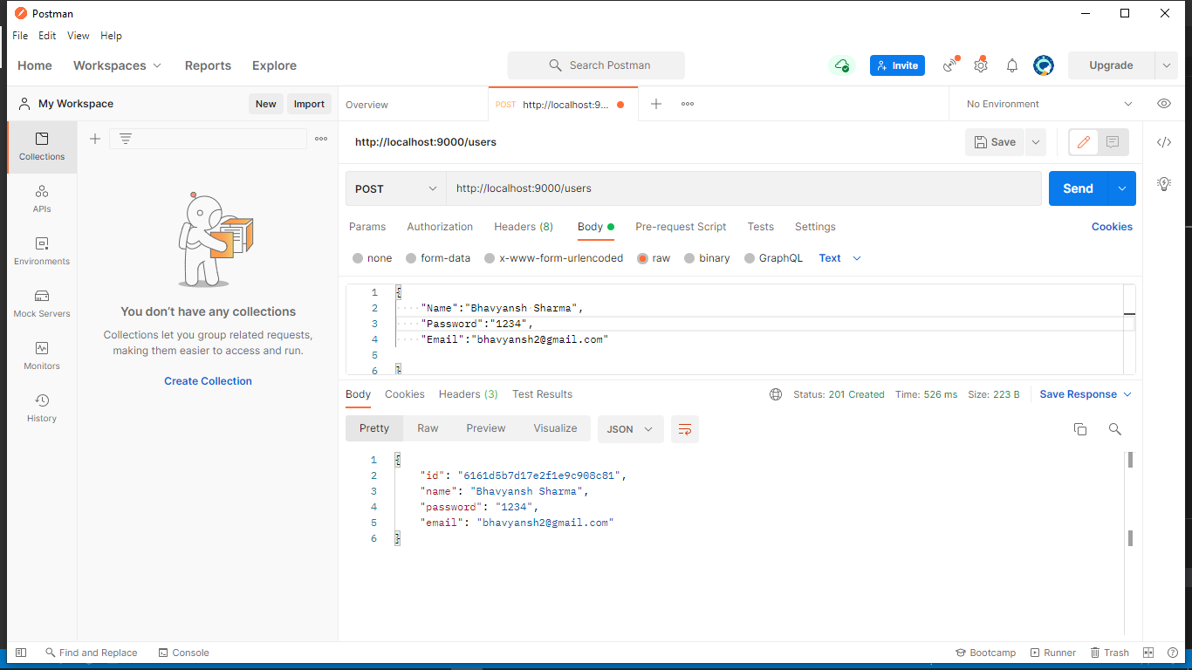

Data being updated in MongoDB

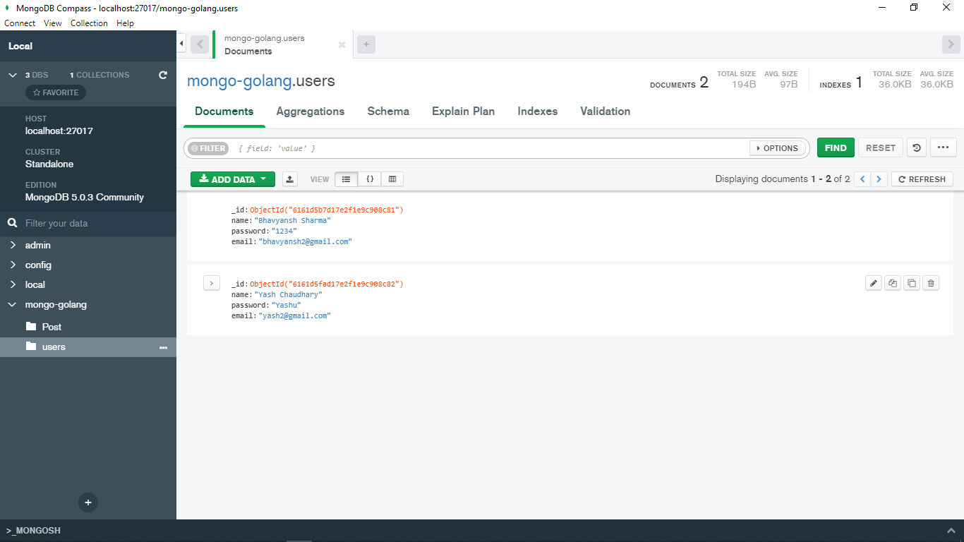

2) Get user by id

Output!

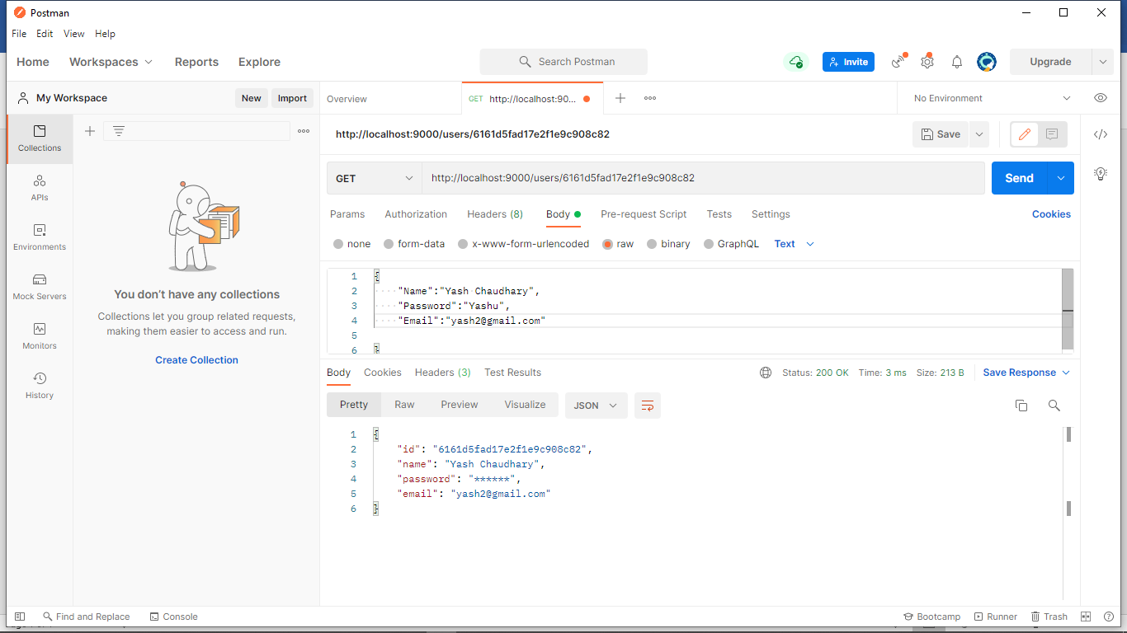

3)Create Posts

Output

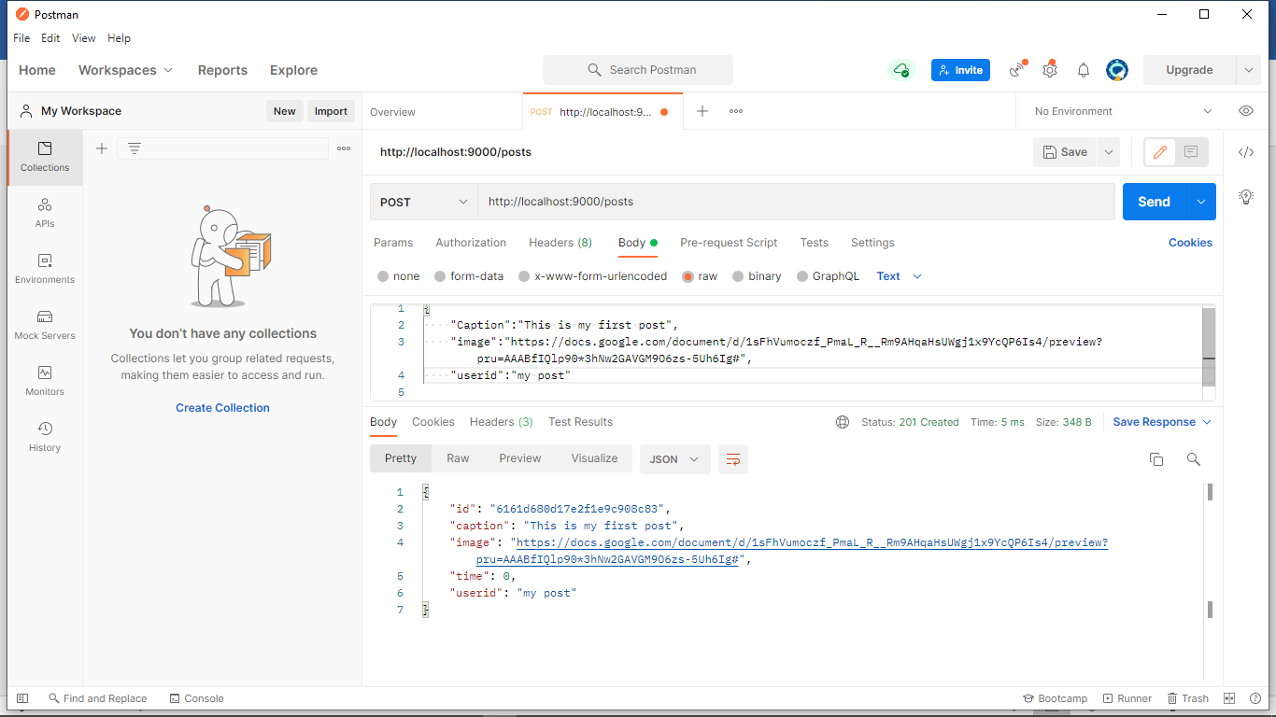

Data being updated

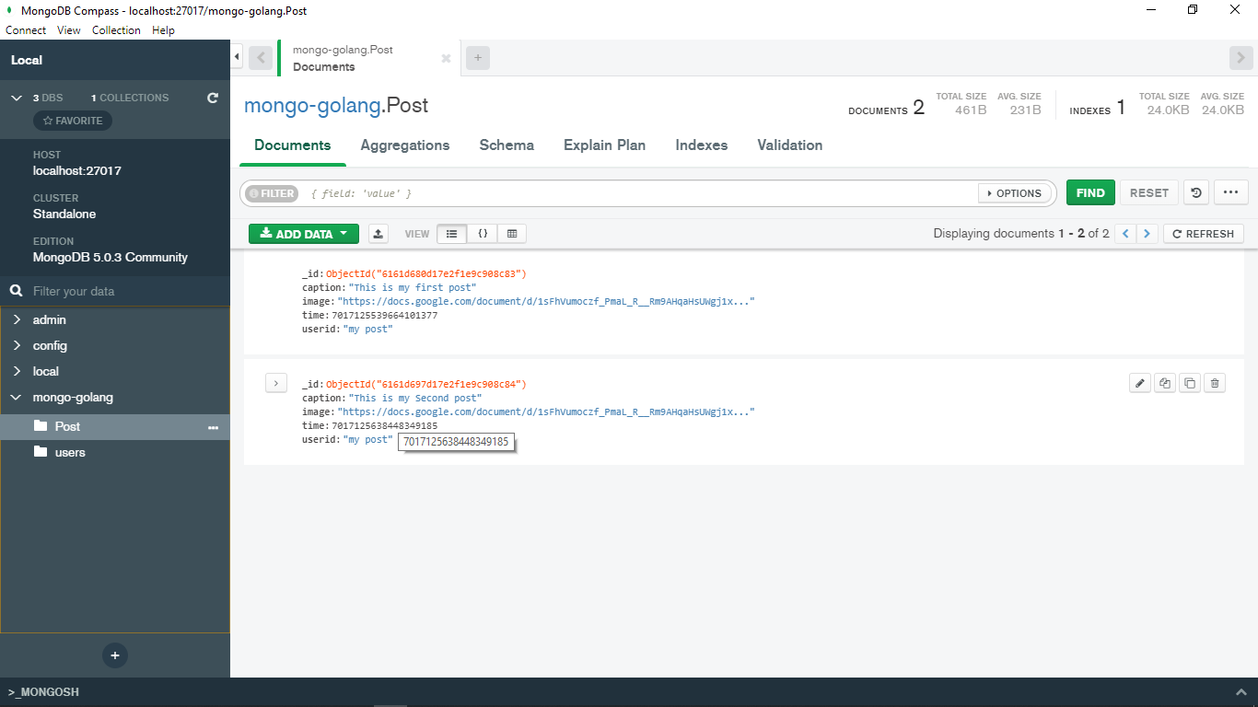

4)Posts by id

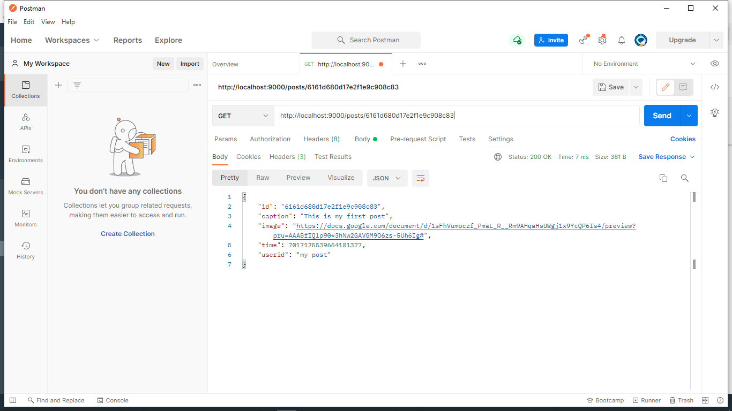

5)All the post of the user by user id

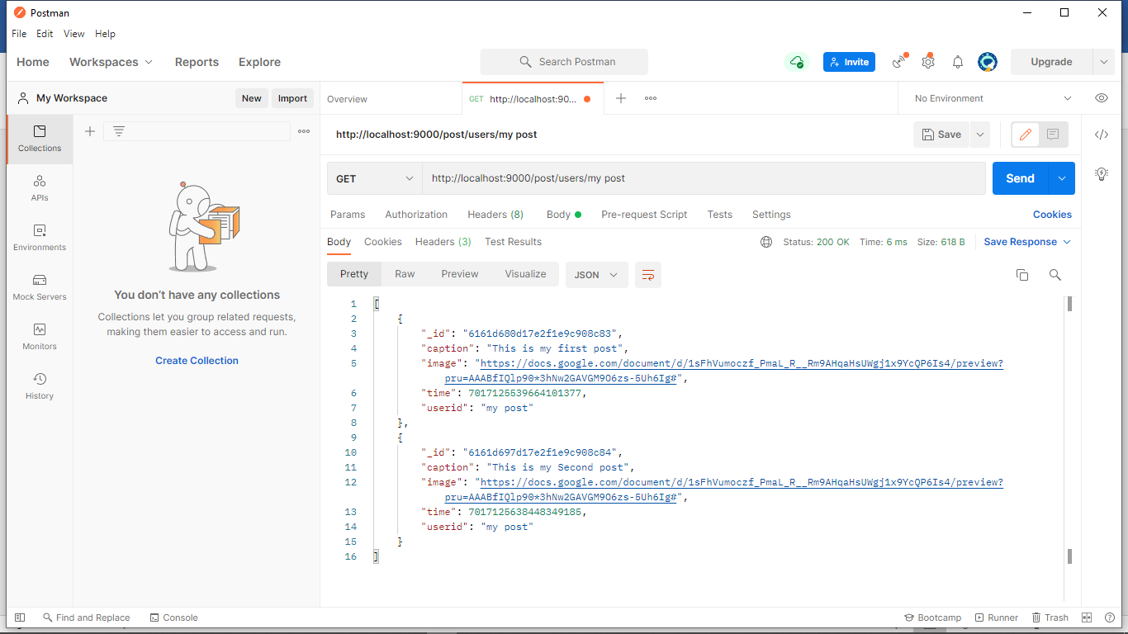

I have implemented all the 5 functions.

The additional packages that I used is httpRouter that’s it!