https://docs.spring.io/spring-framework/docs/3.2.x/spring-framework-reference/html/mvc.html

# Spring MVC

A Spring MVC is a Java framework which is used to build web applications. It follows the Model-View-Controller design pattern. It implements all the basic features of a core spring framework like Inversion of Control, Dependency Injection.

A Spring MVC provides an elegant solution to use MVC in spring framework by the help of **DispatcherServlet**. Here, **DispatcherServlet** is a class that receives the incoming request and maps it to the right resource such as controllers, models, and views.

## **Spring Web Model-View-Controller**

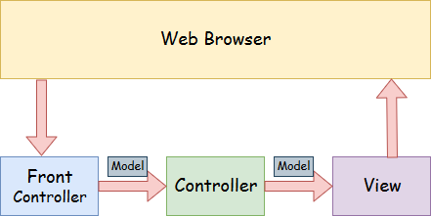

* **Model** - A model contains the data of the application. A data can be a single object or a collection of objects.
* **Controller** - A controller contains the business logic of an application. Here, the @Controller annotation is used to mark the class as the controller.
* **View** - A view represents the provided information in a particular format. Generally, JSP+JSTL is used to create a view page. Although spring also supports other view technologies such as Apache Velocity, Thymeleaf and FreeMarker.
* **Front Controller** - In Spring Web MVC, the DispatcherServlet class works as the front controller. It is responsible to manage the flow of the Spring MVC application.

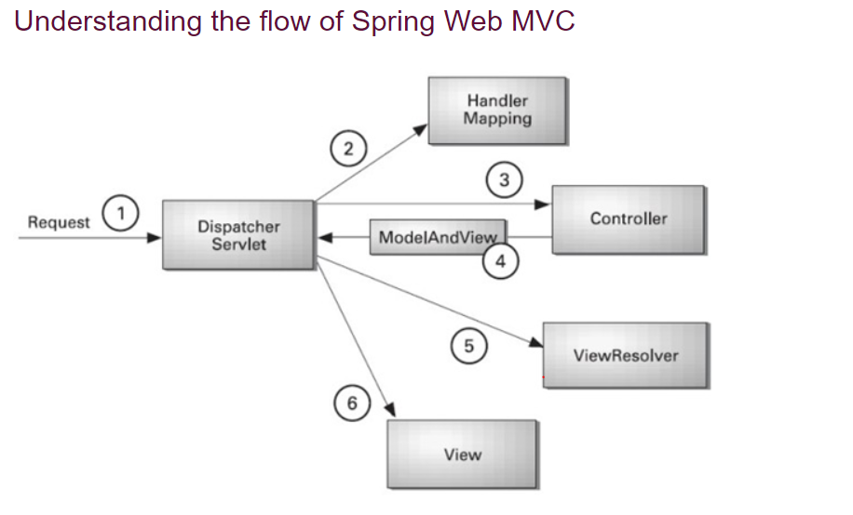

* As displayed in the figure, all the incoming request is intercepted by the DispatcherServlet that works as the front controller.
* The DispatcherServlet gets an entry of handler mapping from the XML file and forwards the request to the controller.
* The controller returns an object of ModelAndView.
* The DispatcherServlet checks the entry of view resolver in the XML file and invokes the specified view component
* **Separate roles** - The Spring MVC separates each role, where the model object, controller, command object, view resolver, DispatcherServlet, validator, etc. can be fulfilled by a specialized object.
* **Light-weight** - It uses light-weight servlet container to develop and deploy your application.
* **Powerful Configuration** - It provides a robust configuration for both framework and application classes that includes easy referencing across contexts, such as from web controllers to business objects and validators.
* **Rapid development** - The Spring MVC facilitates fast and parallel development.
* **Reusable business code** - Instead of creating new objects, it allows us to use the existing business objects.
* **Easy to test** - In Spring, generally we create JavaBeans classes that enable you to inject test data using the setter methods.
* **Flexible Mapping** - It provides the specific annotations that easily redirect the page.

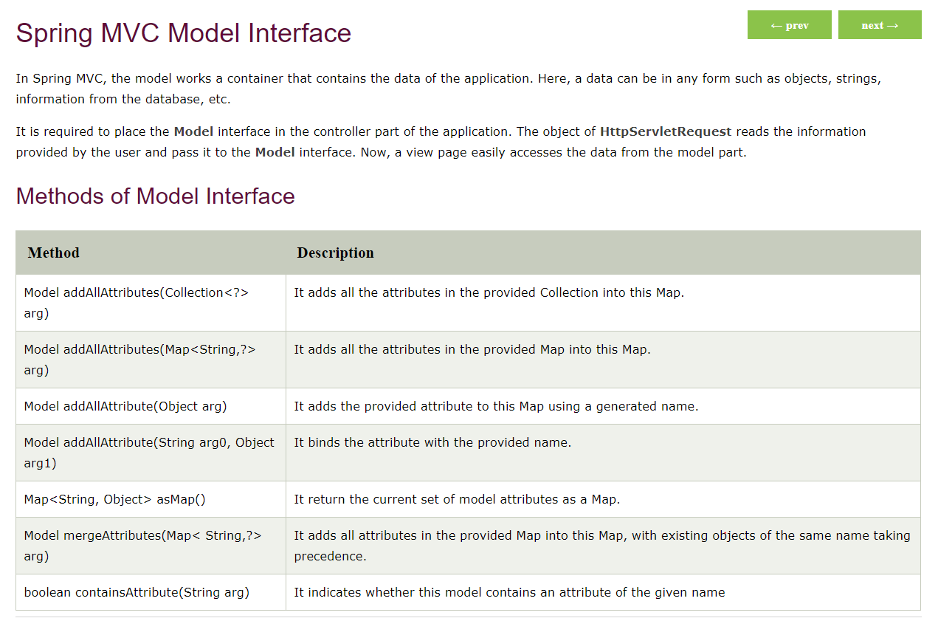

# Spring MVC RequestParam Annotation

In Spring MVC, the **@RequestParam** annotation is used to read the form data and bind it automatically to the parameter present in the provided method. So, it ignores the requirement of **HttpServletRequest** object to read the provided data.

Including form data, it also maps the request parameter to query parameter and parts in multipart requests. If the method parameter type is Map and a request parameter name is specified, then the request parameter value is converted to a Map else the map parameter is populated with all request parameter names and values.