🎨 Drawing Pad using Python Tkinter

📌 Project Overview
This project is a simple Drawing Pad application developed using Python and the Tkinter GUI library. It allows users to draw freely on a canvas, create basic shapes, choose colors, adjust brush and eraser sizes, and clear the canvas. The project demonstrates event-driven programming, GUI design, and canvas manipulation in Python.

✨ Features
- 🖊️ Freehand drawing (Pen Tool)
- 🎨 Color picker using Tkinter Color Chooser
- 📏 Adjustable brush size
- 🧽 Adjustable eraser size
- ▭ Rectangle drawing tool
- ⭕ Circle drawing tool
- 🗑️ Clear canvas option
- 🚪 Exit application
- 📢 Status bar displaying the currently selected tool

🛠️ Technologies Used
- Python 3.x
- Tkinter
- Tkinter Canvas
- Tkinter ColorChooser

📂 Project Structure
DrawingPad/
│
├── drawing_pad.py
├── README.md
└── screenshots/
└── drawing_pad.png (Optional)

▶️ How to Run

Step 1: Clone the Repository
git clone https://github.com/your-username/DrawingPad.git

Step 2: Navigate to the Project Folder
cd DrawingPad

Step 3: Run the Program
python drawing_pad.py

📖 How to Use
- Launch the application.
- Choose a drawing color using the Choose Color button.
- Select the desired brush size using the brush size slider.
- Draw freely on the canvas using the Pen tool.
- Select Rectangle or Circle to draw shapes.
- Use the Eraser with the eraser size slider to erase drawings.
- Click Clear to remove everything from the canvas.
- Click Exit to close the application.

📷 Application Interface
You can add screenshots inside a screenshots folder and display them here.
Example:
screenshots/
drawing_pad.png
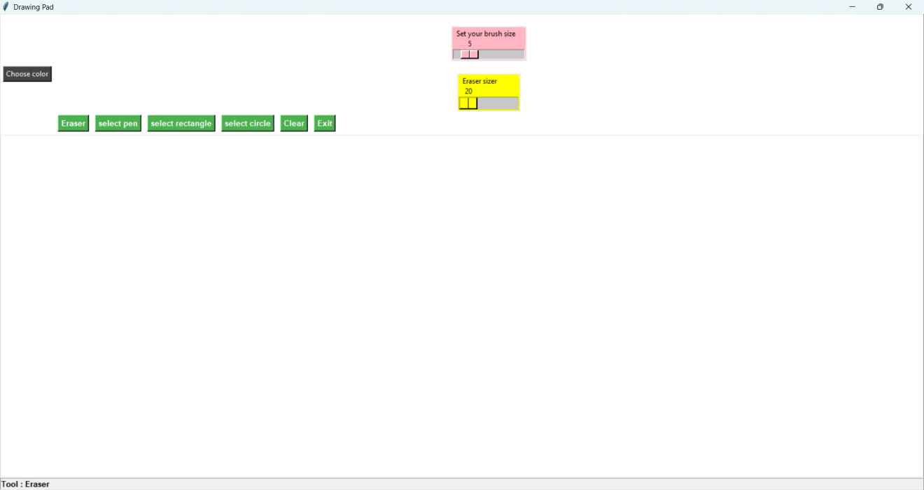

📚 Concepts Demonstrated
This project demonstrates the following Python concepts:
- Tkinter GUI Programming
- Event Handling
- Mouse Events
- Canvas Widget
- Functions
- Global Variables
- Buttons
- Sliders (Scale Widget)
- Color Chooser
- Shape Drawing
- Coordinate Handling

🔮 Future Enhancements
- Save drawing as PNG or JPG
- Open existing images
- Undo and Redo functionality
- Fill Color tool
- Line tool
- Triangle and Polygon tools
- Text tool
- Shape preview while dragging
- Keyboard shortcuts
- Toolbar with icons
- Dark mode support

🎯 Learning Outcomes
Through this project, I learned:
- Building graphical user interfaces using Tkinter
- Handling mouse events for drawing
- Working with Canvas objects
- Implementing drawing tools and shapes
- Managing application state using variables and functions
- Designing an interactive desktop application

👩‍💻 Author
K.Bhavya Sree
B.Tech – Artificial Intelligence & Data Science (AI&DS)
VVIT University

📄 License
This project is developed for educational and learning purposes. Feel free to use and modify it for personal or academic projects.

