**Week-5 Hands-On Solutions**

**Microservices**

**Exercise 1: Creating Microservices for account and loan**

**1.Objective:**

This projects builds a simple microservices-based architecture using Spring Boot that provides:

* Account Service: Handles customer account data.
* Loan Service: Fetches loan details by customer ID.

**2.Project Folder:**

C:\Users\sree\Desktop\123456\microservices

├── account

─src\main\java\com\cognizant\account\controller\AccountController.java

└── loan

─ src\main\java\com\cognizant\loan\controller\LoanController.java

**3.In Intellij Idea:**

Building with Maven (for each service)

1. Open terminal , navigate to each service folder (account and loan)
2. Run :
3. mvn clean install

**4.CREATING CONTROLLERS:**

1.Create AccountController java class in

Path:src/main/java/com/cognizant/account/controller/AccountController.java

**AccountController.java:**

package com.cognizant.account.controller;

import org.springframework.web.bind.annotation.*;

import java.util.*;

@RestController

@RequestMapping("/accounts")

public class AccountController {

@GetMapping("/{number}")

public Map<String, Object> getAccountDetails(@PathVariable String number) {

Map<String, Object> response = new HashMap<>();

response.put("number", number);

response.put("type", "savings");

response.put("balance", 234343);

return response;

}

}

**pom.xml:**

<?xml version="1.0" encoding="UTF-8"?>  
<project xmlns="http://maven.apache.org/POM/4.0.0" xmlns:xsi="http://www.w3.org/2001/XMLSchema-instance"  
 xsi:schemaLocation="http://maven.apache.org/POM/4.0.0 https://maven.apache.org/xsd/maven-4.0.0.xsd">  
 <modelVersion>4.0.0</modelVersion>  
 <parent>  
 <groupId>org.springframework.boot</groupId>  
 <artifactId>spring-boot-starter-parent</artifactId>  
 <version>3.5.3</version>  
 <relativePath/> <!-- lookup parent from repository -->  
 </parent>  
 <groupId>com.cognizant</groupId>  
 <artifactId>account</artifactId>  
 <version>0.0.1-SNAPSHOT</version>  
 <name>account</name>  
 <description>Microservice for handling account details</description>  
 <url/>  
 <licenses>  
 <license/>  
 </licenses>  
 <developers>  
 <developer/>  
 </developers>  
 <scm>  
 <connection/>  
 <developerConnection/>  
 <tag/>  
 <url/>  
 </scm>  
 <properties>  
 <java.version>17</java.version>  
 </properties>  
 <dependencies>  
 <dependency>  
 <groupId>org.springframework.boot</groupId>  
 <artifactId>spring-boot-starter-web</artifactId>  
 </dependency>  
  
 <dependency>  
 <groupId>org.springframework.boot</groupId>  
 <artifactId>spring-boot-devtools</artifactId>  
 <scope>runtime</scope>  
 <optional>true</optional>  
 </dependency>  
 <dependency>  
 <groupId>org.springframework.boot</groupId>  
 <artifactId>spring-boot-starter-test</artifactId>  
 <scope>test</scope>  
 </dependency>  
 </dependencies>  
  
 <build>  
 <plugins>  
 <plugin>  
 <groupId>org.springframework.boot</groupId>  
 <artifactId>spring-boot-maven-plugin</artifactId>  
 </plugin>  
 </plugins>  
 </build>  
  
</project>

**AccountApplication.java:**

package com.cognizant.account;  
  
import org.springframework.boot.SpringApplication;  
import org.springframework.boot.autoconfigure.SpringBootApplication;  
  
@SpringBootApplication  
public class AccountApplication {  
  
 public static void main(String[] args) {  
 SpringApplication.run(AccountApplication.class, args);  
 }  
  
}

**application.properties:**

spring.application.name=account  
server.port=8080

**To Run the application:**

Right-click on AccountApplication.java → Run

**Test in the Browser or Postman:**

🡪http://localhost:8080/accounts/00987987973432

**5.Output:**

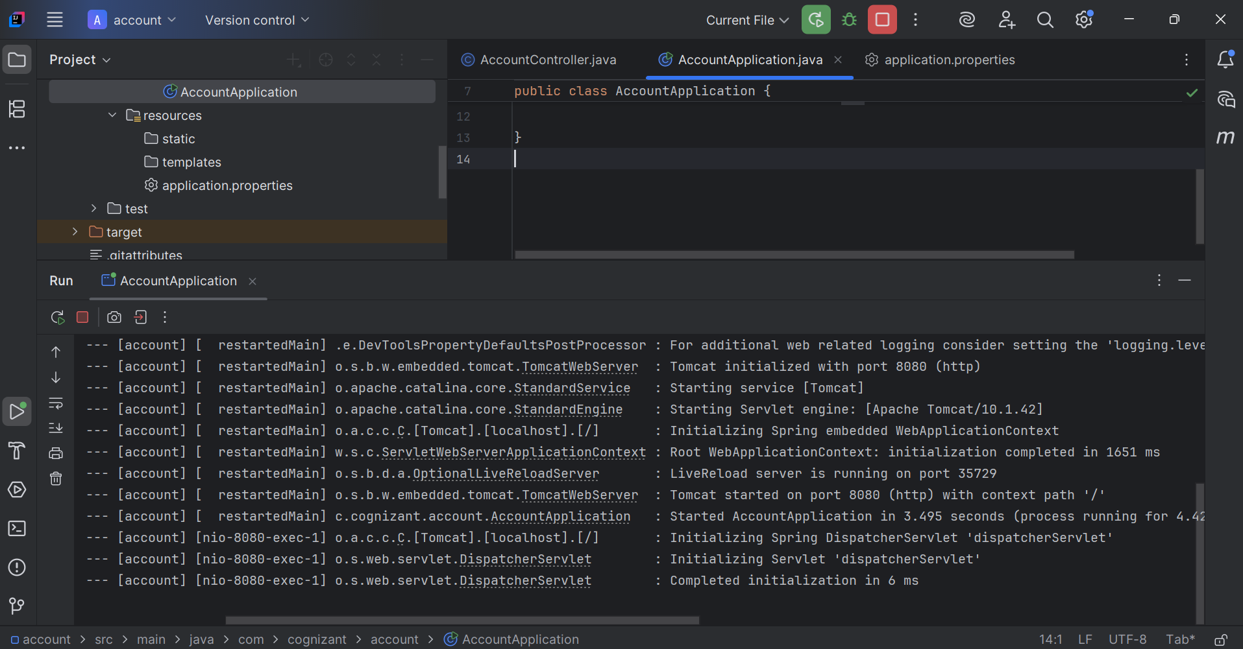

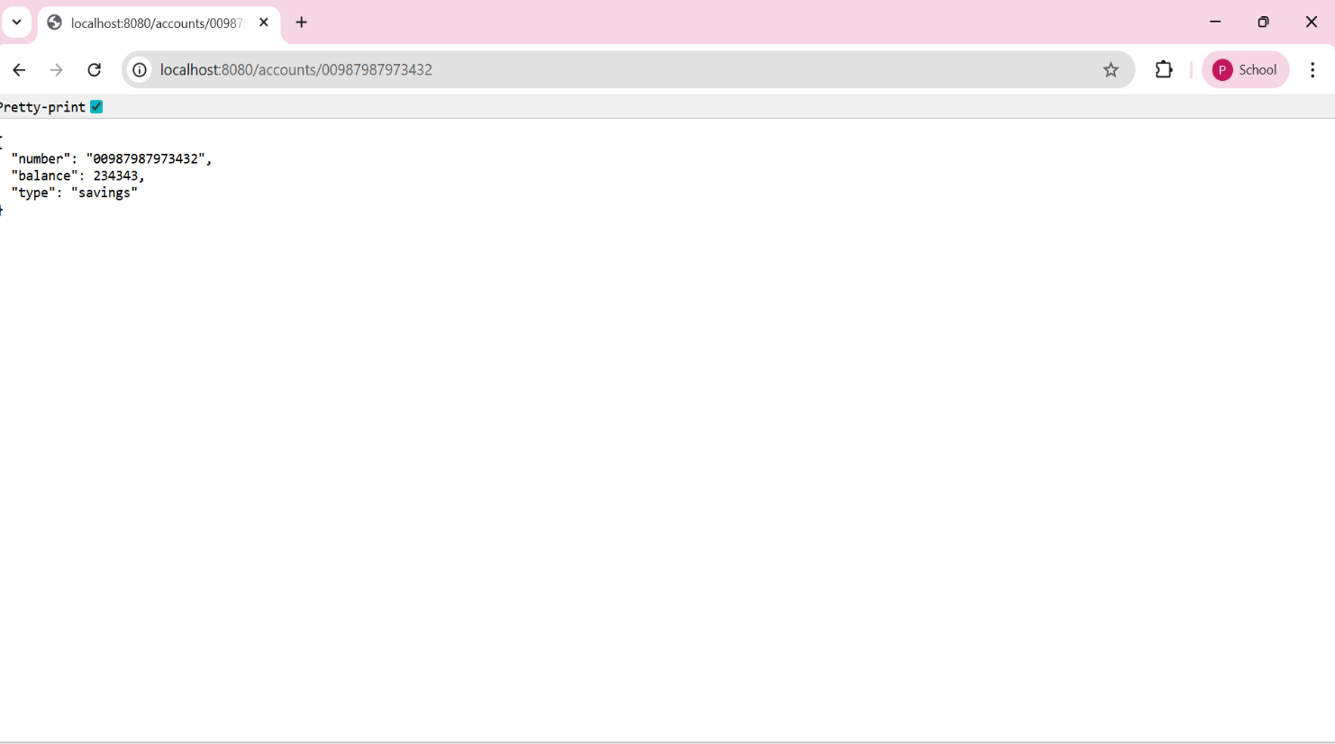

2.Create LoanController java class in

Path:src/main/java/com/cognizant/account/controller/LoanController.java

**LoanController.java:**

package com.cognizant.loan.controller;  
  
import org.springframework.web.bind.annotation.*;  
import java.util.*;  
  
@RestController  
@RequestMapping("/loans")  
public class LoanController {  
  
 @GetMapping("/{number}")  
 public Map<String, Object> getLoanDetails(@PathVariable String number) {  
 Map<String, Object> response = new HashMap<>();  
 response.put("number", number);  
 response.put("type", "car");  
 response.put("loan", 400000);  
 response.put("emi", 3258);  
 response.put("tenure", 18);  
 return response;  
 }  
}

**LoanApplication.java:**

package com.cognizant.loan;  
  
import org.springframework.boot.SpringApplication;  
import org.springframework.boot.autoconfigure.SpringBootApplication;  
  
@SpringBootApplication  
public class LoanApplication {  
  
 public static void main(String[] args) {  
 SpringApplication.*run*(LoanApplication.class, args);  
 }  
  
}

**application.properties:**

spring.application.name=loan  
server.port=8081

**To Run the application:**

Right-click on LoanApplication.java → Run

**Test in the Browser or Postman:**

🡪http://localhost:8081/loans/H00987987972342

**Output:**

