WEEK 6

[ReactJs]

**OBJECTIVES:**

**1.Define SPA and its benefits**

SPA stands for Single Page Application.

It is a web application or website that loads a single HTML page and updates the content dynamically as the user interacts with it — without reloading the entire page from the server.

**2.Define React and identify its working**

React is a JavaScript library used to build user interfaces (UIs) — especially for Single Page Applications (SPAs).

It helps developers build reusable UI components (like buttons, forms, cards) that update efficiently when data changes — without reloading the whole page.

**3.Identify the differences between SPA and MPA**

| **SPA (Single Page Application)** | **MPA (Multi Page Application)** |
| --- | --- |
| Loads a single HTML page | Loads a new HTML page for each view |
| No full-page reloads | Full-page reloads on every navigation |
| Faster user experience after first load | Slower due to frequent reloads |
| Uses JavaScript to update content | Server sends a new page for every request |
|  |  |

**4.Explain Pros & Cons of Single-Page Application**

| **Pros** | **Cons** |
| --- | --- |
| Fast and responsive | Poor SEO (unless optimized) |
| Feels like a mobile app | Slower first load |
| Reusable components | Needs JavaScript always |
| Easy to update UI dynamically | Complex setup for routing and state |
| Works well with APIs | Less secure if not handled properly |

**Steps to create:**

**1.Create React App Using npx:**

**🡪**npx create-react-app myfirstreact

**2.Edit App.js File in VSCode :**

import React from 'react';

function App() {

return (

<div>

<h1>Welcome to the first session of React</h1>

</div>

);

}

export default App;

**3. Start the React App**

**🡪** **npm start in terminal**

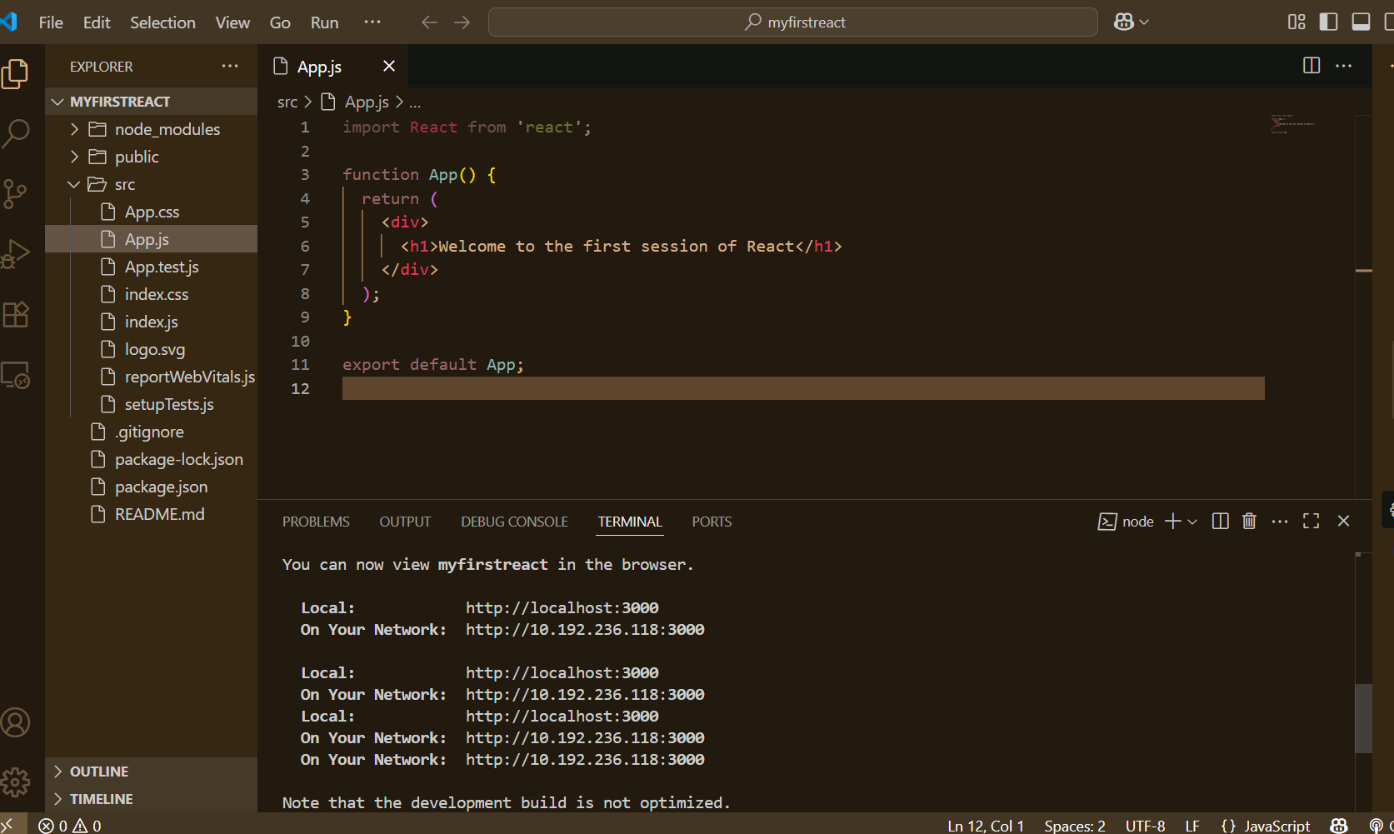

**4.View in Browser**

* **It will automatically open:** [**http://localhost:3000**](http://localhost:3000)

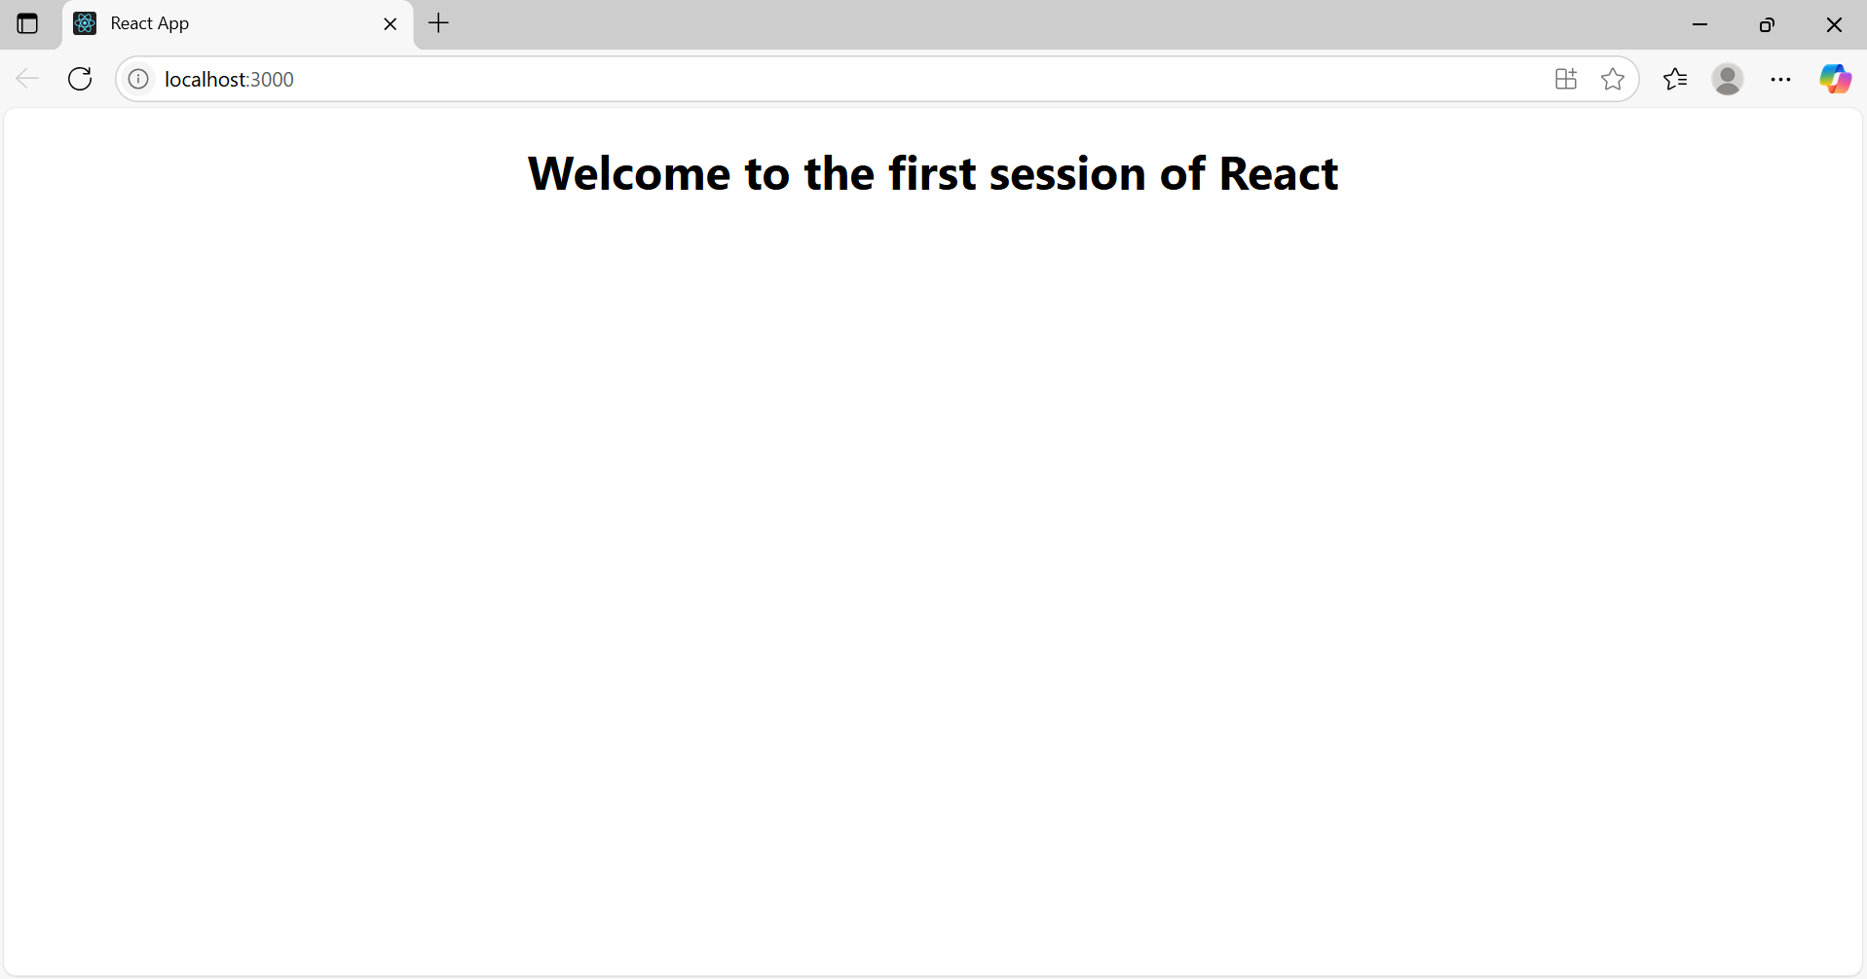

**Exercise 2:**

**Create a react app for Student Management Portal named StudentApp and create a component named Home which will display the Message “Welcome to the Home page of Student Management Portal”. Create another component named About and display the Message “Welcome to the About page of the Student Management Portal”. Create a third component named Contact and display the Message “Welcome to the Contact page of the Student Management Portal”. Call all the three components.**

**1.**create project folder as **studentapp**

**2.**Inside src create subfolder **components**

**3.create components**

**Src/components/**

* Home.js
* About.js
* Contact.js

**Src/components/Home.js**

import React from 'react';

function Home() {

    return (

        <div>

            <h2>Welcome to the Home page of Student Management Portal</h2>

        </div>

    );

}

export default Home;

**Src/components/About.js**

import React from 'react';

function About() {

    return (

        <div>

            <h2>Welcome to the About page of the Student Management Portal</h2>

        </div>

    );

}

export default About;

**Src/components/Contact.js**

import React from 'react';

function Contact() {

    return (

        <div>

            <h2>Welcome to the Contact page of the Student Management Portal</h2>

        </div>

    );

}

export default Contact;

**App.js**

import React from 'react';

import Home from './Components/Home';

import About from './Components/About';

import Contact from './Components/Contact';

function App() {

  return (

    <div>

      <Home />

      <About />

      <Contact />

    </div>

  );

}

export default App;

**Output:**

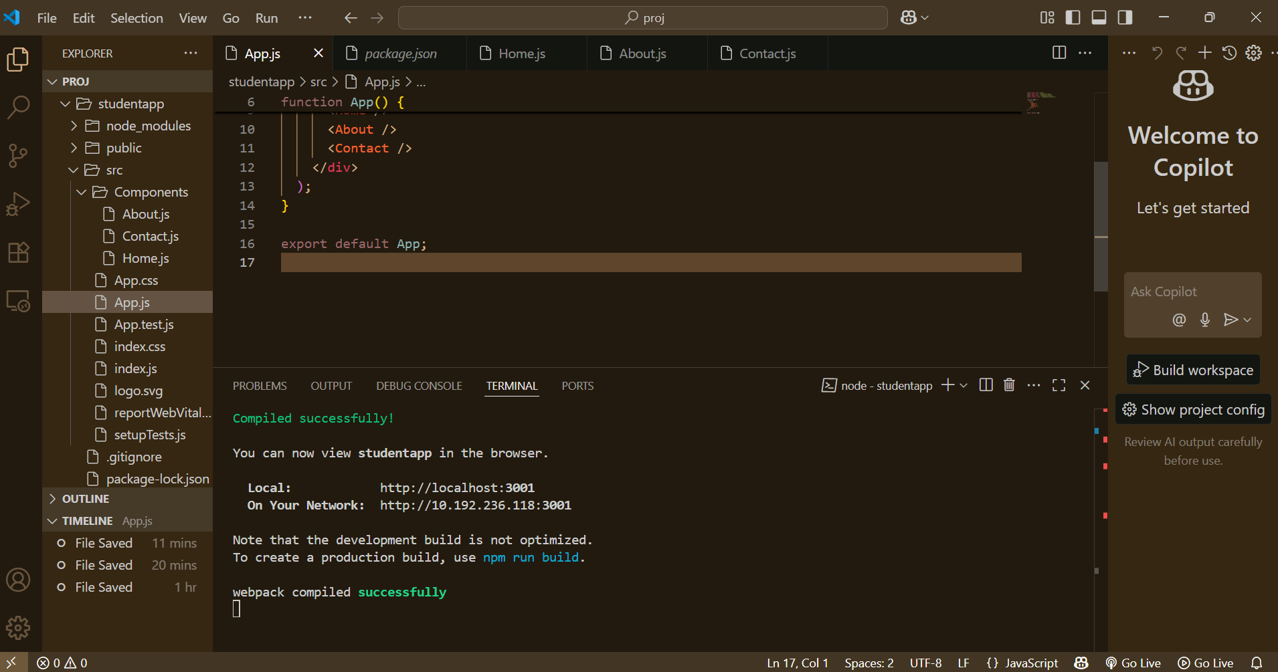

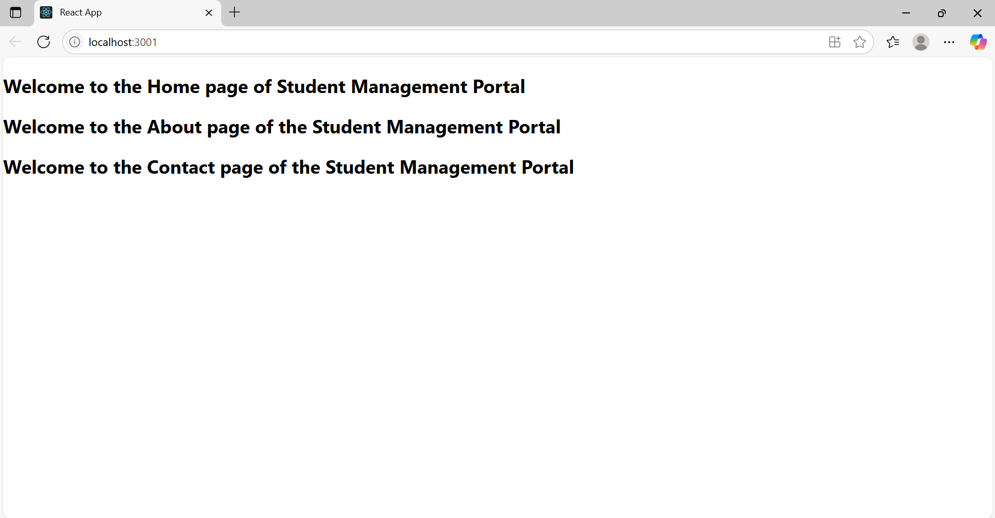

**Exercise 3:**

**1.**create the project folder as **scorecalculatorapp**

**2.**created a folder under src with name as **Components**

**3.**added a new file name as **Calculatescore**

**Calculatescore.js**

import '../Stylesheets/mystyle.css';

const percentToDecimal = (decimal) => {

    return (decimal.toFixed(2) + '%');

};

const calcScore = (total, goal) => {

    return percentToDecimal(total / goal);

};

const CalculateScore = ({ Name, School, total, goal }) => (

    <div className="formatstyle">

        <h1><font color="Brown">Student Details:</font></h1>

        <div className="Name">

            <b><span>Name: </span></b>

            <span>{Name}</span>

        </div>

        <div className="School">

            <b><span>School: </span></b>

            <span>{School}</span>

        </div>

        <div className="Total">

            <b><span>Total: </span></b>

            <span>{total} Marks</span>

        </div>

        <div className="Score">

            <b>Score:</b>

            <span>{calcScore(total, goal)}</span>

        </div>

    </div>

);

export default CalculateScore;

**src/Stylesheets/mystyle.css**

**mystyle.css**

.Name {

    font-weight: 300;

    color: blue;

}

.School {

    color: crimson;

}

.Total {

    color: darkmagenta;

}

.formatstyle {

    text-align: center;

    font-size: large;

}

.Score {

    color: forestgreen;

}

**App.js**

import CalculateScore from './Components/CalculateScore';

function App() {

  return (

    <div>

      <CalculateScore

        Name={"Sparkle"}

        School={"ABC Public School"}

        total={284}

        goal={3}

      />

    </div>

  );

}

export default App;

**Output:**

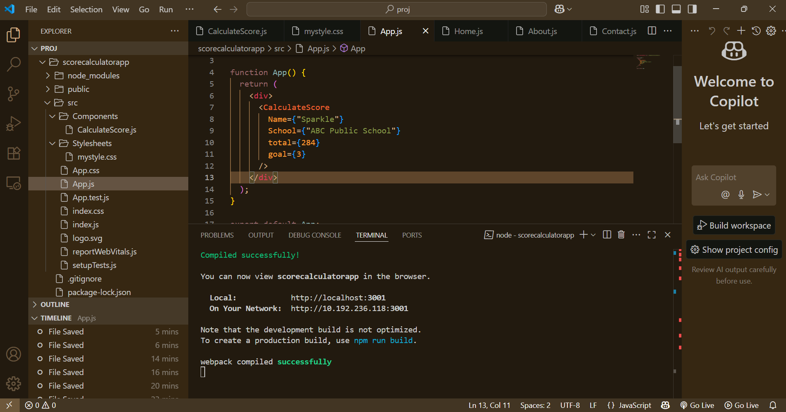

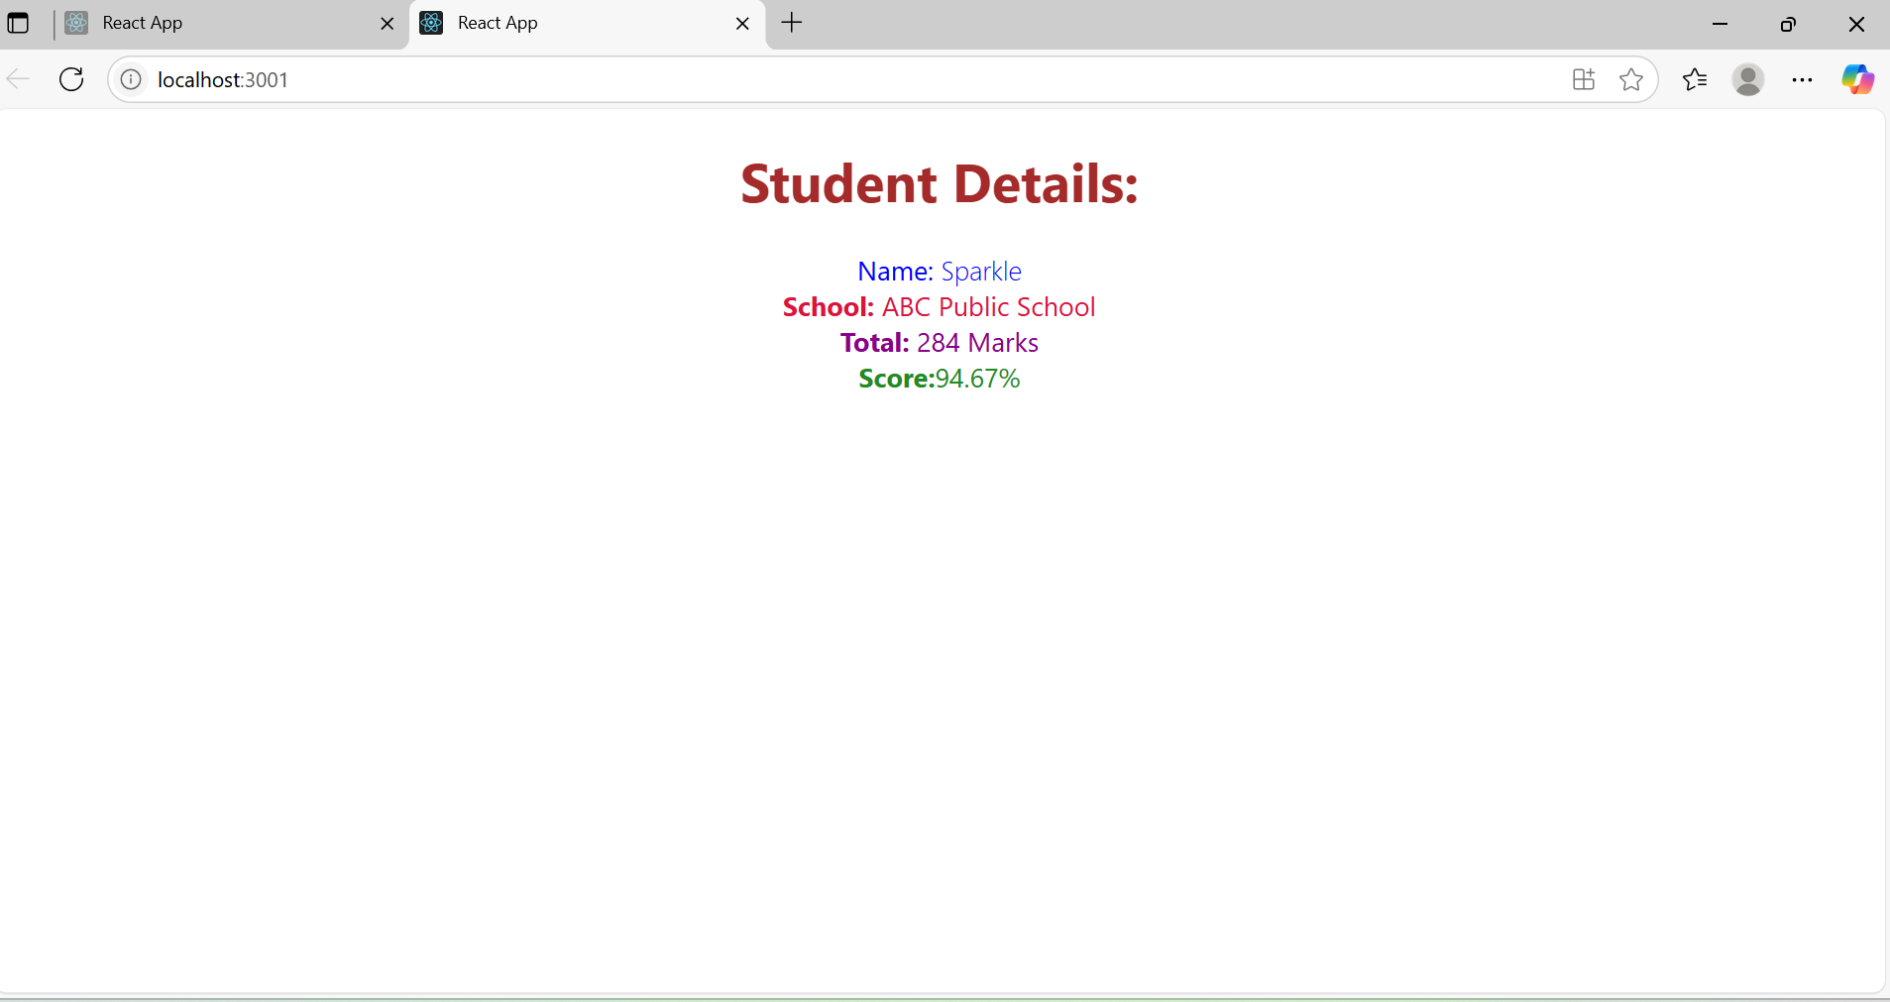

**Exercise 4:**

1.Created a New React Application

**🡪** npx create-react-app blogapp

2. Inside src/, create a new file called Post.js. Add this class:

**// src/Post.js**

import React from 'react';

class Post extends React.Component {

render() {

const { title, body } = this.props;

return (

<div style={{ marginBottom: '20px' }}>

<h2>{title}</h2>

<p>{body}</p>

</div>

);

}

}

export default Post;

4.Created another file in src/ called Posts.js:

// src/Posts.js

import React from 'react';

import Post from './Post';

class Posts extends React.Component {

constructor(props) {

super(props);

this.state = {

posts: [],

error: null

};

}

loadPosts = () => {

fetch('https://jsonplaceholder.typicode.com/posts')

.then((response) => {

if (!response.ok) {

throw new Error('Failed to fetch posts');

}

return response.json();

})

.then((data) => {

this.setState({ posts: data });

})

.catch((error) => {

this.setState({ error });

});

};

componentDidMount() {

this.loadPosts();

}

componentDidCatch(error, info) {

alert(`Error occurred: ${error.message}`);

}

render() {

const { posts, error } = this.state;

if (error) {

return <h3>Error loading posts.</h3>;

}

return (

<div>

<h1>Blog Posts</h1>

{posts.map((post) => (

<Post key={post.id} title={post.title} body={post.body} />

))}

</div>

);

}

}

export default Posts;

**App.js**

// src/App.js

import React from 'react';

import Posts from './Posts';

function App() {

return (

<div className="App">

<Posts />

</div>

);

}

export default App;

5.Run the Application as **npm start**

**Output:**

