SIMATS ENGINEERING
ASSESSMENT TOOL 1

COURSE NAME: CSA16 COURSE CODE: Data Warehousing and Data Mining

COURSE OUTCOME COVERED

CO1: Design data warehouse architectures with appropriate dimensional models for effective decision support systems. BL1,BL2
Assessment Tool Weightage: 40%

QUESTIONS: 4 Total Marks:20

Annexure A
MCQ TEST

Criteria | Conceptual Understanding(3) | Accuracy of Answer(2.5) | Application of Knowledge(2) | Completeness of Response(1.5) | Clarity & Presentation(1) | Total(10)
Weightage | 30% | 25% | 20% | 15% | 10% | 100%
Q1
Q2
Q3
Q4

Code of Conduct:

I P.bhavyasree(192324106)(Name / Reg No) certify that this submission is my original work and that I have adhered to the guidelines specified for this assessment.
I understand that any violation of academic integrity rules will result in disciplinary action. P.Bhavyasree
Signature of the student:

RUBRICS FOR CALCULATION

Criteria | Weightage | Level 4 –  Exemplary (5 Marks) | Level 3 –  Proficient (4 Marks) | Level 2 – Developing (2–3 Marks) | Level 1 – Beginning (0–1 Mark)
Conceptual Understandin g | 30 | Demonstrates clear and complete understanding of the concept | Good understanding with minor gaps | Basic understanding with some misconceptions | Poor or incorrect understandin g
Accuracy of Answer | 25 | Completely correct answer with no errors | Mostly correct with minor errors | Partially correct with noticeable errors | Incorrect or irrelevant answer
Application of Knowledge | 20 | Correctly applies concepts to solve the question/problem | Applies concepts with minor mistakes | Limited or partially correct application | No or incorrect application
Completenes s of Response | 15 | Covers all required parts of the question | Covers most parts with minor omissions | Covers only some parts | Incomplete or missing response
Clarity & Presentation | 10 | Clear, concise, and well-organized answer | Understandabl e with minor issues | Somewhat unclear or poorly structured | Difficult to understand

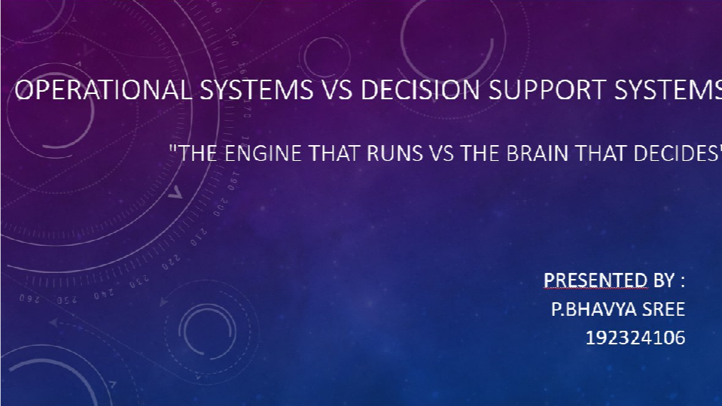


INTRODUCTION


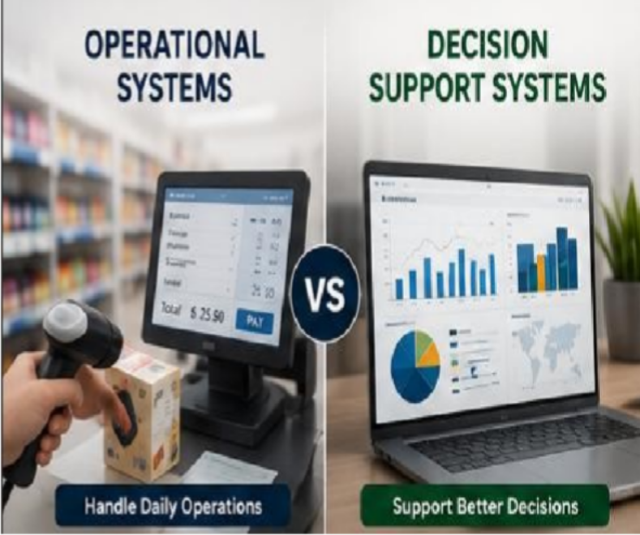
Imagine Running a Supermarket!
- Every time a customer buys a product, the billing system records the sale.
- At the end of the month, the manager checks which products sold the most and plans future stock.
Are both systems doing the same job?
- No! One performs daily operations.
- The other helps in making better business decisions. let's understand these two important systems.

OPERATIONAL SYSTEM


An Operational System is a computer system that handles the day-to-day activities of an organization.
Key Idea:
It keeps the business running smoothly every day. Operational System = Works Today
It performs:
- Billing
- Attendance
- Payroll
- Inventory updates
- Online transactions

Real-Life Examples :
- ATM Transactions
- Hospital Registration
- College Attendance System
- Railway Ticket Booking


DECISION SUPPORT SYSTEM (DSS)

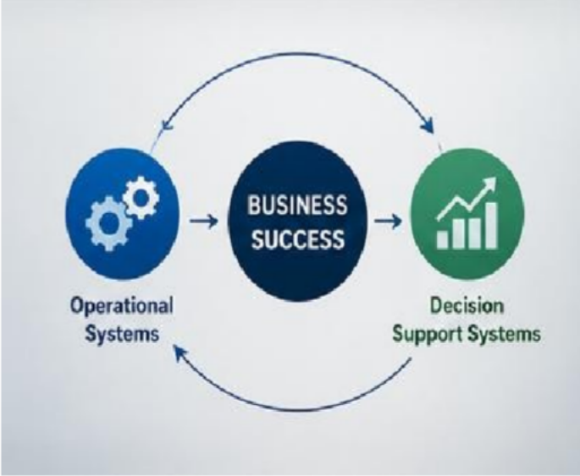
A Decision Support System helps managers analyze information and make better business decisions.
Key Idea:
DSS doesn't replace managers—it helps them make smarter decisions.

Examples
  - Sales Analysis Dashboard
  - Business Intelligence Reports
  - Hospital Disease Prediction
  - Weather Forecast Analysis DSS = Plans for Tomorrow


OPERATIONAL SYSTEM VS DSS (COMPARISON)

Feature | Operational System | Decision Support System
Purpose | Perform daily tasks | Help make decisions
Users | Employees, Cashiers | Managers, Executives
Data | Current transactions | Historical + Current Data
Speed | Very Fast | Analytical
Output | Bills, Receipts | Reports, Graphs
Focus | Efficiency | Improvement

REAL-LIFE EXAMPLE

Morning : Customer buys:
    - Rice
    - Milk
    - Soap
Operational System :
    - Generates bill
    - Updates stock
    - Accepts payment
    - Prints receipt
Conclusion
Month End :
Manager asks :
- Which product sold most?
- Which product is not selling?
- Which supplier gives better profit? Decision Support System :
- Generates charts
- Predicts demand
- Suggests stock planning


- Operational System works every minute.
- DSS works when decisions are needed.

ADVANTAGES & LIMITATIONS



Operational System : Advantages
Fast processing Accurate records Reduces manual work Available 24/7
Limitations
✘ Cannot predict the future
✘ Doesn't analyze trends
Decision Support System : Advantages :

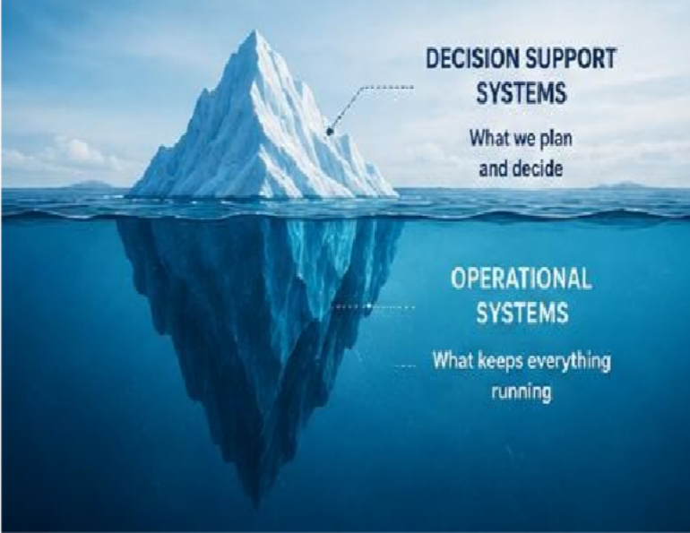
Better decisions Saves time
Predicts future trend Reduces business risk
Limitations :
✘ Depends on quality of data
✘ Requires skilled users


CONCLUSION

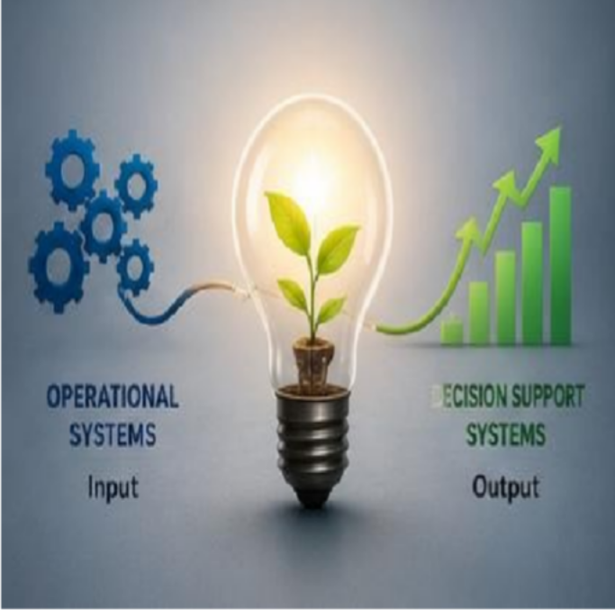
Operational System :
  - Performs daily operations
  - Fast and accurate
  - Transaction-oriented

Decision Support System :
  - Helps managers
  - Uses reports and analysis
  - Improves decision making

"Operational Systems keep the business running. Decision Support Systems help the business grow."





