CO1_AT2_Application based questions
P.Bhavyasree
192324106
1.Library Fine Calculation
A library stores book issue records in CSV format and member information in JSON format. Write a Python program to identify overdue books, calculate fines based on the number of overdue days, and generate a member-wise fine report.
Solution:
- To read library book issue records from a CSV file and member details from a JSON file, identify overdue books, calculate fines, and generate a member-wise fine report.
Concepts used
- CSV File Handling , JSON File Handling , Python Dictionary , Loops ,Date Handling , Conditional Statements , Pandas.
Program:
import csv
import json
from datetime import datetime
# Load member details from JSON
with open("members.json", "r") as file:
members = json.load(file)
member_dict = {}
for member in members:
member_dict[member["MemberID"]] = member["Name"]
# Today's date
today = datetime(2026, 7, 22)
print("====== MEMBER WISE FINE REPORT ======\n")

# Read book records from CSV
with open("books.csv", "r") as file:
reader = csv.DictReader(file)
for row in reader:
due_date = datetime.strptime(row["DueDate"], "%Y-%m-%d")
overdue_days = (today - due_date).days
if overdue_days > 0:
fine = overdue_days * 2
member_name = member_dict[row["MemberID"]]
print("Member ID :", row["MemberID"])
print("Member Name :", member_name)
print("Book :", row["BookName"])
print("Overdue Days :", overdue_days)
print("Fine : ₹", fine)
print("----------------------------")
output:
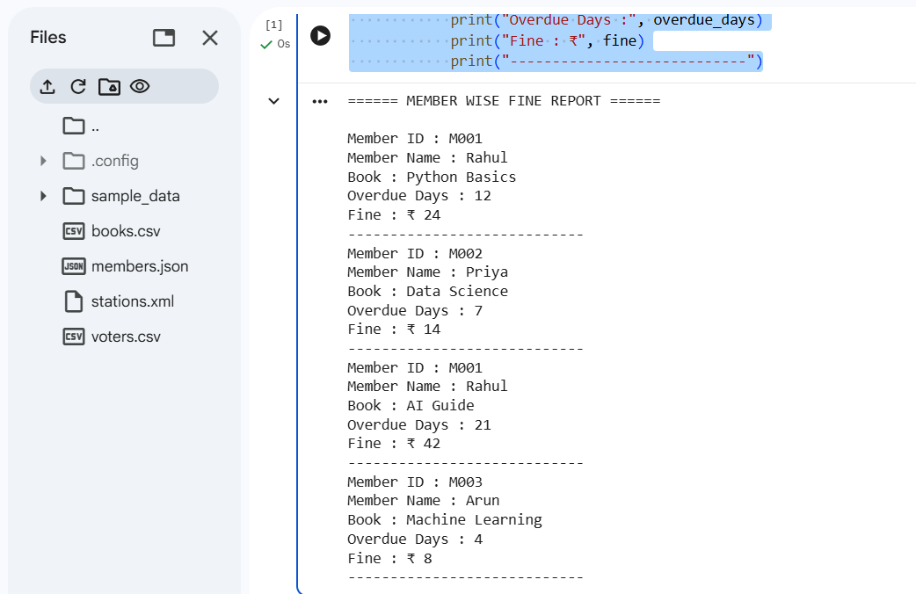
2.Election Voter Management
An election commission stores voter details in CSV format and polling station information in XML format. Write a Python program to combine both datasets, identify duplicate voter records, and generate a polling station-wise voter list.
Solution:
- Read voter details from CSV and polling station details from XML, combine them, identify duplicate voter records, and generate polling station-wise voter lists.
Concepts used:
- CSV , XML ,Pandas ,XML Parsing ,Merge ,Duplicate Detection.

Program:
import csv
import xml.etree.ElementTree as ET
# Read XML file
tree = ET.parse("stations.xml")
root = tree.getroot()
stations = {}
for station in root.findall("Station"):
sid = station.find("StationID").text
sname = station.find("StationName").text
stations[sid] = sname
# Read CSV file
voters = []
with open("voters.csv", "r") as file:
reader = csv.DictReader(file)
for row in reader:
voters.append(row)
# Find duplicate voter names
print("====== DUPLICATE VOTERS ======\n")
names = []
for voter in voters:
if voter["Name"] in names:
print(voter["Name"])
else:
names.append(voter["Name"])
# Polling station-wise voter list
print("\n====== POLLING STATION WISE LIST ======\n")
for station_id, station_name in stations.items():
print(station_name)
for voter in voters:
if voter["StationID"] == station_id:
print(" ", voter["Name"])
print("----------------------")
output:
