EXPERIMENT-02

Customer Feedback Analysis
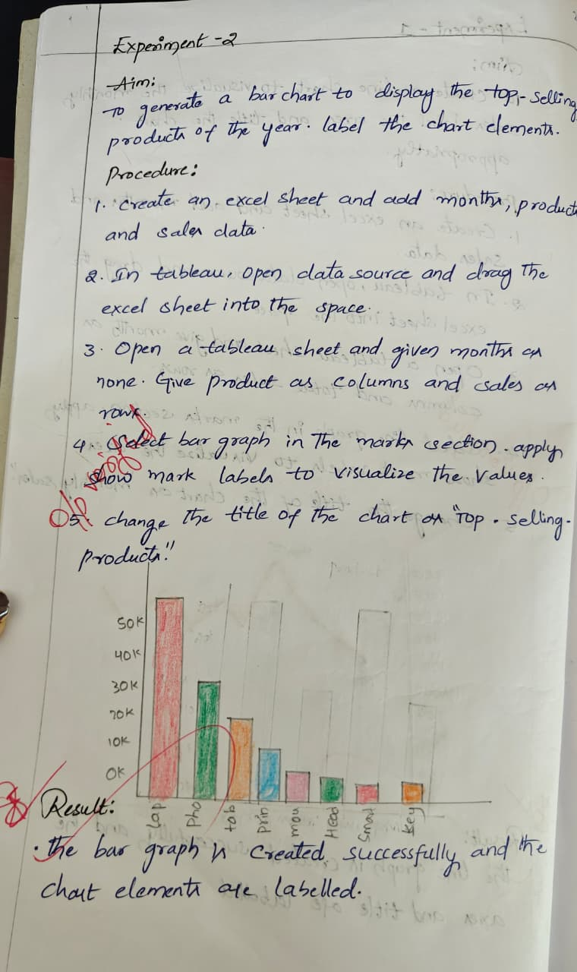

OUTPUT:
