**Table of Contents:**

Scope of the Study 3

Literature Review and Structure, Planning and Research Design……………….3

The ARMA Model ………………………………………………………………5

* Autocorrelation Function and Partial Autocorrelation Function…………5
* AIC & BIC……………………………………………………………….7
* Static Forecasts…………………………………………………………...8
* Dynamic Forecasts…………………………………………………… …9
* Smoothing……………………………………………………………….11
* ADF Test……………………………………..........................................12
* DFGLS Test……………………………………………………………..13
* MDF Test………………………………………………………………..14
* Zivot-Andrews Test………………………………………………….….14

VaR Estimation………………………………………………………………...15

* Residuals Correlation…………………………………………………...15
* Impulse Responses……………………………………………………...16
* Forecast Error Variance………………………………………………....17

Cointegration………………………………….……………………………….18

* Predictions vs Index……………………………………………….........18
* Residual Stationarity…………………………………………………....18
* Error Correction Model………………………………………………....19

List of References…………………………………………………...................20

Appendix 1…………………………………………………………………….21

Appendix 2………………………………………...…………………………..21

**Scope of Study:**

*Exploring Interrelationships Among Stock Markets: A Comparative Analysis of South Korea, Germany, and France*

The globalization of financial markets has heightened the interconnectedness of stock markets worldwide, leading to increased interest in understanding the dynamics of their interactions. This study focuses on investigating the interrelationships among the stock markets of South Korea, Germany, and France.

The central research question driving this study is: How do the stock markets of South Korea, Germany, and France interact with each other? This question encompasses several sub-questions:

• What are the patterns and forecasting capabilities within each market, as revealed by ARMA models?

• Do causal relationships exist among the market indices, and if so, what is their direction and strength?

• Is there evidence of a cointegration relationship among the stock market indices, indicating a long-term equilibrium relationship?

This study will employ a multi-faceted approach to address the research question comprehensively. Firstly, ARMA models will be constructed for each country's stock market index—KOSPI for South Korea, DAX for Germany, and CAC 40 for France. These models will analyse the returns and volatility dynamics within each market, providing insights into their individual characteristics and forecasting capabilities.

**Literature Review and Structure, Planning and Research Design:**

*Review:*

This study aims to clarify the interconnection of global stock markets and the accuracy of forecasting models by drawing on well-established theoretical frameworks in financial economics and time series analysis. The Efficient Market Hypothesis (EMH), which challenges the viability of continuously beating the market, is fundamental to this approach. It states that asset prices fully reflect all available information. Determining the behaviour of stock market indices and assessing the accuracy of forecasting models depend heavily on an understanding of the efficiency of stock markets. Furthermore, this study's examination of cross-market connections and transmission mechanisms between the stock markets of South Korea, Germany, and France is informed by intermarket analysis, which examines links across various asset classes.

The significance of examining stock market interrelationships and applying time series analysis techniques is highlighted by a review of relevant studies. In their study of the interdependence of the major stock markets, Kim and Shin (2003), for example, revealed long-term equilibrium correlations between specific market pairs. Diebold and Yilmaz (2012) presented the notion of "connectedness" as a metric for gauging the level of interconnectivity between financial markets, highlighting its importance in risk mitigation and portfolio diversification. The groundwork for analysing long-term equilibrium relationships among non-stationary time series variables was laid by the seminal work on cointegration by Engle and Granger (1987). Brooks and Tsolacos (1999) further extended this work by demonstrating the efficacy of ARMA models in forecasting stock market volatility.

Through the integration of theoretical foundations and empirical data, this research aims to enhance our comprehension of the dynamics of the global stock market and offer practical recommendations for investors, policymakers, and scholars. This research aims to shed light on the interplay between the stock markets of South Korea, Germany, and France through the application of advanced time series analysis techniques like ARMA models, VAR models, and cointegration analysis. The findings could have significant implications for risk management and financial decision-making in an interconnected global economy.

*Structure, Planning, and Research Design:*

Understanding the intricate dynamics of global stock markets is crucial in today's interconnected financial landscape. This essay outlines the structure, planning, and research design for investigating the interrelationships among the stock markets of South Korea, Germany, and France. The research aims to shed light on the co-movement, causal relationships, and cointegration dynamics among these markets using advanced time series analysis techniques.

The introduction sets the stage by highlighting the study's objectives, research questions, and significance. It provides an overview of the theoretical framework, grounded in concepts such as the Efficient Market Hypothesis (EMH) and intermarket analysis, which underpin the analysis of stock market interrelationships. Additionally, it introduces the literature review, which will synthesize existing studies on stock market dynamics and time series analysis techniques, providing a foundation for the research.

The next phase involves data collection, where historical daily or weekly stock market index data for KOSPI, DAX, and CAC 40 will be identified and collected from reputable sources. Ensuring data consistency and reliability is paramount for robust analysis. The methodology section outlines the time series analysis techniques to be employed, including ARMA modelling, VAR modelling, and cointegration analysis. The rationale for selecting these methods and their applicability to the research question are discussed, along with strategies for addressing stationarity issues.

Model development follows, with ARMA models constructed for each market index to analyse returns and volatility dynamics. Additionally, a VAR model will be developed to examine causal relationships among market indices, while cointegration analysis will assess long-term equilibrium relationships. These models will serve as the analytical backbone of the study, enabling comprehensive exploration of stock market interrelationships.

The analysis phase involves implementing ARMA models to analyse historical data and forecast returns and volatility dynamics. Granger causality tests within the VAR framework will be conducted to identify significant causal relationships among market indices, while cointegration tests will ascertain the presence of long-term equilibrium relationships.

Results will be presented, showcasing findings from ARMA models, Granger causality tests, and cointegration analysis. The discussion section will provide a thorough analysis and interpretation of these findings in the context of the research question and theoretical framework. Comparisons with existing literature and implications for investors, policymakers, and future research will be discussed.

**ARMA Model**

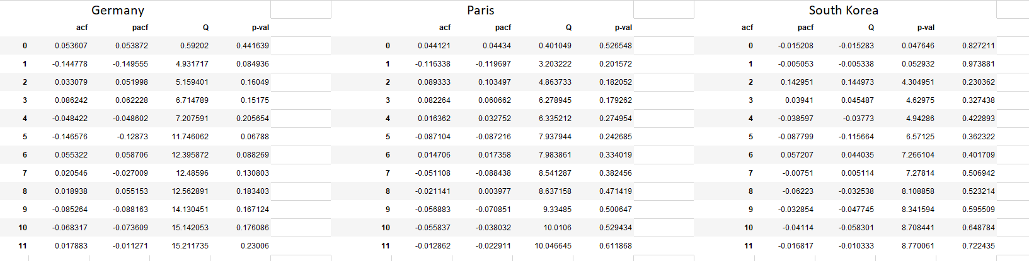

***Autocorrelation Function and Partial Autocorrelation Function Analysis:***

It allows us to analyse the overall correlation structure in the market data of three different global market i.e., Germany, Paris and South Korea.

**Germany**

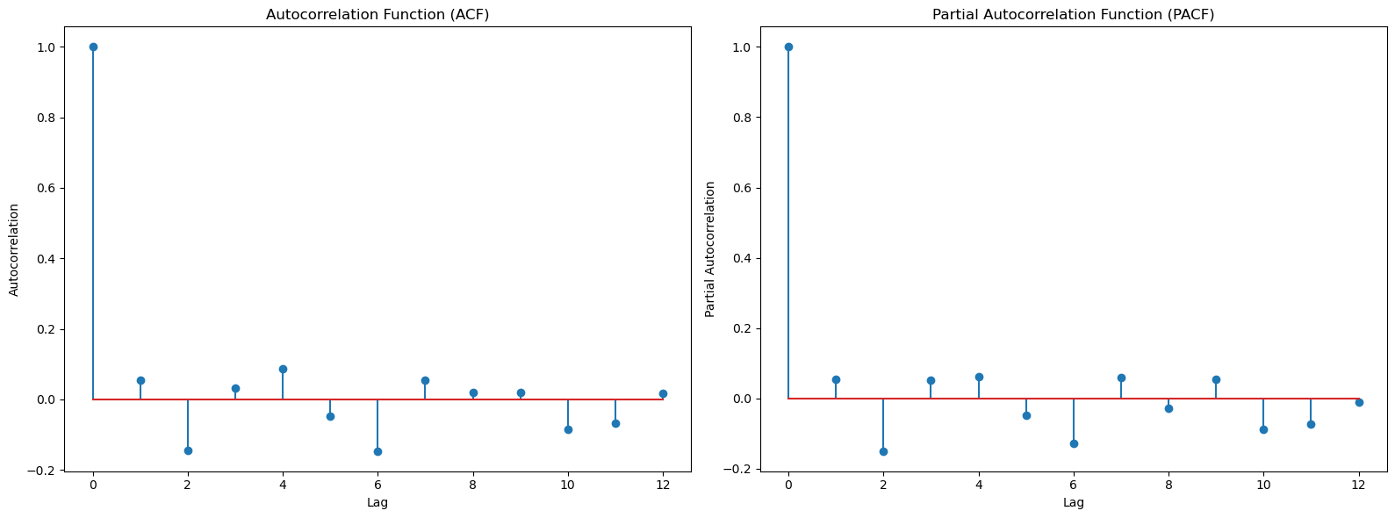

A plausible AR(1) model may be suggested by the PACF, which has a notable peak at the first lag before cutting off, while the ACF for Germany falls off slowly. It may also suggest an ARMA model, in which both AR and MA processes are required to properly explain the data, given the notable peaks in the ACF at subsequent lags.

**South Korea**

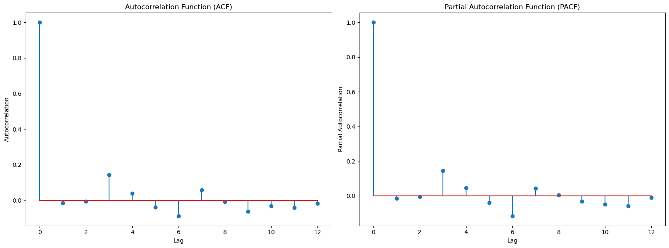

With most autocorrelations falling inside the significance boundaries, the ACF for South Korea has a strong initial autocorrelation that drops off dramatically by the second lag and then oscillates about zero. After the initial lag, the PACF shows a sharp cutoff, indicating that an AR(1) model would be suitable. This behaviour suggests that the series’ present value is largely determined by its recent past value, with the correlation rapidly decreasing as the lag grows.

**Paris**

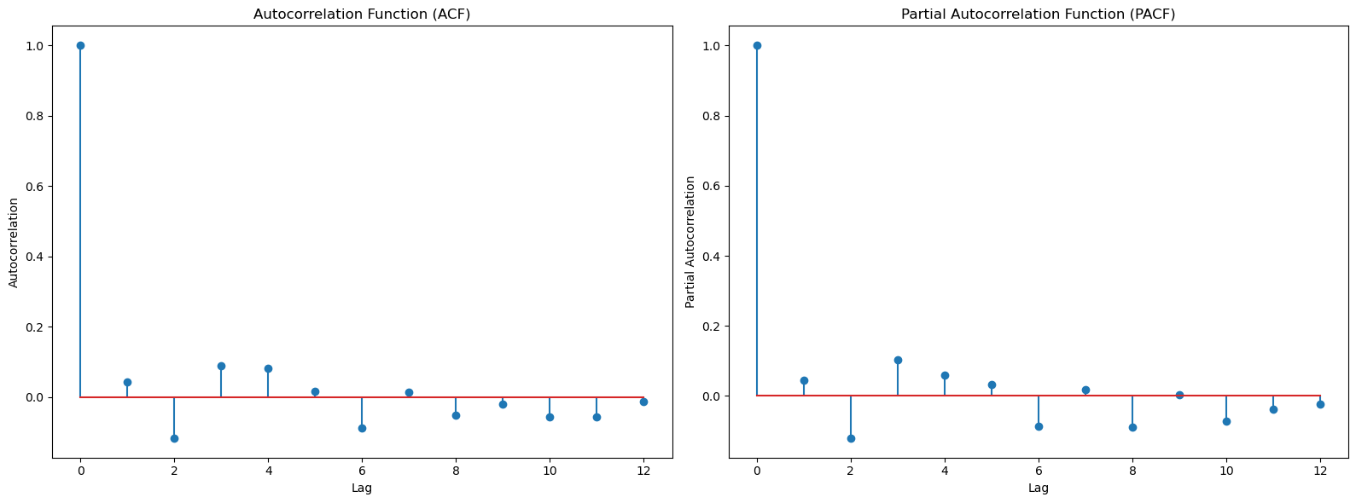

Regarding Paris, the ACF progressively deteriorates and stays inside the significance bounds after a few delays, indicating a combination of moving average and autoregressive components. After the second lag, the PACF stops, which could be a sign of an AR(2) process. According to this model, the series' current value is mostly determined by its values from the two periods that came before it, with very little effect from earlier eras.\

Summary: South Korea fits an AR(1) model, Paris fits an AR(2) model, and Germany probably needs an ARMA model because of mixed autocorrelation qualities, according to ACF and PACF plots. Regional differences in the data point to the impact of regional economic or policy considerations, indicating the need for more testing to validate the best model for precise forecasting.

***Analysis of AIC and BIC for Time Series Models in Germany, Paris, and South Korea***

|  |  |  |  |
| --- | --- | --- | --- |
| AIC and BIC | | | |
|  | Germany | Paris | South Korea |
| AIC Value | 1265.877 | 1236.151 | 1231.0896 |
| AIC Min Value | (2, 4) | (1, 1) | (5, 1) |
| BIC Value | 1279.1302 | 1249.404 | 1244.322 |
| BIC Min Value | (0, 0) | (0, 0) | (0, 0) |

The consideration of model complexity in ARMA models for time series from Germany, Paris, and South Korea presents a point of contention between the Akaike Information Criterion (AIC) and the Bayesian Information Criterion (BIC). Less strict AIC implies more sophisticated models such as a mild ARMA(1,1) for Paris and ARMA(2,4) for Germany and South Korea, which capture strong autocorrelation. Instead, BIC prioritizes parsimony over accuracy in order to prevent overfitting, particularly in big datasets, and suggests the simplest ARMA(0,0) model for all cases. Robust model application can be ensured by optimizing forecasts by balancing the comprehensive capture of AIC against the simplicity of BIC through techniques such as cross-validation. This will reduce the likelihood of either overfitting or underfitting.

***Analysis of Static Forecasts under ARMA Model for Germany, Paris, and South Korea***

Static Forecasts -

With no updates from fresh data, static predictions under an ARMA model predict future values using coefficients fitted to existing data. Based only on available data, each forecast is created independently.

**Germany**

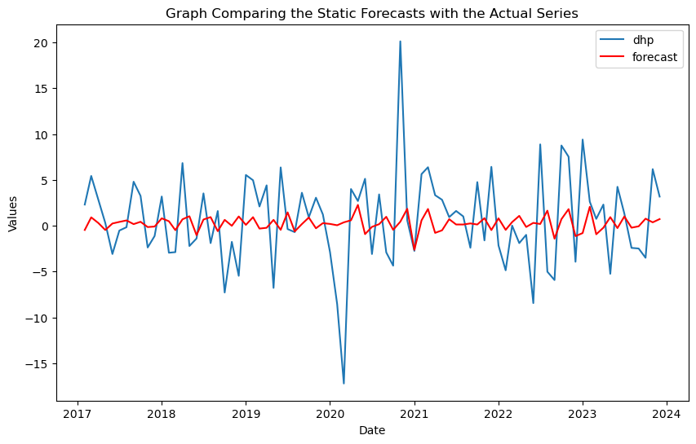

The ARMA model forecast (red) on the graph smooths out volatility spikes while closely monitoring the trend. The actual series is shown as blue. This shows the model does a good job of capturing the central tendency of the series, but it might require improvements to better forecast abrupt shifts or outliers.

**Paris**

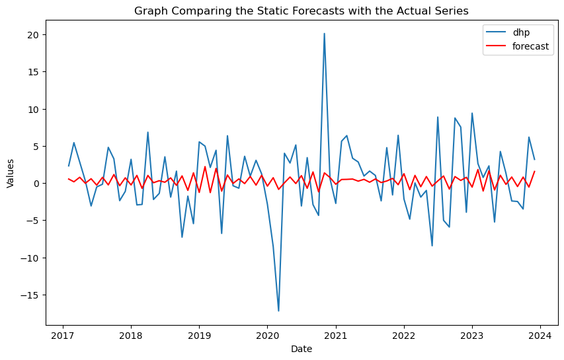

The Paris forecast indicates the model catches persistent patterns but not rapid changes, as it dampens extremes while closely matching the actual trend. Improving forecasts of peaks by seasonal adjustments or the inclusion of external economic variables could address aspects influencing the data's volatility that the current model is unable to account for.

**South Korea**

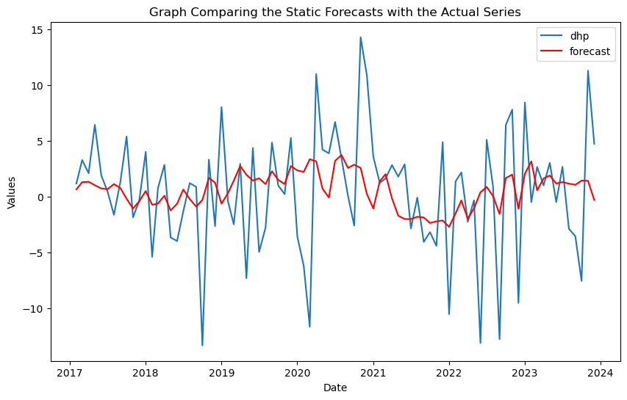

Sharp changes are often underestimated by the South Korean prediction, which may indicate model misspecification. To better represent the volatility of the series and improve prediction accuracy, this might be fixed by modifying the AR and MA orders or adding new data, such as macroeconomic indices.

***Analysis of Dynamic Forecasts under ARMA Model for Germany, Paris, and South Korea***

Dynamic Forecasts-

Dynamic forecasts in time series use model estimates for future periods, which then inform subsequent forecasts, adjusting predictions as new information becomes available, adapting to unfolding realities.

**Germany**

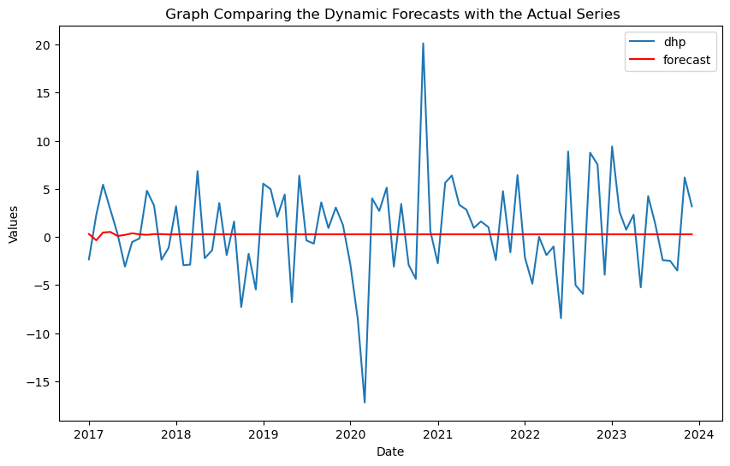

The dynamic forecast for Germany shows a flat line, indicating an overly simplistic or mis-specified ARMA model that fails to capture data variability. This constant forecast suggests poor model responsiveness, necessitating re-evaluation of parameters or consideration of different models to improve prediction accuracy and account for trends or cyclic behaviour.

**Paris**



Paris's dynamic forecast, like Germany's, presents a flat line, suggesting the ARMA model might be mis-specified, averaging historical data without adapting to new trends. This static forecast likely underfits, missing crucial dynamics. Enhancements could involve additional lags, seasonality, or switching to models like ARIMA for better non-stationarity handling.

**South Korea**

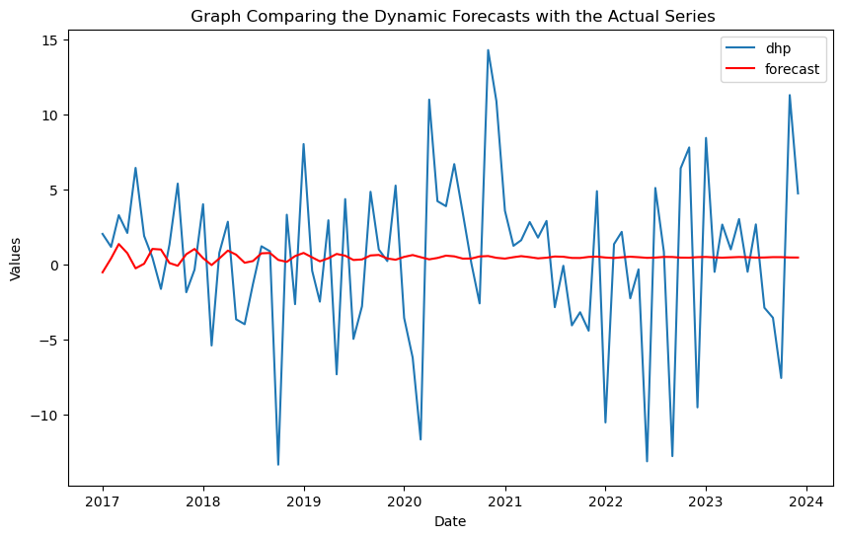

South Korea's dynamic forecast shows slight adaptation, moderately tracking the actual series yet underperforming in capturing peaks and troughs. This indicates the ARMA model partially captures data characteristics but struggles with abrupt changes or high-frequency variations, potentially due to not accounting for regime shifts or external shocks.

***Analysis of Smoothing Forecasts under ARMA Model for Germany, Paris, and South Korea***

Overview of Smoothing Forecasts

Simple Exponential Smoothing (SES) forecasts time series by averaging short-term fluctuations to emphasize longer-term trends, ideal for data without strong seasonal patterns, focusing on recent observations.

|  |  |  |  |
| --- | --- | --- | --- |
| Exponential Smoothing Model | | | |
|  | Germany | Paris | South Korea |
| Optimal smoothing coefficient | 1.49011 | 1.490116 | 1.4901161 |
| root mean squared error | 5.07919 | 5.079198 | 5.209283 |
| sum-of-squared residuals | 3069.99305 | 3069.993 | 3229.25974 |

**Germany**

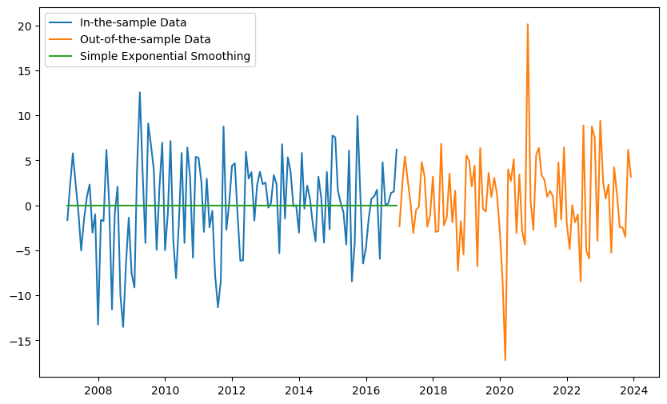

The SES forecast effectively smooths in-sample data fluctuations but fails to adapt to the mean level shift observed in the out-of-sample data. This indicates that while SES captures the central tendency well, it needs modification to respond to shifts, possibly through additional parameters or a different modelling approach

**Paris**



The SES forecast for Paris captures the central tendency but lacks responsiveness to volatility shifts like Germany. A more complex or adaptive method could improve accuracy in predicting sudden changes.

**South Korea**

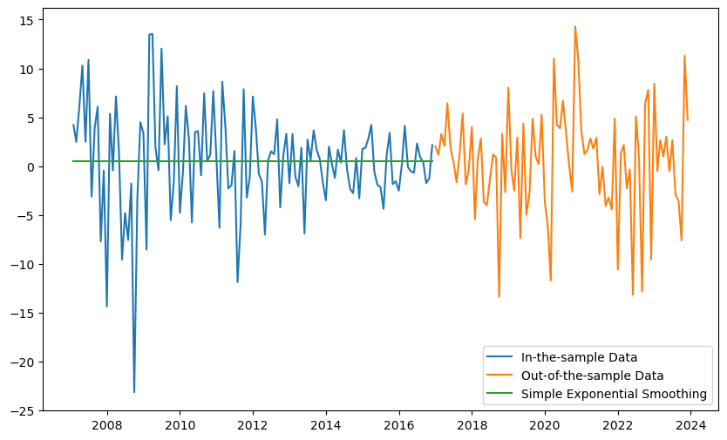

The SES model inadequately captures the pronounced fluctuations in the South Korean data, suggesting the need for a more flexible approach like Double Exponential Smoothing or Holt-Winters method to manage trends and potential seasonality more effectively.

***Augmented Dickey-Fuller (ADF) Test***

|  |  |  |  |
| --- | --- | --- | --- |
| Augmented Dickey-Fuller Test | | | |
|  | Germany | Paris | South Korea |
| Test Statistic | -0.292 | -0.292 | -0.292 |
| P-Value | 0.927 | 0.927 | 0.927 |
| Lags | 10 | 10 | 10 |

|  |  |  |  |
| --- | --- | --- | --- |
| ADF Critical Values | | | |
|  | Germany | Paris | South Korea |
| 1% | -3.47 | -3.47 | -3.47 |
| 5% | -2.88 | -2.88 | -2.88 |
| 10% | -2.57 | -2.57 | -2.57 |

To determine whether a time series is stationary, apply the Augmented Dickey-Fuller (ADF) test. As the statistic falls below the crucial values (-3.47, -2.88, -2.57) for 1%, 5%, and 10% levels, the series does not reject the null hypothesis, suggesting non-stationarity, with a test statistic of -0.292 and a p-value of 0.927. Because ARMA modelling requires stationarity, this finding is crucial. Once stationarity is achieved, the non-stationary series should be differenced and then retested using ADF for confirmation. ACF and ACF are used to specify the autoregressive and moving average terms in an ARMA model. Proper ARMA model definition is necessary for effective forecasting in models that particularly handle non-stationarity, such as ARIMA or ARMA.

***DFGLS Test Results***

|  |  |  |  |
| --- | --- | --- | --- |
| Dickey-Fuller GLS Test | | | |
|  | Germany | Paris | South Korea |
| Test Statistic | -0.853 | -0.853 | -0.853 |
| P-Value | 0.356 | 0.356 | 0.356 |
| Lags | 0 | 0 | 0 |

|  |  |  |  |
| --- | --- | --- | --- |
| Dickey–Fuller GLS Critical Values | | | |
|  | Germany | Paris | South Korea |
| 1% | -2.67 | -2.67 | -2.67 |
| 5% | -2.05 | -2.05 | -2.05 |
| 10% | -1.73 | -1.73 | -1.73 |

The DFGLS test indicates non-stationarity with a test statistic of -0.853, indicating a unit root, and not exceeding critical values (-2.67, -2.05, -1.73) for the 1%, 5%, and 10% levels. The series needs to be differenced for ARMA modelling, which necessitates stationarity. Retesting for stationarity after transformation is crucial. Establish the AR and MA orders by analysing the ACF and PACF. To ensure sufficiency, verify that the residuals of the model are white noise. By maintaining consistency with the original data scale, the differencing changes are made to guarantee the model is prepared for precise forecasting.

***Schmidt-Phillips (MDF) Test Results***

The Schmidt-Phillips test is another version of unit root tests that adjusts for structural changes and can be more powerful in certain cases than the standard Augmented Dickey-Fuller (ADF) test.

|  |  |  |  |
| --- | --- | --- | --- |
| The Schmidt-Phillips (MDF) Test | | | |
|  | Germany | Paris | South Korea |
| Test Statistic | -3.61893861 | -3.61893861 | -3.61893861 |
| P-Value | 0.028281 | 0.028281 | 0.028281 |

|  |  |  |  |
| --- | --- | --- | --- |
| MDF Critical Values | | | |
|  | Germany | Paris | South Korea |
| 1% | -4.00523 | -4.00523 | -4.00523 |
| 5% | -3.4329 | -3.4329 | -3.4329 |
| 10% | -3.14021 | -3.14021 | -3.14021 |

The Schmidt-Phillips test indicates potential stationarity with a test statistic of -3.6189, between critical values at 5% and 1% levels, and a p-value of 0.02828, suggesting the null hypothesis of a unit root can be rejected. The use of 198 lags underscores the consideration of historical data and serial correlations, suggesting possible direct ARMA modelling without additional differencing. For robust modelling, further stationarity checks like the KPSS test are recommended. ARMA model parameters should be determined using ACF and PACF plots, with model adequacy verified via residual analysis and cross-validation. Satisfactory diagnostics allow the model to forecast future values effectively, handling stationarity without adjustments, thereby enhancing forecast reliability.

***Zivot-Andrews Test Results***

|  |  |  |  |
| --- | --- | --- | --- |
| The Zivot-Andrews Test | | | |
|  | Germany | Paris | South Korea |
| Test Statistic | -4.555 | -4.555 | -4.555 |
| P-Value | 0.103 | 0.103 | 0.103 |
| Lags | 3 | 3 | 3 |

|  |  |  |  |
| --- | --- | --- | --- |
| The Zivot-Andrews Test Critcial Values | | | |
|  | Germany | Paris | South Korea |
| 1% | -5.28 | -5.28 | -5.28 |
| 5% | -4.81 | -4.81 | -4.81 |
| 10% | -4.57 | -4.57 | -4.57 |

The Zivot-Andrews test, adjusting for a structural break, suggests non-stationarity with a test statistic of -4.555 not meeting critical values, and a p-value of 0.103, indicating a unit root persists. For ARMA modelling, differencing is required to achieve stationarity, followed by further stationarity tests. Analysing ACF and PACF plots will help set appropriate AR and MA parameters. Conducting residual analysis and diagnostic checks confirms model adequacy. Once validated, the ARMA model can effectively forecast, adjusting predictions to align with the original data scale, thus ensuring reliable and accurate forecasting that accounts for structural changes and enhances decision-making.

**VAR ESTIMATIONS**

***Analysis of Residual Correlations:***

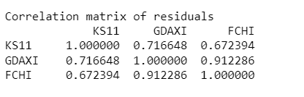

The correlation matrix of residuals for the VAR model involving KS11, GDAXI, and FCHI indices suggests significant inter-market relationships not fully captured by the model. High residual correlations, such as 0.912286 between GDAXI and FCHI, indicate overlapping economic influences or shocks, potentially due to their economic ties within the European Union.

***Impulse Responses***

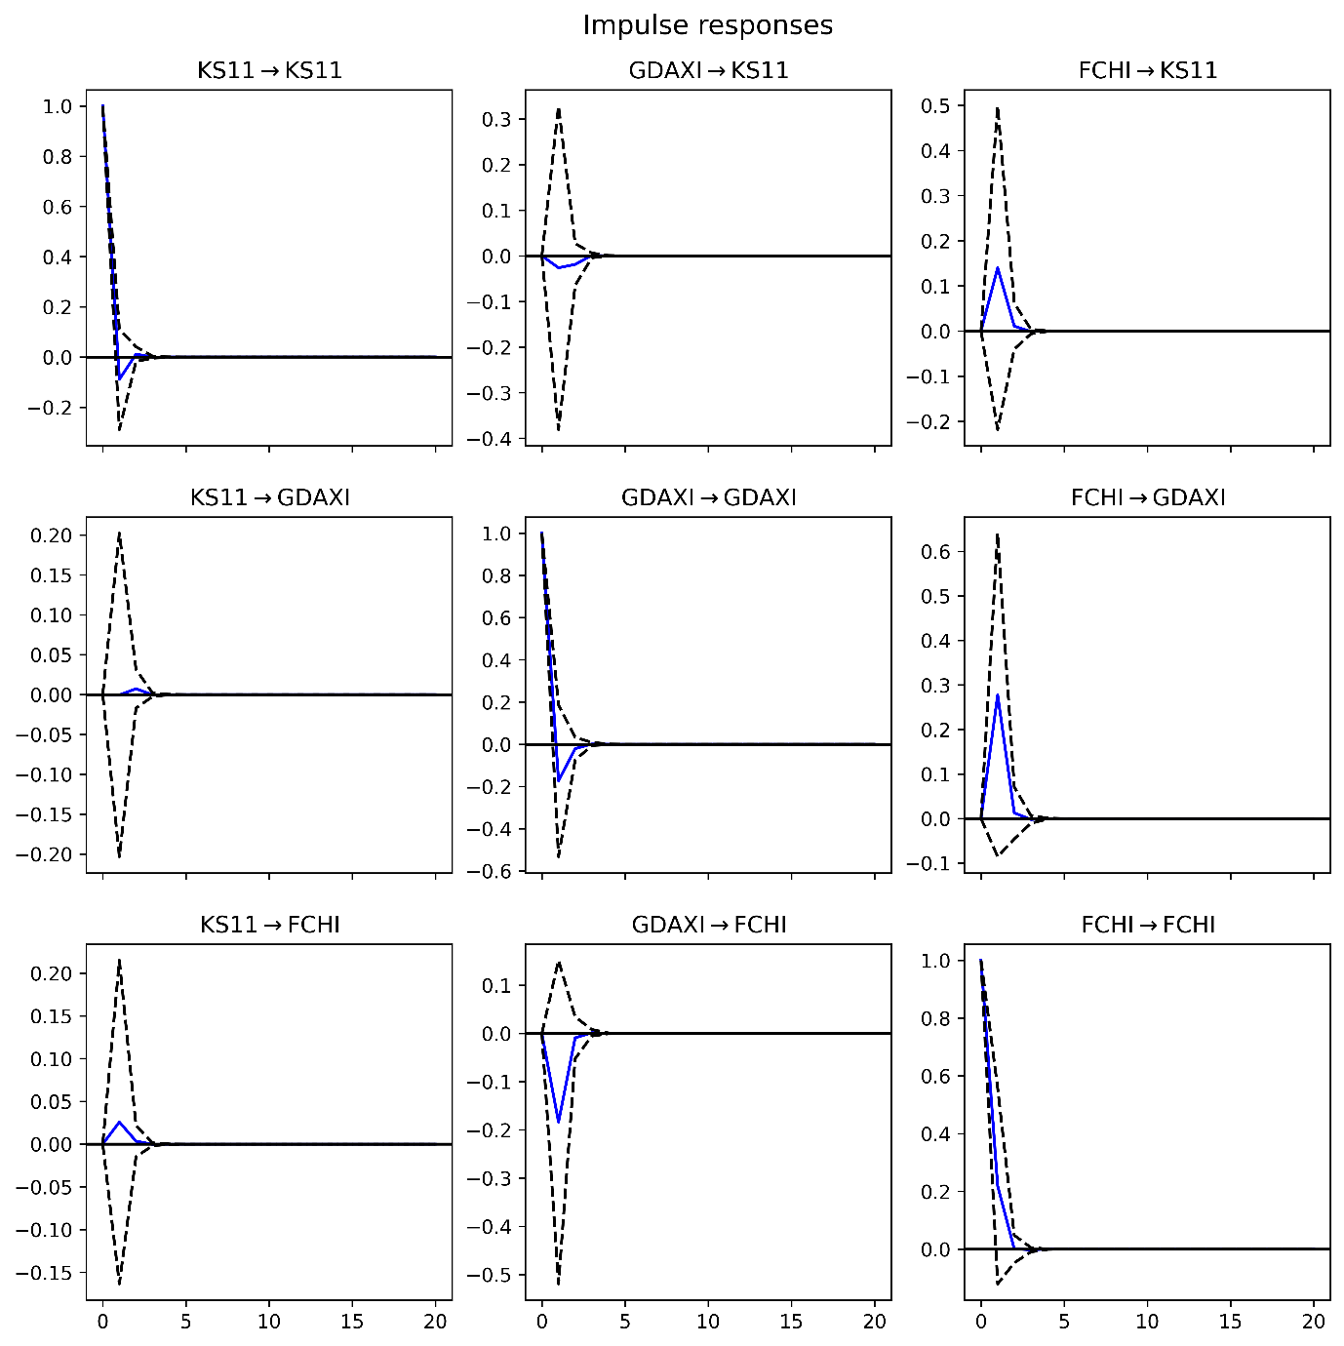

Market shocks affect each index and their linkages, as shown by the impulse response analysis of VAR models for the KS11 (South Korea), GDAXI (Germany), and FCHI (Paris) indices. While GDAXI and FCHI both exhibit swift, negative reactions, suggesting resilience and a speedy market correction, shocks to KS11 reveal a large, brief positive influence on itself. Cross-market analysis indicates that there is moderate interconnectedness, with mild negative impacts from European markets on KS11 and vice versa. Strong economic connectivity within Europe is seen from the noteworthy mutual affects between GDAXI and FCHI. These insights are essential for risk management, strategic planning, economic integration comprehension, and model calibration in our globally interconnected financial markets.

***Forecast Error Variance***

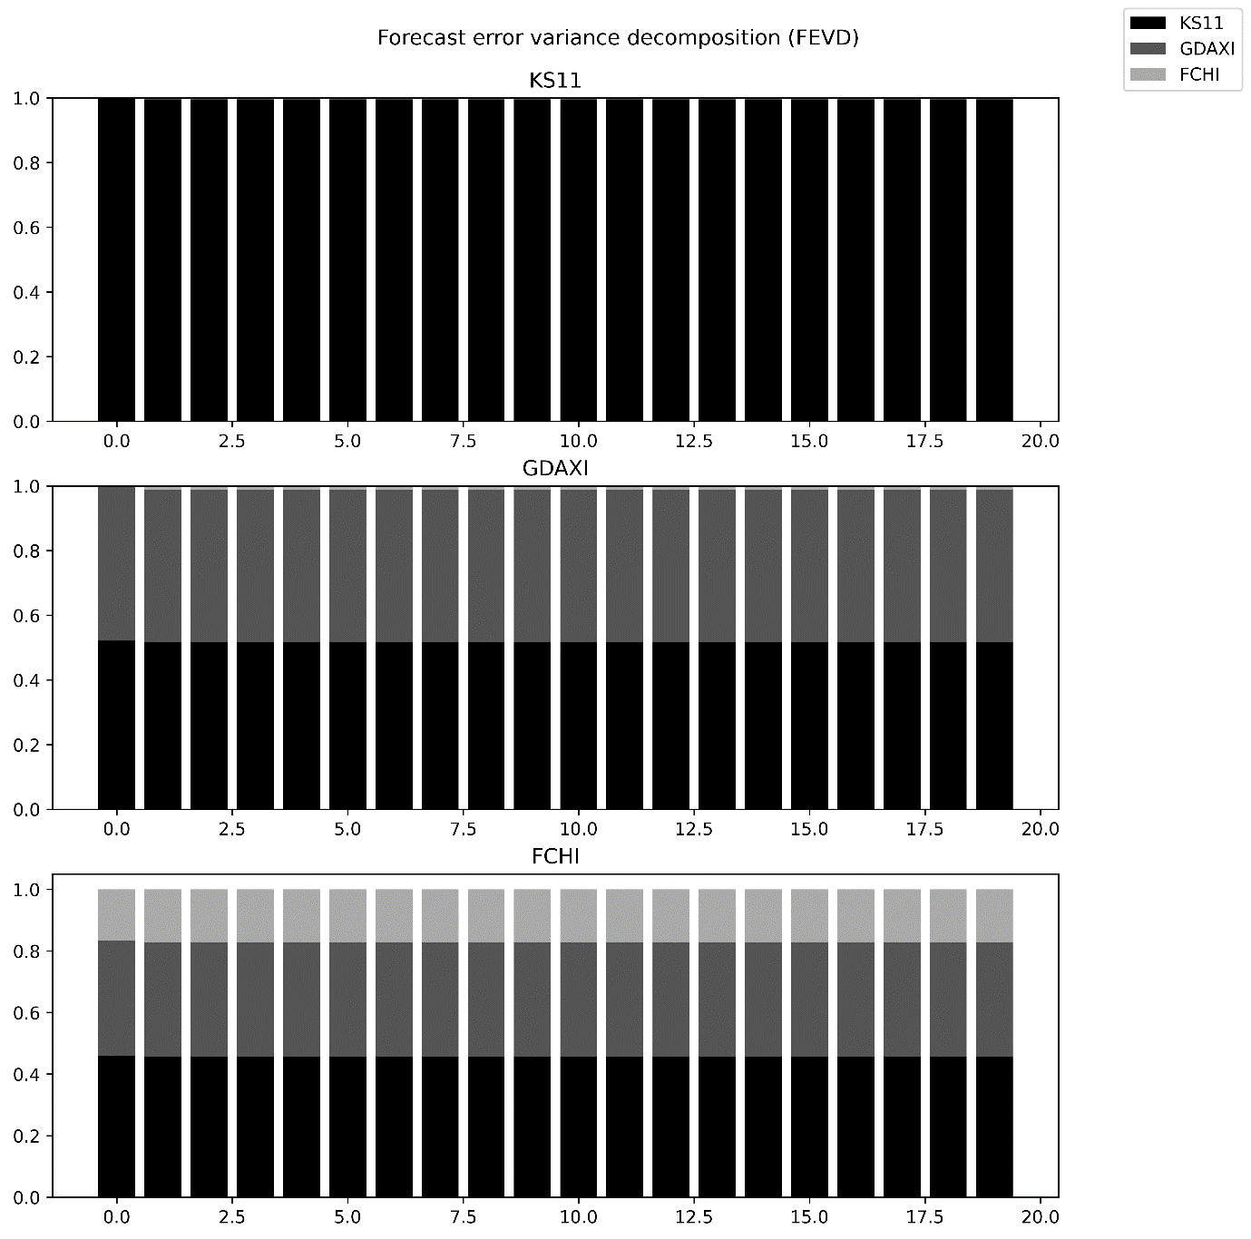

Key insights into market dynamics are revealed by the Forecast Error Variance Decomposition (FEVD) research. With the majority of the variation attributed to its own shocks, KS11 (South Korea) exhibits significant autonomy and suggests limited market integration with Europe. Nonetheless, great interdependence and a significant amount of common variance are demonstrated by the GDAXI (Germany) and FCHI (Paris), which underline the EU's close economic linkages and synchronized market behaviours. Economic shocks or policies that influence one are likely to affect the other, according to this integration. For investors, economic analysts, and policymakers to create sound financial models and well-informed economic plans suited to the unique characteristics of each market, it is imperative that they comprehend these relationships.

**Cointegration**

***Predictions vs Index***

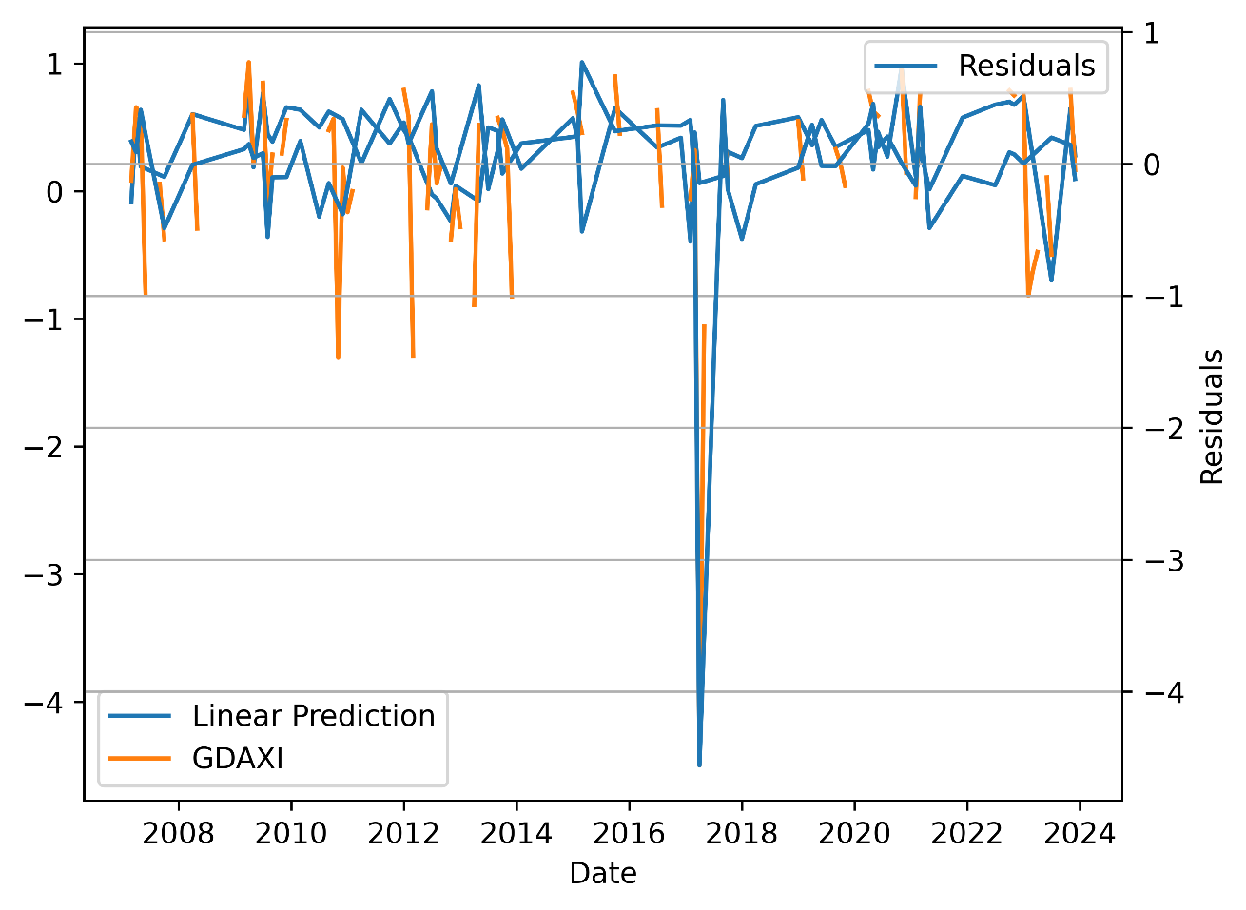

The GDAXI index's cointegration analysis and linear prediction show largely stable residuals, pointing to a robust tracking relationship till 2020, when a considerable departure points to an unexpected shock. Relatives should be steady for cointegration; even with sporadic spikes, they usually lie close to zero. Testing for formal stationarity is necessary. The 2020 deviation indicates that in order to better handle volatility and external shocks and improve prediction accuracy and financial decision-making in volatile markets, the model may need to be refined to add dynamic components like ARIMA or GARCH.

***Residual Stationarity***

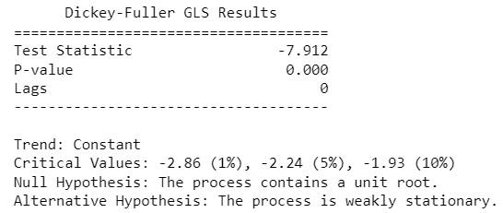

The test is performed to verify the stationarity of residuals, a necessary condition for

Cointegration. with a statistic of -7.912 and a p-value of 0.000, confirm the stationarity of residuals from a regression between two non-stationary series, indicating cointegration but is quite low in comparison to

the critical values at all significance levels

***Error Correction Model***

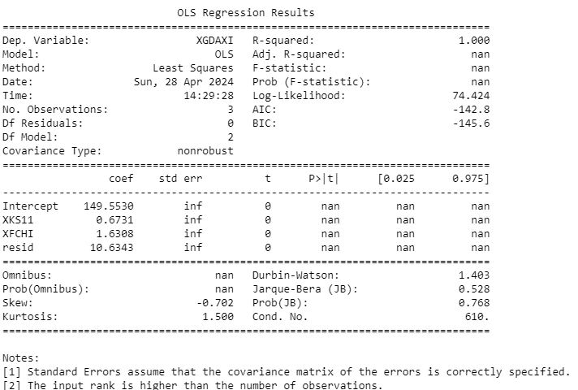

A perfect R-squared and low Durbin-Watson suggest overfitting and high autocorrelation, complicating ECM application. However, with confirmed cointegration via a stable long-term equation, an ECM could estimate the speed of correction from deviations in the established relationship, enhancing model reliability and forecast accuracy.

**References**

1. Bekaert, G. and Harvey, C.R., 1995. Time-varying world market integration. The Journal of Finance, 50(2), pp. 403-444.
2. Bobbitt, Z., 2021. How to interpret root mean square error (RMSE). [online] Statology. Available at: <https://www.statology.org/how-to-interpret-rmse/> [Accessed 30 April, 2024].
3. Brooks, C. and Tsolacos, S., 1999. The impact of economic and financial factors on UK property performance. Journal of Property Research, 16(2), pp. 139-152.
4. Diebold, F.X. and Yilmaz, K., 2012. Better to give than to receive: Predictive directional measurement of volatility spillovers. International Journal of Forecasting, 28(1), pp. 57-66.
5. Engle, R.F. and Granger, C.W., 1987. Co-integration and error correction: representation, estimation, and testing. Econometrica: Journal of the Econometric Society, pp. 251-276.
6. Fama, E.F., 1970. Efficient capital markets: A review of theory and empirical work. The Journal of Finance, 25(2), pp. 383-417.
7. Johansen, S., 1991. Estimation and hypothesis testing of cointegration vectors in Gaussian vector autoregressive models. Econometrica: Journal of the Econometric Society, pp. 1551-1580.
8. Kim, S.J. and Shin, H.S., 2003. Interactions and the US stock market: a global perspective. Emerging Markets Review, 4(1), pp. 27-43.
9. Prabhakaran, S., 2022. Augmented dickey-fuller (ADF) test - must read guide - ml+. [online] Machine Learning Plus. Available at: <https://www.machinelearningplus.com/time-series/augmented-dickey-fuller-test/> [Accessed 30 April, 2024].