CRM Sales Opportunities Data Warehouse
ICT921 Applied Software Engineering, Assessment 3: system documentation
Student name and ID: [insert here]

1. Introduction
This report demonstrates an integrated data warehouse that is created from the CRM_Sales_Opportunities dataset. A java ETL program extracts data from CSV and XML files, cleans and loads it into the MySQL database. An HTML Web interface is then served by a PHP query engine to display two reports and two analyses of the warehouse. The following sections will discuss the architecture, transformations performed, reports and analyses, meeting of each requirement, and screenshots of the working interface. There are four source files: accounts.xml (85 companies with data on sector, year established, revenue, employees, office location and parent company); products.csv (7 products with data on series and price); sales_teams.xml (35 sales agents with data on their managers and regional offices); and sales_pipeline.csv (8,800 opportunities closing between March and December 2017). The fifth file, data_dictionary.csv, is a description of the fields and is used only as a design reference.

2. System architecture
The system has four levels as depicted in Figure 1. The source files are fed into a java ETL program which writes into the MySQL warehouse. At run time, the PHP query engine is the only part that accesses the warehouse, and the browser communicates only with the query engine.
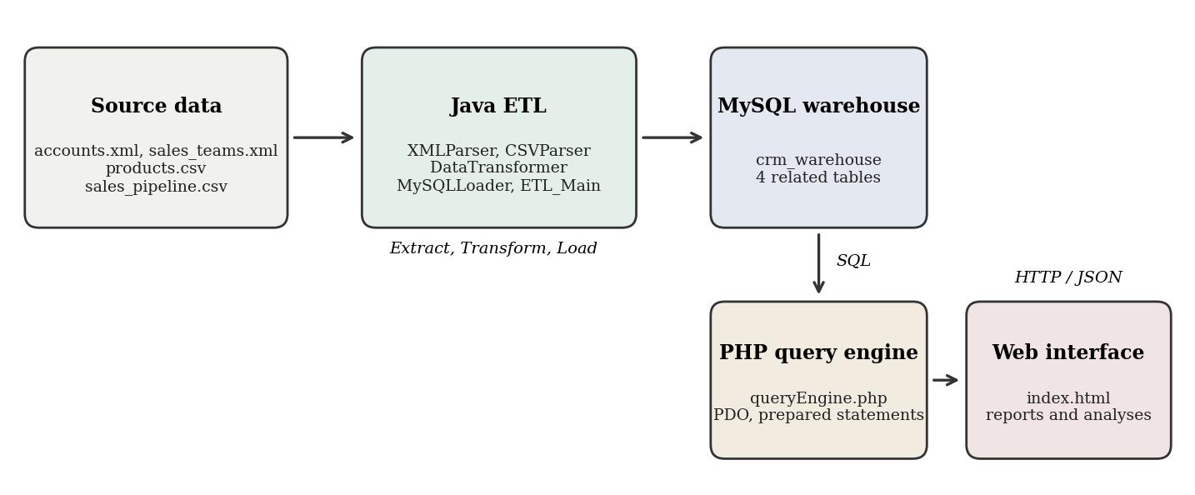
Figure 1. System architecture.
Java ETL. There are five classes that are structured as required. XMLParser and CSVParser extract raw rows from accounts.xml, sales_teams.xml, products.csv and sales_pipeline.csv. DataTransformer cleans and standardises the rows and converts them to typed records. MySQLLoader creates the schema and batch-inserts the records through JDBC prepared statements. ETL_Main runs the three stages in order and prints a transformation log. The data dictionary file is deliberately not read.
PHP query engine. The web interface passes a query name to queryEngine.php which opens a PDO connection, executes the corresponding SQL and returns JSON. The query names and sort columns must be whitelisted, and all user-provided values are bound as parameters in a prepared statement and no part of the request is concatenated into SQL.
Web interface. index.html is just one page that invokes the query engine with fetch and displays tables, bar charts and filters in the browser. It provides a sidebar to switch between the dashboard, the two reports and the two analyses.

3. Data warehouse design
The warehouse database is called crm_warehouse and contains four InnoDB tables that have fields according to the data dictionary. Primary keys are natural keys and foreign keys are used to join the tables, enabling efficient joins and preventing orphan rows.
Table | Primary key | Relationships
accounts | account | accounts (subsidiary) accounts_of references accounts (parent company)
products is a relationship that references product from sales_pipeline.product.
sales_teams | sales_agent | referenced by sales_pipeline.sales_agent
sales_pipeline | opportunity_id | refers to sales_teams, products and accounts
Table 1. Tables and relationships used in a warehouse.
The deal stage is saved as an ENUM (Prospecting, Engaging, Won, Lost). Money is stored in DECIMAL format, not floating point. Indexes are defined on the year of establishment and on the stage, product, agent and account columns that are used by the reports. The full schema is in Appendix A.

4. Transformations applied
DataTransformer performs the two transformations and a number of additional fixes the data required. Each change is recorded and the number of changes is printed at the end of a run (Appendix C) by ETL_Main.
Insertion | Inserts a row | 1
Trim, lower-case, fix "technolgy" typo, Title Case standardise accounts.sector | Values were inconsistently formatted required by brief | 12
Handle missing pipeline.account: store NULL | Early-stage deals do not have an account yet | 1,425
Handle missing engage_date: store NULL | Prospecting deals have not been engaged | 500
Handle missing close_date and close_value: store NULL | Still-open deals; NULL does not affect averages | 2,089
Normalise product name "GTXPro" to "GTX Pro" Must match products.csv for the foreign key 1,480
Fix office_location data quality typo "Philipines" | Data quality | 1
Blank mandatory text becomes "Unknown"; blank Lost value becomes 0 | Rules in place for missing data | 0 hits
Table 2. The transformations and the number of rows that each transformation changed.
The brief does not mean to imply that this data set is complete, but it is not: there are real gaps in the pipeline table, as illustrated by the counts above. Open deals keep NULL values instead of 0 so that averages are not distorted. All 8,800 opportunities, 85 accounts, 7 products and 35 sales agents loaded successfully. The table accounts has been standardised and contains 10 consistent sector values: Employment, Entertainment, Finance, Marketing, Medical, Retail, Services, Software, Technology and Telecommunications.

5. Reports and analyses completed
Products Report. Displays all the seven products along with their series and sales price. Prices range from $55 (MG Special) to $26,768 (GTK 500).
Sales Opportunities Report. Records won and lost opportunities, along with the opportunity value and product/series and list price. Users can filter by outcome, filter by product, search by account/sales agent, sort by any of the main columns, page through the results and export the view as CSV. Deals that are lost are worth 0.
Year Revenue Analysis of Establishment. Sum up the total revenue (in USD millions) from each account, according to the year the account was opened. The 85 accounts cover 35 different years from 1979 to 2017. 1982 has the largest total of approximately $17,108 million, followed by 1993 at approximately $13,696 million.
Sales Opportunity Analysis. Opportunity value shown for each product – total and average. Based on won deals by default or can include lost deals. The results of the won-deal are presented in Table 3.
Product | Won deals | Total value ($) | Average value ($)
GTX Pro | 729 | 3,510,578 | 4,815.61
GTX Plus Pro | 479 | 2,629,651 | 5,489.88
MG Advanced | 654 | 2,216,387 | 3,388.97
GTX Plus Basic | 653 | 705,275 | 1,080.05
GTX Basic | 915 | 499,263 | 545.64
GTK 500 | 15 | 400,612 | 26,707.47
MG Special | 793 | 43,768 | 55.19
Table 3. Sales Opportunity Analysis Outcomes for won sales opportunities.
While GTX Pro has the highest total, GTK 500 has by far the highest average value, and this is based on only 15 sales. MG Special is sold frequently, but provides limited revenue. There are 4,238 won deals and 2,473 lost deals (win rate is approximately 63.2 percent) and won deals total $10,005,534 across the warehouse. Each report uses SQL that is in Appendix B.
Extra features. In addition to the brief, the interface features a dashboard with headline figures, opportunity search, sortable columns and CSV export on each view.

6. Fulfilment of requirements
Requirement | How it is met
Data warehouse in MySQL with types and relationships | schema.sql: four tables, appropriate data types, primary, foreign keys, indexes
All four tables are fed from CSVParser and XMLParser; data_dictionary.csv is not loaded
Transform: Missing values handled (per column) and logged (Table 2)
Transform: standardise sector (standardiseSector()) in DataTransformer
Load into MySQL | MySQLLoader batch inserts within transactions, parents first, children second
queryEngine.php: whitelisted queries, prepared statements, JSON output (PHP query engine as middleware)
Products Report | query=products
Sales Opportunities Report (won/lost, values, products) | query=opportunities
Establishment Year Revenue Analysis_query=establishment
Sales Opportunity Analysis (total and average by product) | query=opportunity_analysis
Easy-to-navigate web interface (index.html) with sidebar navigation, filters, charts and tables
Apache, PHP, HTML, Java, MySQL | Runs on XAMPP (Apache, MySQL, PHP); ETL in Java
Deliverables | warehouse.sql, five ETL classes, queryEngine.php, index.html, this report
Table 4. Requirements and evidence.

8. The location where the website can be found online.
The following screenshots were taken from the running system on http://localhost/crm/index.html. You can access each view by clicking on the sidebar on the left of the page.
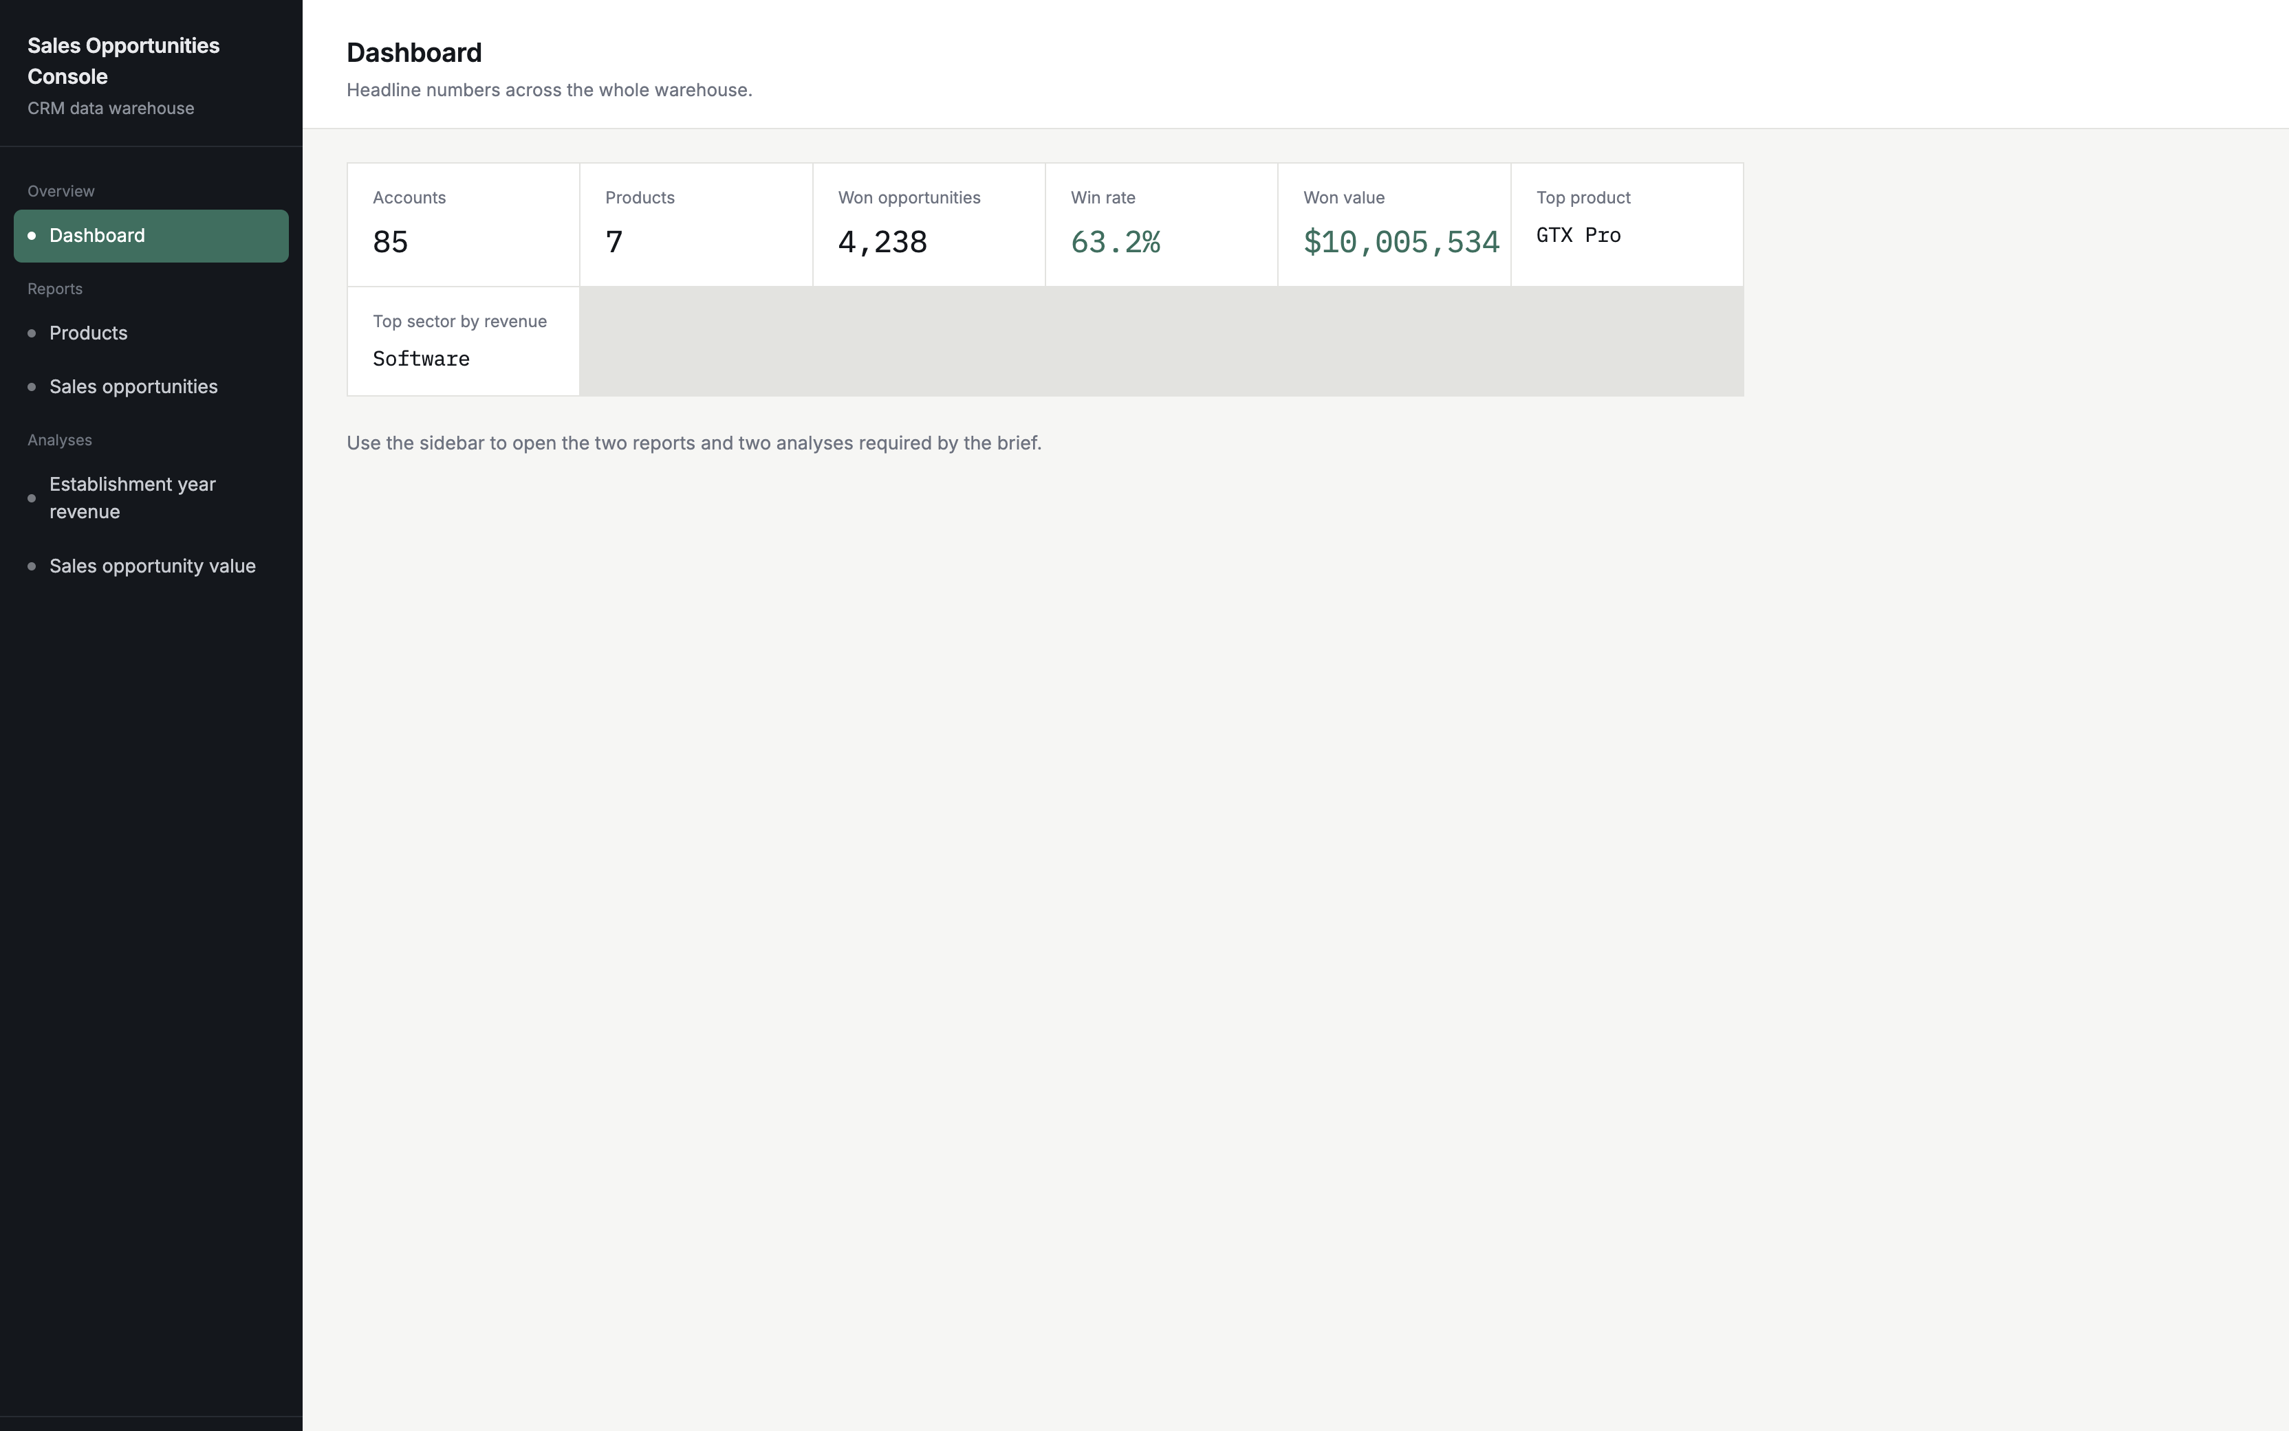
Figure 2. Dashboard of headline figures.
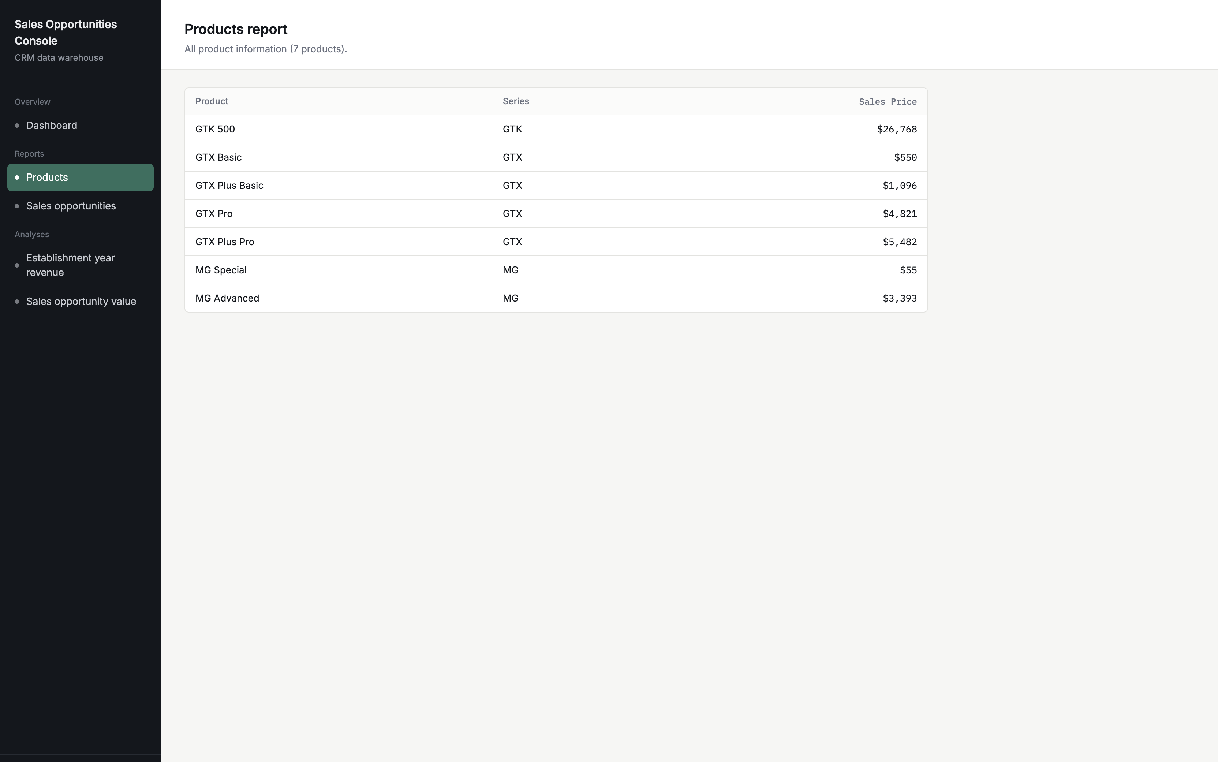
Figure 3. Products Report.
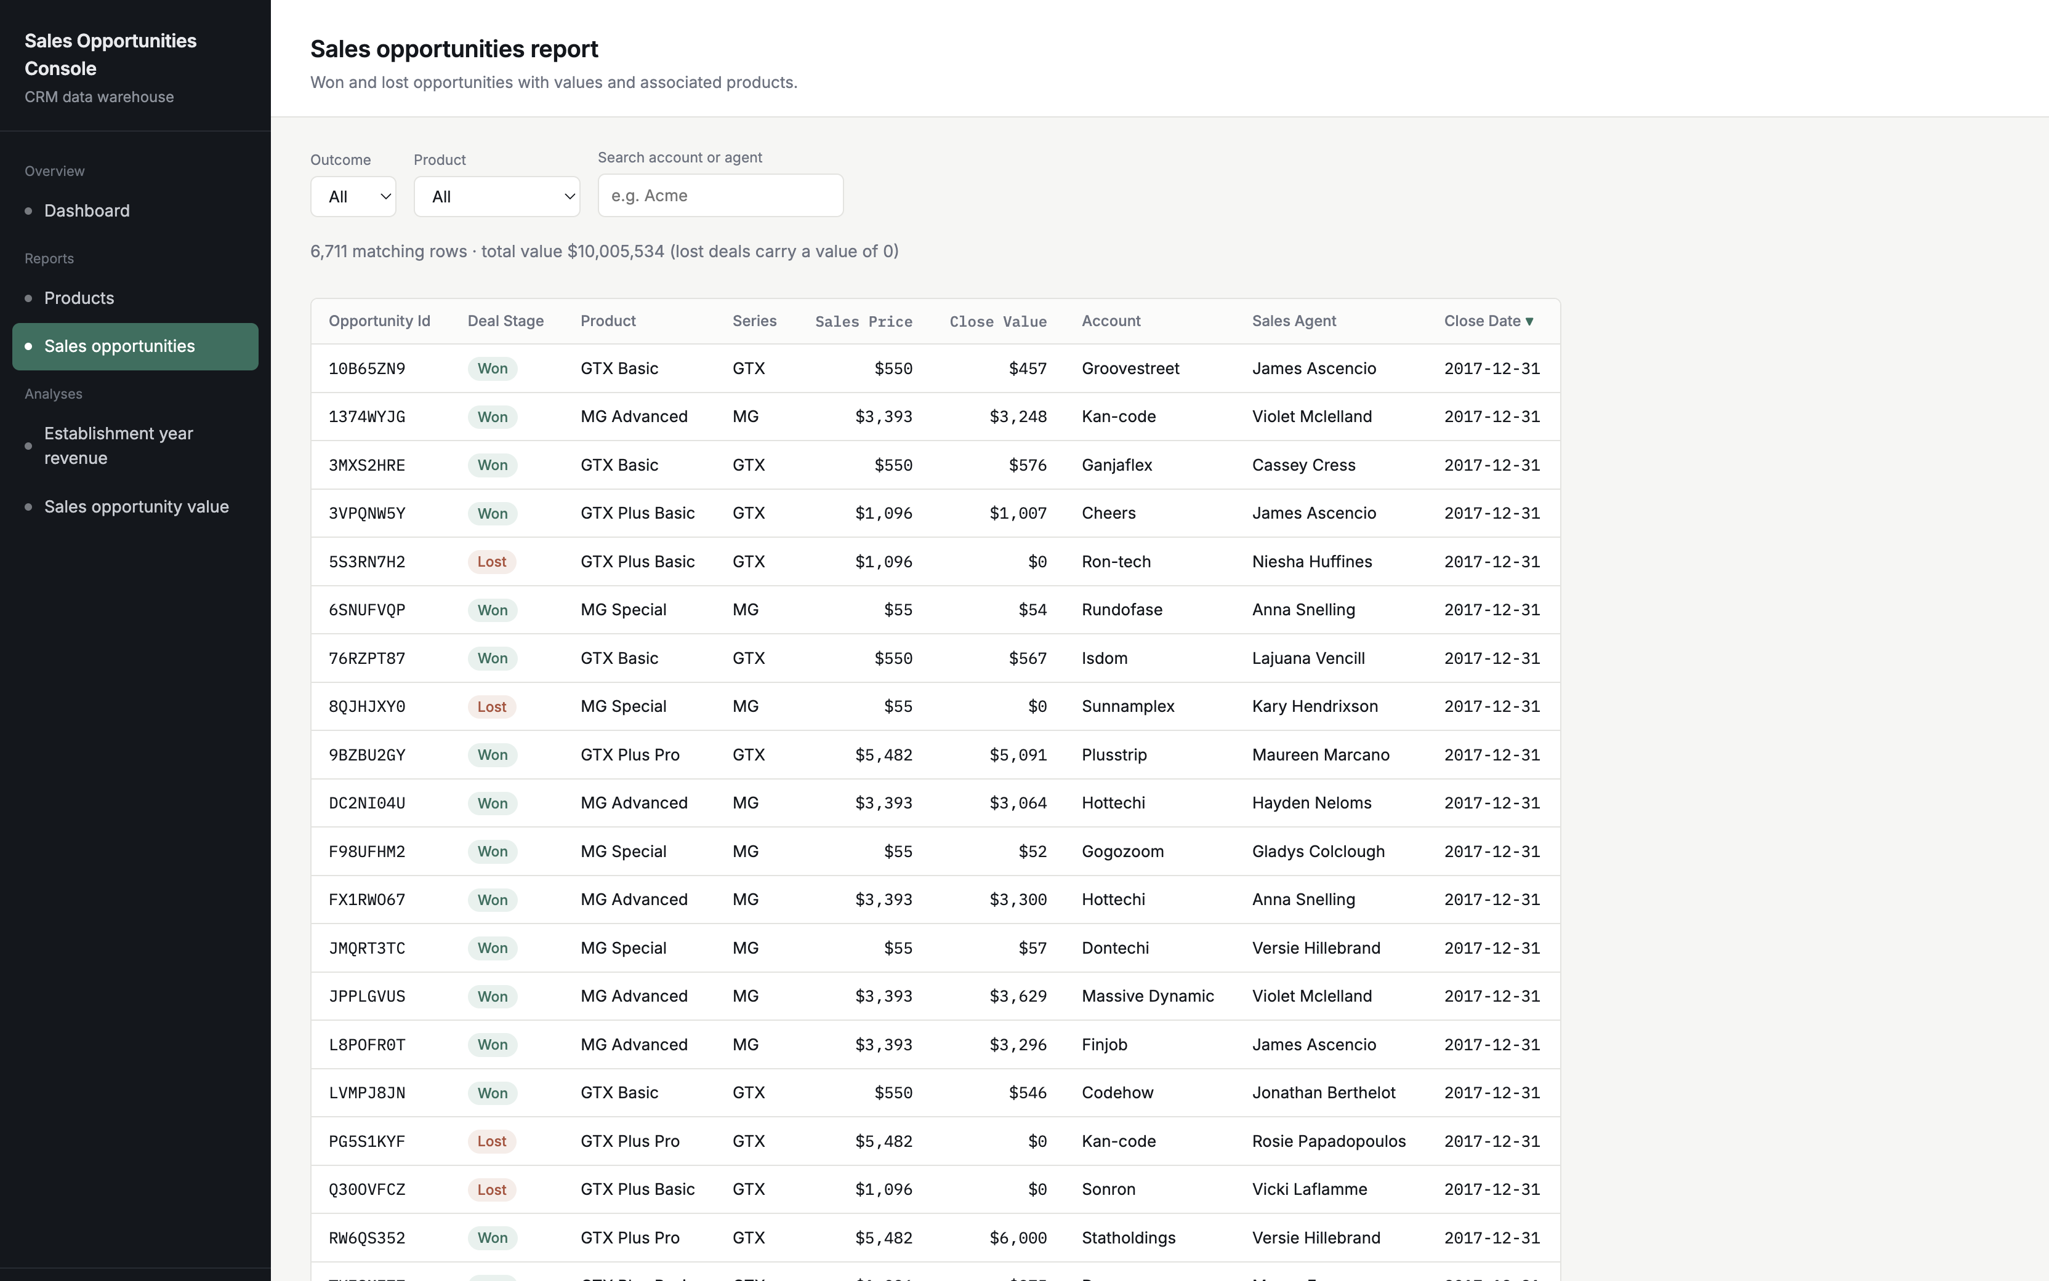
Figure 4. Sales Opportunities Report with outcome, product and search filters.
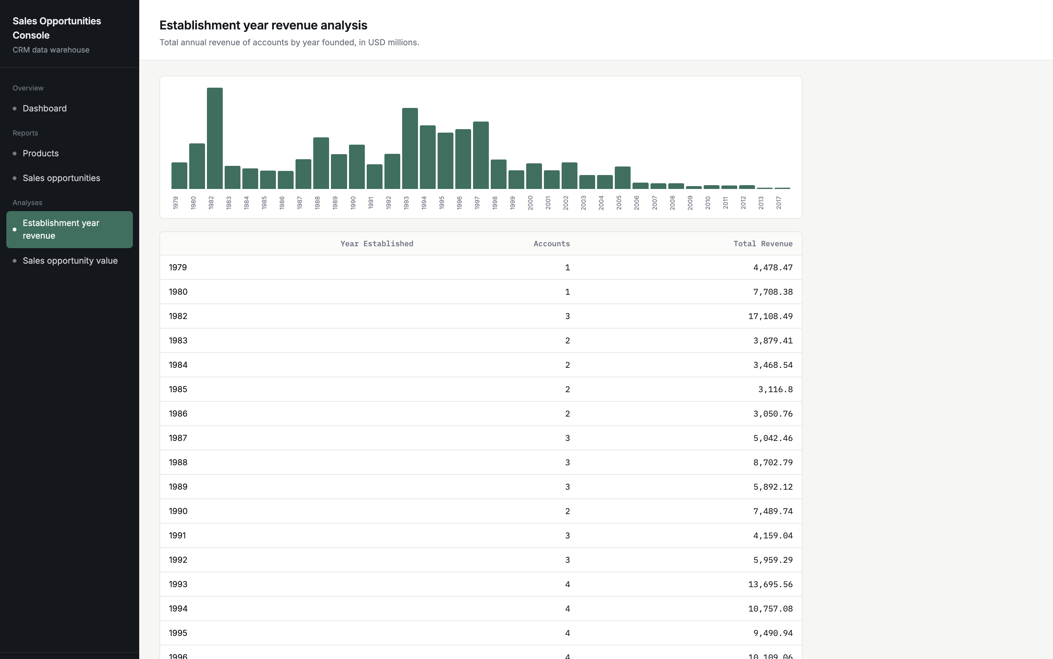
Figure 5. Year Revenue Analysis for Establishment.
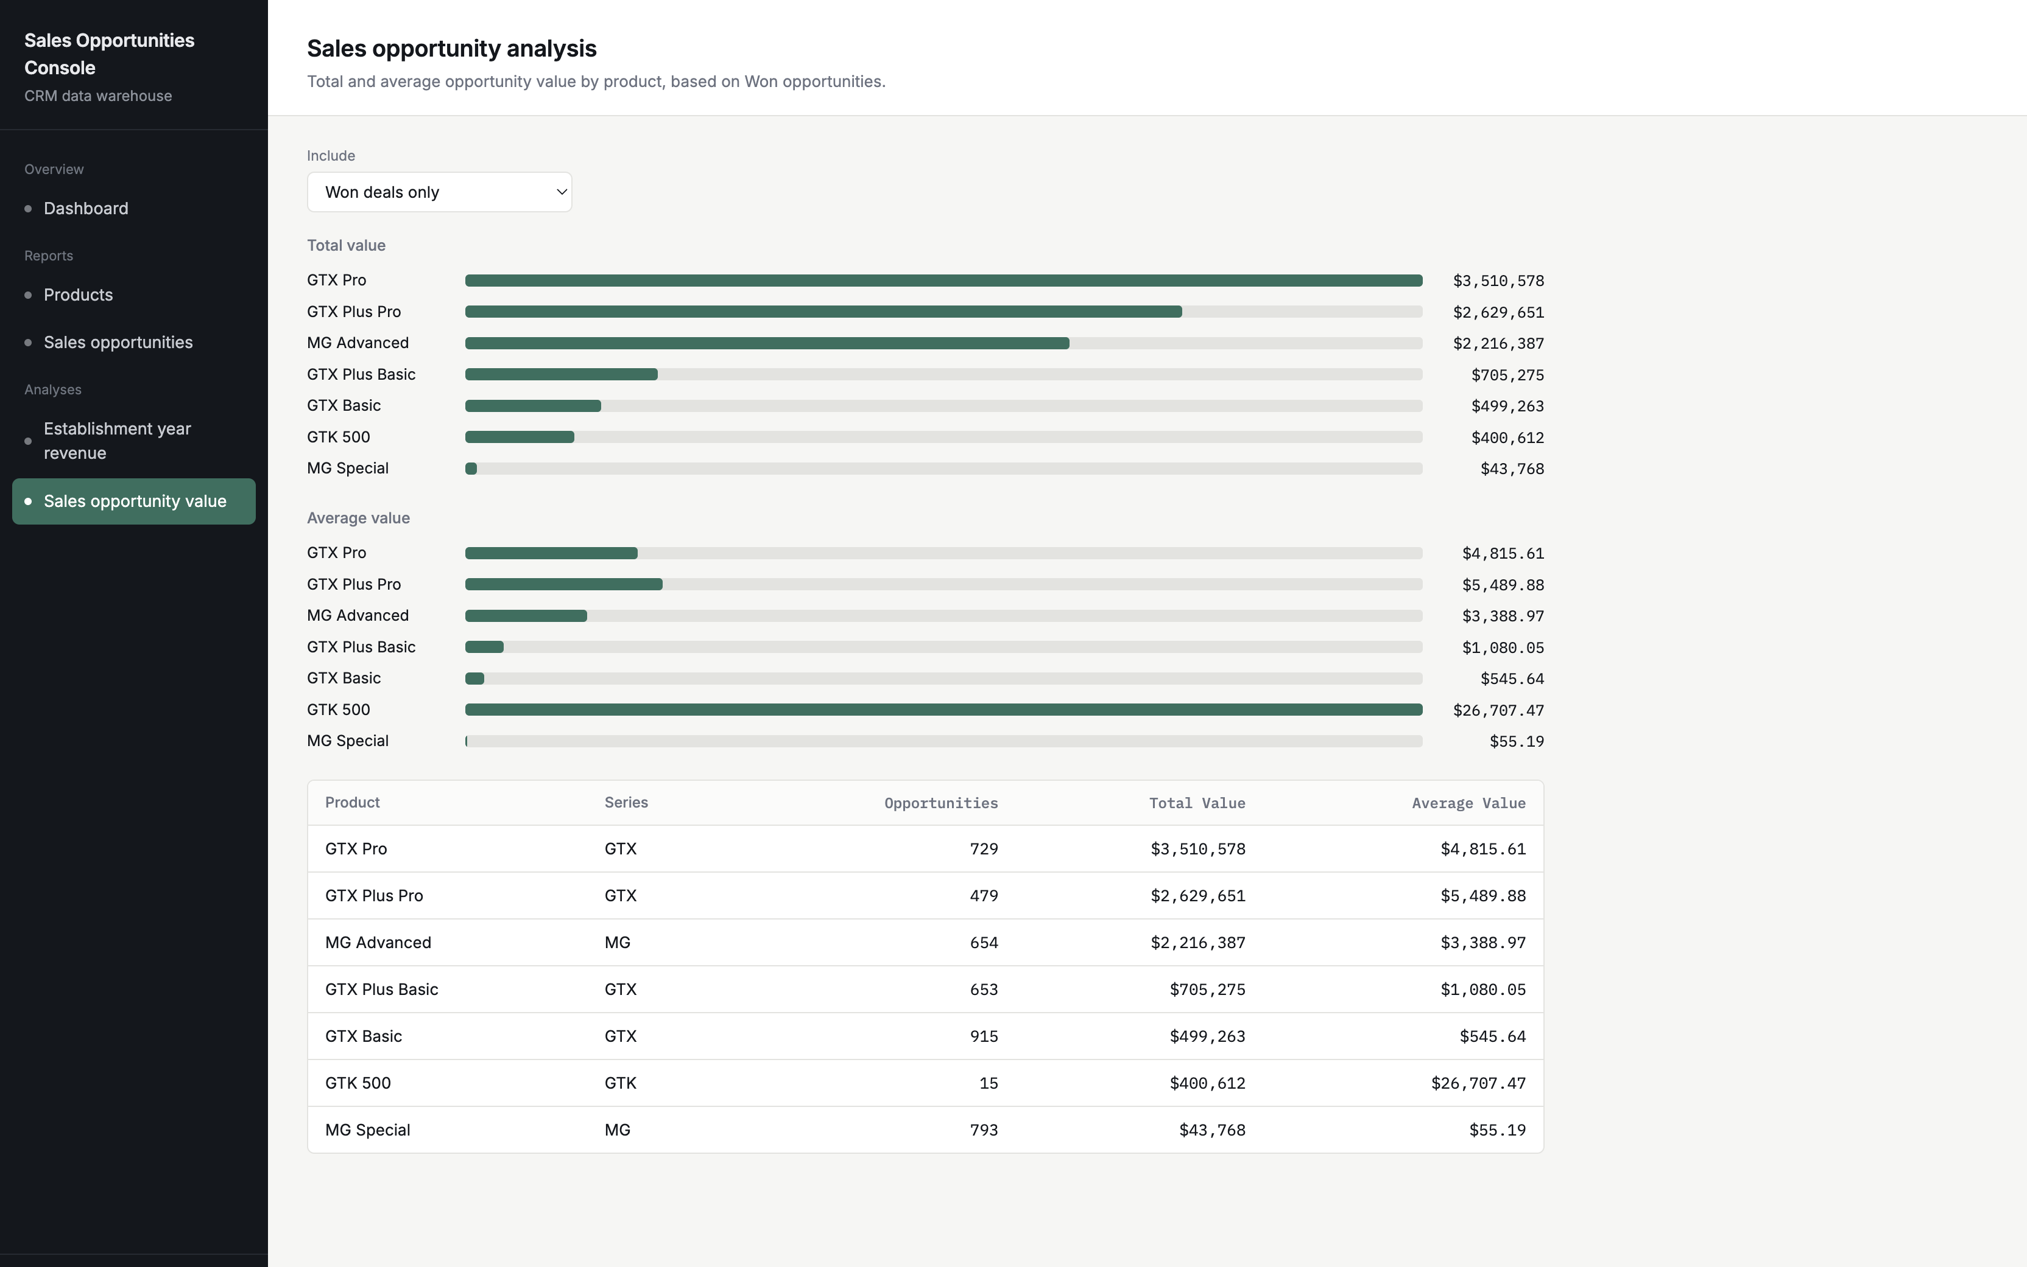
Figure 6. Sales Opportunity Analysis.

8. Conclusion
All four source files are loaded into a related MySQL warehouse, the data is cleaned during the ETL phase, and two reports and two analyses are made available via a secure PHP query engine and a browser interface. All the requirements in the brief are addressed and some additional features are included.

References
Oracle (2024) MySQL 8.0 Reference Manual. Available at: https://dev.mysql.com/doc/refman/8.0/en/ (Accessed: 28 September 2026).
The PHP Group (2024) PHP Manual: PDO. Available at: https://www.php.net/manual/en/book.pdo.php (Accessed: 28 September 2026).
Oracle (2024) Java SE Documentation. Available at: https://docs.oracle.com/en/java/ (Accessed: 28 September 2026).

Appendix A. Warehouse schema (schema.sql)
CREATE DATABASE IF NOT EXISTS crm_warehouse CHARACTER SET utf8mb4 COLLATE utf8mb4_unicode_ci;
USE crm_warehouse;

DROP TABLE IF EXISTS sales_pipeline;
DROP TABLE IF EXISTS sales_teams;
DROP TABLE IF EXISTS products;
DROP TABLE IF EXISTS accounts;

CREATE TABLE accounts (
account VARCHAR(100) NOT NULL,
sector VARCHAR(50) NOT NULL,
year_established SMALLINT NULL,
revenue DECIMAL(10,2) NULL,
employees INT NULL,
office_location VARCHAR(60) NOT NULL,
subsidiary_of VARCHAR(100) NULL,
PRIMARY KEY (account),
KEY idx_accounts_year (year_established),
CONSTRAINT fk_accounts_parent FOREIGN KEY (subsidiary_of) REFERENCES accounts (account)
) ENGINE=InnoDB;

CREATE TABLE products (
product VARCHAR(50) NOT NULL,
series VARCHAR(20) NOT NULL,
sales_price DECIMAL(10,2) NOT NULL,
PRIMARY KEY (product)
) ENGINE=InnoDB;

CREATE TABLE sales_teams (
sales_agent VARCHAR(60) NOT NULL,
manager VARCHAR(60) NOT NULL,
regional_office VARCHAR(30) NOT NULL,
PRIMARY KEY (sales_agent)
) ENGINE=InnoDB;

CREATE TABLE sales_pipeline (
opportunity_id VARCHAR(12) NOT NULL,
sales_agent VARCHAR(60) NOT NULL,
product VARCHAR(50) NOT NULL,
account VARCHAR(100) NULL,
deal_stage ENUM('Prospecting','Engaging','Won','Lost') NOT NULL,
engage_date DATE NULL,
close_date DATE NULL,
close_value DECIMAL(12,2) NULL,
PRIMARY KEY (opportunity_id),
KEY idx_pipe_stage (deal_stage),
KEY idx_pipe_product (product),
KEY idx_pipe_agent (sales_agent),
KEY idx_pipe_account (account),
CONSTRAINT fk_pipe_agent FOREIGN KEY (sales_agent) REFERENCES sales_teams (sales_agent),
CONSTRAINT fk_pipe_product FOREIGN KEY (product) REFERENCES products (product),
CONSTRAINT fk_pipe_account FOREIGN KEY (account) REFERENCES accounts (account)
) ENGINE=InnoDB;

Appendix B. SQL used by the reports and analyses
Products Report.
SELECT product, series, sales_price
FROM products
ORDER BY series, sales_price;

Sales Opportunities Report.
SELECT sp.opportunity_id, sp.deal_stage, sp.product, p.series,
p.sales_price, sp.close_value, sp.account, sp.sales_agent, sp.close_date
FROM sales_pipeline sp
JOIN products p ON p.product = sp.product
WHERE sp.deal_stage IN ('Won','Lost')
ORDER BY sp.close_date DESC, sp.opportunity_id
LIMIT 25 OFFSET 0;

Establishment Year Revenue Analysis.
SELECT year_established, COUNT(*) AS accounts, SUM(revenue) AS total_revenue
FROM accounts
WHERE year_established IS NOT NULL
GROUP BY year_established
ORDER BY year_established;

Sales Opportunity Analysis.
SELECT sp.product, p.series, COUNT(*) AS opportunities,
SUM(sp.close_value) AS total_value, ROUND(AVG(sp.close_value), 2) AS average_value
FROM sales_pipeline sp
JOIN products p ON p.product = sp.product
WHERE sp.deal_stage IN ('Won')
GROUP BY sp.product, p.series
ORDER BY total_value DESC;

Appendix C. ETL run output
Extracted: accounts=85 teams=35 products=7 pipeline=8800
Transformation log:
missing pipeline.account -> NULL 1425
missing pipeline.close_date -> NULL 2089
missing pipeline.close_value -> NULL 2089
missing pipeline.engage_date -> NULL 500
office_location typo fixed 1
product name normalised 1480
sector standardised 12
Loaded: accounts=85 products=7 sales_teams=35 sales_pipeline=8800

