Assessment Cover Sheet

Unit Code and Title
Assessment Name and Number
Teaching Period / Year
Lecturer / Unit Coordinator
Student Full Name
Student ID
Submission Date
Submission Type | ☐ Individual ☐ Group

Team Members (Complete ONLY for group assessments)
Student Name | Student ID | Contribution (%) | Responsibilities for the Assessment

Declaration
By submitting this assessment, I/we confirm that this work is my/our own and complies with the CIHE Academic Integrity Policy. Any use of AI or other tools has followed the assessment instructions and has been fully acknowledged in the AI/Tool Use Declaration Table below. I/we understand that inappropriate or unacknowledged use of AI, or submission of work that is not my/our own, may constitute academic misconduct. I/we also confirm that this assessment has not been previously submitted unless approved, and I/we consent to its use for standard academic integrity and quality assurance processes.

Student(s) Signature:
Date:
GenAI Tool | Description

Team Members and Contributions
Team Member | Student ID | Contribution (%) | Responsibilities for the Project

1. Introduction
[Purpose of the system and an overview of the CRM_Sales_Opportunities dataset]
2. System Architecture
[Describe the components (Java ETL, MySQL data warehouse, PHP query engine, HTML front end) and how data flows between them. Consider adding a diagram.]
3. Data Warehouse Design
[Tables, data types chosen from the data dictionary, primary and foreign keys, relationships]
4. ETL Process
4.1 Extract
[How XMLParser and CSVParser read the source files; why data_dictionary.csv is not loaded]
4.2 Transform
[Missing-value handling and sector standardisation, with the number of rows affected]
4.3 Load
[How MySQLLoader creates the schema and inserts the data]
5. Query Engine
[How queryEngine.php receives a query selection, runs it against MySQL and returns results]
6. Reports and Analyses
6.1 Products Report
[Description and findings]
6.2 Sales Opportunities Report
[Description and findings]
6.3 Establishment Year Revenue Analysis
[Description and findings]
6.4 Sales Opportunity Analysis
[Description and findings]
7. Web Interface Screenshots
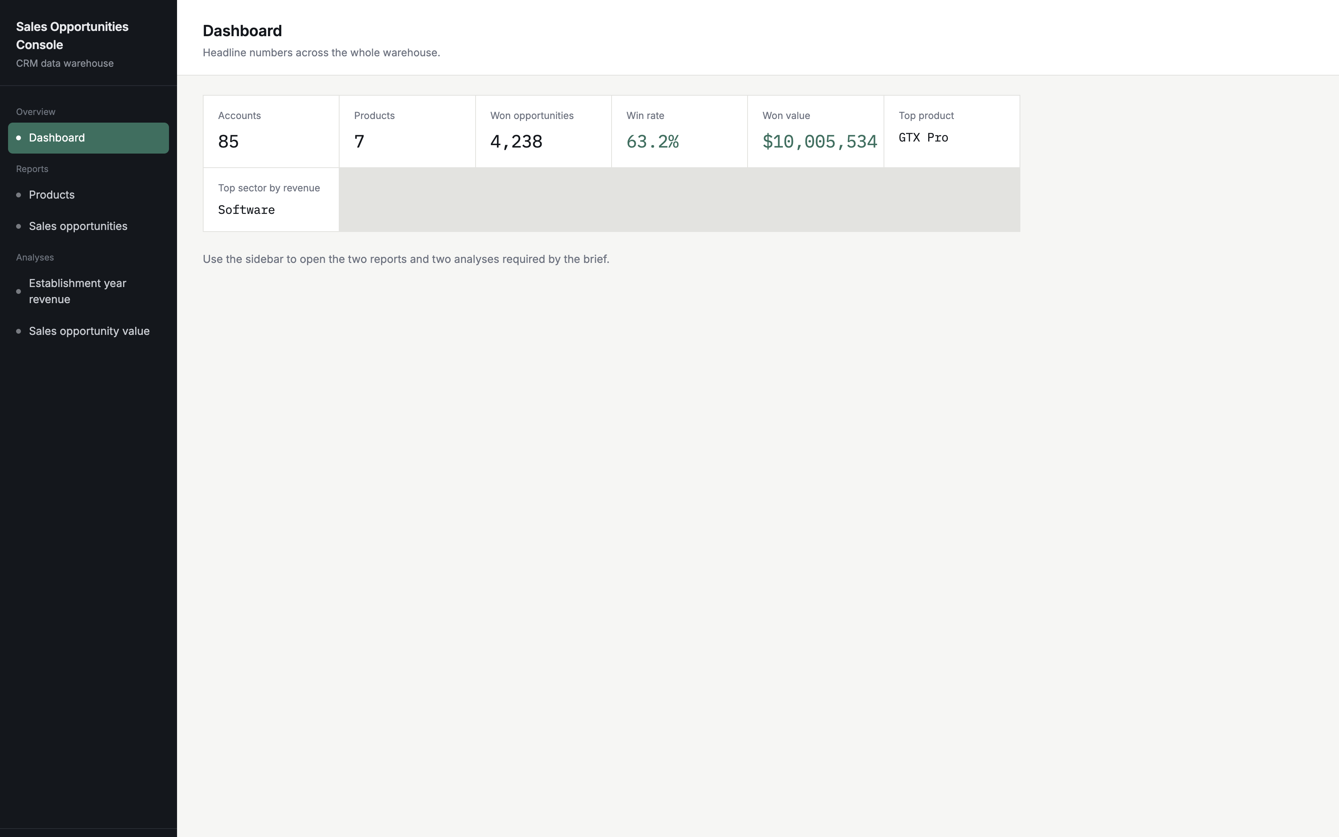
Figure 1: Dashboard
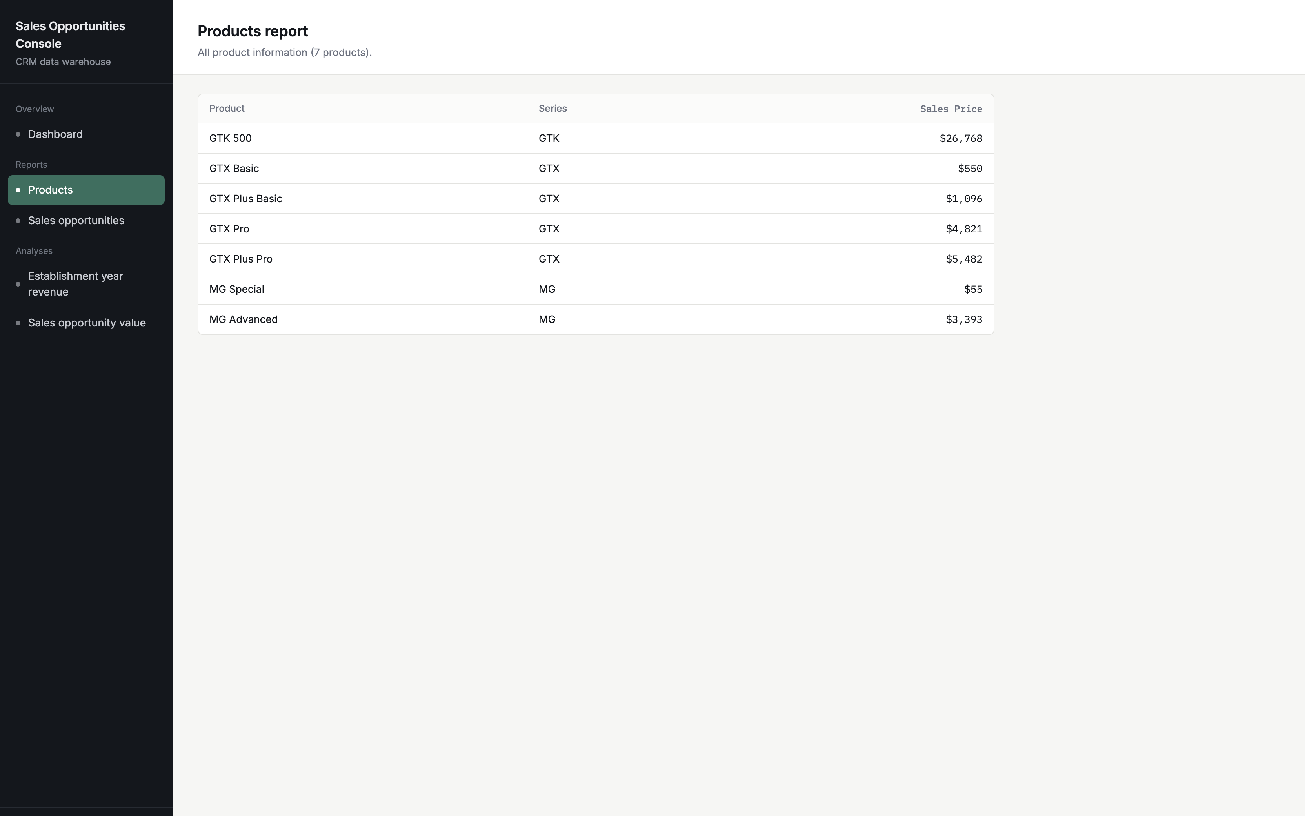
Figure 2: Products Report
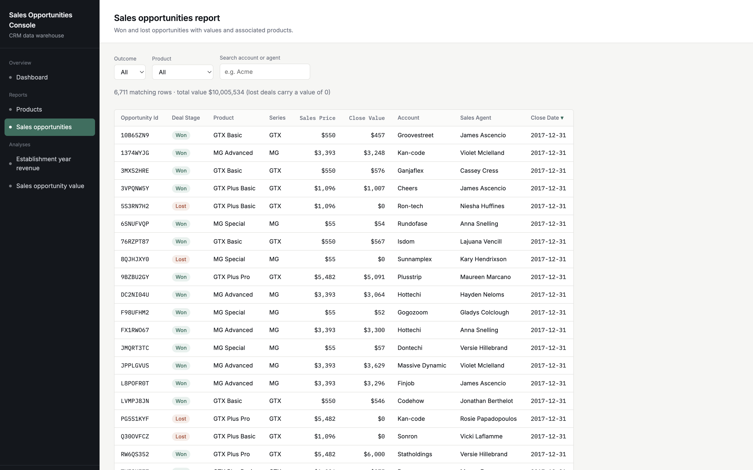
Figure 3: Sales Opportunities Report
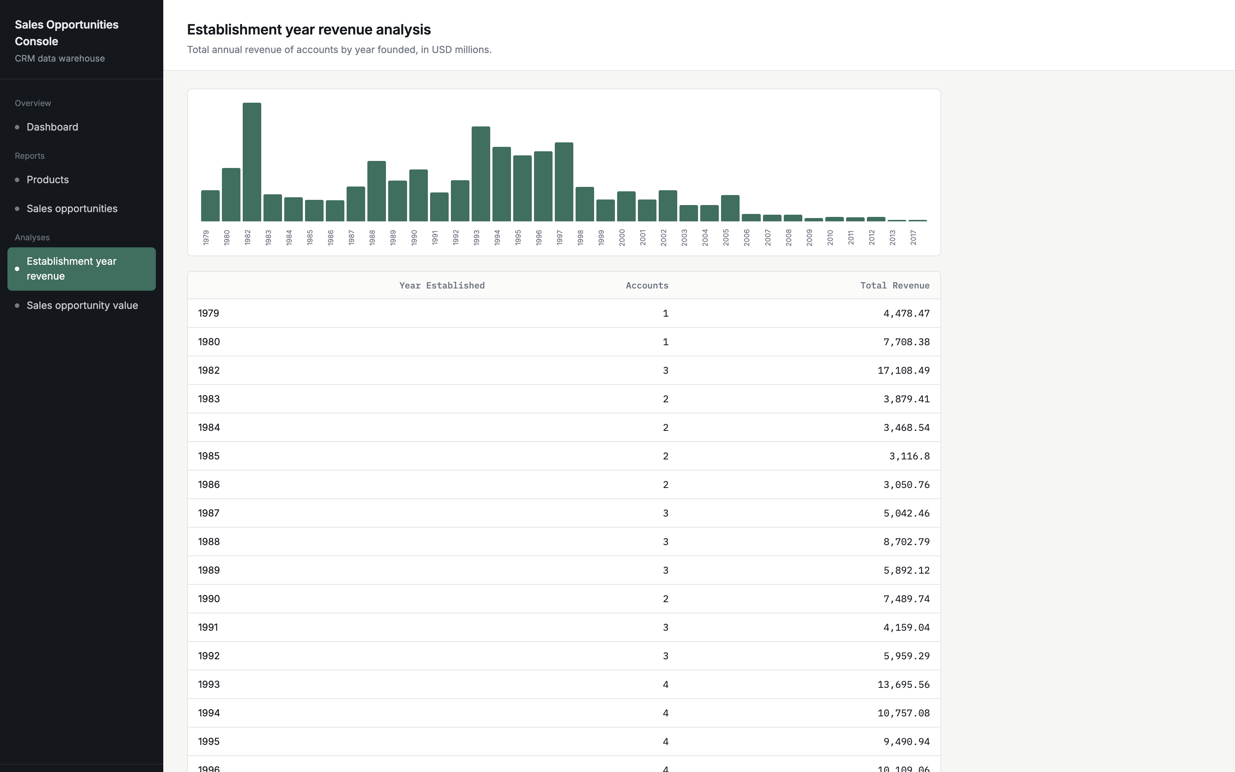
Figure 4: Establishment Year Revenue Analysis
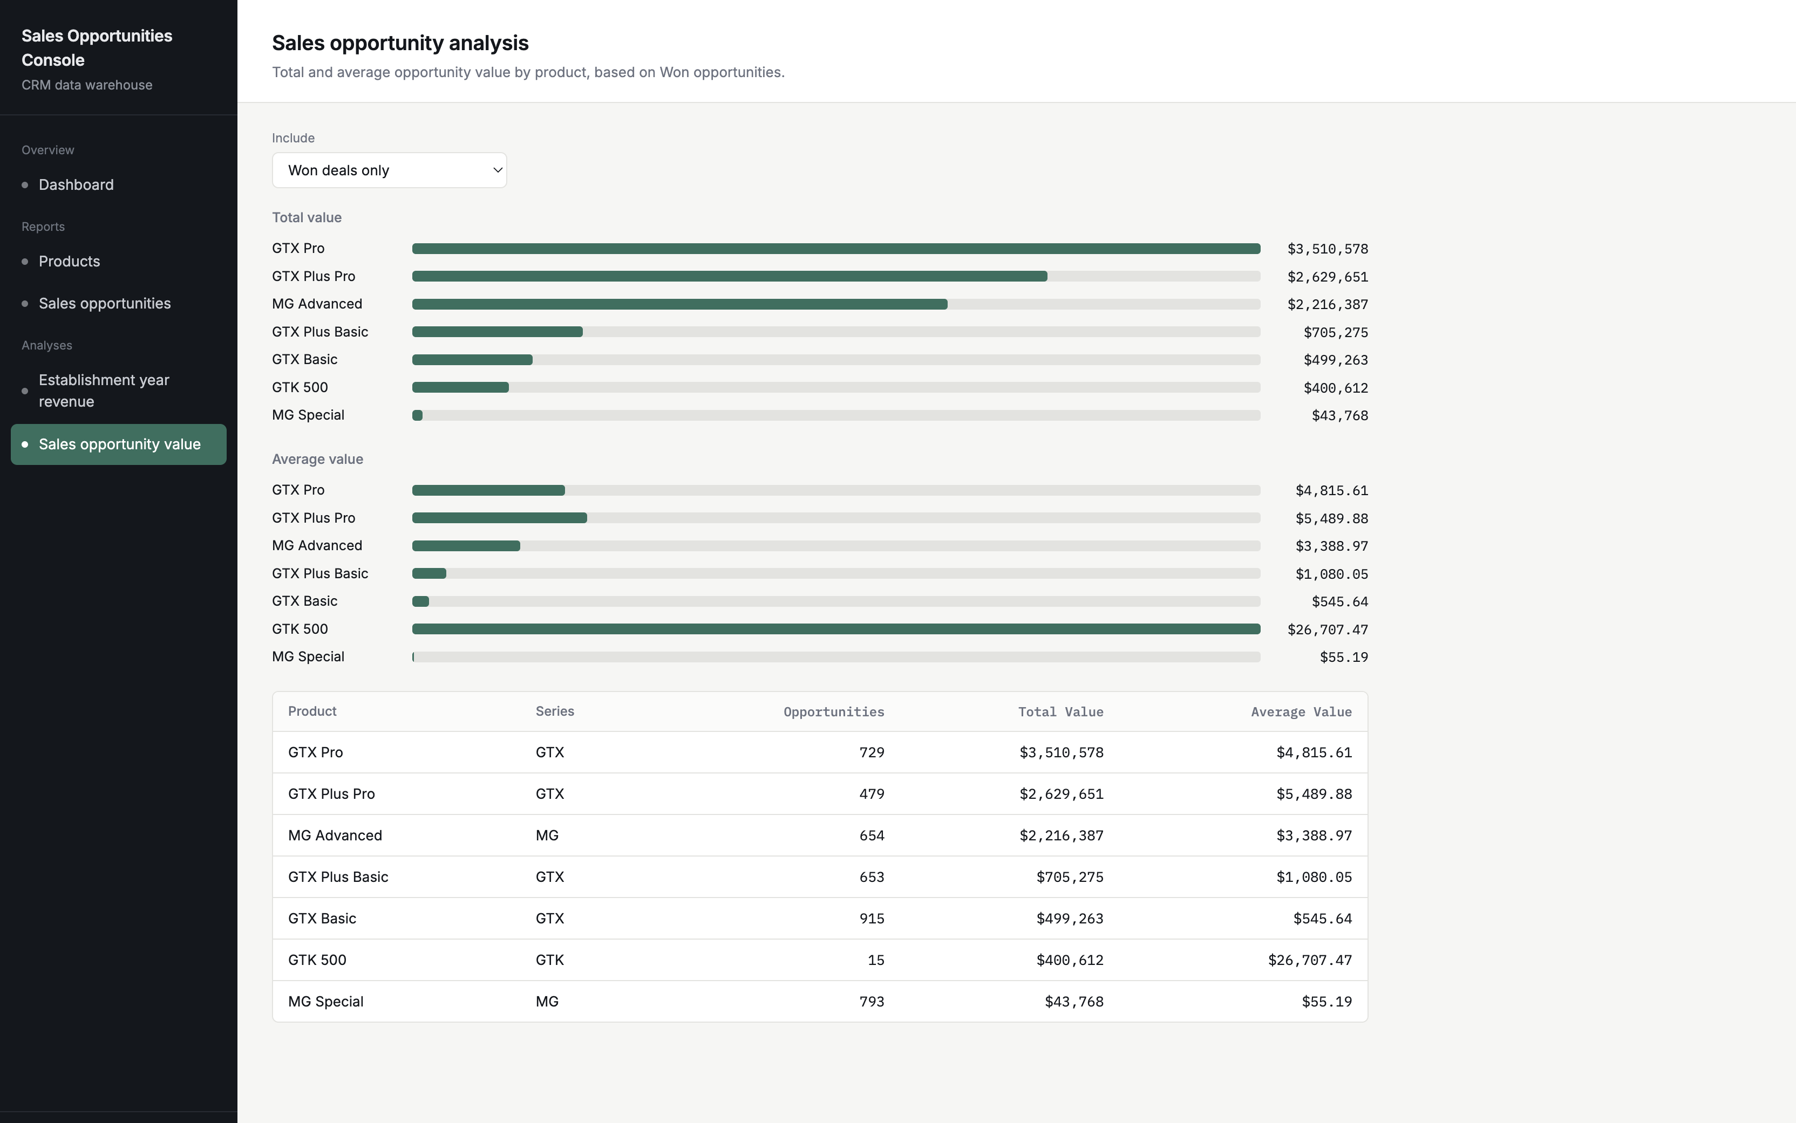
Figure 5: Sales Opportunity Analysis
8. Fulfilment of Requirements
Requirement | How it was met | Evidence

9. Conclusion
[Summary]
References
[APA 7th style]

Appendix A: AI Governance
AI feature chosen
[]
Data handling
[]
Prompt approach
[]
Human-in-the-loop mechanism
[]
AI limitations and mitigations
[]
Appendix B: Evidence of Team Collaboration
[Screenshots of chats, emails, meetings]
Declaration: Additional Help from AI
Name | Description

