After the first attempt with the dummy layout I made using just css styling. I realized that there was a much simpler way to construct the Chat Room layout.

The css grid layout system offers rows and columns making it easier to section off divs without having to use floats and positioning.

the grid layout used was:

* grid-template-areas: 20px auto;
  + 20px makes Column1 a width of 20px and keeps column at an automatic ratio according to the size of column1.
* grid-template-rows: 30px 500px 30px ;
  + 30px keeps rows 1 and 3 at a height of 30px
  + 500 keeps row 3 at a height of 500px;
* To get column 2 to span this wide use:
  + grid-column: 2 / span 6;
  + the “/ span 6” allows the column span wide enough to meet the 500px width set in the grid template area
  + 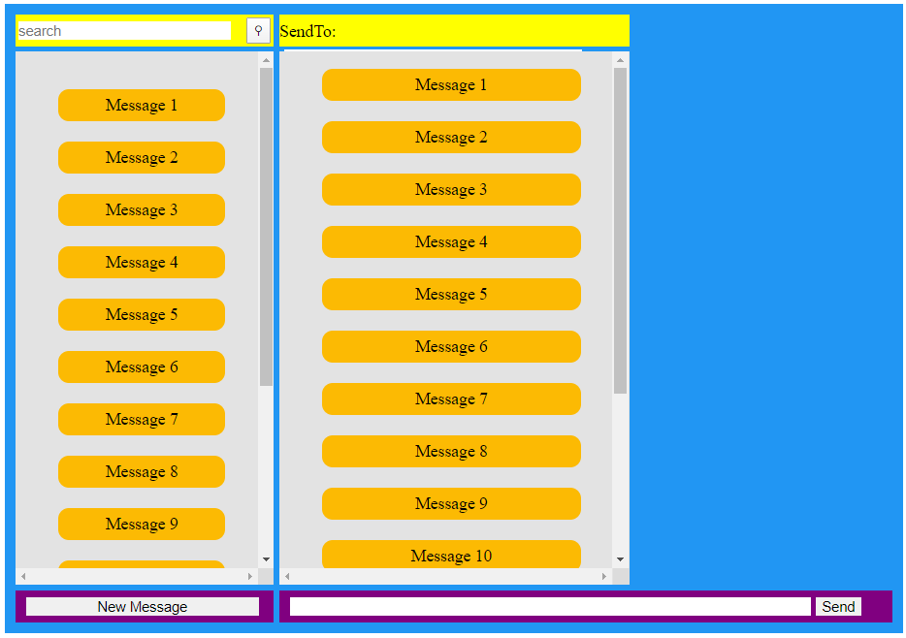example of what /span2 looks like:

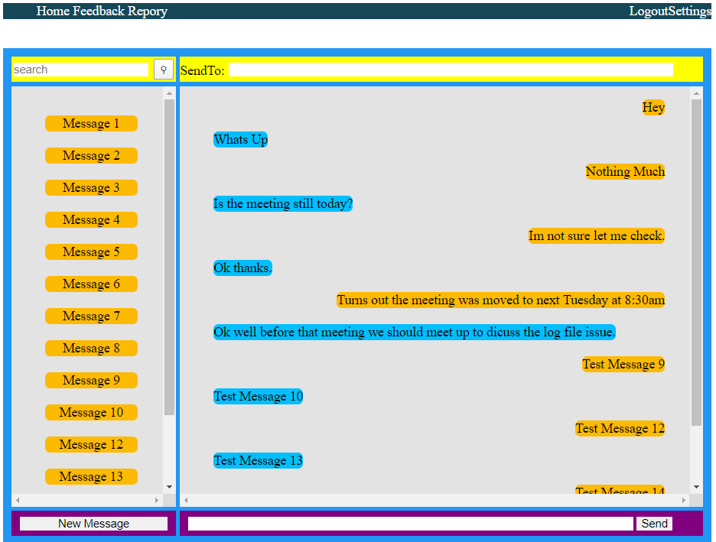

Blue = grid container- this is holding all the elements inside

Yellow = Row1

1. the search bar and icon are located in Row1 Column1

2. the send to label and send to text box are located in Row1 Column 2

Gray: Row2

Purple: Row3

Row2, Column2: this is where the actual chat messages need to go

Row2, Column1: this is where the list of conversations should go

**Solution found:** there was an issue with the styling in regards to the header. The list of messages was conforming to the styling meant for the header list. The solution to fix this is change the message list to ol type list and set the styling that way.

Make sure the header is located outside the grid-container***

Documentation for firebase messaging: <https://firebase.google.com/docs/cloud-messaging/js/first-message>

<https://firechat.firebaseapp.com/docs/#data_structure>