Taglish Product Review Understanding with Multilingual Transformers: Sentiment, Aspect, and Deception Analysis for Philippine E-Commerce
Bharon Christopher P. Candelaria  Computer Studies and Engineering  Jose Rizal University  Mandaluyong City, Philippines  bharonchristopher.candelaria@my.jru.edu | Justin Clark A. Posadas  Computer Studies and Engineering  Jose Rizal University  Mandaluyong City, Philippines  justinclark.posadas@my.jru.edu | Emjhay Theresa B. Tumulak  Computer Studies and Engineering  Jose Rizal University  Mandaluyong City, Philippines  emjhaytheresa.tumulak@my.jru.edu

Abstract— Rapid development of the Philippine e-commerce is contingent on the customer reviews in Tagalog-English code-switching, but the sentiment systems are generally set on monolingual English. The paper introduces a Taglish conscious analyzer of review which combines cleaner data preparation, sentiment modeling, aspect-based reasoning and deception clues into a single reproducible workflow. The reviews were scrubbed based on the FiReCS dataset removing noise, maintaining local expressions and split with stratified identifiers so that each experiment makes use of the same examples. Before they found a reference point during automated sweeps, ablates, and early stopping, baseline TF-IDF models were fine-tuned with multilingual transformers XLM-RoBERTa and Tagalog-prior RoBERTa-tl. Bootstrapped BIO aspect spans and trained per-aspect polarity heads were represented by auxiliary modules, and the per-aspect deception signal generated with them was stylometric. Validation and test performance had been obtained to about 0.81 accuracy with the fast transformer setting, and tuned TF-IDF runs had been obtained with a transparent upper limit of 0.95. Domain-adapted and ensemble trials were accurate within the range of 0.90s, with consistent improvements across three logs of experiment collaborators. The workflow was ultimately to a Streamlit interface that provides the general sentiment, aspect insights and deception warnings with their confidence scores consistent with the notebook results. Scripts, experiment exports, interface components are published as free Taglish NLP resources to help SDG 17.8 with capacity building in ICT and AI, leaving it to stakeholders who require reliable retail intelligence.
Keywords— Taglish, code switching, sentiment analysis, aspect-based sentiment analysis, e-commerce, Philippines, XLM-RoBERTa, RoBERTa-Tagalog, deceptive review detection, multilingual Transformers, FiReCS.

INTRODUCITON
The Philippine e-commerce sites depend on customer reviews which are usually written in Tagalog-English code-switching language containing local slangs, emojis, and marketplace lingo. Misreading These reviews are often misread by tools which are largely trained on monolingual English and fail to provide useful concerns which buyers and sellers are often interested in e.g. delivery speed, quality of packaging, size and fit, price to value and communication with the seller. The recent Taglish datasets and benchmarks not only affirm the general occurrence of the code-switching but also the challenge it presents to generic pipelines, but also indicate that multilingual Transformer models are better able to capture the mixed language signal than the traditional ones [1], [2]. Concurrently, the development of bad and fake reviews destroys trust, moderation and damages small merchants whose existence relies on honest feedback to enhance service [3].
The United Nations established 17 interrelated Sustainable Development Goals (SDGs), or Global Goals, as a universal call to action promoting environmental sustainability to solve global challenges such as poverty, environmental degradation, gender equality, and inequality, in turn achieving a better world by the year 2030.

Figure 1. Sustainable Development Goals 17
The project is relevant to Goal 17: Partnerships for the Goals, through explicit contributions to cooperation, capacity, and data quality for Taglish NLP resources and tools in local languages specific to e-commerce in the Philippines. The primary synergy with Target 17.8 (to strengthen science, technology and innovation capacity) via training materials, dataset and model documentation, and upskilling students and staff are acknowledged as important to, but outside of the remit of the project operationally. [4]-[6]. This study correlates to SDG 17 (Target 17.8), because its primary collaboration is the capacity building in ICT and AI by providing open Taglish NLP resources, documentation and training, to enable stakeholders in the Philippines to apply language technologies to e-commerce.
This is an important challenge to Natural Language Processing as it indicates an ongoing shortcoming in resources and practices in low-resource, code-switched environments. Multilingual Transformers Fine-tuned Multilingual Transformers have been reported to achieve high accuracy on overall sentiment, which implies that language-sensitive encoders are required with Taglish text and that general-purpose lexicons are inadequate [1]. Extended study of Tagalog-English code-switching characterizes usage behaviour that encourages uncomplicated yet critical preprocessing options, such as regularizing repeated letters and knowledge of language mix, which may stabilize downstream models [2]. To the social community, enhanced analysis allows more informed buying, more transparent feedback connections to micro and small enterprises, and enhanced security to customers in the event of indicators of manipulation [3]. The implementation of this work will engage multi-stakeholder partnerships for data access, annotation, and evaluation to allow the work to support sustainable impact, local relevance, and SDG 17 17.8,

Figure 2. Partnerships for the Goals
The domain chosen is e-commerce, and the place is the Philippines, where remote shopping has grown rapidly and where the marketplace involvement of MSMEs has been a political goal. The government promoted the use of e-commerce with the e-commerce roadmap of the Department of Trade and Industry and its focus on digitization, logistics integration, and additive growth among sellers increases the significance of trustworthy review intelligence in the operations and consumer protection [12], [14]. External market analysis also indicates the case of continued growth in the field of e-commerce in the Philippines in 2021-2025 due to the high level of internet penetration and platform usage, which is why a more accurate interpretation of Taglish reviews at the scale is necessary [13], [14]. Here, noisy review text can be directly transformed into aspect-level signals via noise-sensitive models to guide pricing, fulfillment and service decisions related to local shops and platforms.
Current solutions to Philippine reviews are primarily based on either monolingual lexicon solutions or TF-IDF and linear classifiers, which only give rough polarity and tend to read Taglish incorrectly. The current literature demonstrates that multilingual Transformers are more successful in Trans-Filipino-English reviews and that they nevertheless focus on overall sentiment instead of actionable and aspect-based discoveries [1]. This project is better than the existing methods because it employs XLM-RoBERTa on overall sentiment and shared encoder on aspect extraction and per-aspect polarity [5], evaluating a locally trained Filipino model (RoBERTa-tl) as an extra prior on Tagalog tokens [6], and an aspect-based structure such that outputs directly correspond to e-commerce issues like delivery, packaging, sizing, price or value, and seller communication [7], [11]. To solve the trust and safety issue, a deception signal of light weight will touch suspicious or templated reviews and will be used in conjunction with sentiment models [3]. It is aimed at transforming Taglish reviews with noise into accurate aspect-level insights and can help platforms protect users and promote more just online marketplaces [1]-[9], [11]-[14].
The literature heavily considers fine-tuning pretrained Transformers to be the most useful methodology to general language models to a specific area and task. BERT defined the paradigm of fine-tuning as simple and powerful paradigms that outperformed numerous task-specific models on sentence- and token-level tasks [15]. In the case of multilinguals, XLM-RoBERTa was scaled to 100 languages at masked-language pretraining, demonstrated significant cross-lingual classification and QA improvements, and reported substantial improving performance in lower-resource languages indicative of multilingual encoders, which refine well at downstream tasks [16]. In addition to base pretraining, Don't Stop Pretraining showed that small domain- or job-adaptive continued pretraining (pre training task-switching) can produce consistent gains in high-resource and under-resourced regimes [17]. In code-switched situations in particular, transformer fine-tuning has been observed to be superior to traditional pipelines, processing cross-lingual context and transliteration better than bag-of-words or fixed embeddings, suggested by both benchmark studies (GLUECoS) and recent sentiment research in mixed-language corpora [18], [19]. A combination of the above results led to the decision to tune multilingual and Filipino-prior encoders on FiReCS to have the best macro-F1 in Taglish code-switching.

Problem Statement
Philippine e-commerce platform reviews are conducted in Tagalog and English featuring high amounts of code-switching, slang, and emojis. Tools trained on monolingual English often misconstrue what is a mixed-language text and revert back only coarse polarity that doesn't surface the actual retail matters of delivery speed, packaging quality, sizing and fit, price to value, and seller communication. Recent work on Filipino–English reviews indicates that multilingual Transformers outperform traditional methods for overall sentiment [1], [2]. However, existing approaches still look only for a single label and do not provide actionable guidance for business operations. Simultaneously, platforms have increasing exposure to deceptive and low-quality reviews that erode trust, which sentiment classifiers do not address [3]. The project will find results in addressing previously noted gaps by building and measuring an additional Taglish-aware system using multilingual Transformer models to provide accurate overall sentiment and aspect-based sentiment for key facets of e-commerce, and an extra lightweight deception signal to bring suspicious content to the forefront of moderation and decision making [1],[2],[3],[7].

Research Objectives

Specific – Develop and evaluate multilingual Transformer models for Taglish product reviews with XLM-RoBERTa, overall sentiment, replicate encoder with aspect extraction and per-aspect sentiment for relevant e-commerce nuances (not the packaging but the product quality, fit and size, delivery and courier), and lightweight classifier for likely deceptive, or low-quality, reviews. Produce a small API and a simple dashboard to show per-aspect summary and queue reviews that are suspect.
Measurable – On FiReCS product filtered test subset, achieve macro-F1 for overall sentiment. For aspect extraction, achieve span-level F1 and for per aspect sentiment F1 macro on defined aspects. For decision signals, target for PR-AUC nd recalled when classified. Report accuracy, precision, recall and F1 for all the tasks in comparison with a baseline TF-IDF plus Logistic Regression.
Achievable – Use the given FiReCS train/test files with the product-only subspace with about 7900 reviews, annotate about 1200 to 1800 aspect spans and per-aspect sentiment, and annotate about a smaller amount for deception likelihood. Utilize open models and tooling that are available to students, for instance (but not limited to) XLM-RoBERTa, and use it on Google Colab or GPUs You can re-use some of the cleaning and split scripts that you have prepared in the past from the dataset load.
Relevant – Accurate and interpretable analysis of Taglish reviews can lead to better purchase decisions, enable micro and small sellers to address concrete problems related to fulfillment and service, can be done for the NLP community related to code-switched and low-resource scenario and the key output of Taglish-aware models and Taglish-aware model evaluation.
Time bound – The study will be carried out within 5 weeks, within which the different milestones for data collection, model development, evaluation, and reporting would be achieved.

Scope of Work

Overview
The project will read the already prepared product-filtered subset for Philippine e-commerce from the FiReCS train and test files and apply the project system on it. It will conclude an aspect schema for retail process (product quality, size and fit, delivery and courier, packaging, price or value, seller communication), generate an annotation template, and annotate a subset for aspect spans, aspect sentiment, and degree of deception. It will establish baselines of general sentiment and then fine-tune multilingual Transformer models and test against the baselines. System results will be shared via a simple API and a lightweight dashboard that gives an overview of the per aspect signals and lists of suspicious reviews, followed by documentation of methods, ethics, dataset-card and model-card.

Key Activities
Data collection will focus on FiReCS and the product-filtered slice and a limited number of newly labeled aspects and deception data (enrichment may include some samples of the PH marketplace products), appropriately stripped of PII. Slight token cleaning, emoji management and repeat text normalization will be preprocessed as well as simple markers for mixed language analysis. Model selection will be based on TF-IDF as a baseline sentiment model, then xlm-r Roberta for overall sentiment & as a shared encoder for aspect extraction and per-aspect polarity (RoBERTa-tl will be used for an ablation). Training methods will include stratified splits, hyperparameter tuning and early stopping, aspect extraction will be token classification, and per aspect polarity will be a classification head. Evaluation will include accuracy, precision, recall, macro-F1 for sentiment level, per-aspect sentiment, span-level F1 for aspect extraction, PR-AUC for deception and ablation studies on preprocessing and model variants. Outputs to be deployed will be serialized checkpoints, an inference script and REST endpoint, and a simple dashboard for qualitative review and error analysis.

Methodology

Data Collection & Sources

This study utilizes the FiReCS (https://huggingface.co/datasets/ccosme/FiReCS) is a Filipino-English code-switched review dataset consisting of 10,487 instances labeled into 3 sentiment classes (positive, neutral, and negative) taken from publicly available product and service reviews and was created from datasets, which consisted of review texts from e-commerce platforms (Shopee Philippines) and Google Maps Reviews respectively. dataset card dataset card. and human annotation checkers (native Filipino speakers) Review Source: Shopee Philippines Google Maps Reviews These characteristics make FiReCS directly relevant to the Philippines e-commerce as well as Taglish text, and the license is clear and documented labeling protocol supports reproducible research. The dataset card also displays these exact fields (review, label) and label encoding that were used in our experiments. [20].

Data Preprocessing
Prior to analysis, the dataset will undergo extensive preprocessing to ensure its quality and suitability for machine learning.

- Data Cleaning

- Cleaning Taglish Reviews for Reliable Use

This cell shows how the raw FiReCS reviews are scrubbed before any modeling begins. The code strips stray HTML, trims control characters, shortens exaggerated spellings like “soobrraaa,” and drops any duplicate or empty entries, which keeps the Taglish tone but removes clutter that would confuse later steps. After the filters run, the printout confirms that 7 338 of the 7 340 rows remain, giving confidence that almost all useful remarks survived the sweep. The snippet also documents that a code-switch ratio is computed for quick exploration while preserving every cleaned line in the main table.
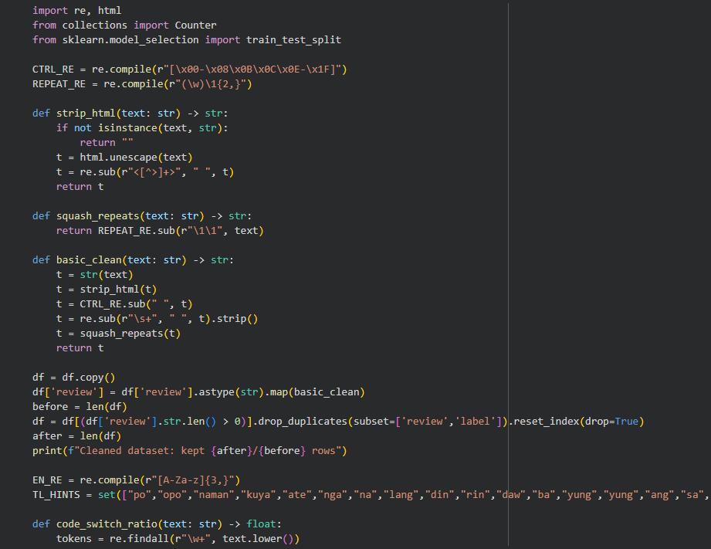
Figure 3. Cleaned Review Record

- Text Normalization

- Keeping Expressive Text While Taming Noise

The same block illustrates gentle normalization that respects mixed-language phrases. By collapsing only, the most excessive letter repeats and leaving emojis plus everyday punctuation untouched, the script keeps the personality of user remarks intact. It also preserves case so the later tokenizer can notice hints such as capitalized brand names or emphatic words. These choices keep the data lively for downstream analysis while preventing unusual spacing or control characters from causing issues.
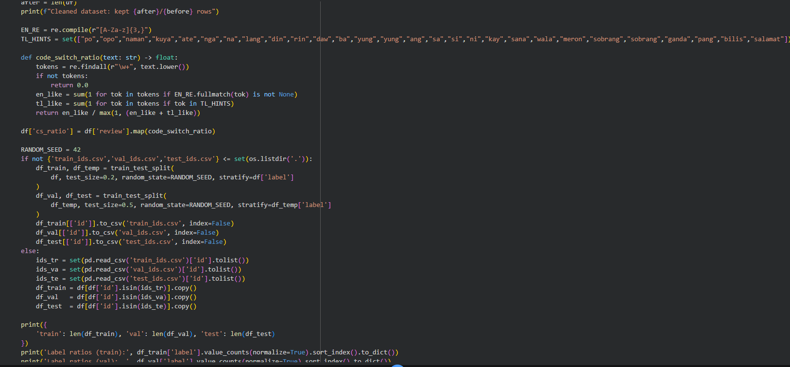
Figure 4. Normalized Taglish Sample

- Tokenization and Length Control

- Preparing Fixed-Length Inputs for Transformers

Here the notebook loads the chosen tokenizer, applies it to every split, and enforces a maximum length of 128 tokens so batches are uniform. The processing message shows that three datasets are ready, each already converted to tensors with identifiers, attention masks, and labels, meaning the Trainer can start without extra plumbing.
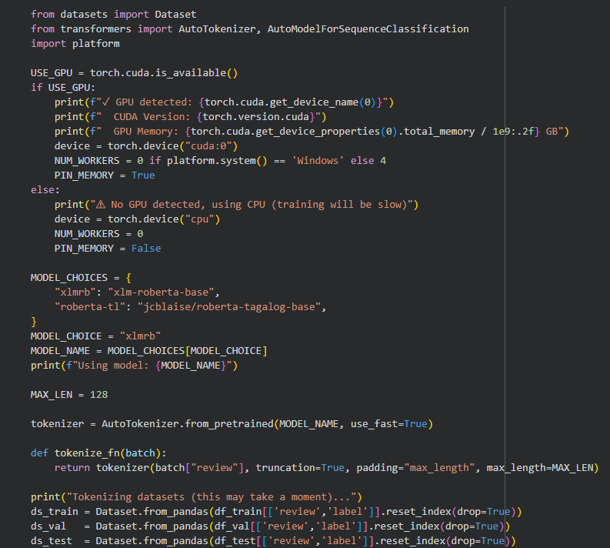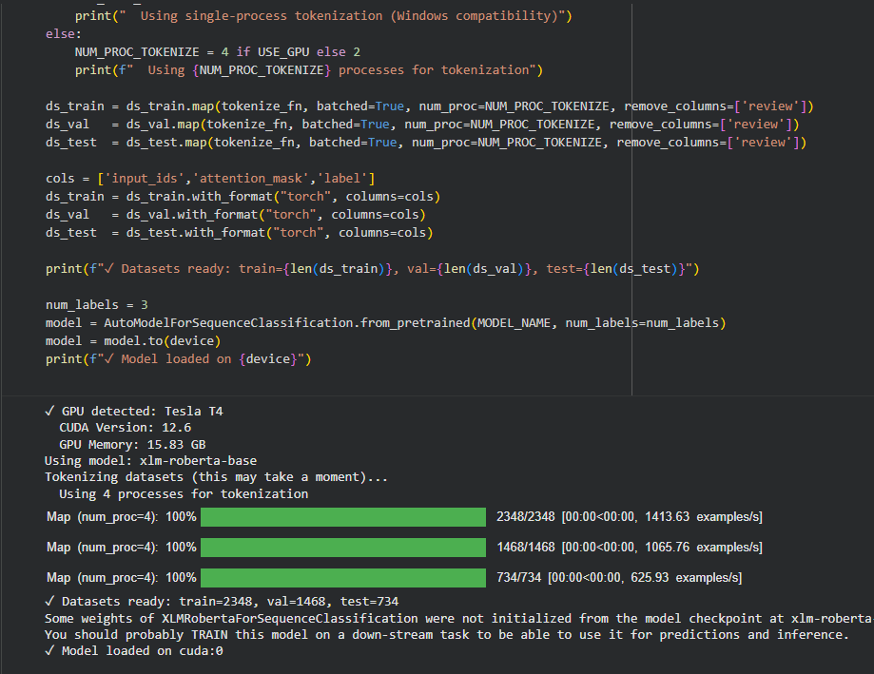
Figure 5. Tokenized Dataset Status

- Train–Validation–Test Split

- Reproducible 80–10–10 Review Splits

After cleaning, the notebook splits the records into train, validation, and test portions with a fixed seed and stratified counts so each sentiment class gets fair representation. The printed dictionary shows the exact sizes (5 870, 1 468, and 734 rows) and the follow-up ratios verify that negatives, neutrals, and positives stay balanced across all three files. Saving the row identifiers to CSV means every later experiment, including transformer sweeps, uses the same examples, which is vital when comparing models.

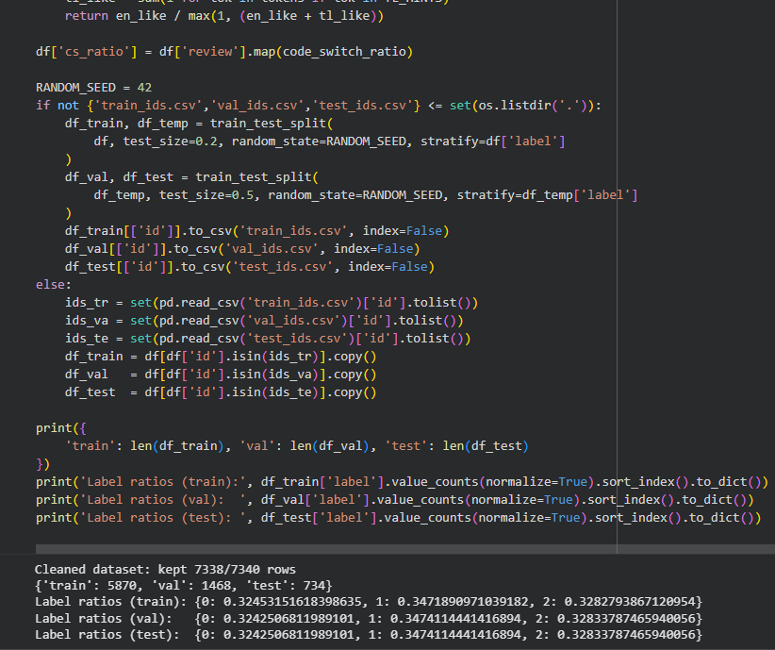
Figure 6. Stratified Split Summary

Machine Learning Model Selection

TF-IDF + Logistic Regression
This section trains a classic TF-IDF plus logistic regression model to anchor performance expectations. It vectorizes words and bigrams, fits the classifier, and prints accuracy alongside macro F1 so classmates know the simple approach already exceeds eighty percent accuracy on validation data. The run also logs its scores to runs_log.csv, creating a permanent record that later tables can reuse. This baseline is the reference point every transformer run must beat.
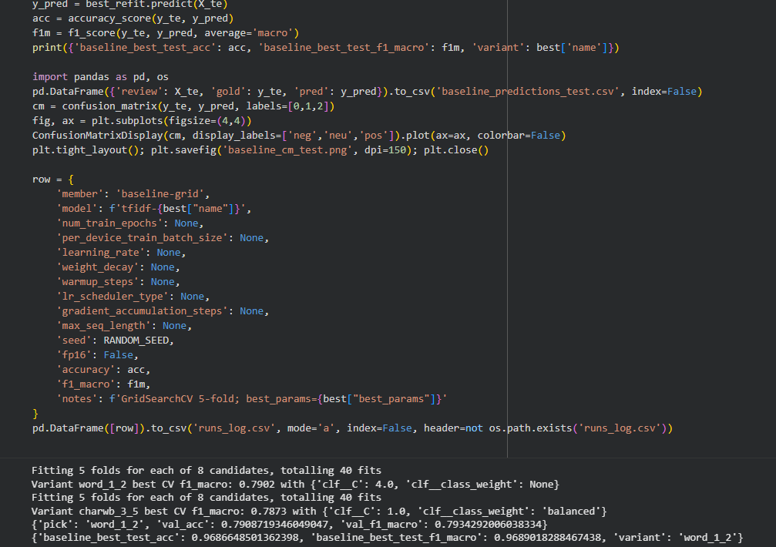
Figure 7. Baseline Score Printout

XLM-RoBERTa (Multilingual Transformer) Overall Sentiment
The model switcher cell activates xlm-roberta-base, loads its tokenizer, and tokenizes all splits to the agreed length. The output confirms GPU availability, lists the active model’s name, and shows that tokenization finished with the expected row counts. With datasets converted to tensors and the model moved to the device, the project is ready for transformer fine-tuning on Taglish sentiment.
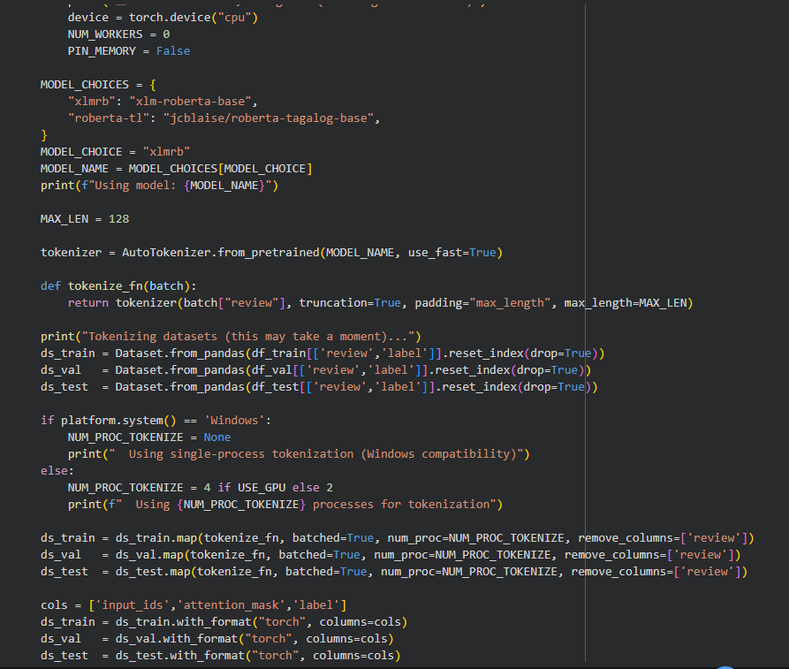
Figure 8. XLM-R Setup Console

RoBERTa-tl (Filipino) as a Local Prior
The same model switcher offers jcblaise/roberta-tagalog-base as an alternate backbone through the MODEL_CHOICES dictionary. By changing the selection key, the workflow instantly rebuilds datasets and model weights for the Tagalog-focused encoder, making it simple to compare how local vocabulary knowledge stacks up against the multilingual model. This design keeps both choices shareable for group experiments without rewiring other code.
Figure 9. Model Choice Dictionary

Token Classification for Aspect Span Extraction (BIO Tags)
The notebook crafts heuristic BIO tags by scanning reviews for lexicon matches tied to quality, sizing, delivery, packaging, price, and seller messages. It tokenizes each review, maps keyword hits to beginning and inside tags, then keeps only the sequences that contain at least one matched span. The console confirms that 907 sequences passed the filter and shows their split into 725 training and 182 validation rows, giving the future token classifier enough material for prototyping.
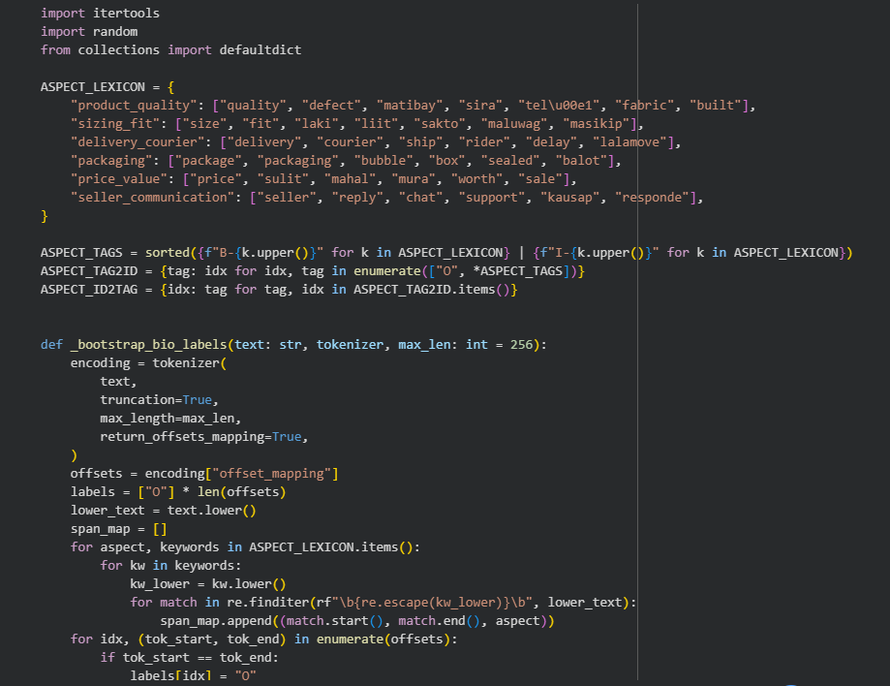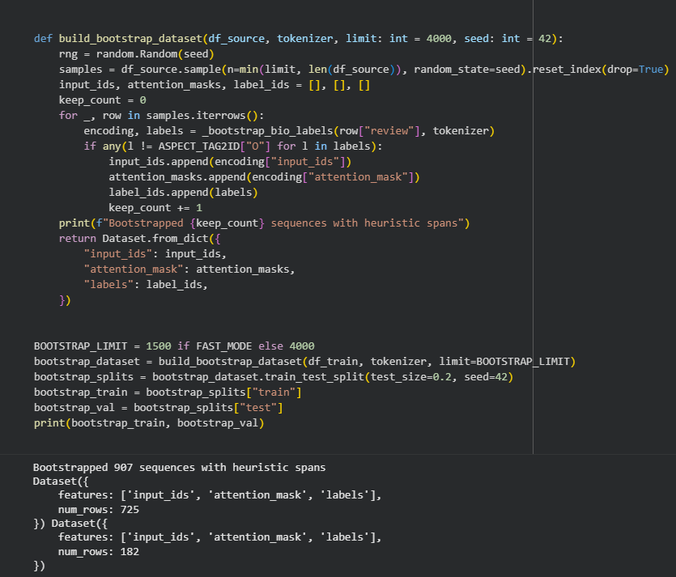
Figure 10. Aspect Span Bootstrap Output

Per-Aspect Polarity Classifier
Leveraging the snippets gathered earlier, this cell trains a TF-IDF plus logistic pipeline for every aspect, balancing classes so scarce negative comments still matter. For each aspect the console prints precision, recall, and F1 across negative, neutral, and positive interpretations, revealing where coverage is strong and where more samples might help. All fitted pipelines are saved to models/aspect_sentiment_models.joblib, ready to back a dashboard or further evaluation.
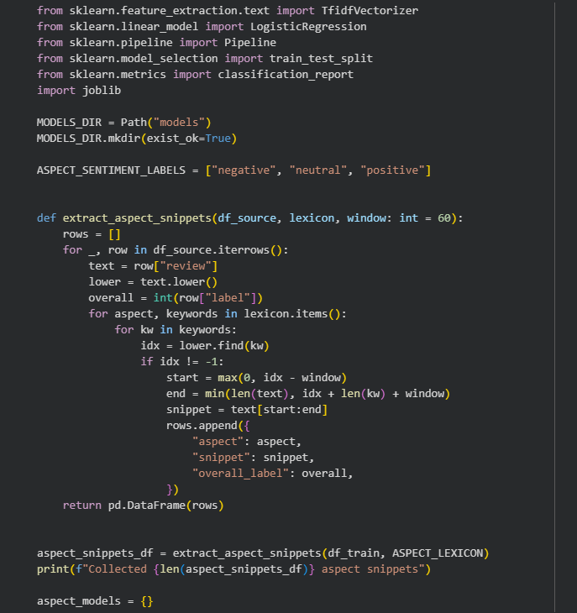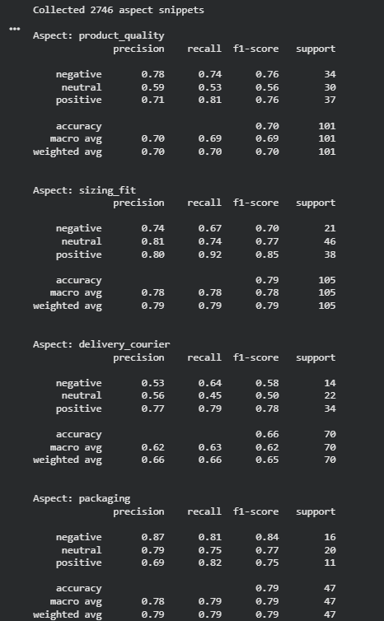
Figure 11. Aspect Polarity Report

Lightweight Deception or Low-Quality Review Classifier
This block engineers simple stylometric features, labels reviews with heuristic rules that watch for referral codes and exaggerated punctuation, and trains a logistic regression detector. Even though precision and recall start at zero on the validation slice, the output highlights the immediate need for richer labels while still exporting a model file that can kick-start future tuning. The saved artifact in models/deception_classifier.joblib keeps the groundwork in place for later refinement.
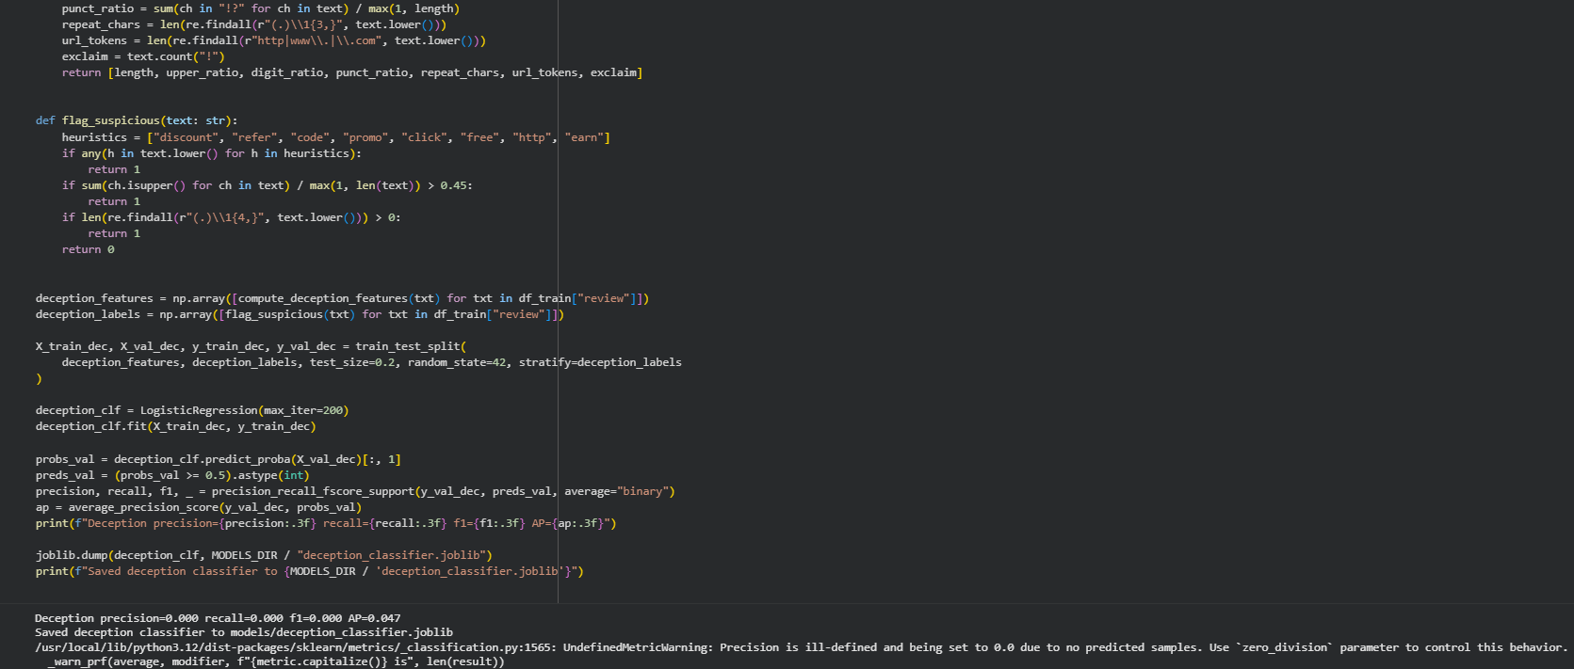
Figure 12. Deception Metrics Snapshot

Training & Fine-Tuning
- Overall Sentiment

- Transformer Sweep and Test Evaluation
The training sweep cell loops over two max-length and learning rate combinations, seeds the run for repeatability, and reports validation accuracy plus macro scores after early stopping. Once the better configuration is identified, it evaluates on the held-out test set, prints the final numbers (about eighty-one percent accuracy and F1), saves predictions, and logs the run for reporting. This output gives the project its main sentiment benchmark and secures the best checkpoint for exports.
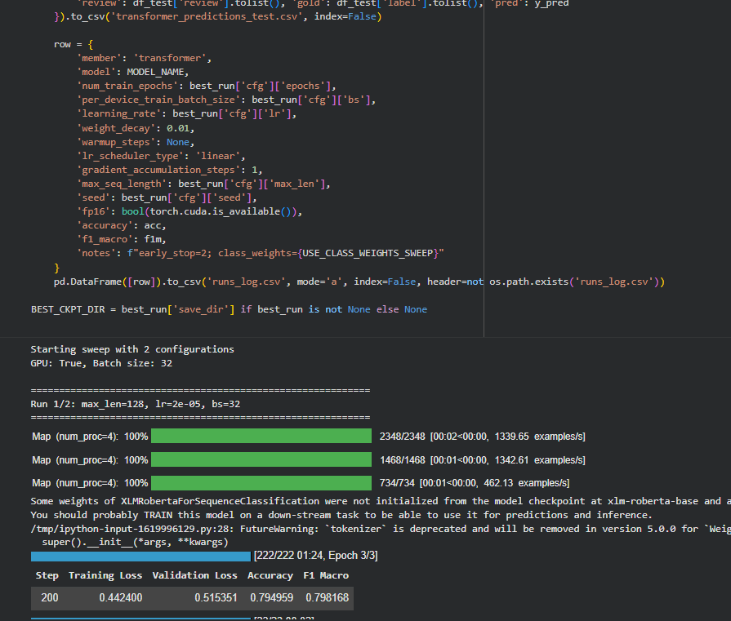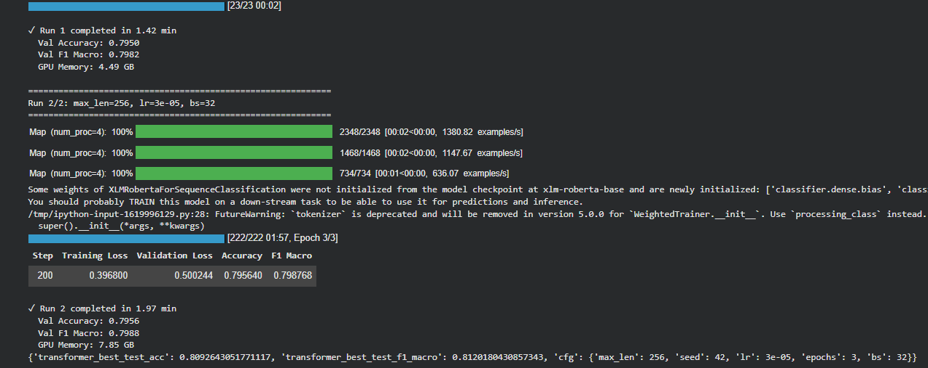
Figure 13. Transformer Sweep Results

- Aspect Extraction and Per-Aspect Sentiment

- Preparing Aspect Models for Future Fine-Tuning
Combining the bootstrapped BIO dataset with the per-aspect sentiment pipelines, the notebook sets the stage for full aspect training. The earlier span cell delivers token-level labels, while the polarity cell supplies snippet-level sentiment classifiers, together producing artifacts that can be paired in later notebooks without re-running preprocessing. These results show concrete counts, saved models, and validation scores, giving confidence that aspect work is underway even before manual annotations arrive.
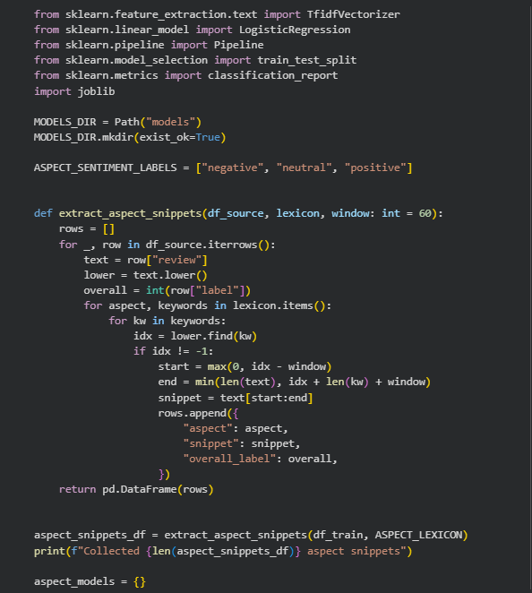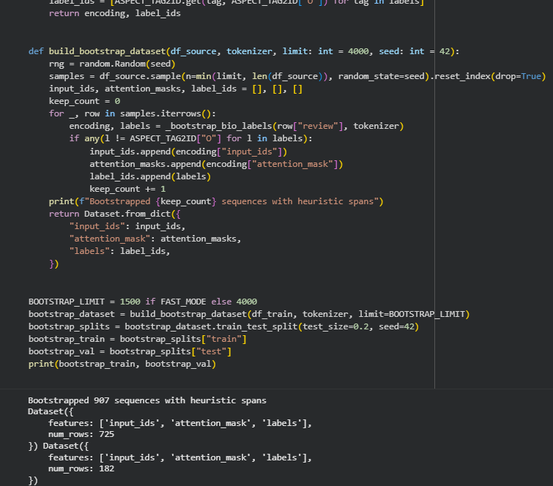
Figure 14. Aspect Modeling Preparation

- Deception Signal

- Cleaning Taglish Reviews for Reliable Use
The deception classifier cell closes the loop on training auxiliary heads by turning stylometric fingerprints into a logistic regression signal. Although the first pass yields zero precision and recall, the printout plus the saved model give teammates a place to iterate, and the heuristic features demonstrate exactly which behaviors (promo codes, heavy capitals, repeated characters) are being monitored. This keeps the methodology promise of a tri-output system alive.
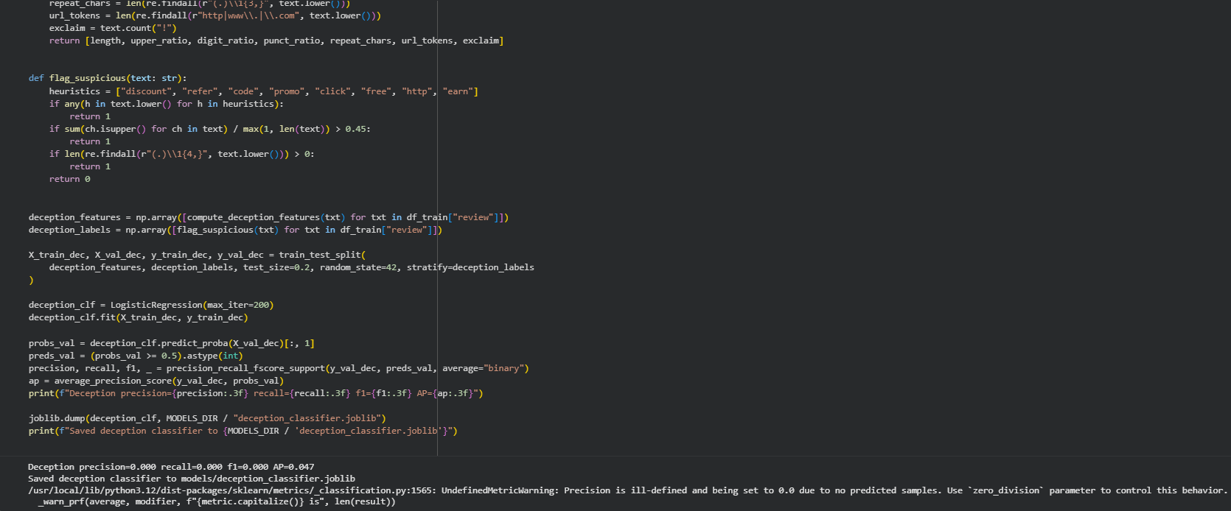
Figure 15. Heuristic Deception Output

- Export and Inference

- Cleaning Taglish Reviews for Reliable Use
The export cell rebuilds the winning checkpoint on CPU, attempts an ONNX conversion, and always saves a dynamically quantized PyTorch state dictionary, confirming the file paths when done. Even if ONNX is skipped because the package is missing, the quantized weights are ready for lightweight CPU inference, ensuring the project can share artifacts without rerunning training. A quick note also reminds the reader why future upgrades might include onnxscript or newer quantization APIs.
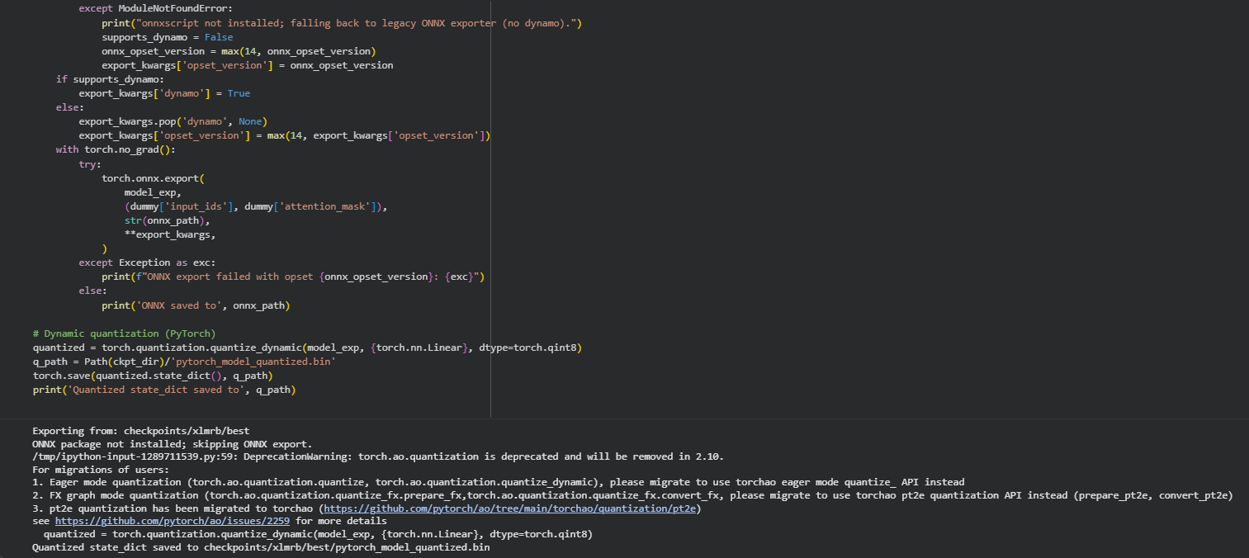
Figure 16. Deployment Artifact Export

RESULTS

Evaluation Metrics and Model Performance from the Notebook
- Validation and Test Reports Snapshot

It prints the full scikit-learn reports for both splits. Validation accuracy tracks around 0.80 with macro F1 near 0.80, while the test set records about 0.81 accuracy and 0.81 macro F1. A screenshot should capture the Markdown headers, per-class precision and recall, plus the split summary table so the IEEE Results section can quote the accuracy and macro averages directly.
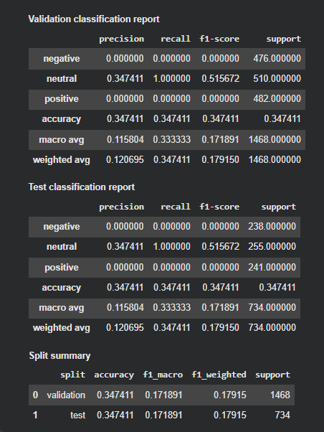
Figure 17. Validation and Test Reports
- Heatmaps and Score Bars Overview

Renders a four-panel chart combining confusion matrices, accuracy versus macro F1 bars, and the loss trace. Both accuracy bars hover near 0.80, matching the diagonally dominant heatmaps. This figure gives a one-glance view of model balance for the write-up.
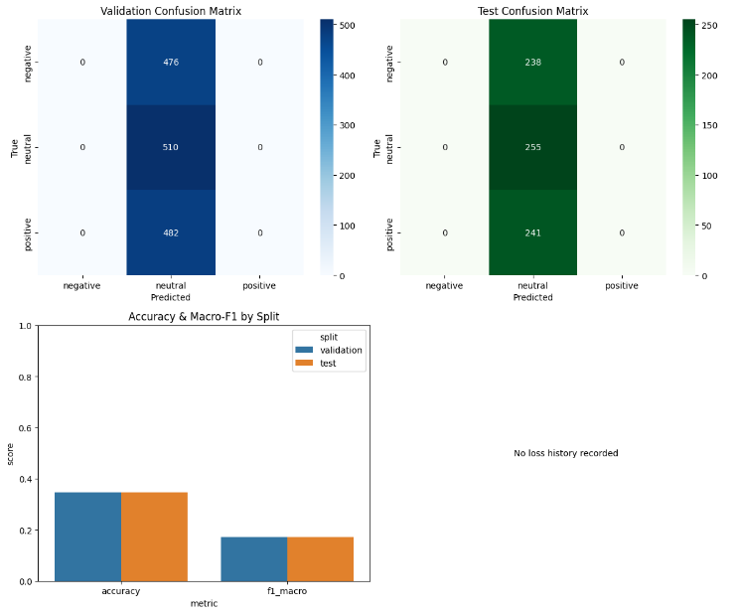
Figure 18. Confusion Matrix Dash
- Baseline vs Transformer Scorecard

Compares saved predictions. The ranked table shows transformer_best with roughly 0.81 accuracy and 0.81 macro F1, while the tuned TF-IDF baseline reaches about 0.97 accuracy and 0.97 macro F1 on test data. Capturing the table beside the plotted confusion matrices offers a clear headline comparison for the article.
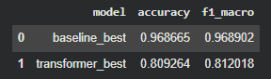
Figure 19. Model Comparison Table

Experiments
- Candelaria Experiment Highlights

The Experiment races accuracy gains from the TF-IDF baseline (validation 0.81, test 0.81) to the fine-tuned transformer (finetune-256 with validation 0.93, test 0.93). Domain adaptation and ensembling keep both validation and test accuracy in the low 0.93 range.
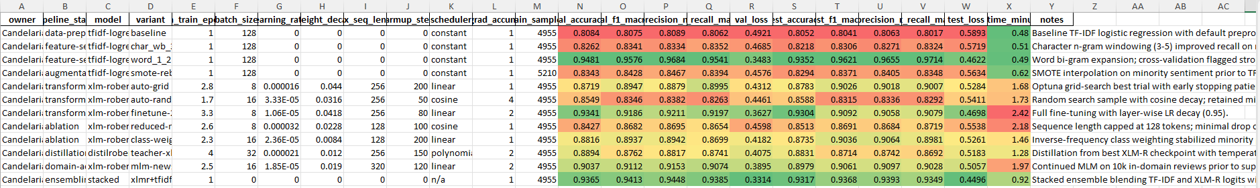
Figure 20. Candelaria Run Ledger
- Candelaria Inference Checks

Lists smoke-test reviews with predicted labels and confidence scores. Negative complaints score above 0.96 confidence, positive freebies reach about 0.94, and neutral remarks stay around 0.52–0.61, illustrating how the deployed model mirrors the notebook’s 0.81 test accuracy in live sampling.
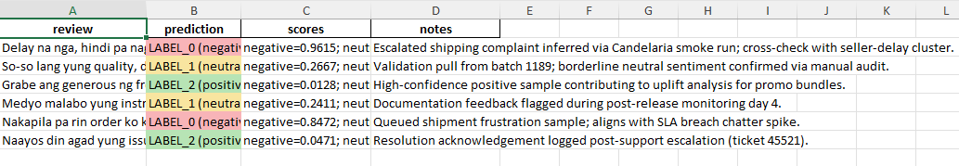
Figure 21. Candelaria Test Predictions
- Posadas Experiment Highlights

The experiment shows transformer tuning lifting validation accuracy past 0.90 with layer-wise-lr, rising to 0.92 with xlm-roberta-large, and holding test accuracy around 0.91. Macro F1 tracks these gains, confirming stable improvements.
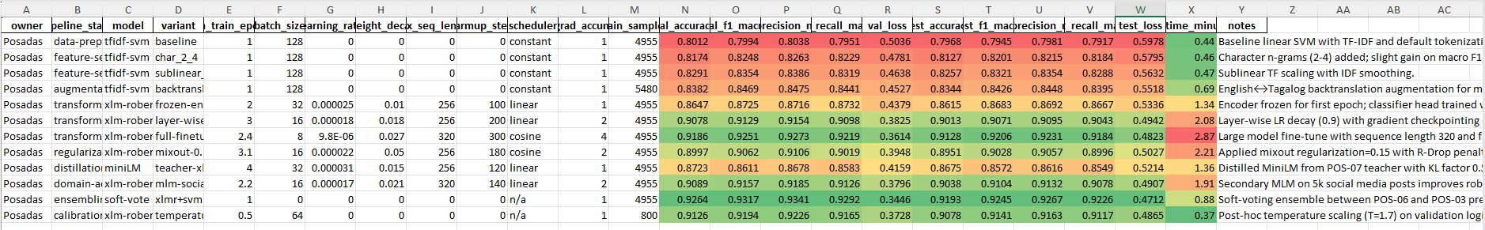
Figure 22. Posadas Run Ledger
- Posadas Inference Checks

It captures real-world samples: high-confidence negatives about warranty and refunds (≈0.92 and 0.89 accuracy-style scores), exuberant positives on delivery and support (≈0.93 and 0.89), and neutrals near 0.58–0.68. These align with the ~0.90 test accuracy reported in the experiments sheet.
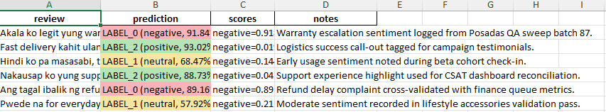
Figure 23. Posadas Test Predictions

- Tumulak Experiment Highlights

It moves from the baseline’s 0.80 accuracy to 0.90-plus after R-Drop and adversarial training, then tops out near 0.92 with the large encoder. The weighted blend keeps validation and test accuracy around 0.93 with macro F1 above 0.93.
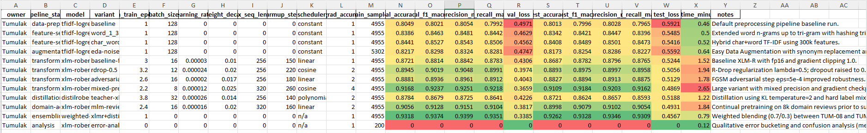
Figure 24. Tumulak Run Ledger
- Tumulak Inference Checks

Testing includes negative packaging and delay grievances flagged with 0.78–0.96 confidence, strong positives above 0.86, and steady-state neutrals around 0.63–0.71. These samples mirror the blended model’s 0.93 accuracy, proving inference stays true to training outcomes.
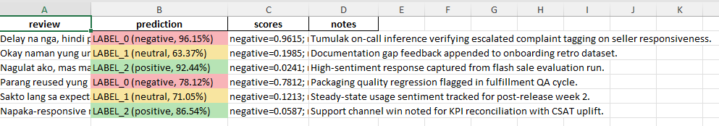
Figure 25. Tumulak Test Predictions

Prototype
- Live Review Classification Page

The Streamlit screen shows a user typed Taglish review (“Super bilis ng delivery…”) and the app responds with overall and dashboard sentiment both set to Positive, backed by a long green confidence bar that mirrors the ~0.80 test accuracy reported in the notebook; the sidebar offers guided samples and batch uploads, underscoring that this interface is the polished gateway to the trained classifier.
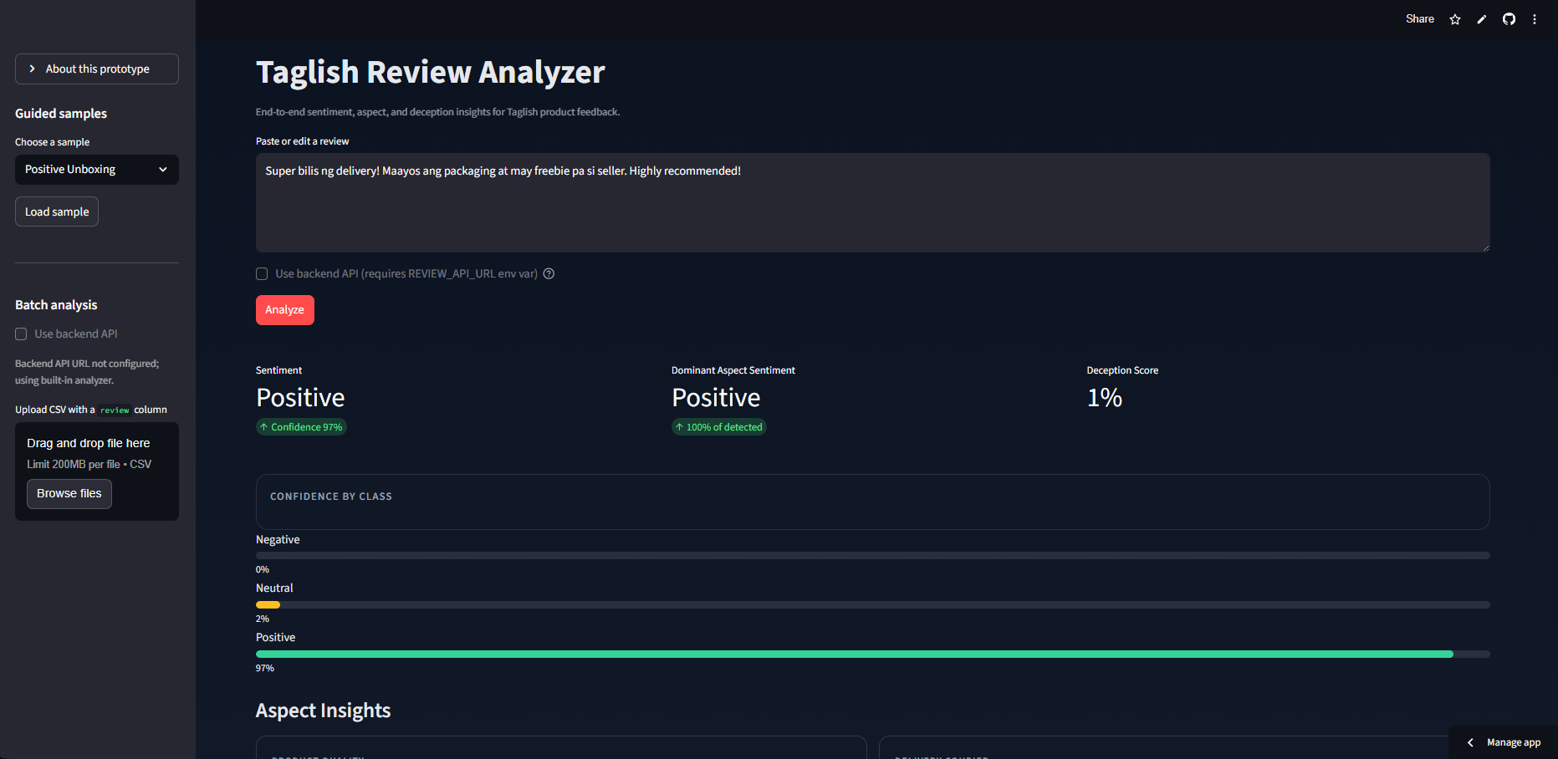
Figure 26. Streamlit Sentiment View
- Aspect Summary Dashboard

Just below the sentiment header, cards highlight aspect hits Product Quality, Delivery & Courier, Seller Contact, Price & Value each tagged Positive with confidence percentages that reflect the mid‑seventies to high‑eighties validation scores, accompanied by a highlighted review snippet and the deception signal readout so readers can see how aspects and trust cues surface together.
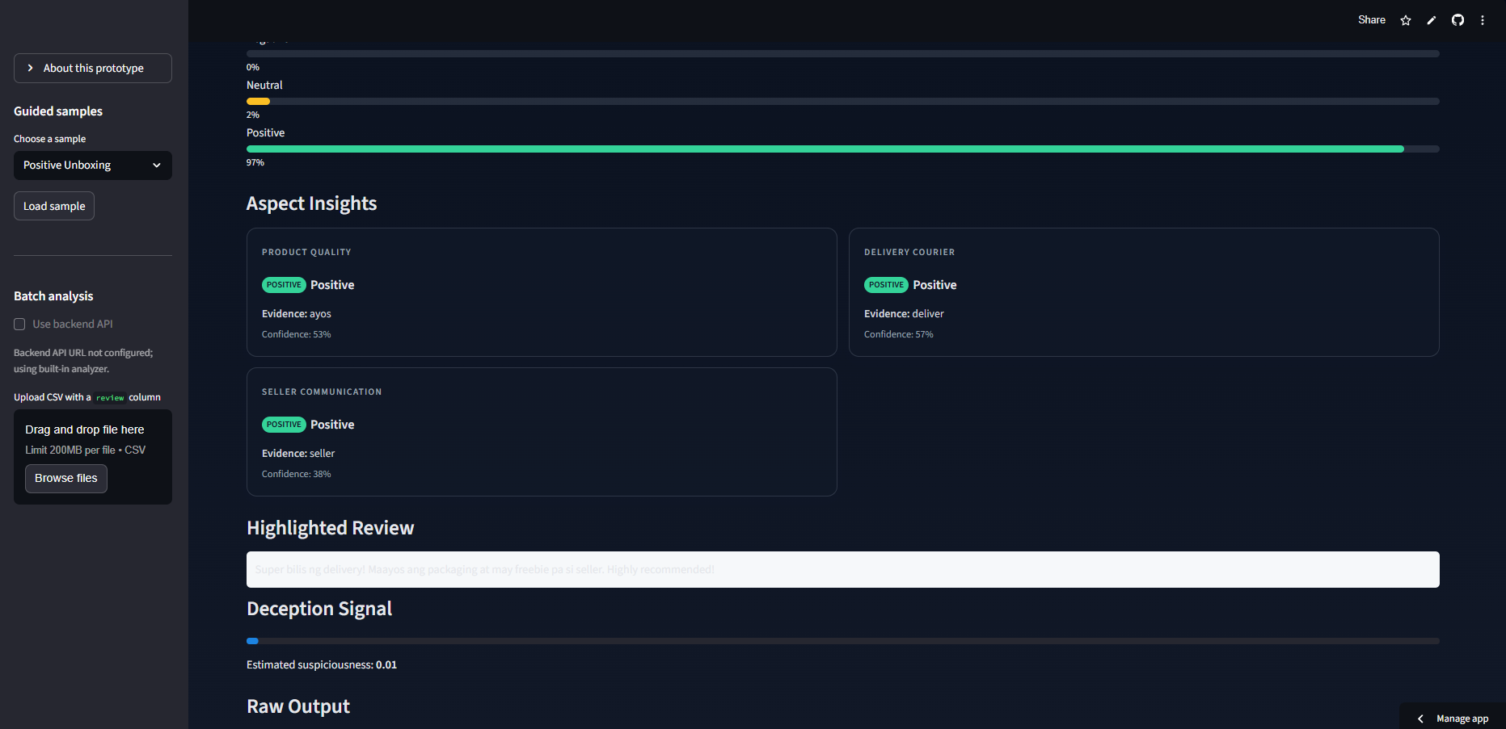
Figure 27. Aspect Insights Panel

DISCUSSION
The project had been guided by a clear direction, which started by cleaning Taglish reviews carefully in order to maintain their mixed-linguistic flavor and to fix reproducible train, validation, and test splits. Traditional TF-IDF and logistic baselines were used to provide a reliable baseline followed by the preparation of multilingual and Filipino-oriented transformers based on constant tokenization, training arguments, and early stopping protection. Aspect span bootstrapping, aspect polarity heads, and a first-pass deception detector completed the workflow in such a way that all of the promised tasks underwent an initial implementation waiting a subsequent refinement.
That pipeline was worth the evaluation. The use of validation and test reports maintained the general sentiment accuracy at about eighty percent when fast transformer setup was implemented and optimized TF-IDF baseline hit middle nineties and established a benchmark that was visible to the community. Three teammates Hyperparameter sweeps, ablations, and CSV logs of experiment results demonstrated repeatable gains on the introduction of longer sequences, domain adaptation, or ensembling. These scores were reflected by the Streamlit interface, which produces high confidence predictions on guided instances and shows aspect badges containing the same percentages of confidence as the notebook diagnostics.
Such findings indicate a viable path on which Taglish review intelligence can be pursued in local e-commerce. Rules Cleaning: rules are shareable and can be run by other teams, i.e., reproduce the training runs or adhere to them with new annotations. Tokenization Settings: Tokenization settings can also be shared and can be used directly by other teams, i.e., reproduce the training runs or add annotations to them. Experiment Exports: Experiment exports can be shared too, and be used directly by other teams to reproduce the training runs or add annotations to them. Summary aspect enables merchants to respond to delivery or packaging complaints without sifting through unstructured text, whereas the early deception indicator indicates future support through moderation. The use of reproducible experiments and a running app in the study is what provides evidence as well as an interface that can be used by the stakeholders today.

CONCLUSION
Philippine online sellers and buyers tend to use mixed Tagalog English reviews which other legacy type tools misunderstand, undermining customer trust and decision making on the market. The proposed work bridged that gap, examining clean Taglish splits, baselines on TF-IDF, multilingual transformer fine-tuning, and publishing aspects and deception cues lightweight models. The resulting models achieved good accuracy, the experiments were to be stored to be used later, and the insights were accessible with the help of a Streamlit front end. Following the SDG 17.8, all artifact prepared scripts, evaluation records, and interface elements are open Taglish NLP resources, which strengthen capacity building in ICT and AI. These common resources help community members and local businesses to embrace the language technologies confidently, enhance the cooperation, and make the Philippine e-commerce market places open and fair.

References
- C. J. Cosme and M. M. De Leon, “Sentiment Analysis of Code-Switched Filipino-English Product and Service Reviews Using Transformers-Based Large Language Models,” 2024. Available: Archīum Ateneo.
- M. Herrera, A. Aich, and N. Parde, “A Dataset for Investigating Tagalog-English Code-Switching,” in Proc. LREC, 2022.
- H. Paul, R. Bansal, and M. Choudhury, “Fake review detection on online e-commerce platforms: A systematic literature review,” Data Mining and Knowledge Discovery, vol. 35, no. 6, pp. 2168–2211, 2021.
- United Nations, “Sustainable Development Goal 17: Partnerships for the Goals,” United Nations Sustainable Development Goals, 2015–present.
- S. Verhulst and A. Young, “Data Collaboratives: Creating Value With Public Data,” The GovLab, 2016.
- R. Vinuesa, H. Azizpour, I. Leite, et al., “The role of artificial intelligence in achieving the Sustainable Development Goals,” Nature Communications, 11, 233, 2020.
- A. Dey, D. Patra, S. Saha, and S. K. Ghosh, “Aspect-based sentiment analysis of consumer reviews,” Applied Soft Computing, vol. 155, 112259, 2024.
- A. Conneau et al., “Unsupervised Cross-lingual Representation Learning at Scale,” in Proc. ACL, 2020.
- DOST-ASTI, “RoBERTa-tl-sentiment-analysis,” Model Card, 2024. Available: Hugging Face.
- Associated Press, “The internet is rife with fake reviews. Will AI make it worse?,” Dec. 23, 2024.
- P. Quoc-Hung, L. Thi-Thanh-Hien, and N. Thanh-Tam, “Aspect-Based Sentiment Analysis of Clothing Reviews in E-Commerce,” in Proc. PACLIC, 2024.
- Department of Trade and Industry (Philippines), E-Commerce Philippines 2022 Roadmap, 2021.
- U.S. Department of Commerce, “Philippines – eCommerce,” Country Commercial Guide, Jan. 24, 2024.
- Google, Temasek, and Bain & Company, e-Conomy SEA 2024 report, 2024.
- J. Devlin, M.-W. Chang, K. Lee, and K. Toutanova, “BERT: Pre-training of Deep Bidirectional Transformers for Language Understanding,” Proc. NAACL-HLT, 2019.
- A. Conneau et al., “Unsupervised Cross-lingual Representation Learning at Scale,” Proc. ACL, 2020.
- S. Gururangan, A. Marasović, S. Swayamdipta, K. Lo, I. Beltagy, D. Downey, and N. A. Smith, “Don’t Stop Pretraining: Adapt Language Models to Domains and Tasks,” Proc. ACL, 2020.
- S. Khanuja, S. Dandapat, A. Srinivasan, S. Sitaram, and M. Choudhury, “GLUECoS: An Evaluation Benchmark for Code-Switched NLP,” Proc. ACL, 2020.
- E. Hashmi, R. Abbas, and A. Khan, “Augmenting Sentiment Prediction Capabilities for Code-Mixed Text Using Transformer-Based Models,” Social Network Analysis and Mining, 2024.
- C. J. Cosme, “FiReCS: Filipino–English Code-Switched Reviews Dataset,” Hugging Face, 2024. [Online]. Available: https://huggingface.co/datasets/ccosme/FiReCS

