**Implementing simple crud API on Library Management System using Go**

1. Create books

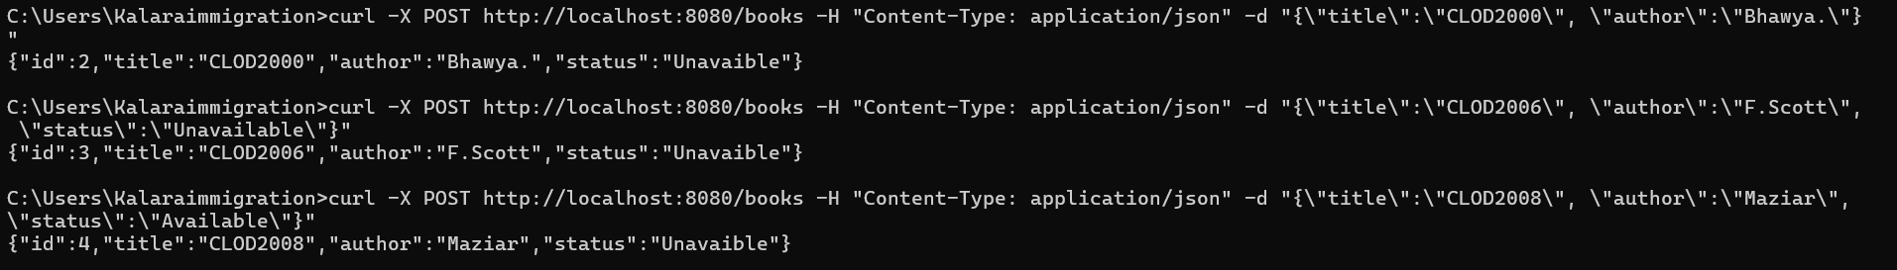

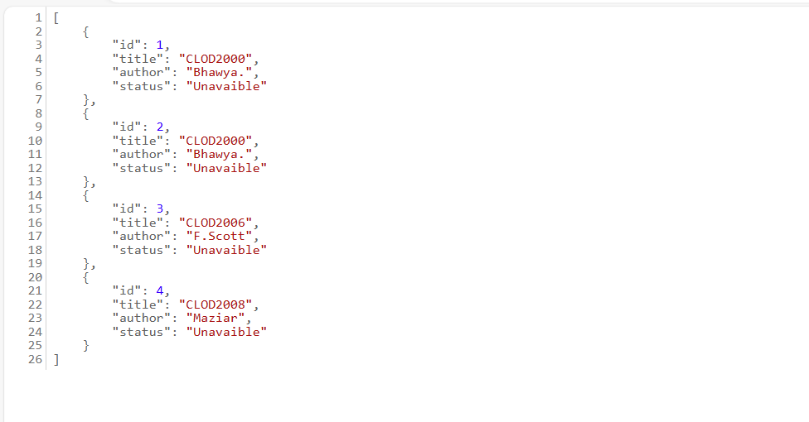

1. Delete a book from a library



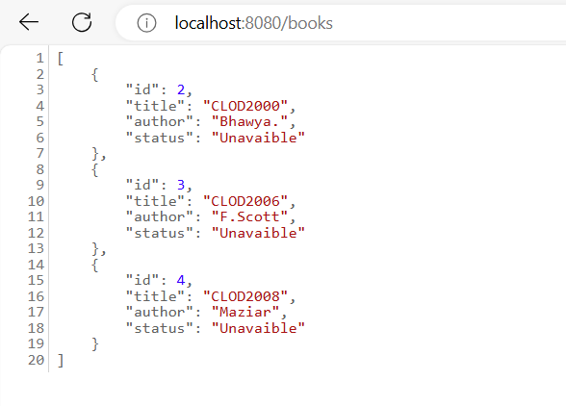

1. Return all books



1. Return book by id



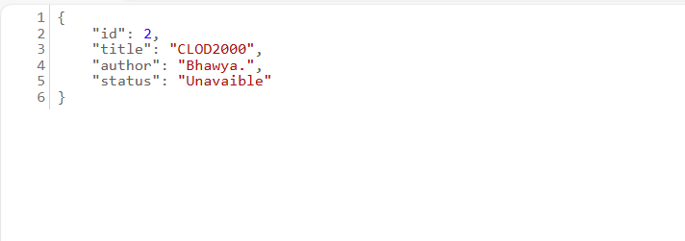

1. Updating the status of a book



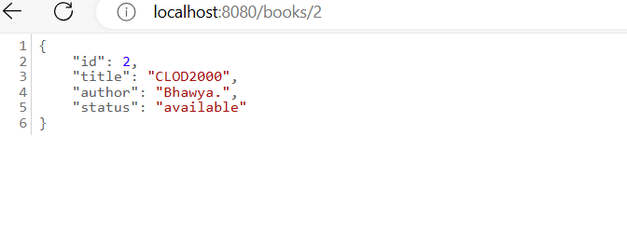

1. Server started

