**Lafoireinfo**

**Our vision**

**We strongly believe that both students and recruiters should have a platform to enable interactivity to a whole different level and this portal just sums up everything we aim to build**

Lafoireinfo is a website that propose to help student in the tertiary education (graduated or not) to find jobs, resources and help. Our goal is to provide the students with a platform where they can discuss their problems, share ideas and obtain advices from senior students. If a student wants to form a team from different fields to create an application or a startup, this platform will help them to do so. This website was created using a template from wix (https://www.wix.com) and customize to fit our need.

* 1. **The Home page**

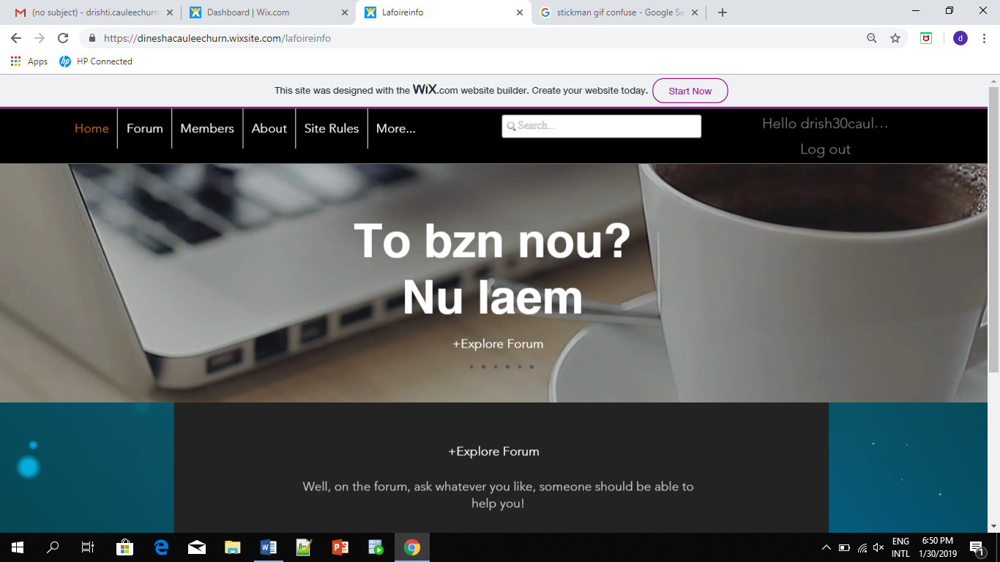

On the home page, there is a slideshow that shows the interesting features of the website. There is a direct link to access to the forum in the middle of the homepage for quick access and to encourage people to visit the forum. When the website will be active this will be replaced with the most popular post on the site.

The top bar contains the menu which include access to all the features that the website offers i.e. Members, forum, about, site rules and more which contain the contact us link.



At the bottom we have the site map and an icon to allow us to jump at the top of the page.

There is also a chat box to facilitate the communication between members of the forum.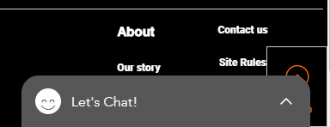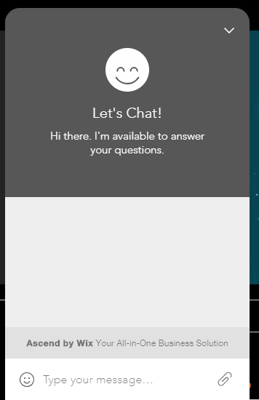



Also the site offers the login/sign in option on the menu bar as well as a search bar to search content on the website as shown below. Existing members of the forum can login to their account and new users are offered the option of creating a new account. The customer can sign up with google and Facebook.

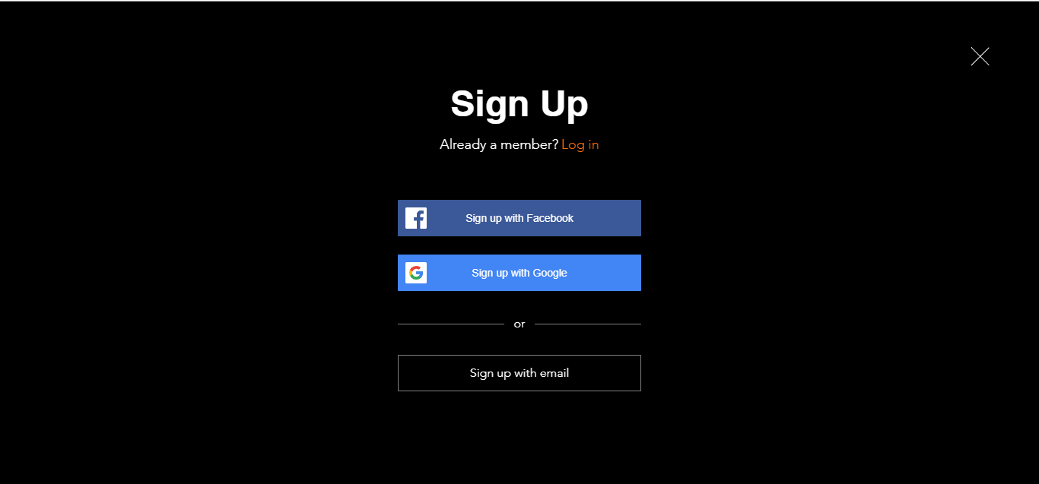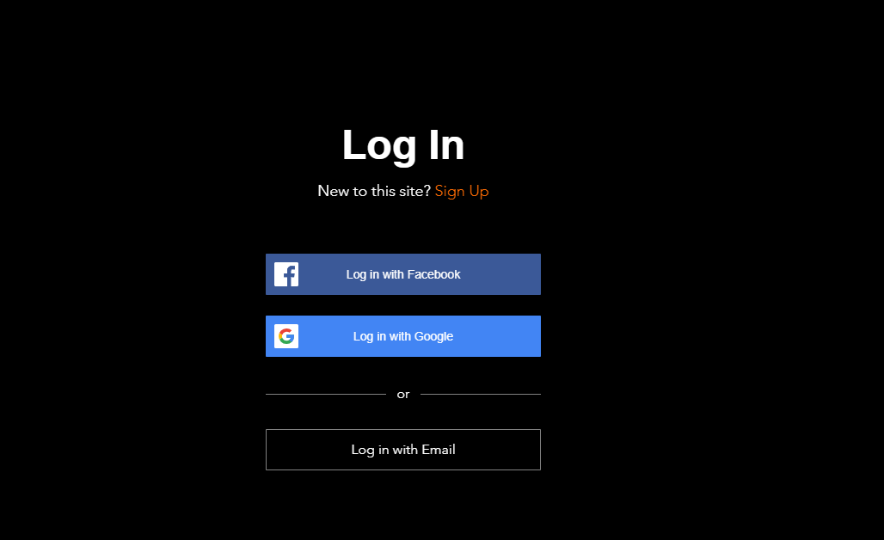



* 1. **The Forum**





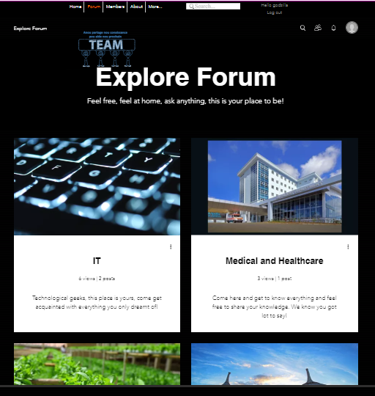

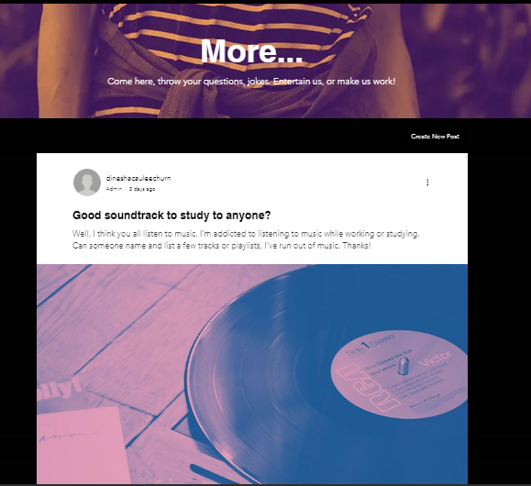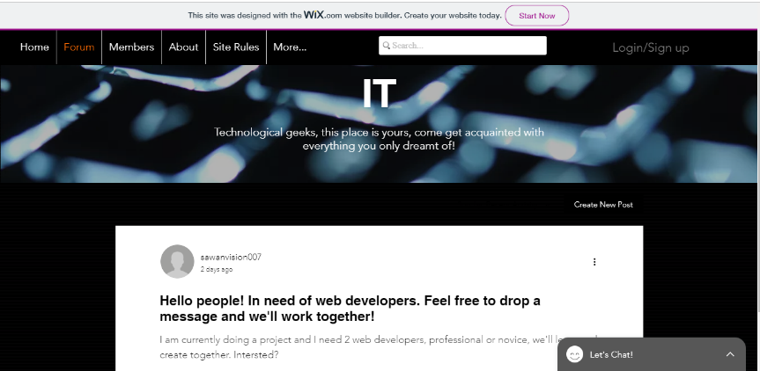

The forum is also the place where old students can give advice to other students who want to start a startup and also help to put them in contact with people that they need to make their objectives real.



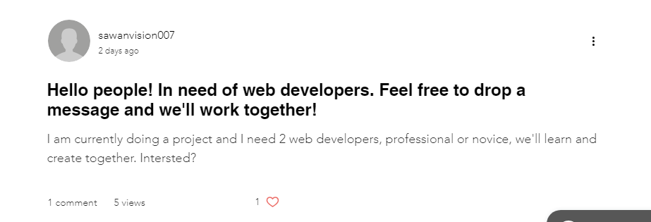

The members can create posts to ask for help or advice from other members. The forum also allow users to like, comment and view a post.

* 1. **About**

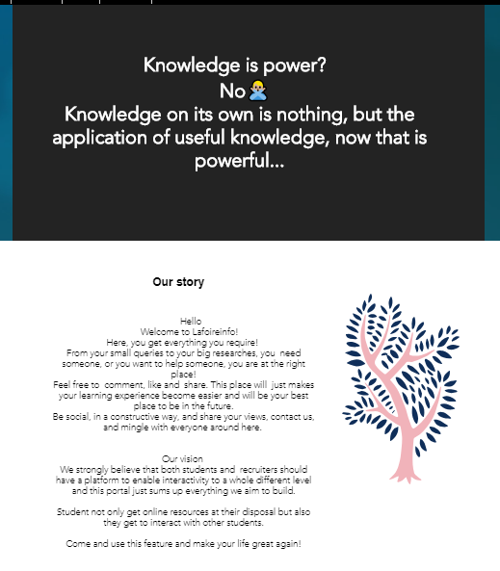

The about page gives new visitors an accurate representation of our website as well as words on our story and vision.

**1.4 Site Rules**

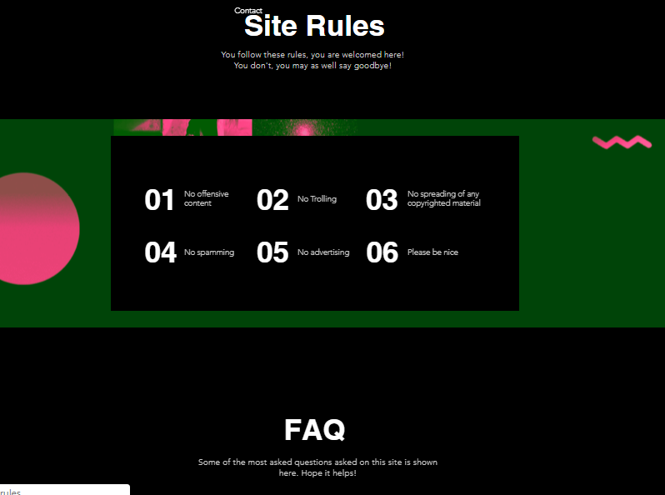

This page contain the site rule as well as the frequently asked question (FAQ) to help the visitors with issues without having them contacting the admin of the site if it is not necessary.

* 1. **Members**

This page allows the users to find other members and interact with them.

The page without signing in:

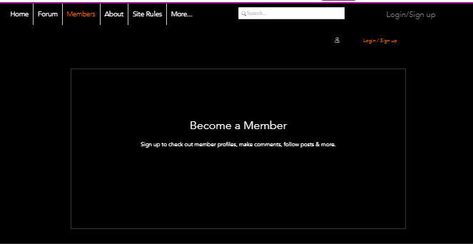

The page when the user has signed in: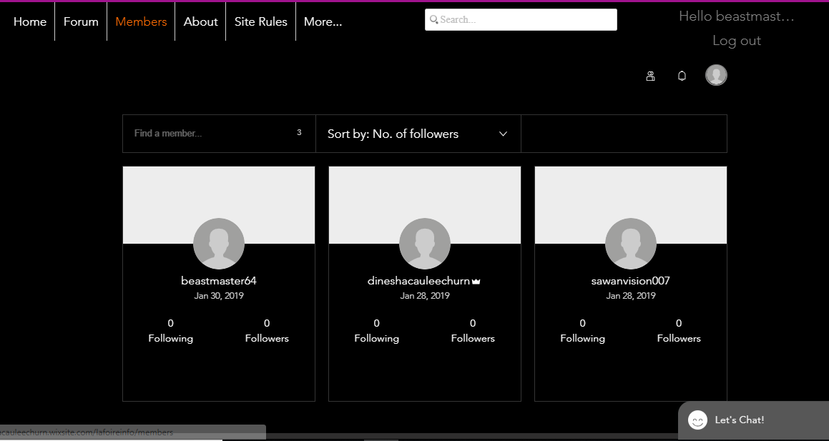

* 1. **Contact Page**

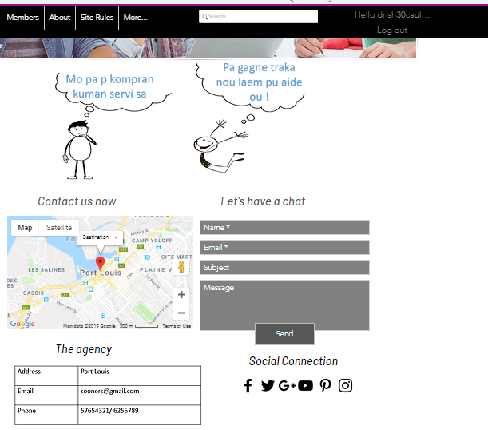

The contact page helps users if they have any queries. The users can visit us at Port Louis if they have any problem. They can also send us an email or call us on the given phone numbers. Furthermore, the users can have a chat by filling the given form or contact us via social Medias such as Facebook and Instagram.

The website is already online and can be viewed from <http://dineshacauleechurn.wixsite.com/lafoireinfo>