ECOSORT AI
Smart Waste Segregation Assistant
♻
1M1B AI for Sustainability Virtual Internship
In Collaboration with IBM SkillsBuild & AICTE
Submitted by:
Bheeshma Shankar A
Chaitanya Bharathi Institute of Technology
B.Tech – Computer Science and Engineering
Primary SDG: SDG 12 – Responsible Consumption and Production
Secondary SDG: SDG 11 – Sustainable Cities and Communities

1. Abstract
EcoSort AI is a simple web-based prototype developed to help users correctly identify how to segregate everyday waste items. A user enters a short description of a waste item, and the system, using curated classification logic, returns the likely waste category, a disposal recommendation, the reason behind the classification, and a related sustainability tip. Hazardous and special-handling items are flagged clearly so that users are guided toward safe, authorized disposal methods rather than unsafe handling instructions.
The prototype was built using HTML, CSS, and JavaScript, without requiring a backend, database, paid APIs, or trained machine-learning models, making it realistic to develop and demonstrate within the timeline of the 1M1B AI for Sustainability Virtual Internship. It aligns with SDG 12 (Responsible Consumption and Production) as its primary goal and SDG 11 (Sustainable Cities and Communities) as a secondary goal, supporting these targets at a small, individual-awareness scale rather than claiming to solve them directly.

2. Introduction

2.1 Waste Segregation
Waste segregation is the practice of separating waste into categories such as wet/organic waste, dry waste, recyclable waste, e-waste, and hazardous waste, based on how each type should be processed or disposed of. Proper segregation at the source makes downstream waste management, recycling, and composting significantly more efficient.

2.2 Problems Caused by Incorrect Segregation
When waste is not segregated correctly, recyclable materials often end up in landfills, organic waste contaminates recyclables, and hazardous items such as batteries or e-waste may be mixed with general waste. This can reduce recycling efficiency, increase pollution risk, and create safety hazards for waste handlers.

2.3 Need for Simple Digital Guidance
Many people are unsure which category a given item belongs to, and official municipal guidelines are not always quick or convenient to consult at the exact moment of disposal. A simple, accessible digital tool that gives an instant recommendation can help bridge this gap in everyday awareness.

2.4 Why EcoSort AI Was Proposed
EcoSort AI was proposed as a lightweight, easy-to-build prototype that demonstrates how an AI-assisted decision-support workflow can guide users toward correct waste segregation. It was designed to be realistic and achievable within a short internship timeline, while still meaningfully addressing a genuine sustainability problem and following responsible AI practices.

3. Problem Statement
People often face difficulty in identifying the correct waste category for everyday items. Incorrect segregation can reduce recycling efficiency and create safety issues for special waste such as batteries and electronic devices.
“How might we use AI to help people correctly identify and segregate waste so that waste management becomes more sustainable?”

4. SDG Alignment

4.1 SDG 12 – Responsible Consumption and Production (Primary Goal)
EcoSort AI directly supports SDG 12 by encouraging responsible waste-management behavior, improving awareness of correct waste segregation, and promoting recycling and reduced landfill dependence at the individual and community level.

4.2 SDG 11 – Sustainable Cities and Communities (Secondary Connection)
Better waste segregation contributes to cleaner shared spaces, more efficient municipal waste collection, and safer handling conditions for waste workers, supporting the broader goal of sustainable, well-managed communities. EcoSort AI is a small-scale technology intervention that supports these SDGs; it does not claim to fully or directly solve them.

5. Target Users
EcoSort AI is designed for the following user groups:

Target User | Use
Students | Learn proper waste segregation
Households | Identify everyday household waste
Offices | Improve workplace segregation
Colleges | Promote sustainability awareness
Communities | Encourage responsible disposal

6. Objectives
- Develop a simple waste-segregation assistant.
- Identify common waste categories.
- Provide disposal recommendations.
- Explain why an item belongs to a category.
- Encourage sustainable waste-management practices.
- Demonstrate an AI-assisted sustainability concept.
- Support SDG 12 and SDG 11.

7. Design Thinking
Empathize ↓ Define ↓ Ideate ↓ Prototype ↓ Test & Refine

7.1 Empathize
Identified the difficulty users face when deciding how to dispose of common waste items, especially when an item does not clearly belong to one obvious category.

7.2 Define
Defined the problem as uncertainty in waste classification and disposal — users need a quick, reliable way to know how to handle a given waste item.

7.3 Ideate
Proposed a simple digital assistant that accepts a text description of a waste item and returns its category, disposal method, reasoning, and a sustainability tip, using an approach that is realistic to build without advanced infrastructure.

7.4 Prototype
Developed the EcoSort AI web application using HTML, CSS, and JavaScript, including the waste analyzer, classification logic, and supporting interface features described in Section 8.

7.5 Test & Refine
Tested representative waste items against the prototype and reviewed additional website features to confirm the interface behaved consistently and clearly communicated results to the user.

8. Prototype Features
The EcoSort AI prototype includes the following features:
- Waste analyzer
- Waste classification
- Recommended action
- Reason for classification
- Sustainability tip
- Hazardous-waste warning
- Example buttons
- Enter-key analysis
- Image upload interface
- Analysis history
- Eco points
- Eco level
- Dark mode

9. AI Methodology
The current EcoSort AI prototype demonstrates an AI-assisted decision-support workflow using curated classification logic for common waste descriptions. The system maps user inputs to predefined waste categories and provides corresponding recommendations, explanations, and sustainability tips.
The current image-upload functionality provides an image preview and is designed as a foundation for future multimodal AI integration. It does not currently perform image classification.

9.1 Future AI Pipeline
The diagram below shows how a future, more advanced version of EcoSort AI could process both text and image inputs using a trained AI model. This pipeline is proposed future scope and is not part of the current implementation.
User Text / Image
↓
AI Model
↓
Waste Identification
↓
Category Classification
↓
Disposal Recommendation
↓
Sustainability Guidance

10. System Architecture
The current prototype's architecture is illustrated below. All processing happens locally within the browser using JavaScript; no backend server or external database is used.
USER
↓
Waste Description
↓
EcoSort AI
↓
Classification Logic
↓
Waste Category
↓
Reason | Action | Safety
↓
USER

11. Technologies
Technology | Purpose
HTML5 | Website structure
CSS3 | Styling and interface
JavaScript | Application functionality
LocalStorage | Store analysis history
Web Browser | Run the application

12. Prototype Implementation
This section presents screenshots of the working EcoSort AI prototype. Screenshot placeholders are provided below — replace each placeholder box with the corresponding image before final submission.

12.1 Organic Waste Analysis
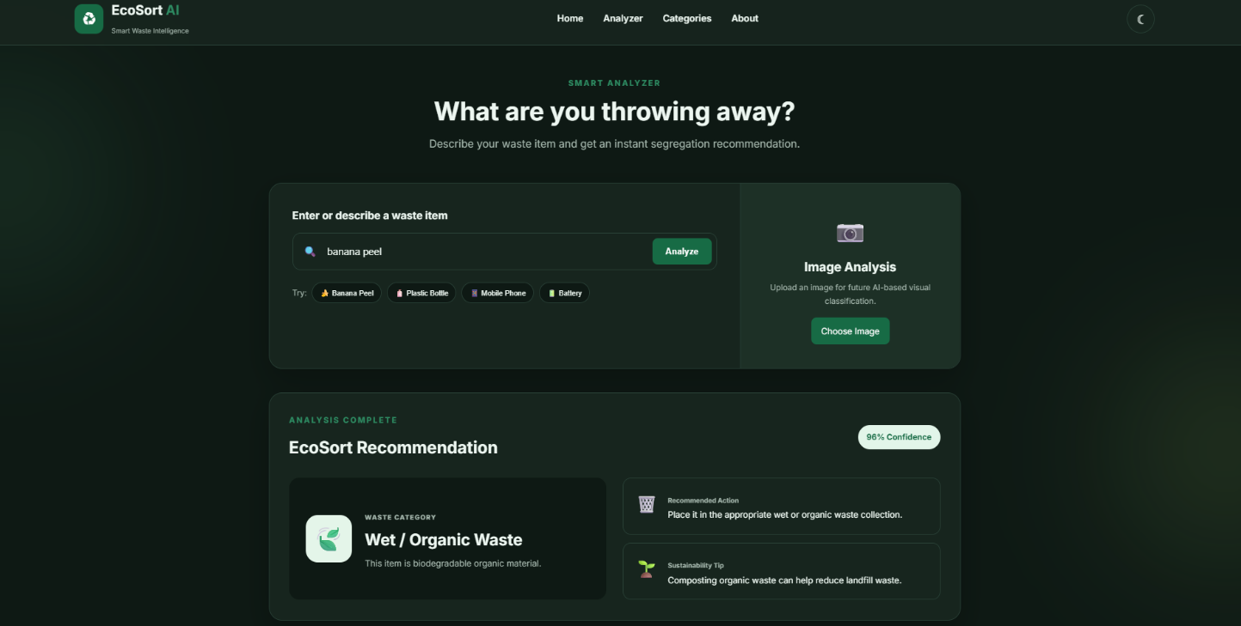
01-banana-peel.png

12.2 Recyclable Waste
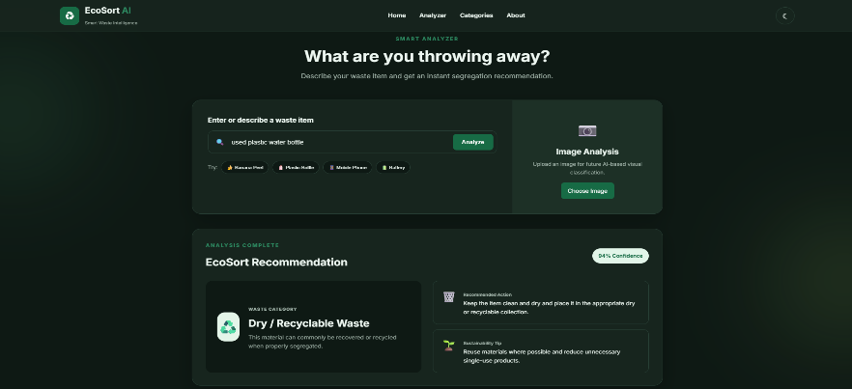
02-plastic-bottle.png
Figure 2: Classification of used plastic water bottle as Dry / Recyclable Waste.

12.3 Newspaper Classification
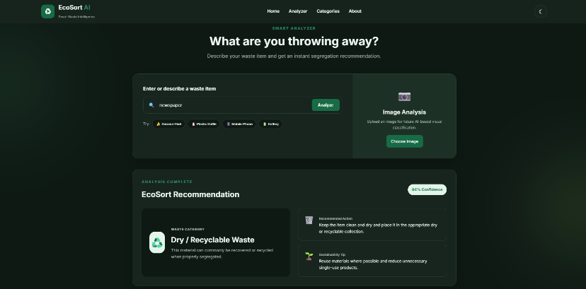
03-newspaper.png
Figure 3: Newspaper classification.

12.4 E-Waste Classification
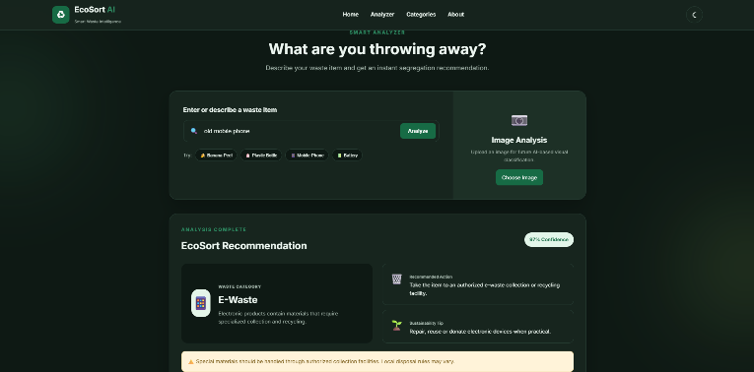
04-mobile-phone.png
Figure 4: E-waste classification.

12.5 Hazardous Waste Classification
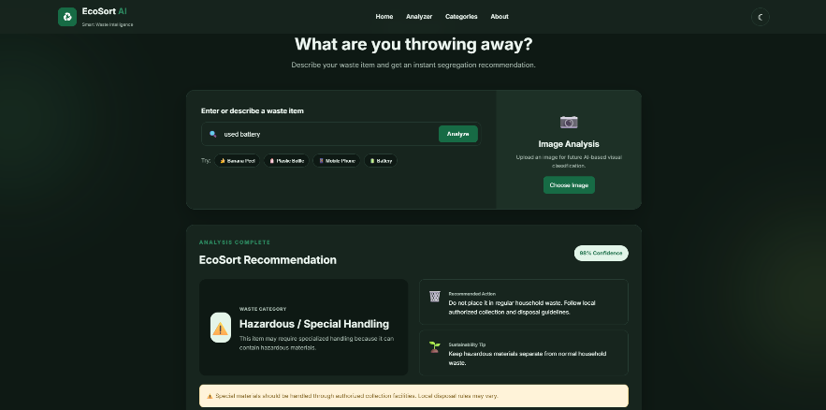
05-battery.png
Figure 5: Hazardous / special-handling classification.

12.6 Food Waste Classification
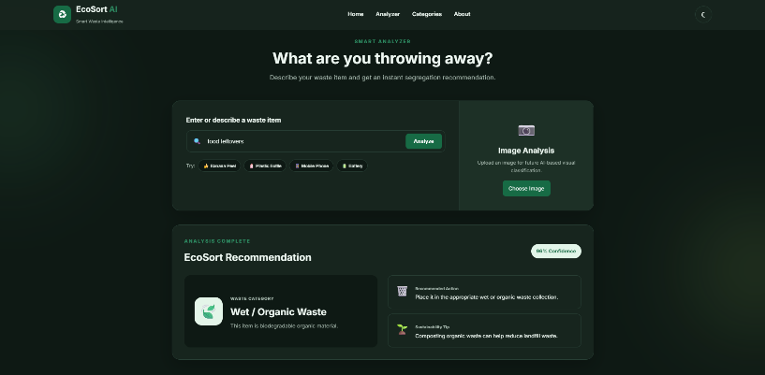
06-food.png
Figure 6: Food waste classification.

12.7 Cardboard Classification
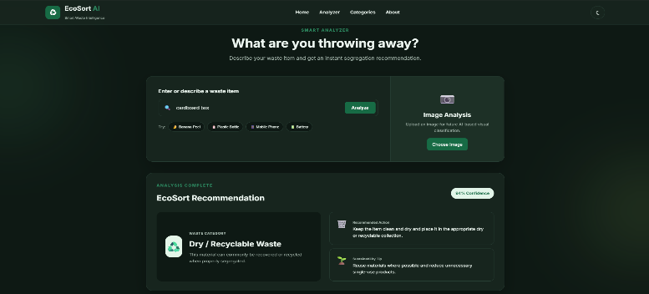
07-cardboard.png
Figure 7: Cardboard classification.

12.8 Glass Classification
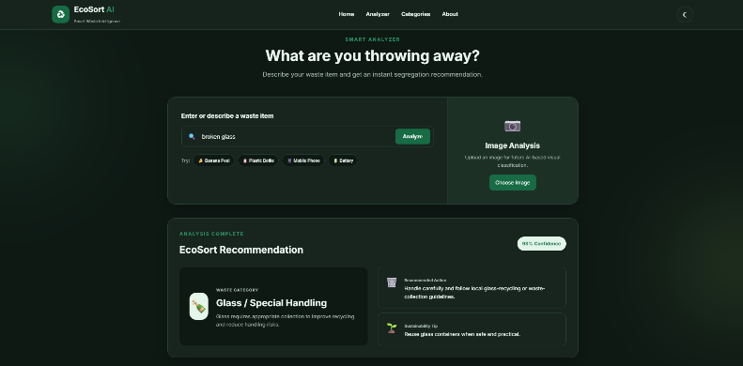
08-glass.png
Figure 8: Glass / special-handling classification.

12.9 Image Upload Interface
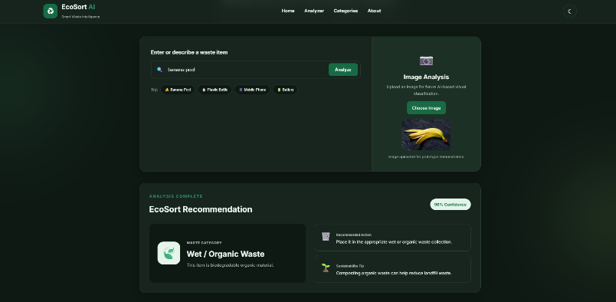
09-image-upload.png
Figure 9: Image upload interface.

12.10 Dashboard and Analysis History
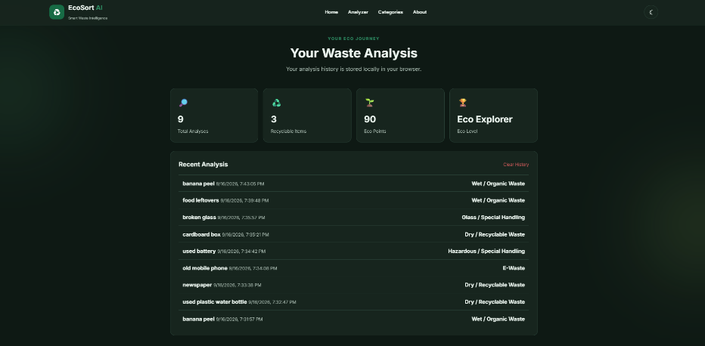
10-dashboard.png
Figure 10: Dashboard and analysis history.

12.11 Light Mode Interface
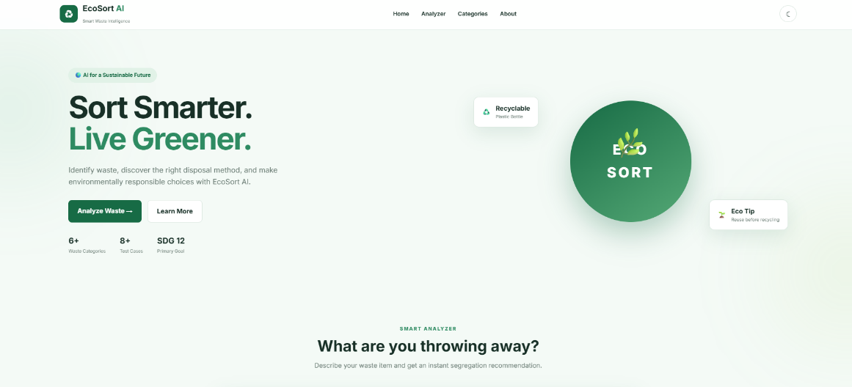
11-light-mode.png
Figure 11: light-mode interface.

13. Testing
The prototype was tested against eight representative waste items. Each test compared the expected classification against the observed output of the EcoSort AI prototype.
Test Case | Input | Expected Result | Result
TC01 | Banana peel | Wet / Organic Waste | Passed
TC02 | Used plastic water bottle | Dry / Recyclable Waste | Passed
TC03 | Newspaper | Dry / Recyclable Waste | Passed
TC04 | Old mobile phone | E-Waste | Passed
TC05 | Used battery | Hazardous / Special Handling | Passed
TC06 | Food leftovers | Wet / Organic Waste | Passed
TC07 | Cardboard box | Dry / Recyclable Waste | Passed
TC08 | Broken glass | Glass / Special Handling | Passed

Prototype test-case result: 8 / 8 test cases passed on the demonstration examples above. This reflects consistency of the current rule-based/curated classification logic on these specific examples and is not equivalent to a real-world AI model accuracy measurement.

14. Responsible AI

Fairness
The classification logic applies consistently to similar waste descriptions, regardless of who is using the system.

Transparency
The current prototype clearly states that it uses curated classification logic rather than claiming a trained machine-learning model.

Privacy
The prototype minimizes data collection and uses browser-based local storage for history; no names, addresses, or other personal information is required.

Safety
Hazardous and special-handling items are flagged for additional care, and users are directed toward authorized disposal points rather than given unsafe handling instructions.

Human Oversight
Users should verify ambiguous items and follow local waste-management guidance. EcoSort AI is a decision-support tool, not a replacement for municipal waste-management authorities.

15. Limitations
- Current classification is based on predefined/curated logic.
- It is not a trained machine-learning model.
- Ambiguous descriptions may produce incorrect classification.
- Mixed-material objects can be difficult to classify.
- Waste-management rules differ between locations.
- Image upload currently provides preview functionality only.
- Real-world deployment would require validated AI models and testing.

16. Future Scope
- Real AI/ML waste classification
- Image-based waste recognition
- Multimodal AI
- Voice input
- Multiple languages
- Location-specific disposal rules
- Recycling-center integration
- Mobile application
- User feedback
- Analytics
- Continuous AI model evaluation

17. Conclusion
EcoSort AI demonstrates how a simple digital assistant can help users make better waste-segregation decisions while promoting sustainability awareness. By combining a clear problem statement, alignment with SDG 12 and SDG 11, a working prototype, and responsible AI considerations, the project presents a realistic and honest example of applying technology to a genuine sustainability challenge. While the current prototype relies on curated classification logic rather than a trained AI model, it lays a clear foundation for future enhancement using image recognition, multimodal AI, and location-specific waste-management data.

