Work Package 4 - Practical

CLXBHE005, KMPKWE002

EEE3096S 2021

[Demonstration Video](https://vimeo.com/625645282)

1. **The circuit diagram:**

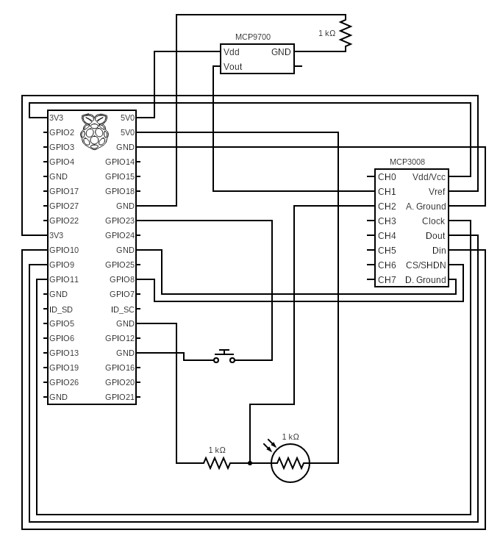

1. **Validation and Testing**

* Light senser
* When light is provided on LDR, the LDR decreases the resistance with respect to receiving luminosity on the component’s sensitive surface. As LDR varies with light the voltage will be varied. When the light level decreases, the resistance of the LDR increases, as this resistance increases it will cause voltage across LDR to also increase. The voltage we get is sent to ADC to be converted to digital. We can see from our code we get ADC values. We use 10-bit resolution to analogue to digital converter to have optimal accuracy, by this resolution we can validate that the ADC values we got mostly accurate
* Temperature senser
* The temperature sensor will sample the current room temperature, the sensors' output will then be sent to analogue to digital converter. The output resistance from the sensor must be moderate (not high or low) for it to be compatible with ADC inputs. A high-resolution ADC is required in many cases as the magnitude of the signal from the sensor is quite small hence, we used 10-bit resolution. A high-resolution ADC is required so that the low-level signal from the sensor can be converted into digital information. When the temperature sensor is powered on, the voltage output will be proportional to the temperature. Generally, A temperature of 25 degrees C will result in an output of 0.750V, we can see from our values that the relationship still holds.

1. **The Prac4.py code contents**

The initialisations and imports are as follows:

import RPi.GPIO as GPIO

import busio

import digitalio

import board

import adafruit_mcp3xxx.mcp3008 as MCP

from adafruit_mcp3xxx.analog_in import AnalogIn

import threading

import datetime

import time

# some global variables that need to change as we run the program

frequencyOfReadingData = 10.0

startTime = None

# DEFINE THE PINS USED HERE

btn_submit = 23

The setup method is as follows:

# Fuction to setup the GPIO Pins

def setup():

    #Button Setup

    GPIO.setup(btn_submit, GPIO.IN, pull_up_down=GPIO.PUD_UP)

    # Setup debouncing and callbacks

    GPIO.add_event_detect(btn_submit, GPIO.FALLING, callback=incrementFrequency, bouncetime=300)

The fetch_sensor_vals method is as follows:

# Function to get sensor_values from the ADC

def fetch_sensor_vals(channel):

    # create the spi bus

    spi = busio.SPI(clock=board.SCK, MISO=board.MISO, MOSI=board.MOSI)

    # create the cs (chip select)

    cs = digitalio.DigitalInOut(board.D5)

    # create the mcp object

    mcp = MCP.MCP3008(spi, cs)

    if(channel == 1):

         # create an analog input channel on pin 1

        chan1 = AnalogIn(mcp, MCP.P1)

        return chan1.value, chan1.voltage

    elif(channel == 2):

        # create an analog input channel on pin 2

        chan2 = AnalogIn(mcp, MCP.P2)

        return chan2.value, chan2.voltage

The convertToTemp method is as follows:

# Function to calculate temperature from

# ADC value, rounded to specified

# number of decimal places.

def convertToTemp(tempArg, places=2):

    temp = ((tempArg)/float(1023))

    temp = round(temp * (1/0.01),places)

    return temp

The main method is as follows:

# Fuction, it uses threads to read data from the sensors

def main():

    global startTime

    runTime = (datetime.datetime.now() - startTime).total_seconds() # Calculates run time

    global frequencyOfReadingData

    tempADC_Value, tempVoltage = fetch_sensor_vals(1)

    lightADC_Value, lightVolatge = fetch_sensor_vals(2)

    print("{:<11d}{:<16d}{:05.2f} C{:>10d}".format(int(runTime), tempADC_Value, convertToTemp(tempADC_Value,2), lightADC_Value))

    thread = threading.Timer(frequencyOfReadingData, main)

    thread.daemon = True  # Daemon threads exit when the program does

    thread.start()

The printHeading method is as follows:

# Fuction, to print the heading of the table

def printHeading():

    print('{:<11s}{:<16s}{:<13s}{:<17s}'.format("Runtime", "Temp Reading", "Temp", "Light Reading"))

Finally, the main program when executed does the following:

if __name__ == "__main__":

    try:

        setup()

        printHeading()

        startTime = datetime.datetime.now()

        main()

        # Tell our program to run indefinitely

        while True:

            pass

    except Exception as e:

        print(e)

    finally:

        GPIO.cleanup()