Bhekanani Cele and Kwena Komape Tutorial 1 EEE3096S

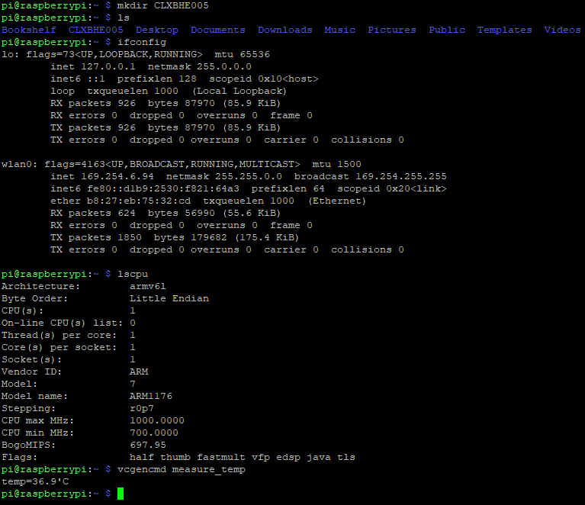

1. Git tracks the changes you make to files, so you have a record of what has been done, and you can revert to specific versions should you ever need to. Git also makes collaboration easier, allowing changes by multiple people to all to be merged into one source.
2. git add, git commit git remote, and git push commands
   1. It means a file that has been created within your repo's working directory but has not yet been added to the repository's tracking index using the git add command.
   2. It means a file has been prepared to be committed, i.e. it is ready to be committed. Git, with its index, allows you to commit only certain parts of the changes you've done since the last commit.
   3. It means an individual change to a file (or set of files) has been saved and a unique ID (hash) has been created, that allows you to keep a record of what changes were made when and by who.

Git Shared Repository Link: <https://github.com/BhekananiCele/Tutorial1.git>