**Practical 1**

**Design a model for Flu**

**Professor Nyabadza**

**Objective:** The main objective is to develop a flu model taking into account the epidemiology of the disease.

*We recommend working in pencil so you can easily make changes.*

**Model 1**

Influenza or flu is a viral infection that is readily transmitted through the air and causes respiratory problems in humans and other animals. It occurs seasonally and may result in deaths among the young and old.

Important features of Flu that we would want to capture in a model are:

* Influenza (flu)
  + - * + Is a contagious respiratory illness.
        + Caused by influenza viruses (3 types).
        + The illness can be mild, severe and sometimes fatal.
        + Not really related to common cold.
* Transmission process
  + - * + Infectious individuals cough and sneeze viruses in the air.
        + Viruses enter the human body through the nose and mouth.
        + If infected you will get the symptoms 1-4 days later.
        + One can spread the illness before the onset of symptoms and 3-4 days after the onset of symptoms.
        + Recovery begin 2-3 days after becoming infectious.
        + Overall recovery takes at least 7 days.
        + Recovery is with immunity.
        + Can be treated with antiviral drugs
        + Prevention is usually by flue vaccines administered on a yearly basis.

Symptoms: include headaches, coughing, fever, body and muscle aches, soar throat and chilles.

* The transmission process is key
  + - * + We have people at risk.
        + If we introduce a single infective, there is a chance of new infections being generated.
        + Once infection takes place, symptoms manifest1-4 days later, meaning there is a short period of latency.
        + Once symptoms appear, individuals become highly infectious.
        + After a few days individuals recover.
        + Recovery is with immunity for that particular strain.

**THE MODEL**

* Consider a closed system, boarding school, prison, refugee camps, Isolation camps.
* The time frame is usually two weeks for an influenza epidemic.
* No births, deaths, immigration and emigrations are assumed.
* Individuals are grouped according to their state of infection, creating classes or compartments.
* Each compartment contains individuals of the same characteristic, in this case, the same stage of infection.

|  |
| --- |
| Draw the flow diagram of the model that takes into account the described transmission process. **SUGGEST YOUR OWN MODEL** |
| Write the model equations in words |

Attach parameters to the flow diagram and then work out the **DISCRETE** algebraic expressions for the word equations above. Rewrite the equations in algebraic form in the table below:

|  |
| --- |
|  |

List all the major assumptions made in this model

|  |
| --- |
|  |

**Modelling with data**

In this section we want to link the model we designed with data and find the correct parameter values that will make the model fit to the data.

Below is a brief background of the exercise

Background:  
  
In 1978, a study was conducted and reported in the British Medical Journal (4 March 1978) of an outbreak of the influenza virus in a boys boarding school. The school had a population of 763 boys. Of these 512 were confined to bed during the epidemic, which lasted from 22 January until 4 February. It seems that one infected boy initiated the epidemic. At the outbreak of the epidemic, none of the boys had previously had influenza, so no resistance to the infection was present.

Below is a table showing the number of cases recorded.

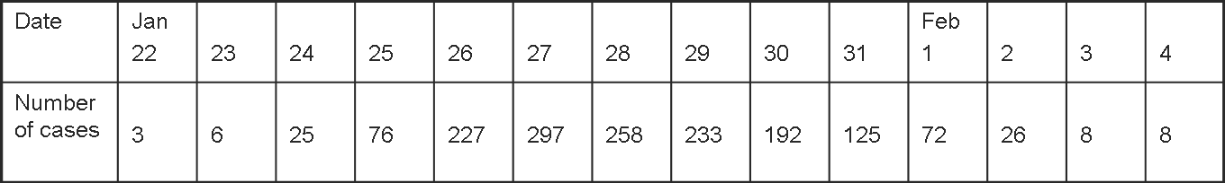

We will use Excel to fit the model to the data. (Please note that we can use numerous software for this task, eg Matlab, Mathematica, R, Python, STELLA etc).

Study the example in the flue.exls.

Play around the parameter values and find the parameters that best fit the model.