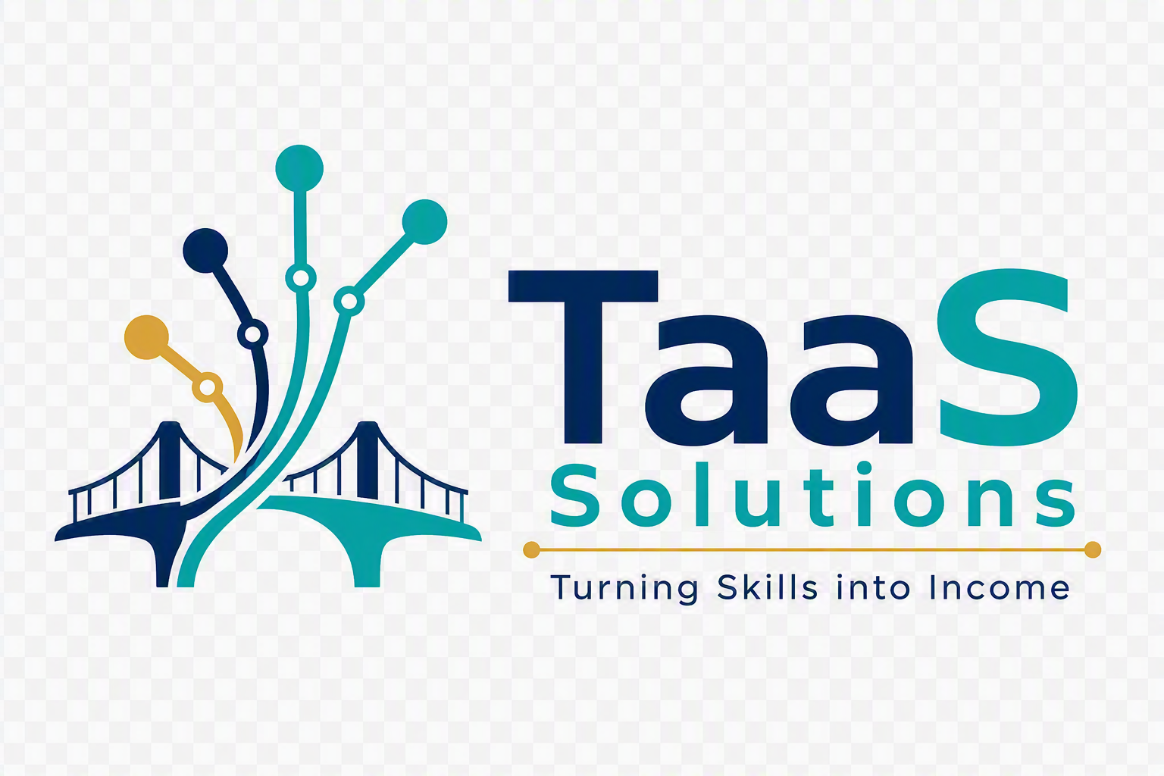
COMPANY PROFILE
Youth-powered ICT delivery. Business outcomes. Career pathways.

OUR PROMISE
We deliver practical technology solutions through managed, quality-assured teams of emerging professionals, creating value for clients and verifiable experience for young talent.
CONCEPT-STAGE VENTURE | SOUTH AFRICA

COMPANY SNAPSHOT

Building the bridge from skills to paid work

TaaS Solutions, short for Talent as a Service Solutions, is a concept-stage, youth-led ICT solutions venture. We are designed to help organisations access agile, cost-conscious technical delivery while giving emerging professionals the real project experience, income, references, and confidence needed to progress into the job market or independent practice.
Unlike a recruitment agency, TaaS Solutions is positioned around outcomes. Clients procure a defined solution or delivery capacity, while TaaS Solutions assembles the right talent, manages execution, embeds mentorship and quality assurance, and remains accountable for delivery.
POSITIONING
An ICT solutions company powered by emerging technology talent, not a CV marketplace and not a low-cost body-shopping service.

At a glance
Purpose | Turn proven digital skills into paid project experience and sustainable careers.
Client value | Flexible ICT delivery, clear scopes, accountable teams, and fit-for-purpose pricing.
Talent value | Income, portfolios, references, mentorship, commercial exposure, and a path to independence.

Brand line
Turning Skills into Income.

WHY TAAS SOLUTIONS

A market gap hiding in plain sight

The challenge
- Many emerging professionals have technical training but lack the commercial project experience employers request.
- Organisations often have useful technology work that is too specialised for general temp staffing, too small for a large consultancy, or too urgent for a long hiring process.
- Unmanaged freelance engagements can create uncertainty around quality, accountability, security, continuity, and delivery governance.

Our response
TaaS Solutions converts fragmented demand and underutilised talent into managed delivery. A client brings a business need. We clarify the outcome, define the scope, assemble a fit-for-purpose Talent Pod, manage the work, and deliver against agreed acceptance criteria.
THE DIFFERENCE
The client receives a solution. Emerging professionals receive supervised, portfolio-building work. TaaS Solutions provides the bridge, delivery discipline, and quality controls.

Value proposition
FOR CLIENTS  Agile access to multidisciplinary ICT capability without immediately adding permanent headcount. | FOR TALENT  Paid, meaningful work that builds evidence of competence and market confidence. | FOR PARTNERS  A practical mechanism to extend training programmes into livelihoods and enterprise exposure.

SERVICE PORTFOLIO

Outcome-led ICT services

Software Engineering | Design, build, integrate and support fit-for-purpose digital products.  Web applications • APIs & integrations • Internal systems • Application support

Artificial Intelligence | Apply AI to service, knowledge and operational use cases.  AI assistants • Chatbots • Workflow intelligence • AI prototypes & readiness

Data & Analytics | Turn operational data into trusted insight and reporting.  Data preparation • Analytics models • Dashboards • Reporting automation

Cloud & DevOps | Establish secure, observable and repeatable cloud delivery foundations.  Cloud setup • Deployment pipelines • Monitoring • Cost reviews

Business Analysis | Translate business problems into delivery-ready requirements and process improvements.  Discovery • Requirements • Process mapping • Solution documentation

Automation & Productivity | Reduce manual work using lightweight digital workflows and integrations.  Workflow automation • Digital forms • Productivity tools • System connectors

Initial commercial focus
The launch offer should prioritise compact, clearly scoped assignments that can be demonstrated quickly: dashboards, data clean-up, websites, internal tools, AI prototypes, cloud deployments, automation workflows, process maps, and requirements packs.

TALENT PODS

The right team for the outcome

A Talent Pod is a small, multidisciplinary team assembled for a defined client need. Pod composition changes with the scope, but every engagement has one accountable delivery lead and documented quality gates.
Pod | Typical roles | Typical outcomes
Product Pod | Business Analyst, UI/UX, Developer, QA | Web apps, internal tools, MVPs
Data Pod | Data Scientist, Data Analyst, BI Developer | Dashboards, models, reporting automation
AI Pod | AI Engineer, Developer, Cloud Technician | Assistants, chatbots, prototypes
Cloud Pod | Cloud Technician, DevOps Engineer, Security reviewer | Deployments, pipelines, monitoring

Talent progression
1 Emerging Talent
Joins supervised projects and builds commercial evidence.
2 Associate Professional
Owns defined work packages and mentors newer members.
3 Delivery Lead
Owns quality, client communication and project outcomes.
4 Independent Partner
Runs independently and may continue collaborating through the TaaS network.

HOW WE DELIVER

Governed from brief to benefit

01 | DISCOVER | Clarify the business problem, users, constraints, data, risks, and success measures.
02 | SCOPE | Define deliverables, roles, assumptions, milestones, acceptance criteria, and commercials.
03 | ASSEMBLE | Select verified talent and appoint an accountable delivery lead.
04 | DELIVER | Work in short cycles with client demonstrations, issue management, and documented decisions.
05 | ASSURE | Apply peer review, testing, security checks, and client acceptance before release.
06 | HAND OVER | Transfer documentation, knowledge, access, support arrangements, and lessons learned.

Quality and trust controls
- Skills and identity verification appropriate to the engagement.
- Signed contracts, confidentiality commitments, intellectual-property terms, and agreed payment milestones.
- Least-privilege access, secure handling of client information, and compliance aligned to the client environment.
- Defined review, testing, approval, escalation, change-control, and handover procedures.
- No unsupported claims about capability. Each proposal is based on confirmed skills and delivery capacity.

ENGAGEMENT MODELS

Flexible ways to work with us

Model | Best suited to | Commercial basis
Fixed-scope project | Clear deliverable with agreed acceptance criteria | Milestone or deliverable based
Managed Talent Pod | Evolving backlog requiring multidisciplinary capacity | Monthly pod fee with agreed capacity
Discovery sprint | Problem framing, feasibility and solution definition | Fixed short engagement
Support retainer | Ongoing improvements, monitoring or maintenance | Monthly service allowance

Commercial principles
- Price the outcome, risk, delivery effort, oversight, tools, and support rather than competing only on the lowest hourly rate.
- Make talent compensation transparent internally and pay against clear contractual milestones.
- Include a delivery and quality margin that funds project management, mentorship, assurance, administration, and future growth.
- Begin with smaller engagements, prove the operating model, and expand only after repeatable delivery.
IMPORTANT
Final pricing, labour arrangements, tax treatment, insurance, data protection, and contracting must be reviewed with qualified South African legal, accounting, and labour advisers before trading.

YOUTH SPRINGBOARD

Impact built into the operating model

TaaS Solutions is designed to create both client value and measurable talent progression. Social impact is not a donation added after delivery. It is created through the way teams are sourced, supported, paid, and progressed.

What we intend to measure
PAID OPPORTUNITIES | INCOME GENERATED | EXPERIENCE BUILT | PROGRESSION
Number of project assignments completed. | Compensation paid to participating talent. | Portfolio evidence, references and project exposure. | Movement into jobs, leadership or independent practice.

Founder-market alignment
TaaS Solutions is being shaped by a founder who understands both sides of the gap: emerging technical talent seeking a first chance, and enterprise teams that need disciplined analysis, delivery, and stakeholder alignment. That lived perspective informs a practical model centred on dignity, capability, accountability, and progression.

Alignment with development partners
The model may complement skills-development and youth-employability programmes by creating a structured route from learning into paid assignments. Potential collaborators could contribute talent referrals, mentors, pilot opportunities, technical resources, client introductions, or outcome measurement support.

PILOT PROPOSITION

From concept to first proof

Proposed first pilot
- Recruit a small, verified founding network across cloud, data science, software development, AI engineering, business analysis, design, and quality assurance.
- Select one low-risk, clearly bounded client problem with visible business value.
- Form one supervised Talent Pod and deliver through the six-stage framework.
- Capture delivery evidence, client feedback, talent learning, compensation, and progression outcomes.
- Use the evidence to refine pricing, controls, service packages, and partner conversations.

What we are looking for
PILOT CLIENTS | Organisations with a suitable digital project and willingness to co-design a first engagement.
ECOSYSTEM PARTNERS | Skills academies, universities, youth organisations, accelerators, and technology vendors.
MENTORS & ADVISERS | Experienced delivery, commercial, legal, finance, security, and sector specialists.
FOUNDING TALENT | Capable emerging professionals ready for accountable, paid project work.
CONVERSATION STARTER
What small but meaningful ICT challenge could your organisation pilot with a managed, youth-powered Talent Pod?

BRAND & CONTACT

A brand built around connection and momentum

Brand idea
The bridge represents the route from capability to opportunity. The rising connected nodes represent technology, collaboration, progression, and the compounding effect of real work experience.
DEEP NAVY | #092B5A | Trust • governance • enterprise
VIVID TEAL | #00A7A7 | Technology • youth • momentum
WARM GOLD | #E2A72E | Opportunity • value • optimism

Founding statement
“We are not asking organisations to lower the bar for young talent.
We are building the structure that helps talented young people meet it.”

Contact
Founder | Bhekumusa Eric Ntshwenya
Email | [Insert dedicated TaaS Solutions email]
Website | [Insert website when available]
LinkedIn | [Insert company page when available]
TaaS Solutions • Turning Skills into Income
This profile describes a concept-stage venture and is intended for exploratory partner and pilot discussions. Service commitments are subject to due diligence, contracting, confirmed delivery capacity, and applicable legal and regulatory requirements.

