Doctor-Patient Service System

User Manual

William Abernathy, Zachary Bray, Bereket Demesie

Eastern Kentucky University  CSC 340 Ethics & Software Engineering

Contents

General Information 2

1. System Overview 2

Getting Started 2

1. Installation 2

2. Setting Up 2

Using the System 2

1. Altering Data Outside of the Software 2

2. Using the Software 2

3. Troubleshooting 2

References 2

# General Information

This software’s sole purpose is to serve as the bridge for the gap between a Doctor and a Patient. It handles specific requests on either end, using UI elements in tandem with user interaction to undergo each request. The software and its accompanying system were built upon the request of a contractor, and as such maintain the appropriate copyright laws. The software relies on the entry and pull of database queries, as describe later in this manual. In stating so, it is the responsibility of the onsite database technician to maintain the data being entered, as well as the integrity of the database and its hosting systems.

## System Overview

This system was developed with the customer in mind. Its purpose is to fulfill the requests of its contractors’ needs. It features a user-friendly UI, quick and accurate function undertaking as well as security features implemented on both software and database side to ensure the user’s privacy. This software features low resource requirements and can be logged through command line. This system was developed using x64 resources, and as such was tested on pairing systems.

# Getting Started

## Installation

Installation only requires that you obtained this product through legitimate means. Simply run the executable that was included with the download. It will be located in the same file as this user manual. The file is named **CSC340TeamProject.exe**.

## Setting Up

This project requires a connect to a MySQL database. In order to connect, the user will need the appropriate software. During the development of this software, the development used **XAMPP**. As such, this is the product our team recommends. You can find the download link below under references.

**Running XAMPP**

After following the installation instructions found in the download link, and having XAMPP installed, simply run the program. You will be presented with an interface:

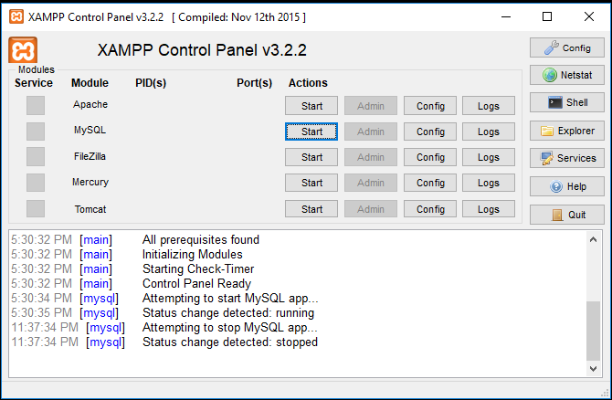

After opening XAMPP, click the **“Start”** button. This will create a connection to the MySQL database.

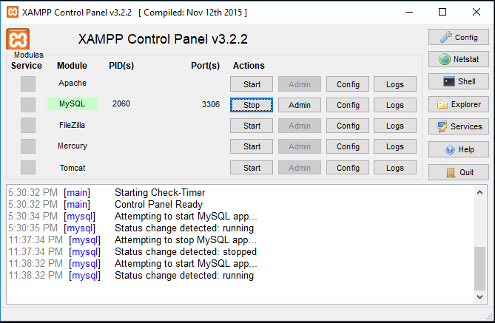

If starting the connection succeeds, MySQL will now be highlighted in green. To stop the connection, simply press the **“Stop”** button that has replaced the Start button.

After running XAMPP, simple run the executable to **CSC340TeamProject** will start the program and allow it to be accessed.

# Using the System

## Altering Data Outside of the Software

Certain types of data must be entered or assigned manually to the database. This is done by the database technician. A database technician has the necessary tools to access the information in the database, and to update or alter it accordingly. An example would be that a user’s login must be assigned manually through database entry. During the development of this software, the programs used were **HeidiSQL** and **Visual Studio Community 2017**. Download links for each are included in the references, as well as respective installations on the “Downloads” page.

**HeidiSQL**

HeidiSQL acts as an interface allowing the user to interact with the database. This software was developed using MySQL. HeidiSQL accompanies this need, allowing the input, checking or altering of data using MySQL queries.

**Visual Studio**

Visual Studio is an IDE, or an Integrated Development Environment. The software was built in Visual Studio using C#, along with the corresponding functions, frameworks and libraries to allow the execution of MySQL queries. Included in the package this User Manual was obtained through is the final build of the system, along with the original **.sql** file.

Database queries and commands can be altered through the pair of HeidiSQL and Visual Studio. Should a problem call for this, contact the development team at 859-622-1935.

**WARNING: Alter the build at your own risk! We DO NOT recommend trying to alter the build yourself, but rather through the help of the development team. Should this be a final means, ensure that a back is created!**

## Using the Software

The software features many simple ways to maneuver the activities.

**Buttons**

The interface has two forms of interaction, the first being buttons. Simply clicking on various buttons through the software will allow the user to navigate it and perform activities.

**Input**

Working in tandem with specific buttons, the software features many opportunities for the user to input information. This information is crucial to the execution of activities throughout the software. An input field is usually indicated by a label, corresponding to the data that should be entered. Be careful when inputting information, as this information is stored and used through the activity. Should you input incorrect information, contact your database technician immediately.

## Troubleshooting

When working with this software, several issues may occur:

**Invalid Username/Password**

This error refers to a user attempting to login. If you believe this error to be incorrect, double check the credentials and try again. If the problem persists, ensure that the connection to the database and the internet is running and stable. Should the problem continue, try restarting the application. If this doesn’t fix the issue, contact the database technician.

**Invalid Input**

This message means that the entered information of one of the on-screen inputs is incorrect. This could be due to the fact that certain inputs require certain types of information, such as a text field requiring a number, rather than a name or city , for example. Double-check that any information entered is correct, and in the correct format. Should the problem persist, contact your database technician or the team at 859-622-1935.

**Something went wrong**

This message refers to an issue with the database connection. Double check that XAMPP or a similar program allowing you to connect to a MySQL database is running. Also check that the system on which the software is running has a stable internet connection. Should the problem continue, try restarting the application. If this doesn’t fix the issue, contact the database technician.

**No ‘X’ Found**

This message indicates that an activity that requires a search did not return any data. If you believe this to be an error, double check the inputs then try again. If the issue persists, ensure that the connection to the database and the internet is running and stable. Should the problem continue, try restarting the application. If this doesn’t fix the issue, contact the database technician.

# References

**XAMPP Download:** <https://www.apachefriends.org/download.html>

**HeidiSQL Download:** <https://www.heidisql.com/download.php>

**Visual Studio Download:** <https://visualstudio.microsoft.com/downloads/>