A PROJECT ON

“ONLINE WEB PORTAL FOR SELLING/PURCHASING OF TILES”

SUBMITTED IN
PARTIAL FULFILLMENT OF THE REQUIREMENT
FOR THE COURSE OF
DIPLOMA IN ADVANCED COMPUTING FROM CDAC


SUNBEAM INSTITUTE OF INFORMATION TECHNOLOGY
Hinjawadi

SUBMITTED BY:

DHAKATE BHESHAJKUMAR BHAIYYALAL SUSHILA
33038

UNDER THE GUIDENCE OF:
PRIYANKA PATIL
Faculty Member
Sunbeam Institute of Information Technology, PUNE.

CERTIFICATE

This is to certify that the project work under the title ‘Web Portal for Selling/purchasing of tiles’ is done by DHAKATE BHESHAJKUMAR BHAIYYALAL SUSHILA in partial fulfillment of the requirement for award of Diploma in Advanced Computing Course.

Mrs. Priyanka Patil Mr. Yogesh Kolhe
Project Guide Course Co-Coordinator

Date:30/01/2020

A PROJECT ON
“ONLINE PORTAL FOR SELLING/PEUCHASING OF TILES”
SUBMITTED IN
PARTIAL FULFILLMENT OF THE REQUIREMENT
FOR THE COURSE OF DIPLOMA IN ADVANCED COMPUTING FROM CDAC

SUNBEAM INSTITUTE OF INFORMATION TECHNOLOGY
Hinjawadi
SUBMITTED BY:
DHAKATE BHESHAJKUMAR BHAIYYALAL SUSHILA

UNDER THE GUIDENCE OF:
MRS. PRIYANKA PATIL
Faculty Member
Sunbeam Institute of Information Technology, Pune

ACKNOWLEDGEMENT

A project usually falls short of its expectation unless aided and guided by the right persons at the right time. We avail this opportunity to express our deep sense of gratitude towards Mr. Nitin Kudale (Center Coordinator, SIIT, Pune) and Mr. Yogesh Kolhe (Course Coordinator, SIIT ,Pune) .
We are deeply indebted and grateful to them for their guidance, encouragement and deep concern for our project. Without their critical evaluation and suggestions at every stage of the project, this project could never have reached its present form.
Last but not the least we thank the entire faculty and the staff members of Sunbeam Institute of Information Technology, Pune for their support.

B.B. DHAKATE
DAC Aug 2019 Batch,
SIIT Pune

INTRODUCTION TO PROJECT

This project is a web based shopping system for an existing shop. The project objective is to deliver the online shopping application into J2EE platform .This project is an attempt to provide the advantages of online shopping to customers of a real shop. It helps buying the products in the shop anywhere through internet by using an website. Thus the customer will get the service of online shopping and home delivery from his favorite shop.
This system can be implemented to any shop in the locality or to multinational branded shops having retail outlet chains. If shops are providing an online portal where their customers can enjoy easy shopping from anywhere, the shops won’t be losing any more customers to the trending online shops such as Kajaria
In short,online shopping website attracts customers for its anytime
and favorable availability of products.

2.REQUIREMENTS

2.1 FUNCTIONAL REQUIREMENTS
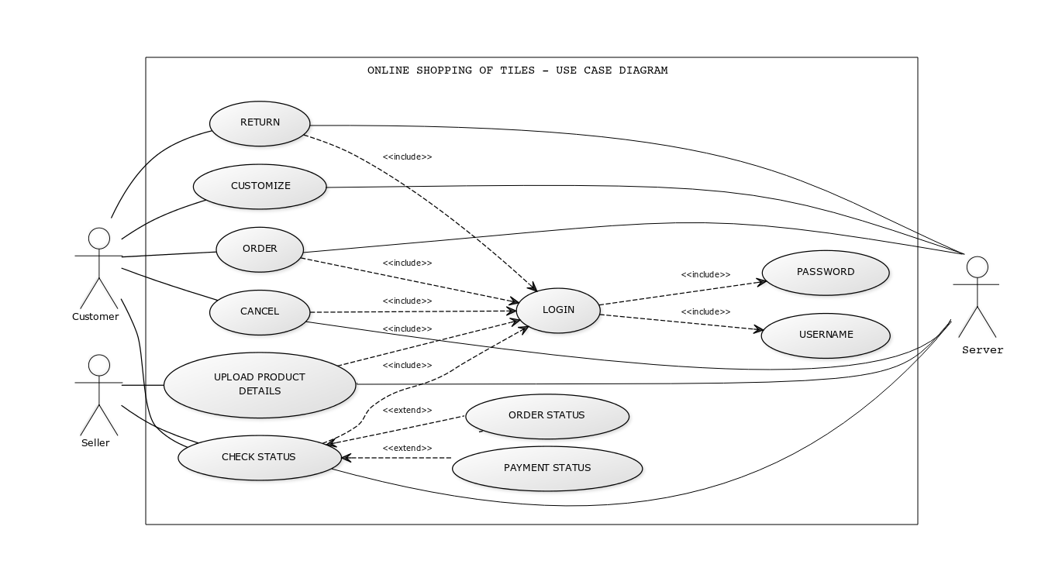

2.1 User Account

The passenger, who will henceforth be called the ‘user’, will be presented with 3 choices by the reservation system, as the first step in the interaction between them. A user can choose one of these and his choice would be governed by whether he is a guest or a registered user and whether he wants to check the availability of tickets or also block/buy them. The terms ‘registered user’ and ‘guest’ are described below.
A user who has traveled by the airline earlier would have been given a user id and a password. This ‘personal information’ would be henceforth referred to as ‘profile’. Such a user with a profile in DB-user shall be called a ‘registered user’. A registered user will be able to check the availability of tickets as well as block/buy a ticket by logging into the system.
A new user, on the other hand, would either have to
- register himself with the system by providing personal information or
- log into the system as a guest.
In case of ‘a’, the new user becomes a registered user.
In case of ‘b’, the new user would remain a guest.
A customer can only check the availability of garments. He can choose the garments
based on category(PORCELAIN,CERAMIC,PAVING ETERNITY) and shape(
PENNY,SUBWAY,MOSAIC,PLANK),series(CARVING DECOR,WOOD,GLOSSY)
finish(GLAZED,GLOSSY),material(CLAY,STONE,METAL)
The system shall present the user with an option to exit from the system at any time during the following processes.

2.2 Registration and creation of user profile

The system shall require a user to register, in order to shop garments based on his needs. It will ask the user for the following information at the least – a user id, a password, first name, last name, address, phone number, email address etc.
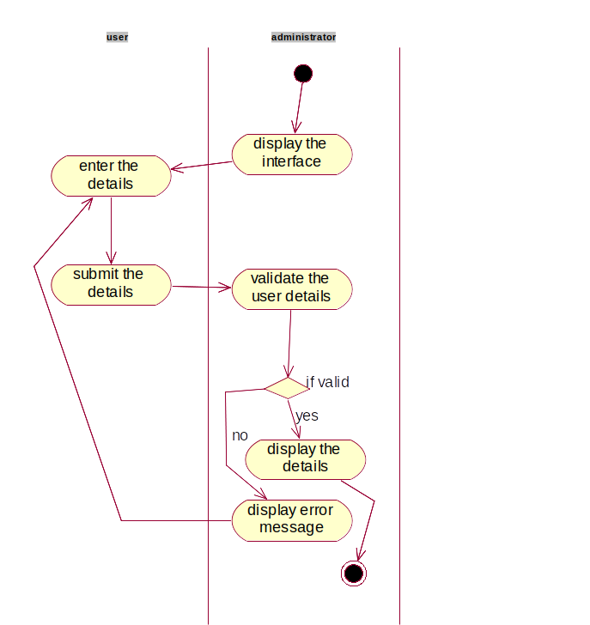

  - Search Tiles

After the login of user or guest user,user can see functionalities which makes him comfortable to check either about home ,about us ,downloads information etc. Initially,after login ,he will home see home page which shows him product list of
garments.
The product list includes information regarding category,name,series,shape,price,image of product .The system shall now allow the user to add the product to cart. The product gets added to cart message will be popped up after successful insertion of product into the cart.
  - Add to cart

After successful adding of product into the cart user can either increase the no of product quantity or decrease the no of product quantity according to his needs. The respected price will get displayed into the price column. In short,in cart functionality is available only to customer .Based on his needs and requirements,he can add products into the cart. He can also remove any product from cart if he required. In price column,he gets exact price which gets calculated as price of product * no of products(quantity).
The customer further goes to order table where he can see order placed by him followed by payment options.

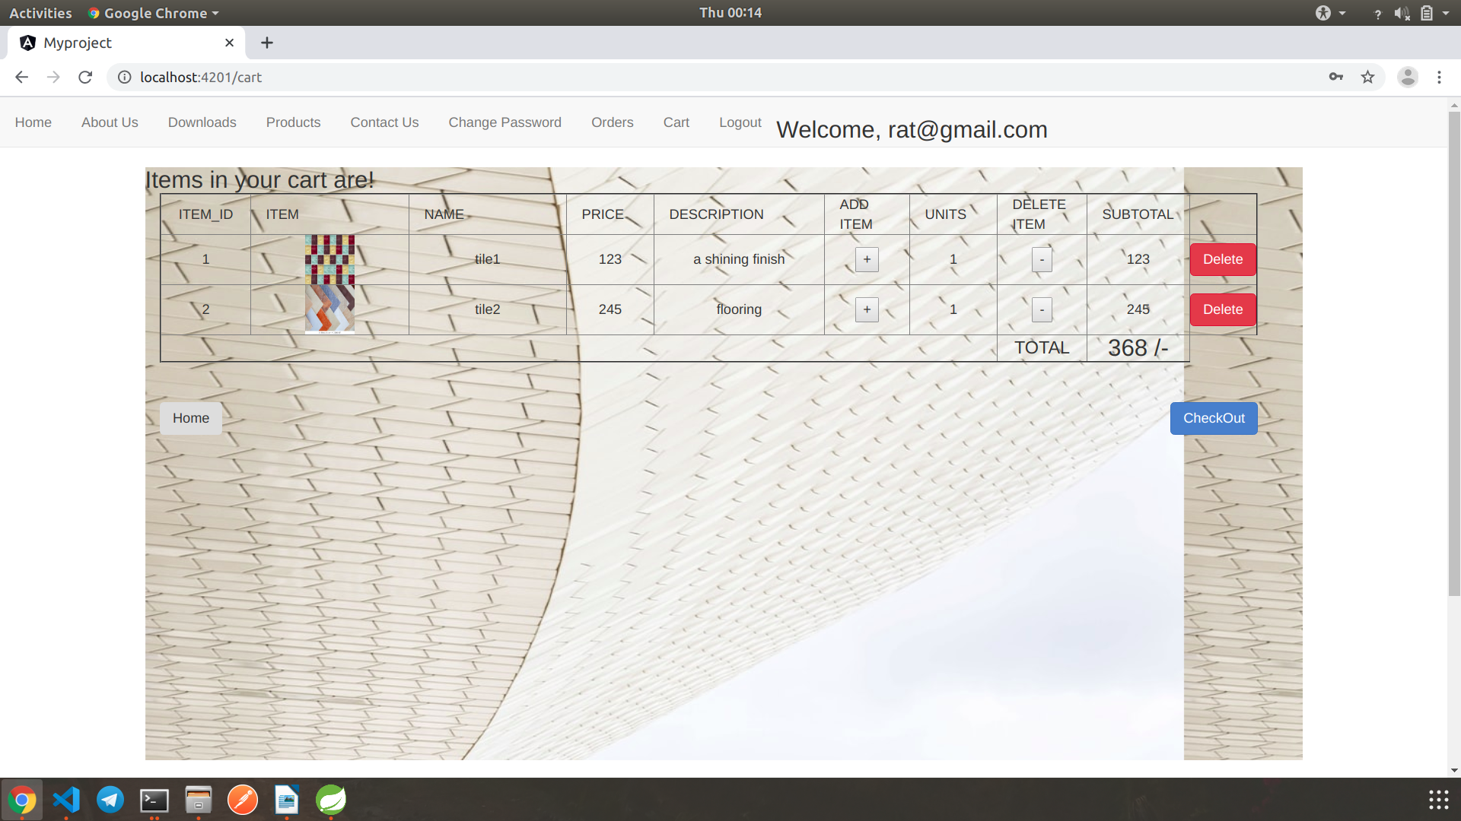

  - Change Password
User can change his password if he wants. For changing the password ,he first requires to put his email alongwith his old password .Then he needs to add his new password. At backend in the user table where information of all customers is kept,the password of that respected customer gets replaced by new password.
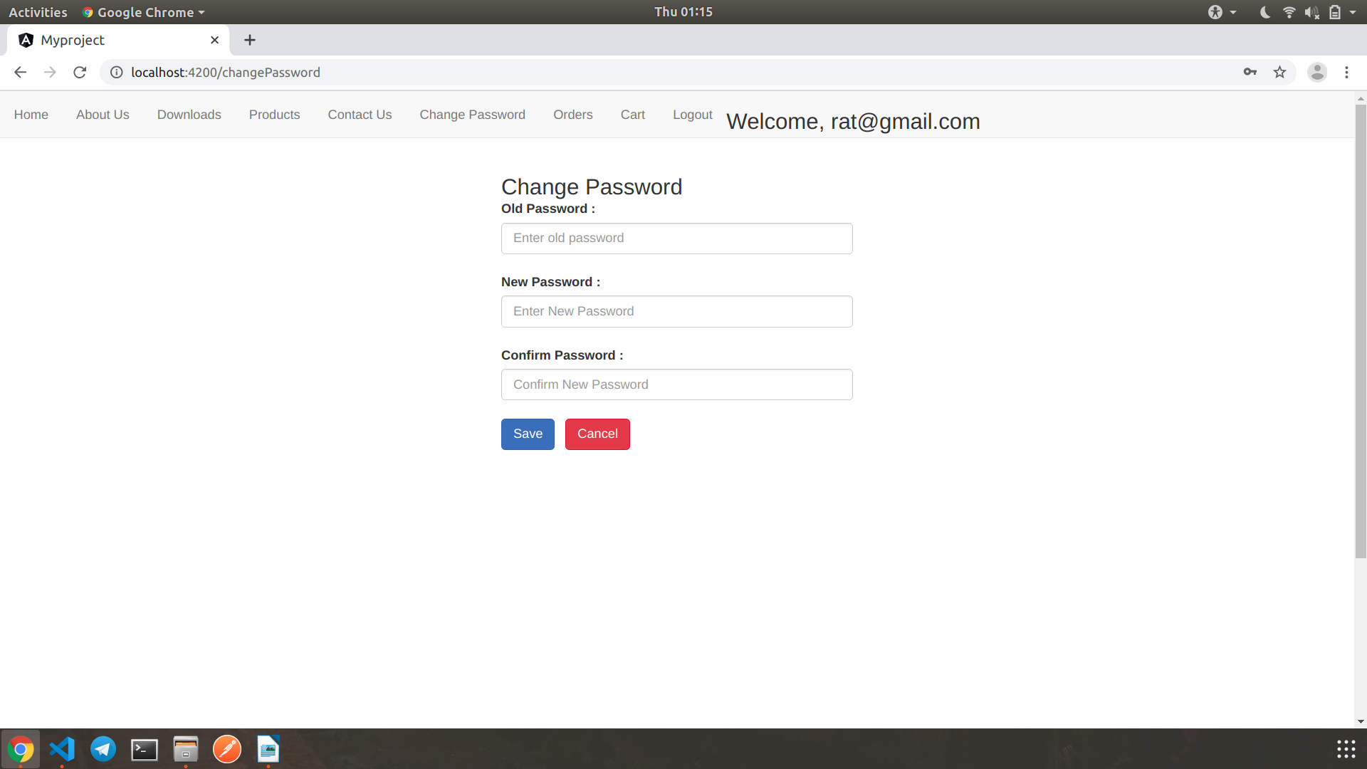

  - Delete from cart

A user can remove some product items from cart if he doesn’t want to proceed with those items.

  - Logout
After surfing or after successful addition of products into cart or after placing order,validated user can logged off from the website. In short,validated customer can be logged off anytime he wants. After logging out,login page will again be displayed .

VENDOR FUNCTIONALITIES-

  - Add product
Vendor has allocated specific Vendor-id. After logging successfully by vendor,that particular vendor can add product which is available in his shop. The added entry of product gets stored into database. That particular product gets mapped with particular vendor-id so that one comes to know about product which is added by particular vendor.

  - Registration of Vendor

There is a provision to add new vendor .Vendor needs to get himself registered with selection of role = vendor functionality .The vendor gets allocated with particular vendor-id .This is done by admin. It means admin provides specific id to particular vendor.
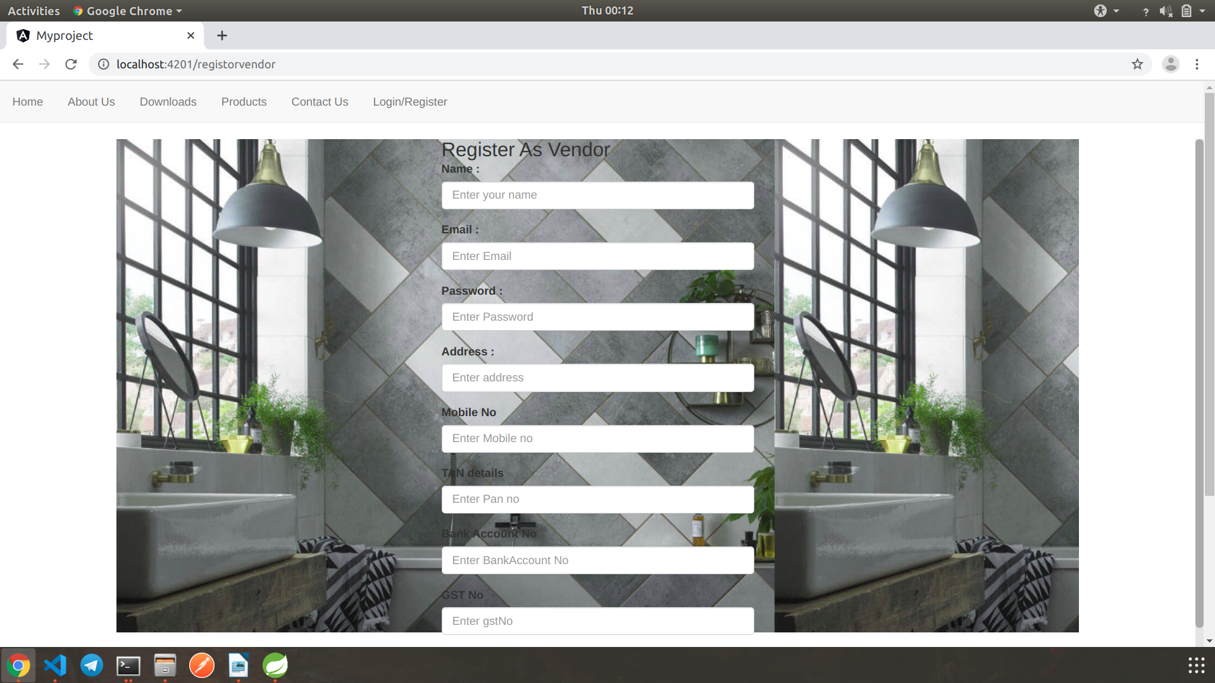

ADMIN FUNCTIONALITIES-

Admin is registered by default in database by developer itself. It has got the functionality of adding the product of the vendor who cannot operate the website due to any reason.
Admin can login ,logout,change password and can control of functionalities of user,vendor.

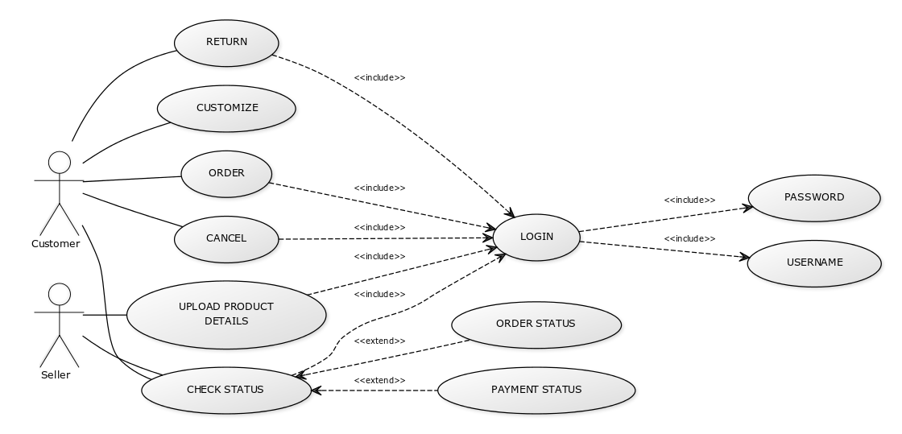

3. DESIGN

3.1 Database Design

The following table structures depict the database design.

Table1: User_Info

Column Name | Data Type | Length | Allow Null (1=Yes;0=No)
id | int | 11 | 0
address | varchar2 | 50 | 0
bankAccount | Varchar2 | 50 | 1
email | Varchar2 | 30 | 1
gstNo | Varchar2 | 20 | 1
mobileNo | Varchar2 | 11 | 1
name | Varchar2 | 30 | 1
password | Varchar2 | 20 | 1
regNo | Varchar2 | 20 | 1
role | Varchar2 | 20 | 1
tan | Varchar2 | 20 | 1

Table2: OrderProduct

id | int | 11 | 0
quantity | int | 11 | 1
order_id | int | 11 | 1
product_id | int | 11 | 1

Table3: Product

id | int | 11 | 0
category | Varchar2 | 20 | 0
description | Varchar2 | 50 | 1
finish | Varchar2 | 20 | 0
gtin | int | 11 | 0
image | longblob | 0 | 1
material | Varchar2 | 20 | 0
name | Varchar2 | 30 | 0
price | Double | 5,2 | 0
series | Varchar2 | 20 | 0
shape | Varchar2 | 20 | 0
vendor_id | int | 11 | 1

Table4:Orders

Id | int | 11 | 0
orderTime | datetime |  | 1
user_id | int | 11 | 0

4. CODING STANDARDS IMPLEMENTED

Naming and Capitalization
Below summarizes the naming recommendations for identifiers in Pascal casing is used mainly (i.e. capitalize first letter of each word) with camel casing (capitalize each word except for the first one) being used in certain circumstances.
Identifier | Case | Examples | Additional Notes
Class | Pascal | Person, BankVault, SMSMessage, Dept | Class names should be based on "objects" or "real things" and should generally be nouns. No ‘_’ signs allowed. Do not use type prefixes like ‘C’ for class.
Method | Camel | getDetails, updateStore | Methods should use verbs or verb phrases.
Parameter | Camel | personName, bankCode | Use descriptive parameter names. Parameter names should be descriptive enough that the name of the parameter and its type can be used to determine its meaning in most scenarios.
Interface | Pascal with "I" prefix | Disposable | Do not use the ‘_’ sign
Property | Pascal | ForeColor, BackColor | Use a noun or noun phrase to name properties.
Associated private member variable | camelCase | _foreColor, _backColor | Use underscore camel casing for the private member variables
Exception Class | Pascal with "Exception" suffix | WebException,

Comments
- Comment each type, each non-public type member, and each region declaration.
- Use end-line comments only on variable declaration lines. End-line comments are comments that follow code on a single line.
- Separate comments from comment delimiters (apostrophe) or // with one space.
- Begin the comment text with an uppercase letter.
- End the comment with a period.
- Explain the code; do not repeat it.

5. TEST REPORT

Another group called Linux did the testing and the report of the testing is given hereunder.
GENERAL TESTING:
SR-NO | TEST CASE | EXPECTED RESULT | ACTUAL RESULT | ERROR MESSAGE
1 | Register Page | Redirected to Next page | OK | Nothing
2 | Login Page | Pop-up will come | Ok | Please enter username and password again .
3 | Change password | User,admin,vendor password will be reseted | Ok | Nothing
4 | Admin page | Admin can see all activities | Ok | Nothing
5 | Homepage | Home page contains product info with contact us ,downloads navigational options | Ok | Nothing
6 | Checking login or not | User is logged in or not | Ok | Nothing
7 | Add product details | Vendor adds product details in product table | Ok | Nothing
8 | Search garment | Customer can search for fashionwear. | Ok | Nothing
9 | Add to cart | Customer can add products into cart . | Ok | Nothing
10 | Order table view | Products gets displayed into order table after successful placement. | Ok | Nothing
11 | Delete product from cart | User can delete product from cart | Ok | Nothing
12 | Logout | It will logout from user profile. | Ok | Nothing
 | STATIC TESTING
SR-NO | Deviation | Program
1 | Commenting not followed | All Web Application
6. PROJECT MANAGEMENT RELATED STATISTICS

DATE | WORK PERFORMED | SLC Phase | Additional Notes
JAN 12,2020 | Project Allotment and User Requirements Gathering | Feasibility Study | Our team met the client Mr. Nitinkudale (CEO, SIIT Pune) to know his requirements.
JAN 17,2020 | Initial SRS Document Validation  And Team Structure Decided | Requirement Analysis  (Elicitation) | The initial SRS was presented to the client to understand his requirements better
JAN 18,2020 | Designing the use-cases, Class Diagram, Collaboration Diagram, E-R Diagram and User Interfaces | Requirement Analysis &  Design Phase | Database Design completed
JAN 19,2020 | Business Logic Component design Started | Design Phase | ----------------------
JAN 20,2020 | Coding Phase Started | Coding Phase | 70% of Class Library implemented.
JAN 21,2020 | Implementation of Web Application and Window Application Started | Coding Phase | Class Library Development going on.
JAN 22, 2020 | Off | Off | Off
JAN 23, 2020 | Implementation of Web Application and Window Application Continued | Coding Phase and Unit Testing | Class Library Modified as per the need.
JAN 24, 2020 | Implementation of Web Application and Window Application Continued | Coding Phase and Unit Testing | --
JAN 25, 2020 | After Ensuring Proper Functioning the Required Validations were Implemented | Coding Phase and Unit Testing | Module Integration was done by the Project Manager
JAN 26, 2020 | The Project was Tested by the respective Team Leaders and the Project Manager | Testing Phase (Module Testing) | --
JAN 27, 2020 | The Project was Submitted to Other Project Leader of Other Project Group For Testing | Testing Phase (Acceptance Testing) | The Project of Other Team was Taken up by the Team for Testing
JAN 28-29, 2020 | The Errors Found were Removed | Debugging | The Project was complete for submission
JAN 30, 2020 | Final Submission of Project

Appendix A

Entity Relationship Diagram

Data Flow Diagram:

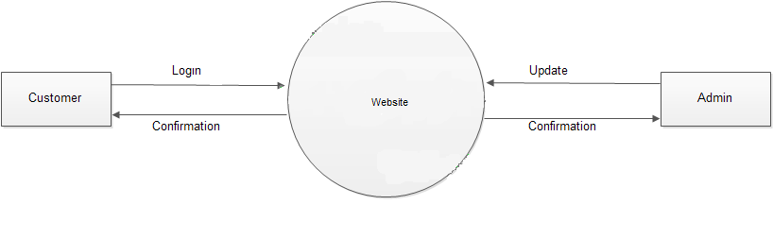
df1

df2

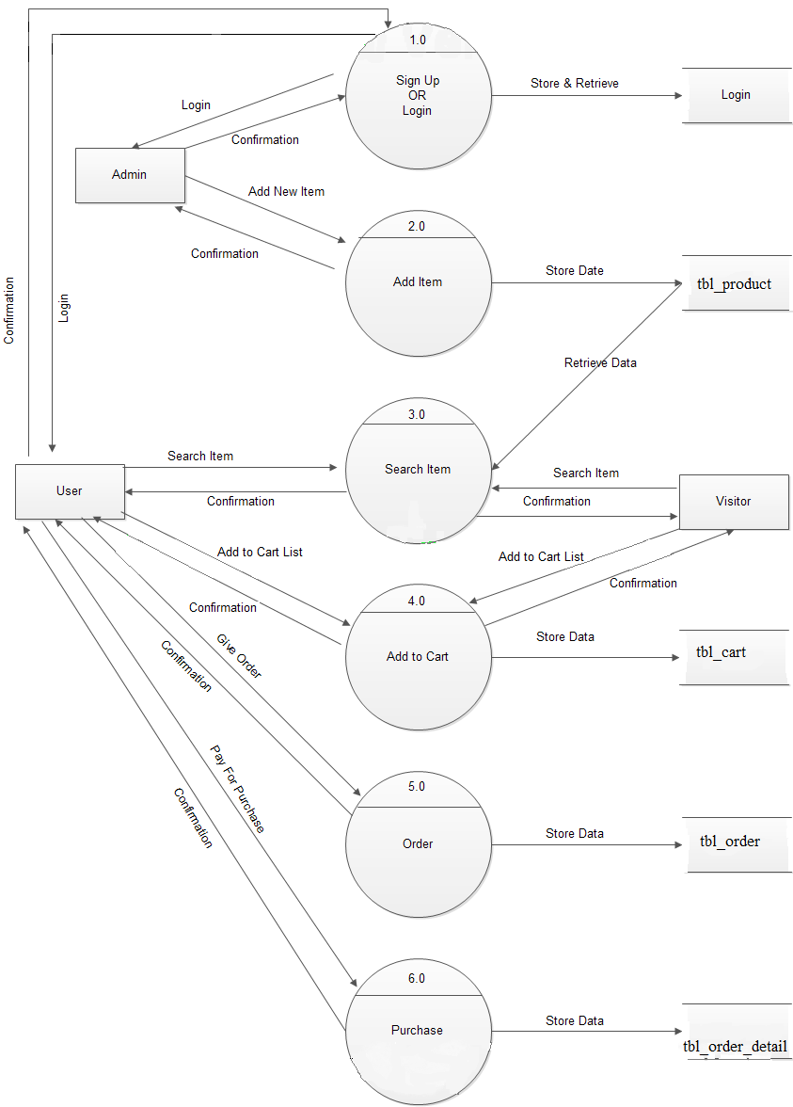

Homepage:

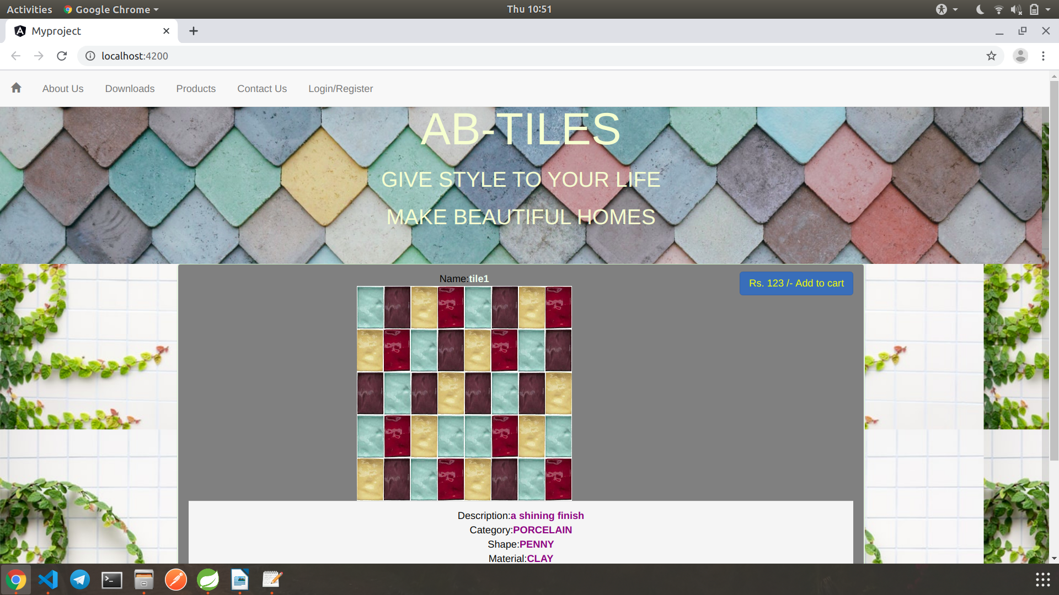

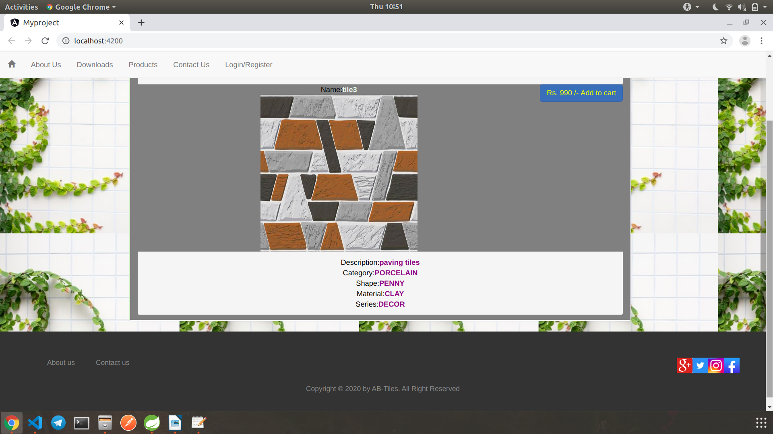

Login page:

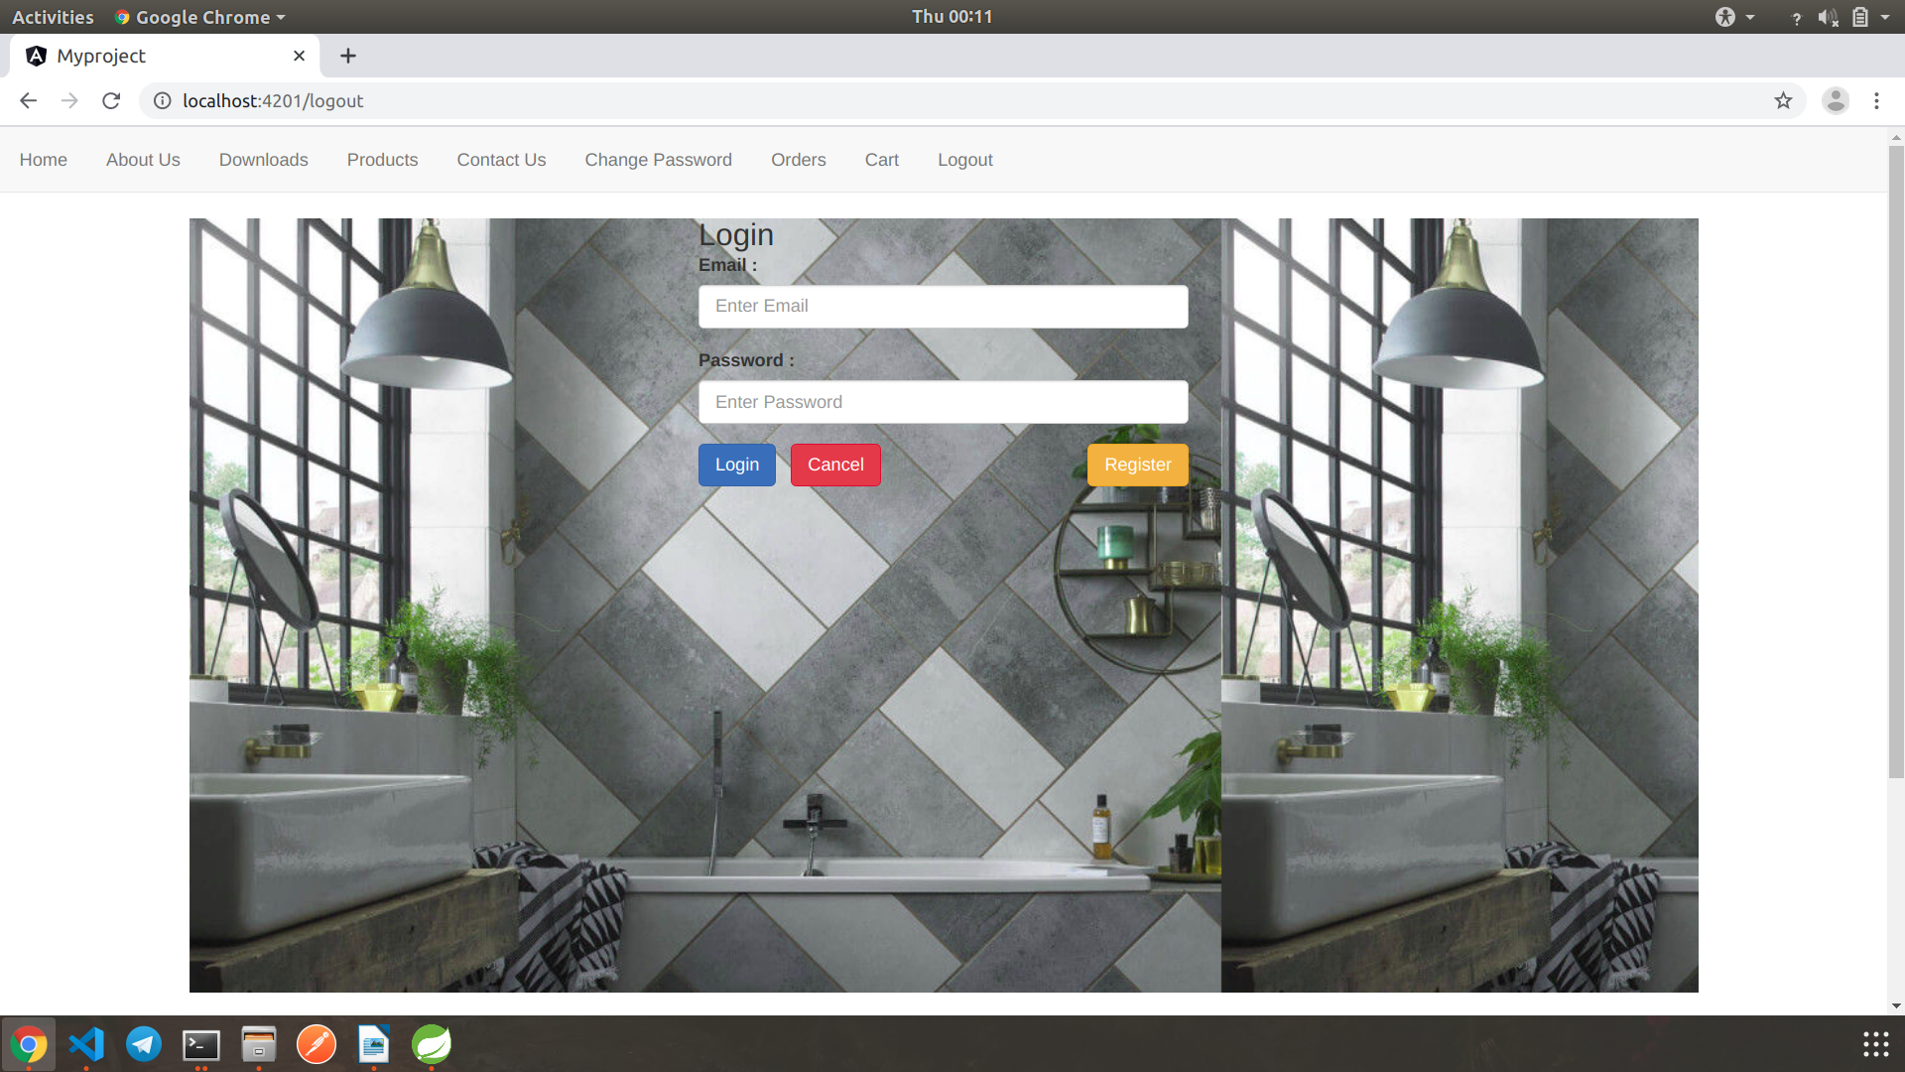

Vendor Registration:

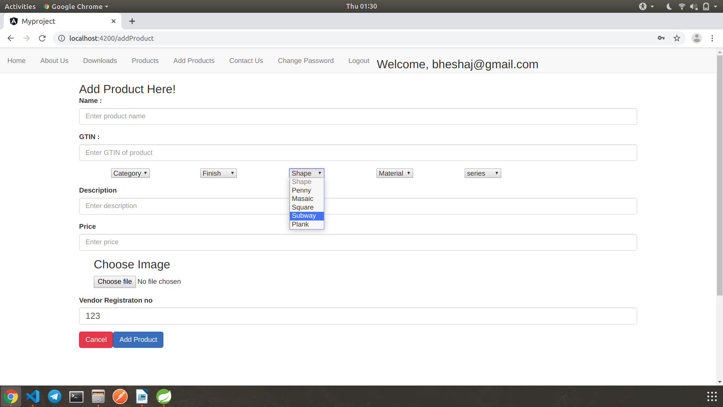

Add Product:

Orders:

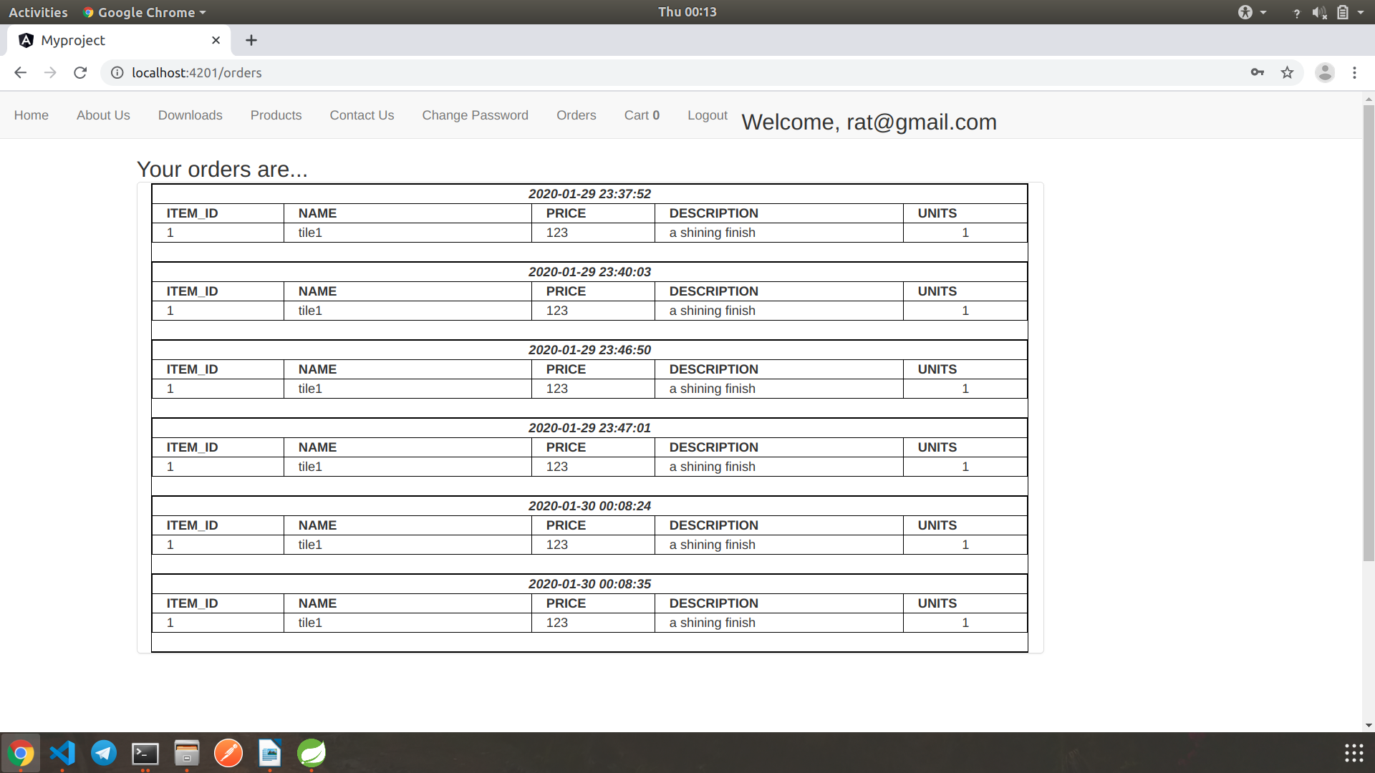

Cart:

7.REFERENCES:

http://www.google.com

http://www.unsketch.com

http://www.webdevelopersjournal.com/

http://www.w3.org

http://www.wikipedia.org

http://www.kajaria.com

