MEDYAES FUTUREGEN SOFTWARES PVT. LTD.

Expect the Unexpected

**Bhim Sen Rai** Date: 20/02/2021

Software Developer

**Sub: Relieving Letter**

Dear Mr. Bhim Sen Rai

This is with reference to your resignation letter dated February 12, 2021 wherein you expressed 2 your desire to be relieved from the services of our company on Feb 20, 2021.

We would like to inform you that your resignation has been accepted. You are being relieved from all the duties and services of the company and the relieved date is the same as you proposed, 20/02/2021.

Your Stipend/allowances and other benefits have been settled with the organization.

Your contribution to the organization toward its growth and success will always be appreciated. Wish you all the best in your future endeavours.

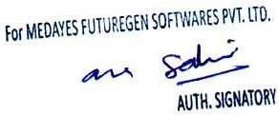Authorized Signatory

Head Office: A 18, Shyam Park Extension, Near Shyam Park Metro Station, Sahibabad, Ghaziabad - 201005

Regd. Office: B-73/5, East of Kailash, New Delhi - 110065, India

Contact Number. : 08800428803

Email: ashok@futuregensoftwares.com, sahniashoka@gmqil.com