Source control Tool : (version control tool)

1)GitHub

2)SVN (sub version)

3)per force

4)VSS (Visual Source Safe)

GitHub : Github is de-centralised cloud repository where we can maintain our entire framework in one place .so that it can be shared easily with multiple engineers working on the same project in different location.

Advantages:

1.De-centralised repository

2.cloud repository

3.No need of system engineer to maintain github

4.File sharing between the team members will be easier

5.Highly secured and we can have the back up any time.

6.Master copy of the frame work available in github,so that we can perform batch execution any time easily.

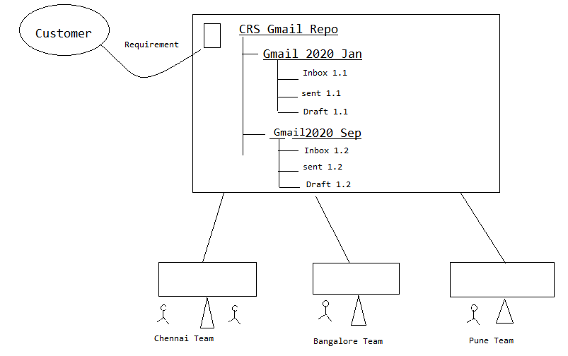

There are two type of software available in git

1)GitServer--GitHUB

2)Git client

a).github desktop

b).git bash

c).git Gui

d).E-git (Eclipse Git)

e) Git command Prompt

1. First Create an Account in Github.( <https://github.com>)
2. Login to github account and create an new empty repository.

a)click on new button

b)Enter the repository name

c)And select public radio button and click on create reposity button

d) it will create an uri for the repository and save it.

1. Create a new token for the repository

a)click on user icon🡪setting🡪developer setting🡪personal access token🡪token classics🡪generate new token 🡪classic token🡪Enter the token name🡪select repo checkbox🡪click on generate token🡪token will be create🡪save it

1)**Exporting :**

**How FrameWork developer Export the framework from Eclipse(system) to github server**

**Q. How to store existing Project (Framework) in to Git**? (How Frame work developer put the frame work in Github for the first time)

🡪 1.Select the project🡪 Right Click🡪  
Select Team -> share project ->   
🡪2.Click on Create in the popup & click on finish and Finish ( In share project window) (it will Create new local repository)  
3. Status of the project will be [Repository --master].->.(Local repo is created but not yet commited means project is not saved in local repo that’s why we see ? symbol in all the files)  
  
**Q. How to transfer the framework from working directory(eclipse) to local repository**.(How to commit**)**

🡪 Select the project ->Right click->Team and -> click on commit   
[Git Staging window will be displayed ]  
Select all the files & drag from unstaging changes 🡪 to 🡪 staged changes and drop it 🡪Enter the commit message and click on commit   
🡪 Symbol of the files get changes to cylindrical symbol (means Commited).

**Q. How to transfer the framework from local repository to Git hub(Global Repository).**

🡪 Select the project [right click] 🡪 team 🡪 select push brand master 🡪 provide 🡪 github 'uri' & UN & Token in password textbox 🡪 click on check box ‘store in secure Store 🡪click on preview🡪 click on force over right check box then click preview - preview - Push (ok) & Close .

**Importing** : (Cloning)

**Q. How to get the framework from github global rep to Local System (importing or cloning)**

🡪go to eclipse 🡪 file 🡪 import 🡪 click & expand git folder 🡪 select project from git 🡪 click on next 🡪 select on clone URI and click next   
🡪 provide github 'uri' & UN & Token in password textbox 🡪 click on next🡪 next🡪 click next🡪click next and .finish.

How to **PUSH** the testscript from eclipse to github after writing the testscript ?

🡪 Select the project ->Right click->Team and -> click on commit   
Select the files to be commited & drag from unstaging changes 🡪 to 🡪 staged changes and drop it 🡪Enter the commit message and click on commit .

Select the project [right click] 🡪 team 🡪 select push brand master🡪

click on force over right check box then click preview 🡪 Push & Close .  
  
How to **PULL** the testscripts from github to local repository?

🡪 Select the project ->Right click->Team🡪pull 🡪close

== ==

# Maven

# 

It is a popular open source **Build Management Tool** ( or creating and testing tool) used by developers and automation test engineers.

## Maven usage in development:

* In case of development maven will be used to test the application build, when multiple developers working in the same application.
* If one developer modify the source code of the module 1, it might effect other modules. So that maven will be used for build testing and for build creation

Maven Usage in automation:

It is used to test the framework build, when ever multiple automation engineer working on the same framework. When one automation engineer modify the library it might effect other components of the framework, so that we go for Maven to identify such kind of issues.

Maven Folder Structure:

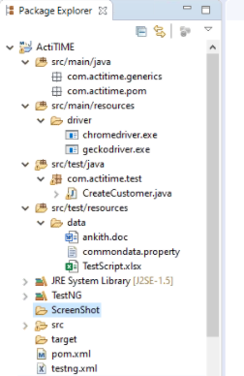

<https://mvnrepository.com/>

How to handle Dependency in Maven :

Dependency is a feature available in Maven which is used to connect global repository automatically and download all the jars into local repository and eclipse project as well.

In order to handle dependency go to pom.xml file inside maven project and write dependency code for all the jars like TestNG,WebDriver,apache Poi and surefire plugin for running testing.xml inside pom.xml file

== ==

<project xmlns=[*http://maven.apache.org/POM/4.0.0*](http://maven.apache.org/POM/4.0.0) xmlns:xsi=*"http://www.w3.org/2001/XMLSchema-instance"*

xsi:schemaLocation=*"http://maven.apache.org/POM/4.0.0 http://maven.apache.org/xsd/maven-4.0.0.xsd"*>

<modelVersion>4.0.0</modelVersion>

<groupId>Elf</groupId>

<artifactId>Elf</artifactId>

<version>0.0.1-SNAPSHOT</version>

<dependencies>

<dependency>

<groupId>org.seleniumhq.selenium</groupId>

<artifactId>selenium-java</artifactId>

<version>3.141.59</version>

</dependency>

<dependency>

<groupId>org.testng</groupId>

<artifactId>testng</artifactId>

<version>6.14.3</version>

<scope>test</scope>

</dependency>

<dependency>

<groupId>org.apache.poi</groupId>

<artifactId>poi-ooxml</artifactId>

<version>3.17</version>

</dependency>

<dependency>

<groupId>commons-io</groupId>

<artifactId>commons-io</artifactId>

<version>2.7</version>

</dependency>

</dependencies>

<build>

<plugins>

<plugin>

<groupId>org.apache.maven.plugins</groupId>

<artifactId>maven-surefire-plugin</artifactId>

<version>2.21.0</version>

<configuration>

<suiteXmlFiles>

<suiteXmlFile>testng.xml</suiteXmlFile>

</suiteXmlFiles>

</configuration>

</plugin>

</plugins>

</build>

</project>

How to Execute the programs in command prompt ( ie without using eclipse)

Maven command Line Pulgin : It is a plugin which is used to handle maven project in command line.

In order to handle maven project in command line ,we should follow maven build life cycle.

mvn clean 🡪clean/delete the older report

mvn validate 🡪validate the project and download the all the jar (dependency)

mvn compile🡪check the compilation issue in the framework

mvn test 🡪Execute all the tests.

Installation steps of Maven command line plugin :

Go to google & search for download Maven

Click on first link navigate to Maven community(website)

Click on apache-Maven-3.6.3-bin-zip ( take latest version)

It will Download the zip file & unzip the file.

**Path Setting :**

1. Set the Path of Maven as shown below
2. Go inside the folder & copy the bin location (including the bin) c:\Selenium.ocmm-32\apache-maven-3.6.1\bin>
3. Go to “This PC “ and right click on this pc 🡪properties🡪click on advance system settings🡪click on Environment Variables🡪double click on path under system variables🡪click on new🡪and Cpy Paste the path of maven bin location..-->click on ok🡪 click on ok.

NOTE: In order to check Maven installation ->go to command line &check (Type) mvn -Version .

In order to execute go to the location where pom.xml is present and open the command prompt and type **mvn test** for executing all the test case.

EX : E:\sandeep\eclipse-workspace\seleniumExp\Actitime1>mvn test

== ==

**Jenkins :**(Continous Integration/Continous Development Tool)

==============================================================

Jenkins is a popular Open Sources CI & CD Tool which is used by developer & Automation test Engineers.

-> In case of developement Jenkins will be used to continuos developement - It means whenever developement of source code is completed Jenkins automatically get the source code from the github & create a build, then install the build in testing environment or staging or production environment automatically..

jenkins Usage in Automation:-

In case of automation Jenkin will be used for continous integration, It means jenkins continuosly monitors the build (Framewrork)in git Location. Then Automatically starts the execution based on configuration of the Jenkins(or whenever there is change ).

->Jenkins provide 3 level of Excecution

i)**On demand** execute whenever it is required(based on the need)

ii)**On Schedule** execute based on Time scheduled by you

iii) **Poll SCM** execute based on keeps on monitor the git or build

(means Monitors the build in Github then automatically executes whenever there is a change in the framework).

(Ie starts execution whenever new build arrived)

Advantage of Jenkins-->

i)Monitor the build system or is location then execute testscripts- When ever New Build or arrive & send out the email Notification.

ii)Monitors the build in Git Location then send out an email if build fails(if modification,addition,deletion done)

iii)Jenkins Provide email Notification

iv)Jenkins Provide 3 level of execution

v)We can execute the build in any system

===================================================

Steps to install Jenkins:- (precondition is jdk 17 or 21 and git should be installed)

1)Go to google search for jenkins

2)click on first link to navigate jenkins community

3)click on windows (present under latest version) & it will start download

4)MSI file will be downloaded , then double click on msi file& install the jenkins.

a)click on next🡪next🡪select run service as local system radio button🡪next🡪click test port🡪next🡪give the path of jdk 11 or jdk 17 or jdk21🡪next🡪next🡪install🡪 accept the warnings by cicking yes..-🡪finish

5) After installation access the jenkins by using the url <http://localhost:8080/> in the browser.

6)Enter the password—by going to --C:\ProgramData\Jenkins\.jenkins\secrets\initialAdminPassword -(path will be given by Jenkins ) and click on continue

7) select install suggested plugins and click on skip continue as admin

8)click on save and finish and start using Jenkins..

**New Variable Creation : (2 varibles should be created)**

1. Create the variable for Maven and java as shown below
2. Go to the downloaded maven folder & copy the location (excluding the bin) c:\Selenium.ocmm-32\apache-maven-3.6.1 >
3. Go to “This PC “ and right click on this pc 🡪properties🡪click on advance system settings🡪click on Environment Variables🡪Click on new button and Enter the name as M2_HOME and paste the above path location and click on ok.

e)Similarly create Another variable with the name JAVA_HOME and copy paste the location of JDK 17 or 21 and click on ok…

Ex :

M2_HOME=c:\selenium_OCCM_32\apache-maven-3.6.1 --------------🡪excluding bin

JAVA_HOME=c:\programfiles\Java\Jdk1.8.0-51 --------------🡪excluding bin

==

**Git installation :**

1)go to google.com and search for git download

2)click on first link and select windows

3)select click here to download link and starts downloading

4)double click on the downloaded file and follow default installation by clicking next and install and finish…

**Plugin Installation :**

i>Maven Integration Plugin (In Order to create Maven Project in Jenkins we should mandatory install below plugin)

🡪Manage Jenkins🡪plugin🡪select available plugins🡪search for maven integration plugin=> select the check box and click on install button…

Similarly install GitHub Integration Plugin…

ii>GitHub Integration Plugin

🡪Manage Jenkins🡪plugin🡪select available plugins🡪search for github integration plugin=> select the check box and click on install button…

**Set the path of JAVA,MAVEN and GIT in Jenkins : (**\*\*\*Below Environment should be set.

**)**

===========================================================

->Go to Jenkins & click on Manage Jenkins-> Click On tools -> Add JDK->Enter the Name as->JAVA_HOME and paste the path of JDK without bin..and click on apply…

(C:\Program Files\Java\jdk-21 )

->Go to Git Installation🡪click on add git->enter Path to get executable as

[ C:\Program Files\Git\bin\git.exe ] and click on apply

->go to Maven installation-🡪click on add maven🡪unselect the check box install automatically..

Enter Name :M2_HOME

In Maven_Home : c:\Selenium.ocmm-32\apache-maven-3.6.1  …without bin

=============================================================================

***Below Environment should be set.

=============================================================

Build Trigger (0-23Hrs) (1-12Months) -> ( 4 21 23 8 5)

| | | | |---Aug/23/2019(5-friday)9.04pm(or 21.04)

Build Schedule-> * * * * * ***

Periodically | | |------Day of Week

Min Day of (0-7)SUN,MON...

(0-59) Month

(1-31)

[Space & space for every stars]

Poll SCM:- * * * * *->Executes when ever any one changes the frame work in the github

================================================================

Step1:-> New Item-> Select Maven project -> get Inside Project->Click on configure-> click on git & provide path of repository from clone.

or

=======================================================

How to create Project/Job in Jenkins :->( How to schedule the job in Jenkins )

1)Go to Dashboard in Jenkins ,click on New Item and provide the name for the project and select maven project and & click on ok.

2)Provide a project description.

3)In source code Management select git radio button & provide repository URI-🡪click on ADD and Jenkins🡪Enter the username and token in the popup –and click on add..

4)Select the added credentials..

5) Go to Build triggers..-->select Build periodically 🡪Enter the tie five star pattern

6)GO to Build 🡪Add the project name under Root POM (\git Project Name\POM.xml) 🡪 Goals and option --test

7)Apply and Save…

Note : [Under Build and Root POM]: \git Project Name\POM.xml(ex: \SDET Project\POM.xml )

Goals and option --test

How to provide recipient mail to address to selector:->

1)Login to jenkins-> select the project -> click on configure ->under Build settings, provide a recipient mail address and click on save...