|  |  |  |  |  |  |
| --- | --- | --- | --- | --- | --- |
| **Sno** | **BTE (%)** | **BSFC (kg/kWh)** | **CO (%)** | **HC (ppm)** | **Nox (ppm)** |
| **Mean Absolute Error** | 0.376723 | 0.016886 | 0.075486 | 2.898666 | 43.889233 |
| **Mean Squared Error** | 0.172235 | 0.000516 | 0.006776 | 13.303155 | 3099.156806 |
| **Root Mean Squared Error** | 0.415012 | 0.022727 | 0.082319 | 3.647349 | 55.670071 |
| **R2 score** | 0.995782 | 0.961860 | -8.309875 | 0.416528 | 0.809398 |

**Gradient Boost Regression Model – Metrics**

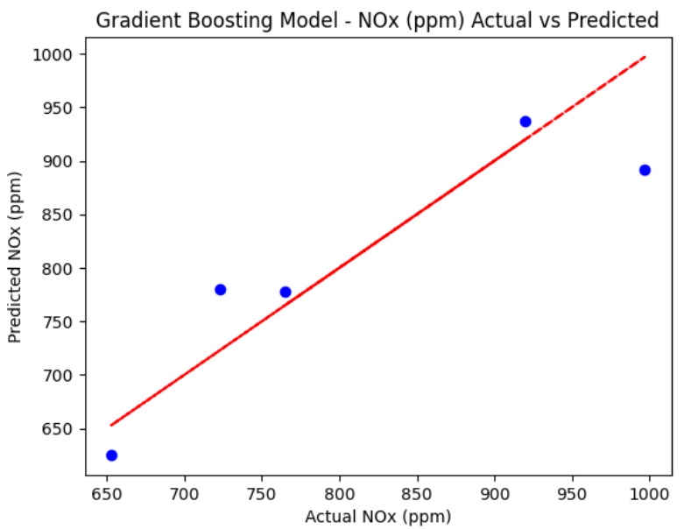

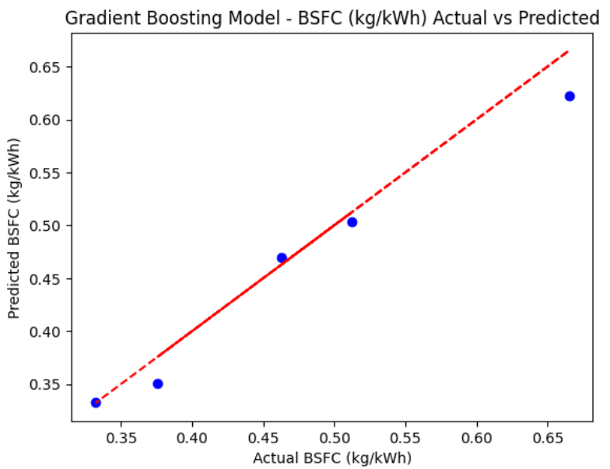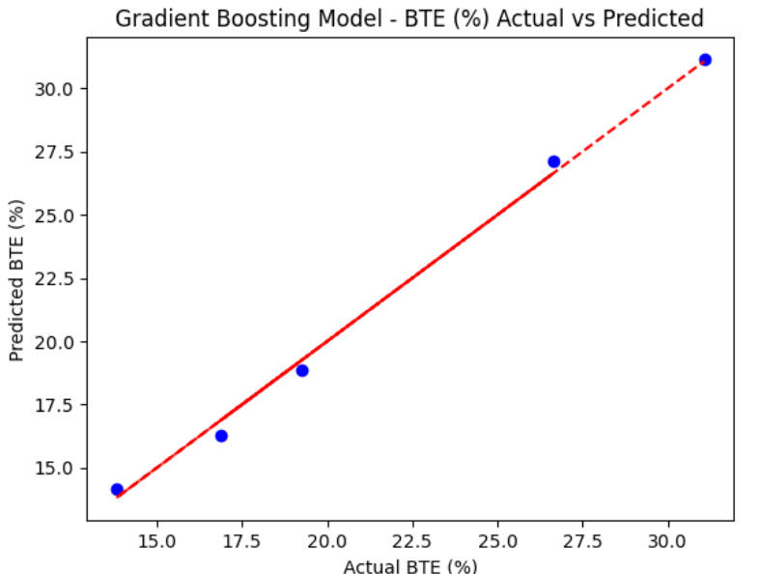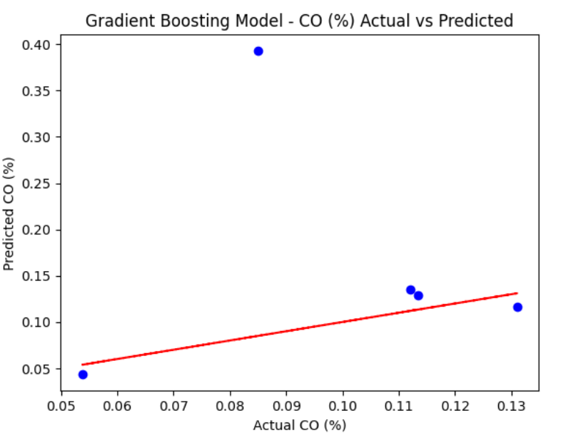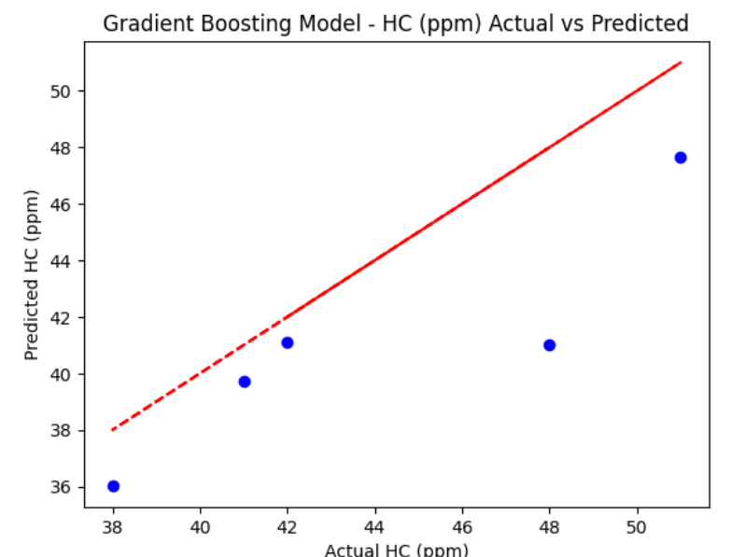

|  |  |  |  |  |  |
| --- | --- | --- | --- | --- | --- |
| **Sno** | **BTE (%)** | **BSFC (kg/kWh)** | **CO (%)** | **HC (ppm)** | **Nox (ppm)** |
| **Mean Absolute Error** | 0.375539 | 0.028625 | 0.087132 | 3.063999 | 56.874 |
| **Mean Squared Error** | 0.178698 | 0.001676 | 0.022286 | 13.361439 | 5555.35454 |
| **Root Mean Squared Error** | 0.422727 | 0.040945 | 0.149286 | 3.655330 | 74.534250 |
| **R2 score** | 0.995623 | 0.876212 | -29.618305 | 0.413971 | 0.658338 |

**Random Forest Regression Model – Metrics**

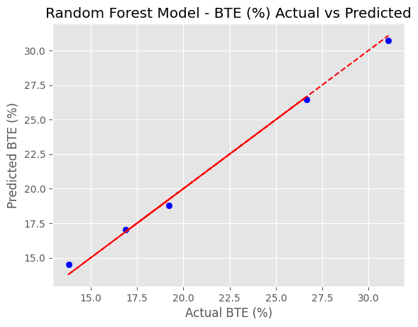

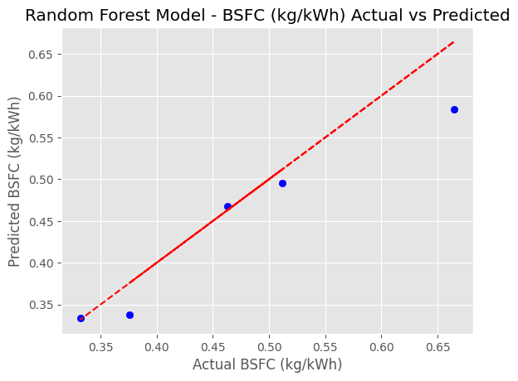

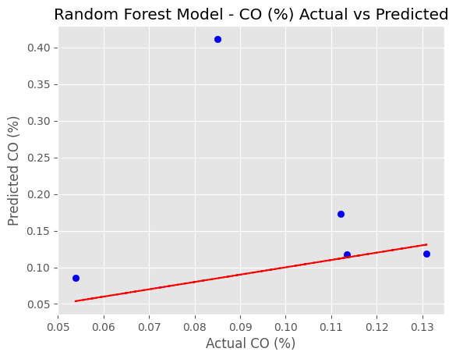

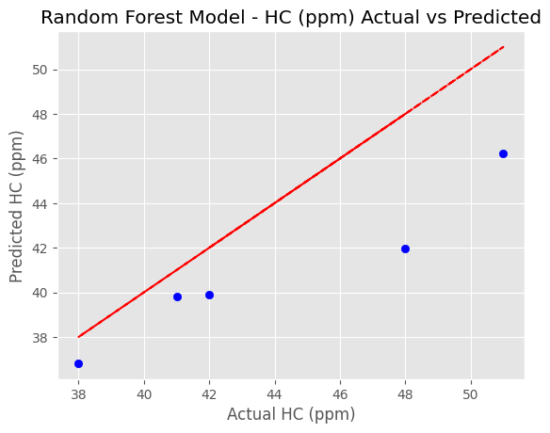

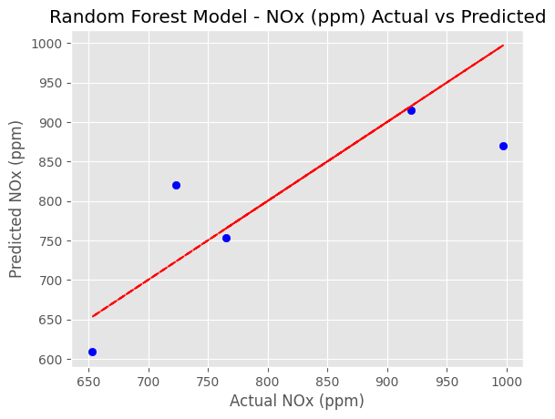

|  |  |  |  |  |  |
| --- | --- | --- | --- | --- | --- |
| **Sno** | **BTE (%)** | **BSFC (kg/kWh)** | **CO (%)** | **HC (ppm)** | **Nox (ppm)** |
| **Mean Absolute Error** | 0.926312 | 0.083110 | 0.075486 | 3.144932 | 86.014209 |
| **Mean Squared Error** | 1.127752 | 0.012323 | 0.006776 | 15.692545 | 9743.885827 |
| **Root Mean Squared Error** | 1.061957 | 0.111010 | 0.082319 | 3.961381 | 98.711123 |
| **R2 score** | 0.972382 | 0.090093 | -8.309875 | 0.311730 | 0.400739 |

**Elastic Net Regression Model – Metrics**

