 | SDG 15.4.3  SDG 15 Life on Land  Policy on hazardous waste disposal  Mariano Marcos State University · THE Sustainability Impact Ratings 2027
The question
Have a policy, process or practice on waste disposal covering hazardous materials.
1 Introduction
Yes. The Integrated Pollution and Waste Management Program, revised in 2020 and implemented by the Pollution Control Unit and the General Services directorate, sets out how hazardous materials are handled. It assigns focal persons for hazardous wastes, air and water pollution, solid wastes, and PCBs; unit waste coordinators must store and label hazardous wastes before collection; and units that generate hazardous waste are registered as generators. Wastes are kept in centralised, separate storage, including for PCBs, for up to one year under Republic Act 6969 and its storage guidelines, then disposed of through a DENR-accredited transport, storage and disposal facility in coordination with DENR-EMB. Memorandum No. 26-370 of 30 September 2026 adds an inventory of PCB-containing equipment, written clearance from the Sustainability and Futures Thinking Office before any such equipment is moved or disposed of, and records of manifests and certificates of treatment.
2 Body
2.1 Memorandum No. 26-370 Institutionalizes MMSU’s Environmental Compliance and Hazardous Waste Procedures
Ongoing programme · 30 September 2026
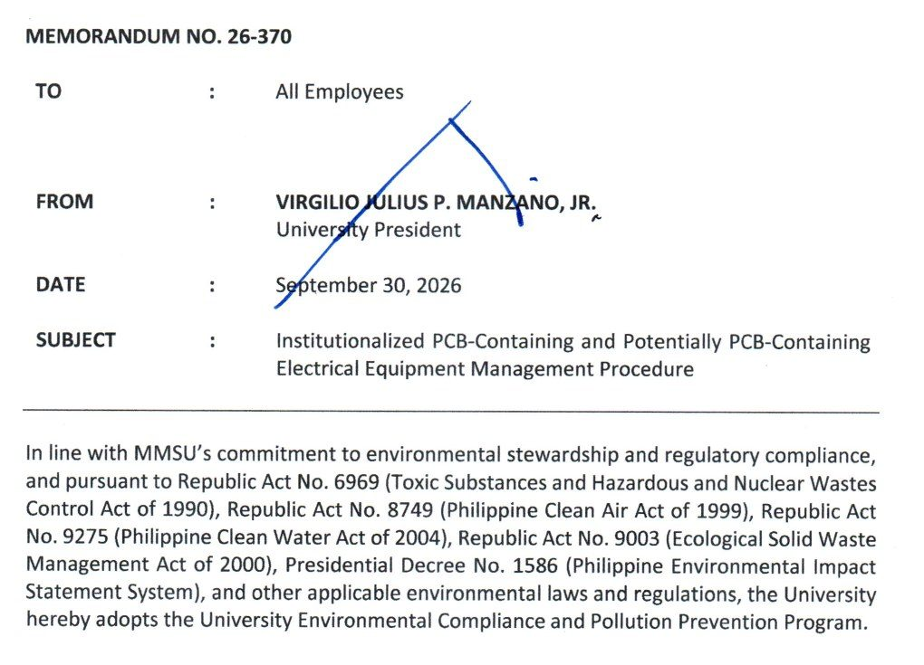  Document: Office of the President Memorandum No. 26-370, 30 September 2026, adopting the University Environmental Compliance and Pollution Prevention Program. | 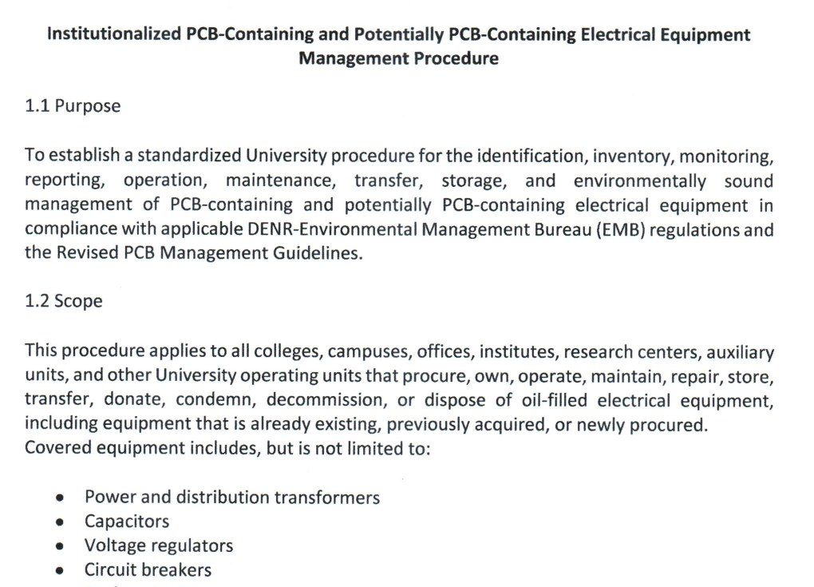  Document: attached procedure for PCB-containing and potentially PCB-containing electrical equipment (purpose, scope and inventory), Memorandum No. 26-370.

Policy | Memorandum No. 26-370, University Environmental Compliance and Pollution Prevention Program
Approved by | University President Virgilio Julius P. Manzano Jr.
Reference no. | 26-370
Date | 30 September 2026
Provisions | Environmental Compliance Procedures; PCB-containing equipment procedure

On September 30, 2026, University President Virgilio Julius P. Manzano Jr. issued Memorandum No. 26-370 to all employees, adopting the University Environmental Compliance and Pollution Prevention Program under Republic Act 6969 (Toxic Substances and Hazardous and Nuclear Wastes Control Act), Republic Act 8749 (Clean Air Act), Republic Act 9275 (Clean Water Act), Republic Act 9003 (Ecological Solid Waste Management Act) and Presidential Decree 1586 (Environmental Impact Statement System). The memorandum covers the management of hazardous wastes, wastewater, air emissions, solid wastes and chemicals, together with permits, monitoring, reporting and inspections required by the Department of Environment and Natural Resources – Environmental Management Bureau (DENR-EMB), and directs all offices, colleges, laboratories, research units and auxiliary enterprises to comply with the attached Environmental Compliance Procedures.
The attached procedure for PCB-containing and potentially PCB-containing electrical equipment, such as transformers, capacitors, voltage regulators, circuit breakers, reclosers and oil-filled switches, requires every unit to inventory its equipment and submit the inventory to the Sustainability and Futures Thinking (SFT) Office. The SFT Office validates the inventory, keeps the university’s central PCB inventory and the DENR-EMB online PCB inventory, ensures labelling, conducts inspections and annual inventory validation, and prepares the reports required by DENR-EMB. No covered equipment may be relocated, transferred, repaired through oil handling, decommissioned, condemned or disposed of without the SFT Office’s written clearance, and PCB wastes and equipment may be disposed of only through DENR-accredited transporters, treaters and disposal facilities. The SFT Office keeps hazardous waste manifests and certificates of treatment or disposal among its records.
Resources 1
2.2 Hazardous Waste Disposal under MMSU’s Integrated Pollution and Waste Management Program
Policy · Integrated Pollution and Waste Management Program (revised 2020)
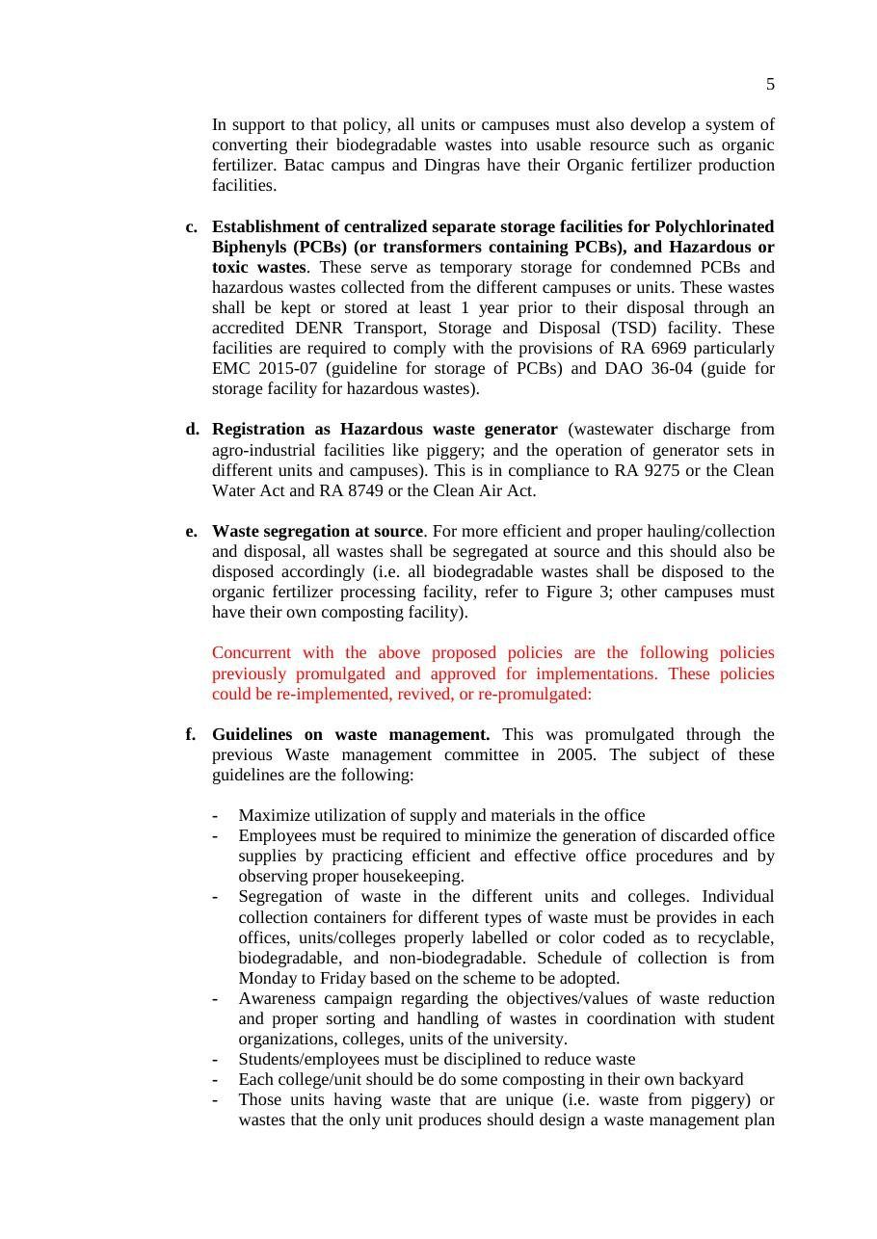
Document: Revised Integrated Pollution and Waste Management Program of MMSU, provisions on PCB and hazardous waste storage and registration.

Policy | Integrated Pollution and Waste Management Program (IPWMP)
Date | 2020.
Provisions | Hazardous waste provisions: focal persons, labelling, central storage, DENR-accredited disposal (RA 6969)

MMSU’s Integrated Waste Management Program was revised in 2020 into the Integrated Pollution and Waste Management Program (IPWMP), implemented by the Pollution Control Unit and the General Services directorate, to cover hazardous materials. The IPWMP assigns focal persons for hazardous wastes (chemical and related wastes), air and water pollution, solid wastes, and PCBs and related industrial wastes, and requires the waste coordinators of every unit to store and label generated hazardous wastes properly before collection.
The program establishes centralized, separate storage facilities for polychlorinated biphenyls (PCBs) and other hazardous or toxic wastes collected from the campuses, where the wastes are kept for up to one year before disposal through a DENR-accredited transport, storage and disposal facility, in compliance with Republic Act 6969 and its storage guidelines. Units that generate hazardous waste are registered as hazardous waste generators, and the university coordinates with the Environmental Management Bureau of DENR for final collection and disposal.
Resources 2, 3
3 Conclusion
Registered generators, labelled and centrally stored wastes, DENR-accredited disposal and a PCB inventory with written clearance give hazardous materials a traceable path.
4 Resources
1. MMSU Office of the President, Memorandum No. 26-370, “Institutionalized PCB-Containing and Potentially PCB-Containing Electrical Equipment Management Procedure,” 30 September 2026
2. MMSU, Hazardous Waste Disposal (SDG 15 page). https://www.mmsu.edu.ph/resources/1jo6-3cVqxRAIllIxEhnSCgyT5ef5LGOW/data
3. MMSU, Revised Integrated Pollution and Waste Management Program. https://www.mmsu.edu.ph/resources/1fNUCZwyOozOKO27L2Bm6pNN-P_cJNpLd/view

