 | SDG 15.3.5  SDG 15 Life on Land  Collaboration for shared land ecosystems  Mariano Marcos State University · THE Sustainability Impact Ratings 2027
The question
Collaborate with the local community to maintain shared land ecosystems.
1 Introduction
MMSU’s commitment is to take an active role in protecting and promoting sustainable use of terrestrial ecosystems, responsible land use, and biodiversity conservation. Shared land, shared work: LGUs, DENR, a service club, a foundation and barangays planting and protecting together.
2 Body
2.1 MMSU, TMP Foundation, DENR and Pasuquin LGU Sign Agreement to Conserve a Coastal Forest
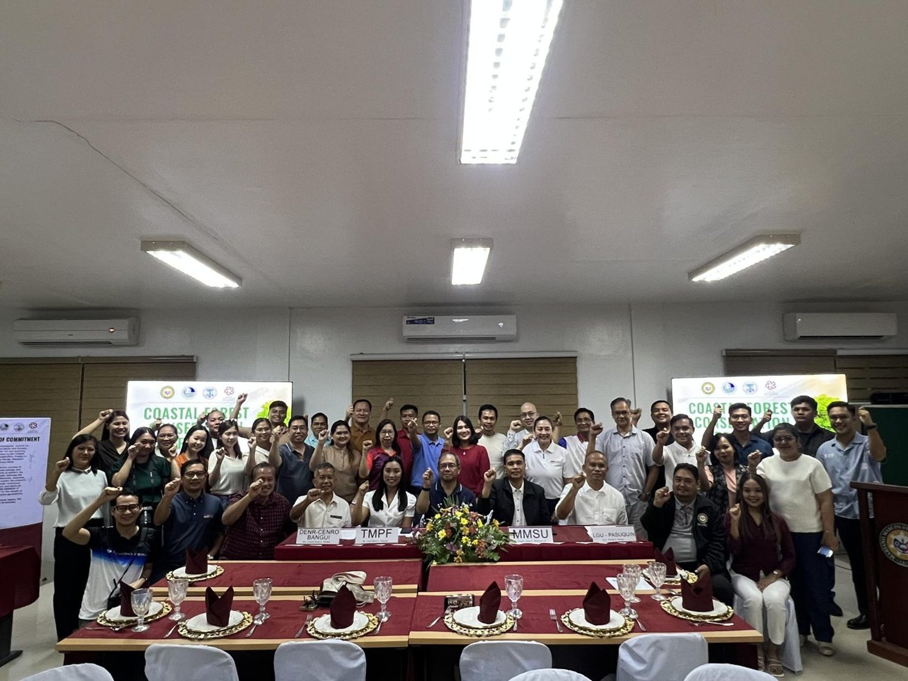  Signing of the memorandum of agreement among MMSU, TMP Foundation, DENR and LGU-Pasuquin, 29 November 2025. (Photo: MMSU STRATCOM) | 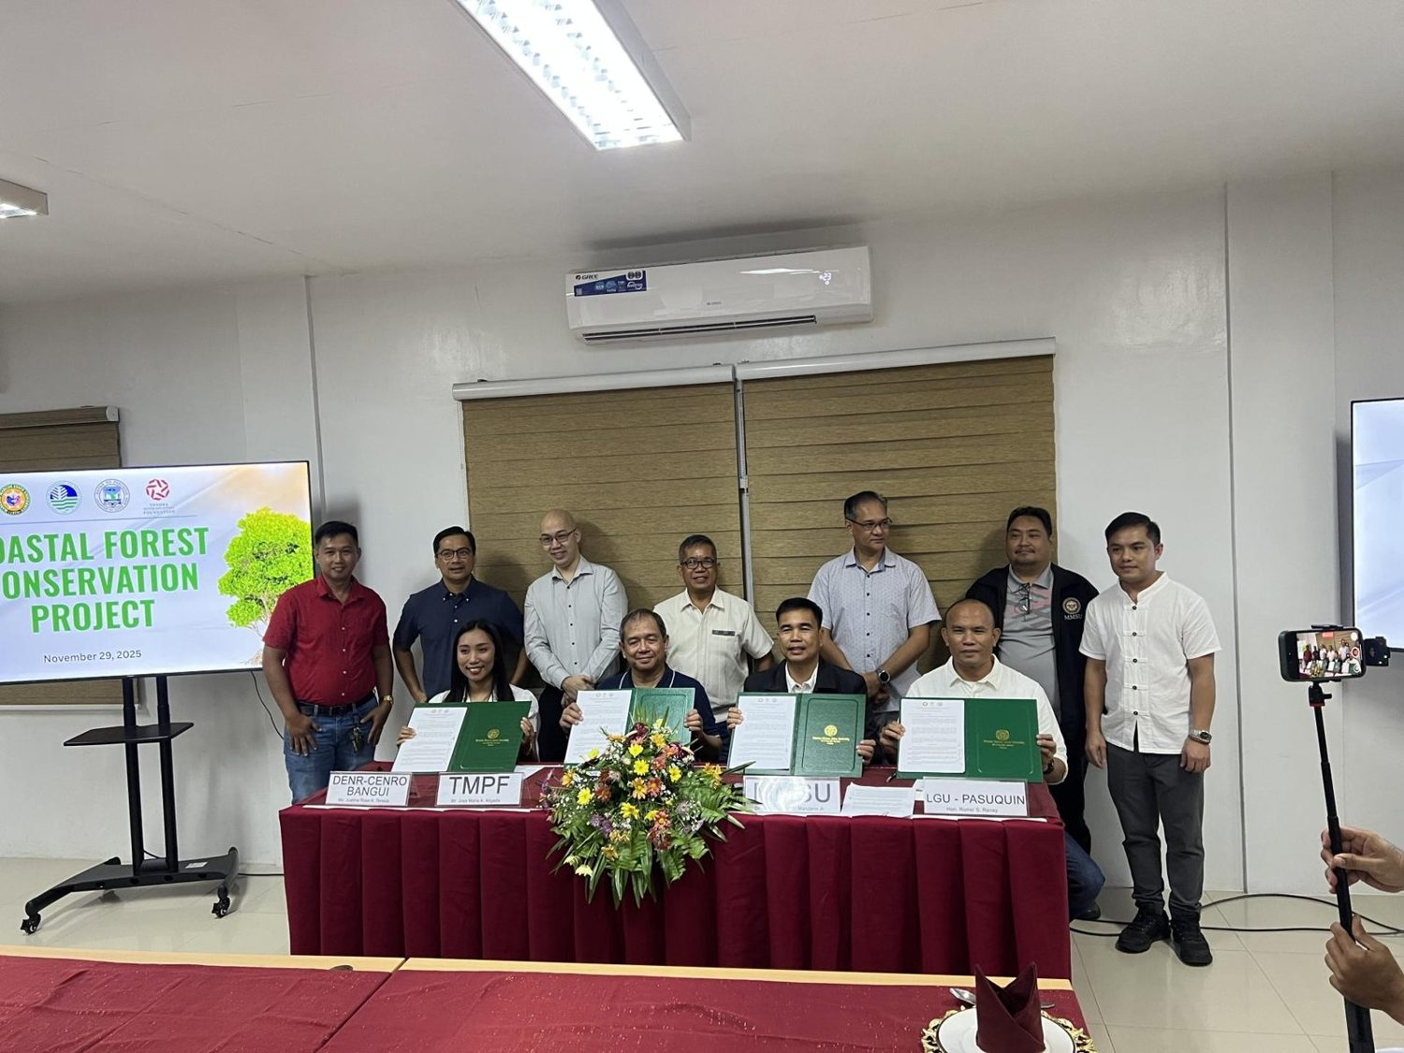  MMSU, TMP Foundation, DENR and LGU-Pasuquin officials at the agreement signing, 29 November 2025. (Photo: MMSU STRATCOM)

On November 29, 2025, Mariano Marcos State University, the Toyota Motor Philippines Foundation (TMPF), the Department of Environment and Natural Resources and the Local Government Unit of Pasuquin formalized through a memorandum of agreement a partnership to strengthen coastal forest conservation in Barangay Davila, Pasuquin, Ilocos Norte. The agreement was signed by MMSU President Virgilio Julius P. Manzano Jr. with TMPF leadership, Toyota Motor Philippines and Toyota Ilocos Norte executives, DENR-CENRO Bangui Ecosystem Management Specialist Justine Rose Teneza, and Sangguniang Bayan Member Romel Ranay for LGU-Pasuquin.
A mangrove planting followed the signing at the degraded two-hectare National Greening Program site in Barangay Davila: about 110 volunteers, including members of the MMSU College of Industrial Technology, DENR-CENRO Bangui, the Municipal Environment and Natural Resources Office and residents, planted 1,750 seedlings, and the partners will plant 3,500 seedlings of the native mangrove species lapis-lapis and arinaya over two years. TMPF President Jose Maria Aligada described the partnership as shared stewardship to restore native mangrove species, rehabilitate coastal systems and boost community resilience to climate-related hazards. Former MMSU College of Industrial Technology Dean Cesario Pacis was recognized as one of the initiators of the MMSU–Toyota partnership.
Resources 1, 2
2.2 MMSU, Rotary Club and Badoc LGU Restore a Typhoon-Damaged Mangrove Stand
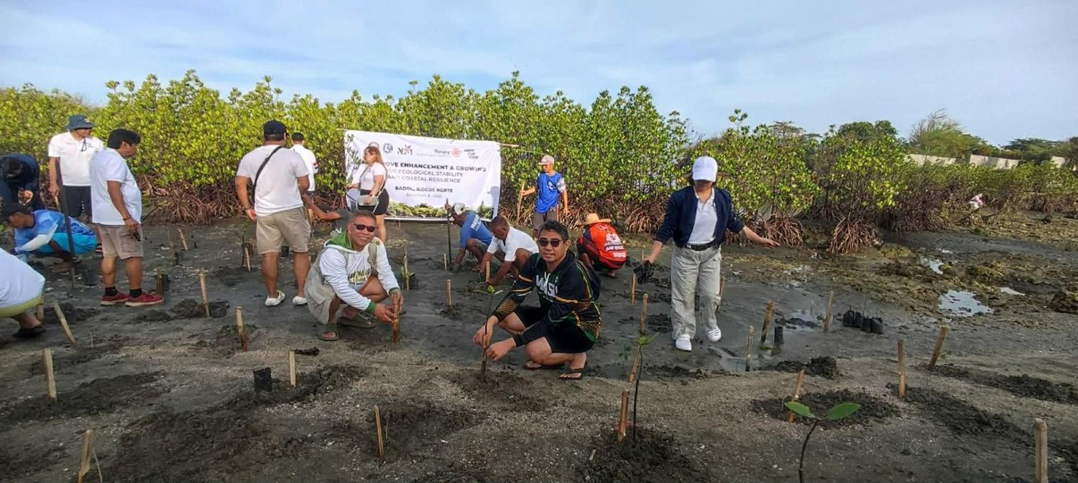  MMSU, Rotary Club of Laoag Sunshine and LGU-Badoc plant mangrove propagules in Brgy. Pagsanahan, Badoc, 6 December 2025. (Photo: MMSU) | 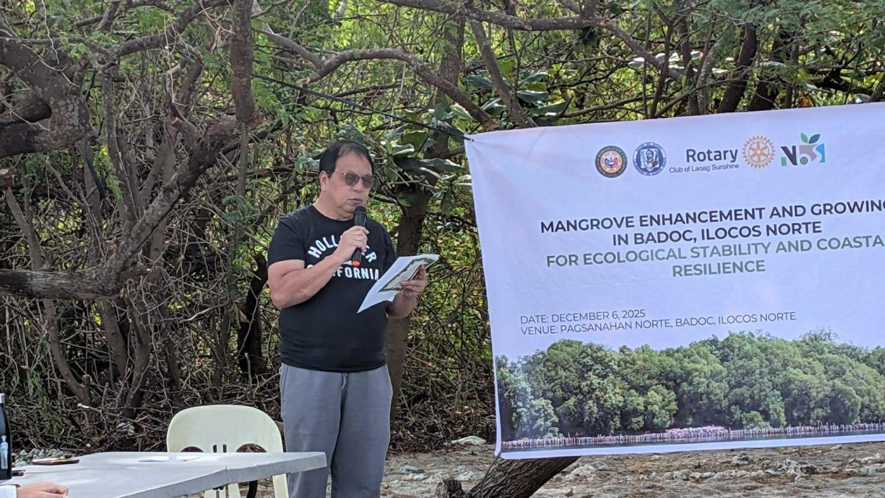  Participants of the mangrove enhancement and growing activity in Badoc, 6 December 2025. (Photo: MMSU)

On December 6, 2025, Mariano Marcos State University, the Rotary Club of Laoag Sunshine and the Local Government Unit of Badoc planted 280 mangrove propagules in Barangay Pagsanahan, Badoc, Ilocos Norte, to restore a mangrove stand extensively damaged by past typhoons and to ensure the continuity of ecological succession at the site.
The activity was led by MMSU President Virgilio Julius P. Manzano Jr., with the LGU of Badoc headed by Hon. Virgilio M. Calajate and the Rotary Club of Laoag Sunshine under Atty. Zsa Zsa Raval. MMSU’s Vice President for Resource Generation and its Directors for Extension, Curriculum Development and Innovative Learning, and Student Affairs and Development also took part.
Resources 3
2.3 MMSU Plants 250 Mangrove Propagules in Currimao on World Environment Day
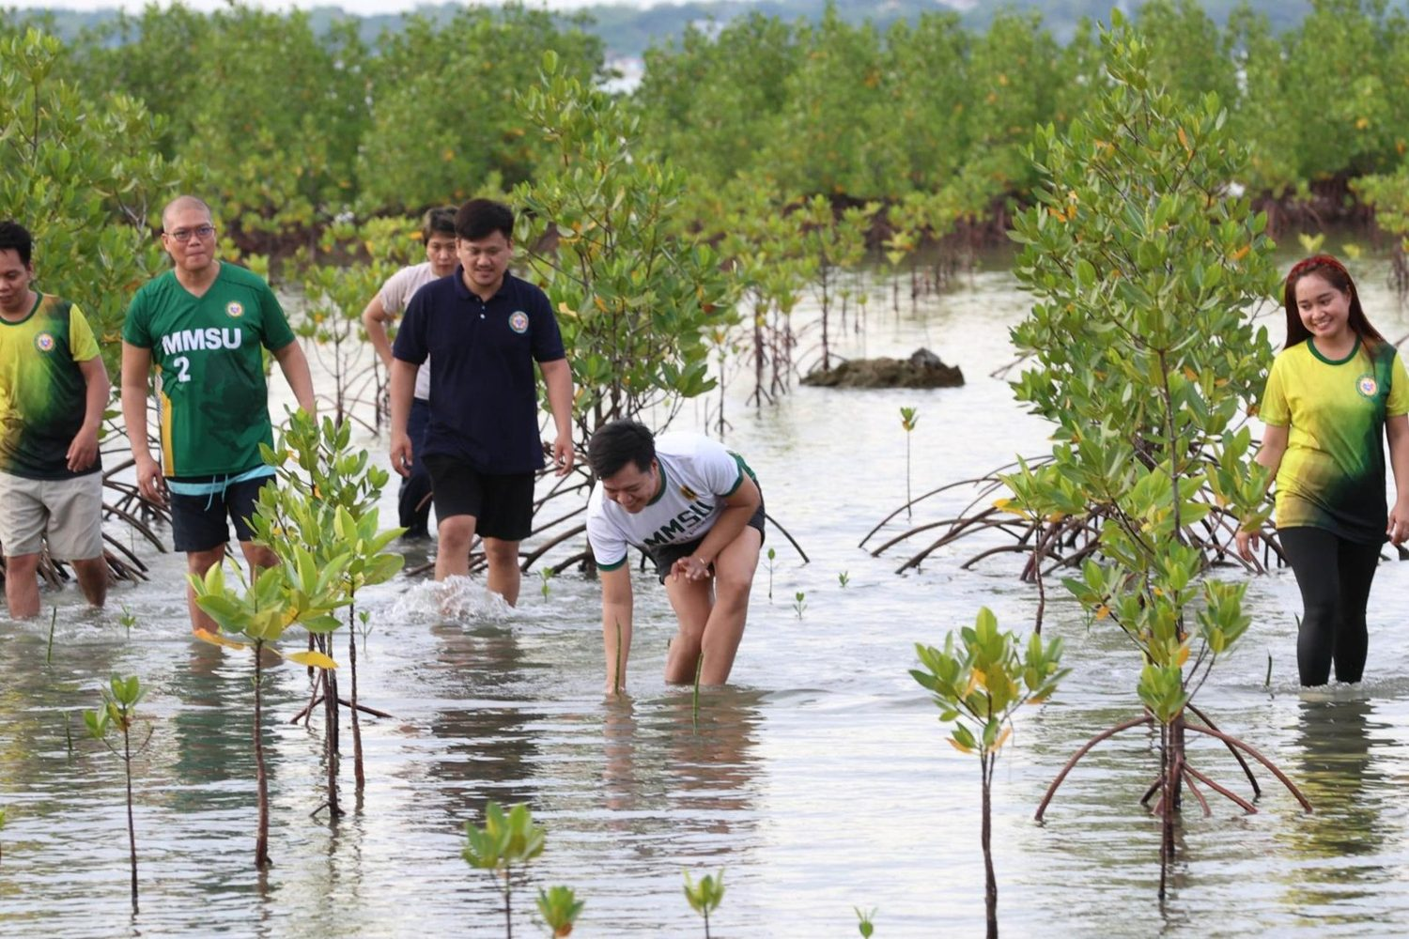  Mangrove planting for World Environment Day, Brgy. Maglaoi, Currimao, June 2025. (Photo: MMSU STRATCOM) | 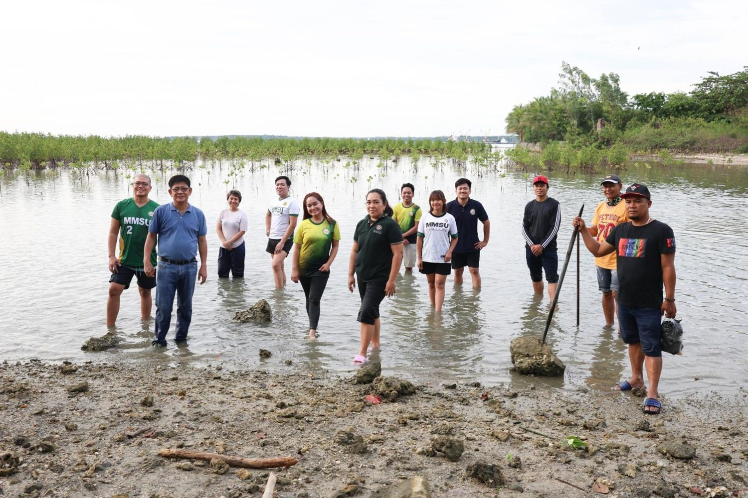  MMSU, LGU Currimao, DENR and fisherfolk volunteers at the planting site, June 2025. (Photo: MMSU STRATCOM)

In June 2025, in celebration of World Environment Day, Mariano Marcos State University planted 250 mangrove propagules along the coastal area of Barangay Maglaoi, Currimao, Ilocos Norte, to restore degraded shorelines, enhance climate resilience and promote sustainable coastal resource management. The activity was spearheaded by the MMSU Sustainability and Futures Thinking (SFT) Office with the Local Government Unit of Currimao and led by Dr. Mee Jay Domingo, Vice President for Planning and Strategic Foresight.
MMSU faculty, education support personnel and students joined representatives of the Department of Environment and Natural Resources, barangay officials, members of local fisherfolk organizations and community members. SFT Director Dr. Arlene Gonzales explained that mangroves were chosen because they act as natural filters that intercept plastic waste from land before it reaches the sea, while absorbing carbon, protecting shorelines from erosion and providing habitat for marine life.
Resources 4
2.4 MMSU and DENR Region 1 Strengthen Partnership for Mangrove Conservation
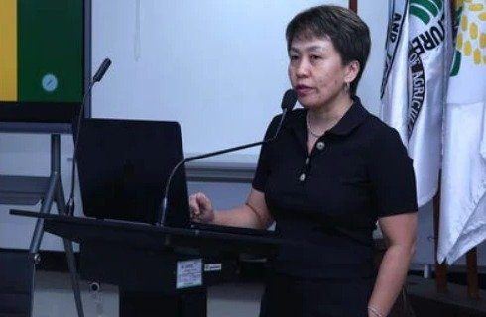  Dr. Arlene L. Gonzales at the MMSU–DENR Region 1 dialogue on mangrove conservation, ILAARRDEC. | 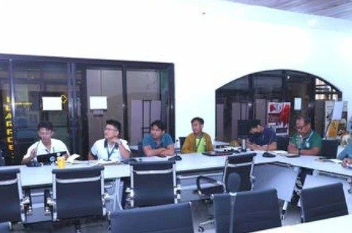  MMSU and DENR Region 1 officials during the dialogue at ILAARRDEC.

MMSU, in partnership with the Department of Environment and Natural Resources (DENR) Region 1, convened a dialogue at ILAARRDEC to advance mangrove conservation and coastal resilience in the Ilocos Region through science-based and community-centered approaches. Central to the dialogue was the DOST-PCAARRD-funded nature-based solutions mangrove project led by Dr. Arlene Gonzales.
DENR officials pledged technical support and active participation in restoration, monitoring and evaluation activities. The same project brought representatives of Currimao, Pasuquin, Badoc and Burgos, with DENR-PENRO, to MMSU’s mangrove propagation seminar-workshop on October 27–28, 2025.
Resources 5, 6
2.5 Indigenous Food Plant Foodscapes Established with Vintar and San Nicolas Partners
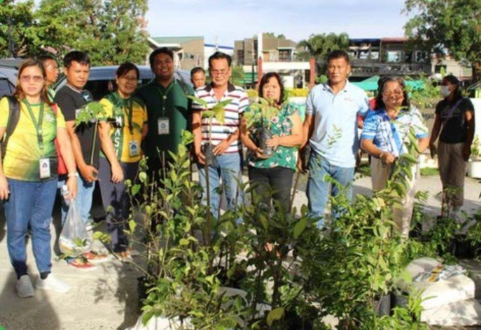
Partners receive indigenous food plant planting materials for the Community Foodscapes and Seedbanks, World Food Day 2025.

In October 2025, the MMSU Extension and Research Directorates partnered with local government units and schools to establish Community Foodscapes and Seedbanks for Indigenous Food Plants. Held at Eladio V. Barangan Memorial Elementary School in San Nicolas, Ilocos Norte, the activity brought together officials of Barangays San Roque and Parut, Vintar, the Municipal Agriculture Office of Vintar, agricultural extension workers, school leaders and community representatives as the second batch of partner sites.
The partner communities maintain the foodscapes as shared seedbanks and learning gardens, with planting materials and technical assistance from MMSU, to conserve indigenous food resources such as kapaskapas, alokon, pako, dalayap, wild singkamas and roselle. They join existing foodscape sites in Sarrat and Batac.
Resources 5, 7
2.6 A New Bambusetum in Barangay Aglipay, Pinili
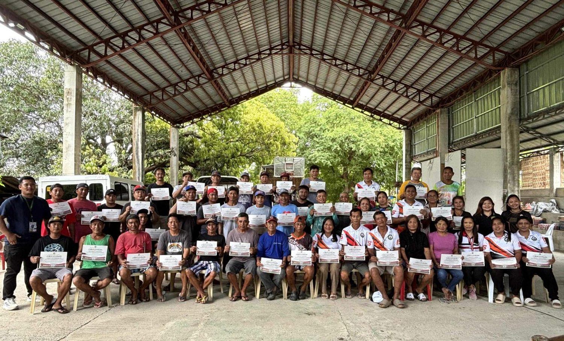
Participants of the bamboo propagation, nursery and plantation management training, Brgy. Aglipay, Pinili, 2025. (Photo: MMSU)

During a two-day bamboo production training in 2025, the MMSU Extension Directorate and CAFSD, with Barangay Aglipay, Pinili, and the support of ILAARRDEC, worked with 46 farmers, local leaders and community members to establish a new bambusetum, a collection of bamboo species, in Barangay Aglipay. The training covered bamboo propagation, nursery establishment and plantation management.
Resources 8
2.7 Mangrove Nature-based Solutions Project Runs from 2024 to 2026
Ongoing programme · 1 May 2024 to 30 April 2026
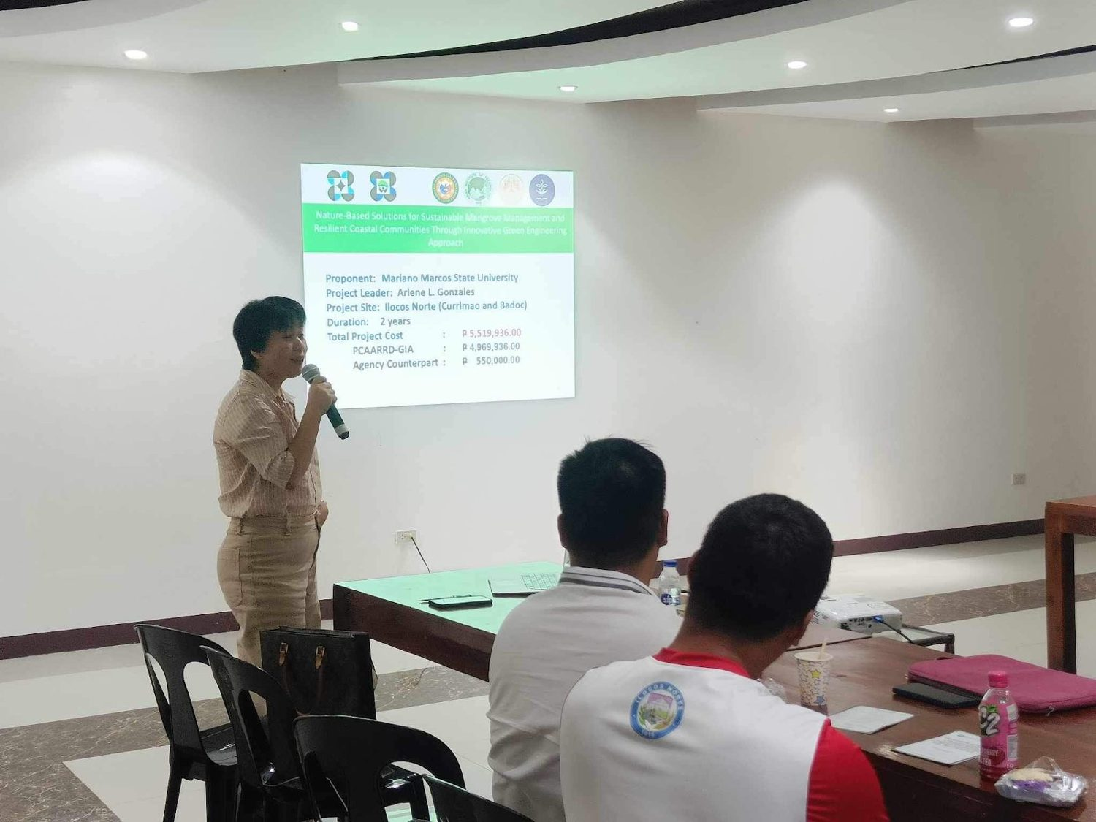  Project Leader Dr. Arlene L. Gonzales presents the project at its launch, MMSU Review Center, 27 June 2024. (Image credit: TTPD, DOST-PCAARRD) | 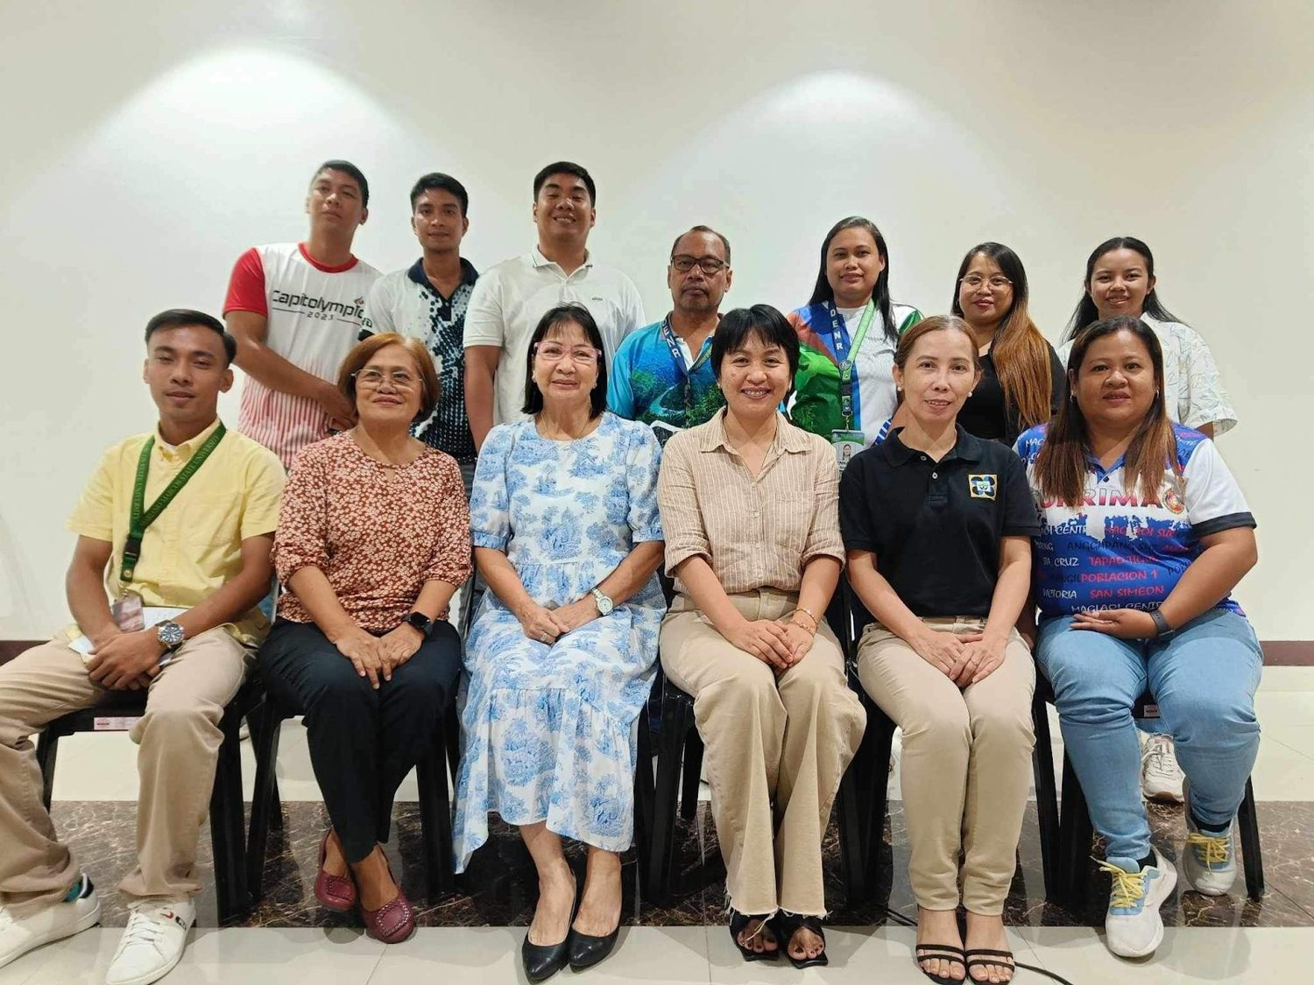  The MMSU project team with DOST-PCAARRD, DENR-PENRO Ilocos Norte, the Provincial Government of Ilocos Norte and the LGUs of Badoc and Currimao at the launch. (Image credit: TTPD, DOST-PCAARRD)

The DOST-PCAARRD-funded project “Nature-based Solutions (NbS) for Sustainable Mangrove Management and Resilient Coastal Communities Through Innovative Green Engineering Approach,” led by Dr. Arlene L. Gonzales of MMSU, was launched at the MMSU Review Center on June 27, 2024, and runs from May 1, 2024 to April 30, 2026 in Badoc and Currimao, Ilocos Norte. DENR-PENRO Ilocos Norte, the Provincial Government of Ilocos Norte and the local government units of Badoc and Currimao support the project.
The project addresses the poor hydrological conditions that keep young mangrove propagules from surviving, using technology-assisted plantations and locally available, ecologically friendly materials, including bamboo-engineered structures that protect young mangroves and improve their survival.
The 2025 activities of the project, including the dialogue with DENR Region 1 and the October 2025 mangrove propagation seminar-workshop, are described under Indicators 15.2.3 and 15.2.4.
Resources 9
2.8 MMSU Expert Serves on the Kalbario-Patapat Natural Park Technical Working Group
Ongoing role · appointment of 29 March 2023
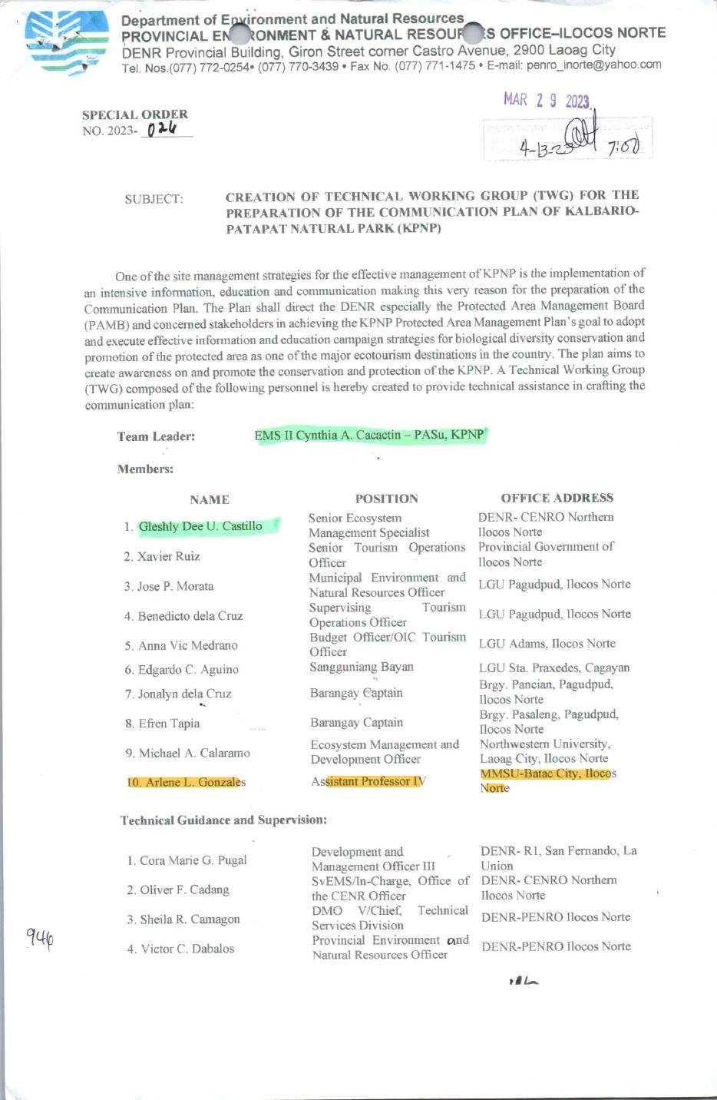
Document: DENR-PENRO Ilocos Norte Special Order No. 2023-024 (29 March 2023) naming Dr. Arlene L. Gonzales of MMSU to the KPNP Technical Working Group.

Through DENR-PENRO Ilocos Norte Special Order No. 2023-024, dated March 29, 2023, Dr. Arlene L. Gonzales of MMSU was named a member of the Technical Working Group that prepares the Communication Plan of the Kalbario-Patapat Natural Park (KPNP), a protected area in Ilocos Norte. The group, led by the KPNP Protected Area Superintendent, brings together DENR offices, the Provincial Government of Ilocos Norte, the LGUs of Pagudpud and Adams in Ilocos Norte and Sta. Praxedes in Cagayan, barangay officials and Northwestern University.
The Communication Plan supports the goal of the KPNP Protected Area Management Plan to adopt and carry out effective information and education campaigns for biological diversity conservation and for the promotion of the protected area as a major ecotourism destination.
Resources 10
3 Conclusion
Mangroves in Pasuquin, Currimao and Badoc, indigenous food plant foodscapes in Vintar and San Nicolas, a bambusetum in Pinili and a seat on a park working group: MMSU works with LGUs, DENR, a foundation, a service club and barangays on land and coast they share.
4 Resources
1. MMSU News, “MMSU ties up with Toyota and DENR for coastal preservation in Pasuquin town,” 4 December 2025. https://www.mmsu.edu.ph/news/mmsu-ties-up-with-toyota-and-denr-for-coastal-preservation-in-pasuquin-town
2. The Manila Times, “TMP Foundation adopts mangrove forest for climate mitigation,” 10 December 2025. https://www.manilatimes.net/2025/12/10/tmt-newswire/tmp-foundation-adopts-mangrove-forest-for-climate-mitigation/2239598
3. MMSU News, “MMSU ties up with Rotary Club of Laoag Sunshine for mangrove planting in Badoc town,” 11 December 2025. https://www.mmsu.edu.ph/news/mmsu-ties-up-with-rotary-club-of-laoag-sunshine-for-mangrove-planting-in-badoc-town
4. MMSU News, “MMSU plants 250 mangrove propagules in Currimao,” 11 June 2025. https://www.mmsu.edu.ph/news/mmsu-plants-250-mangrove-propagules-in-currimao
5. MMSU SDG 15 Life on Land report (2025), Office of Sustainability and Futures Thinking
6. MMSU News, “MMSU trains Ilocos Norte coastal towns on mangrove propagation and management,” 5 November 2025. https://www.mmsu.edu.ph/article/news/2670/mmsu-trains-ilocos-norte-coastal-towns-on-mangrove-propagation-and-management
7. MMSU Extension Directorate, “MMSU expands indigenous food plant seedbanks and foodscapes in LGUs,” October 2025. https://extension.mmsu.edu.ph/news/show/389/mmsu-expands-indigenous-food-plant-seedbanks-and-foodscapes-in-lgus
8. MMSU News, “Sustainable livelihood: MMSU, ILAARRDEC hold bamboo training in Pinili,” 3 September 2025. https://www.mmsu.edu.ph/news/sustainable-livelihood-mmsu-ilaarrdec-hold-bamboo-training-in-pinili
9. DOST-PCAARRD, “DOST-PCAARRD, MMSU launch nature-based solutions project on mangrove management in Ilocos Norte,” 7 August 2024. https://www.pcaarrd.dost.gov.ph/index.php/quick-information-dispatch-qid-articles/dost-pcaarrd-mmsu-launch-nature-based-solutions-project-on-mangrove-management-in-ilocos-norte
10. DENR-PENRO Ilocos Norte Special Order No. 2023-024, 29 March 2023 (MMSU SDG 15 page). https://www.mmsu.edu.ph/resources/1TCpM-DxbkgfOh4QGwlfVr8QavCchKWKu/data

